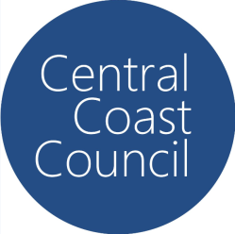
Event Bin Application 2023-2024
Event bins can be ordered for your event:
- 240 litre Mobile event waste bins cost $48.80 each per day
- 240 litre Mobile event recycle bins cost $41.50 each per day

Above charges are current for the period 1 July 2023 – 30 June 2024

To order bins please return this form to Council via email ask@centralcoast.nsw.gov.au or take to your nearest Customer Service Centre.
You will be contacted to discuss bin arrangements such as delivery, service and removal.
Please provide a minimum of five working days notice to allow sufficient time for bins to be delivered.
Event information
Event name:
Date of event:
Location of event:
Number of 240L waste bins required:
Number of 240L recycle bins required:

Contact information
Name:
Phone:
Mobile:
Email:

Invoice information
Name:
Address:
ABN (if applicable):
Type of Legal Entity (please select): Individual / Sole Trader / Partnership / Trust / Company / Government Department / Sporting Body / Incorporated Not For Profit Body

Contact a Central Coast Council Waste Officer on (02) 4325 8817 or (02) 4306 7900 for further information.

