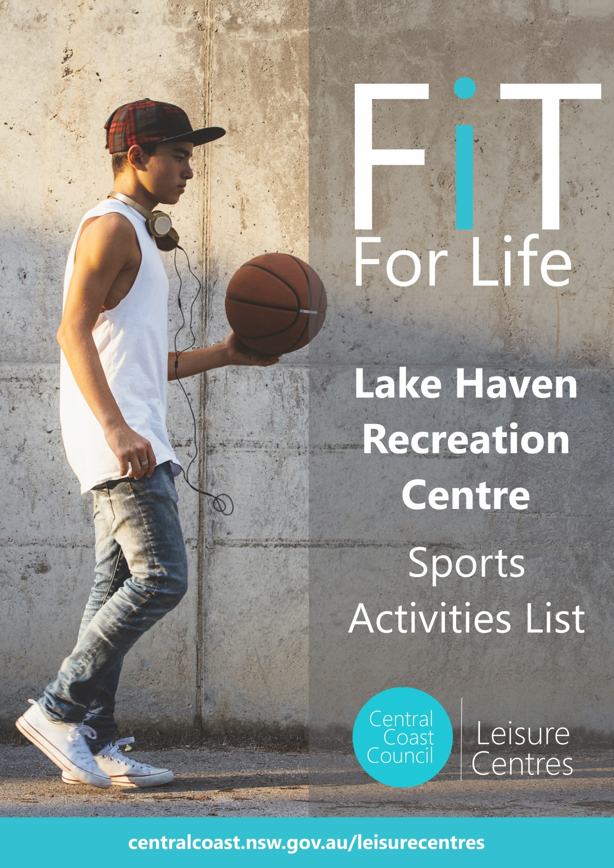

**Lake Haven Recreation Centre  
P** 4304 8020   
**E** lhrc@centralcoast.nsw.gov.au

|  |  |  |  |
| --- | --- | --- | --- |
| **\* ADULT ACTIVITIES** | **DAY, TIME & LOCATION** | **COST (valid to 30th June 2026)**  **CONTACT** | **SEASONS** |
| **Sports Court Hire**  **Squash Court Hire** | Mon to Sun (operating hrs)  Mon to Sun (operating hrs) | $75/hour or half crt $37.50/hour  $27/hour #members free | All year round (court avail. varies)  All year round (court avail. varies) |
| **Sports Court Casual Entry** | Mon to Sun (operating hrs) | $7.50 per person #members free | All year round (court avail. varies) |
| **Basketball**  Men’s & U25s comp night  Social drop-in games 16 + (staffed) | Sports court 1 & 2  Mon 6.15pm-9.30pm  Tue 6.15pm-8pm | Teams pay $70per game***\****  $10 per person #members free | Mar-Jun, Jul-Oct & Nov-Feb  All year round except PH |
| **Netball**  Women’s comp night  Mixed Summer comp night | Sports court 1  Wed 6.00pm-9.00pm  Wed 6.00pm-9.00pm | Teams pay $70 per game***\****  Teams pay $70 per game***\**** | Mar-Aug  Sept -Dec |
| **Squash**  Mens Comp (X Wyong)  Doubles Comp (X Wyong)  Social comp (CC Squash)  Womens Comp (X Wyong) | Squash courts 1-3  Mon 530pm-9pm  Tue 6pm-830pm  Wed 9.00am-11.00am  Wed 5.30pm-9pm | $10 per person #members free  michael.mortiss@gmail.com  djtheman1950@gmail.com  mandy.biddle@bigpond.com  irenazena@gmail.com | All year round except PH |
| **Badminton**  90min Social drop-in games  Beyond Badminton Inc Club | Sports court 2  Mon, Tue & Thu 10.30am  Wed & Fri 930am, Sun 9am  Wed 6.30pm & Sun 10.30am | $7 per person #members free  beyondbaddy@gamil.com | All year round except PH |
| **Pickleball**  90min Social drop-in games | Sports court 2  Mon, Tue & Thu 10.30am  Wed & Fri 930am | $7 per person #members free | All year round except PH |
| **Dodgeball**  Training and games | Sports court 2  Tue 6pm-8pm | Info – northern nsw dodgeball | All year round except PH |
| **Evolution Judo**  Classes by Evolution Judo Acad. | Thurs 5.00pm-6.00pm  Classes held on our stage | info: 0423 466 212  matthewlipman36@hotmail.com | School terms |
|  |  |  |  |
| **\* JUNIOR ACTIVITIES** | **DAY, TIME & LOCATION** | **COST (valid to 30th June 2026)**  **CONTACT** | **SEASONS** |
| **Sports Court Hire**  **Squash Court Hire** | Mon to Sun (operating hrs)  Mon to Sun (operating hrs) | $75/hour or half crt $37.50/hour  $27/hour #members free | All year round (court avail. varies)  All year round (court avail. varies) |
| **Sports Court Casual Entry** | Mon to Sun (operating hrs) | **\***$6.50 per person #members free | court availability varies |
| **Basketball Programs**  Learn to play coaching for 6-11s  Game skills coaching for 11-16s  U12, U14, U16 team competition  U19s team competition | Sports courts 1 & 2  Mon & Thur 4.05-5.00pm  Mon & Thur 5.10-6.05pm  Games Fri 4.20pm-8.20pm  Games Fri 7.40pm-9.40pm | From $12.90/session AK vouch yes  From $12.90/session AK vouch yes  Teams pay $600 per season  Teams pay $60 per game*\** | School terms  School terms  School terms (3x12 week comps)  School terms (3x12 week comps) |
| **Central Coast Little Kickers**  Soccer lessons for pre-schoolers | Mon & Sat mornings  Classes held on sports crt 1 | info: 4326 1997  littlekickers.com.au | All year round except PH |
| **YMCA Street Gym**  Free teens indoor sports & fitness | Thurs 2.30pm-4.30pm  Court & outdoor gym use | centralcoast.youth@ymcansw.org.au  Free indoor crts & outdoor gym | School terms |
| **Evolution Judo**  Classes for 6-15s by Evolution Judo | Mon & Wed from 4.30pm  Classes held on our stage | info: 0423 466 212  matthewlipman36@hotmail.com | School terms |
| **Northern NSW Dodgeball**  Training and games | Sports court 1  Wed 5pm-6pm | Info – northern nsw dodgeball | School terms |
| **Go4 Fun**  Kids Free healthy lifestyle prog | New program TBA | Info:1800 780 900 or go4fun,com.au  Free gov program | School terms |
| **School Holiday Activities**  Basketball coaching (6-11/12-15yrs)  Basketball casual entry | Sports court 1  Mon/Thurs from 4.30pm  Mon to Fri 9.00am-5.00pm | $15 per session  **\***$6.50 per person #members free | School holidays  School holidays |

***\* Children 11 years and under require supervision by an adult or responsible teenager***

***\* Team registration fee applies***

***Operating Hours - 6am to 8pm Monday to Thursday, 6am to 7pm Fridays, 8am to 4pm Saturdays & 9am to 3pm Sundays (closed most Public Hols)***