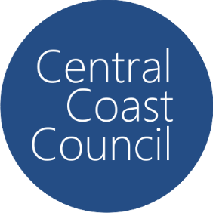Central Coast Council

PFAS Monitoring Results

## August 2024 - August 2025

# Mangrove Creek Weir Catchment

| **Site** | **Month** | **PFAS Substance** | **Notes** |
| --- | --- | --- | --- |
| 1 | 17 December 2024 | PFHxS (0.002)  PFBS (0.001) | Detection below both current and proposed Australian Drinking Water Guidelines |
| 1 | 18 February 2025 | PFHxS (0.002)  PFBS (0.001) | Detection below both current and proposed Australian Drinking Water Guidelines |
| 2 | N/D |  |
| 3 | N/D |  |
| 4 | N/D |  |
| 5 | N/D |  |
| 6 | N/D |  |