Central Coast Council

PFAS Monitoring Results

## August 2024 - August 2025

# Ourimbah Catchment

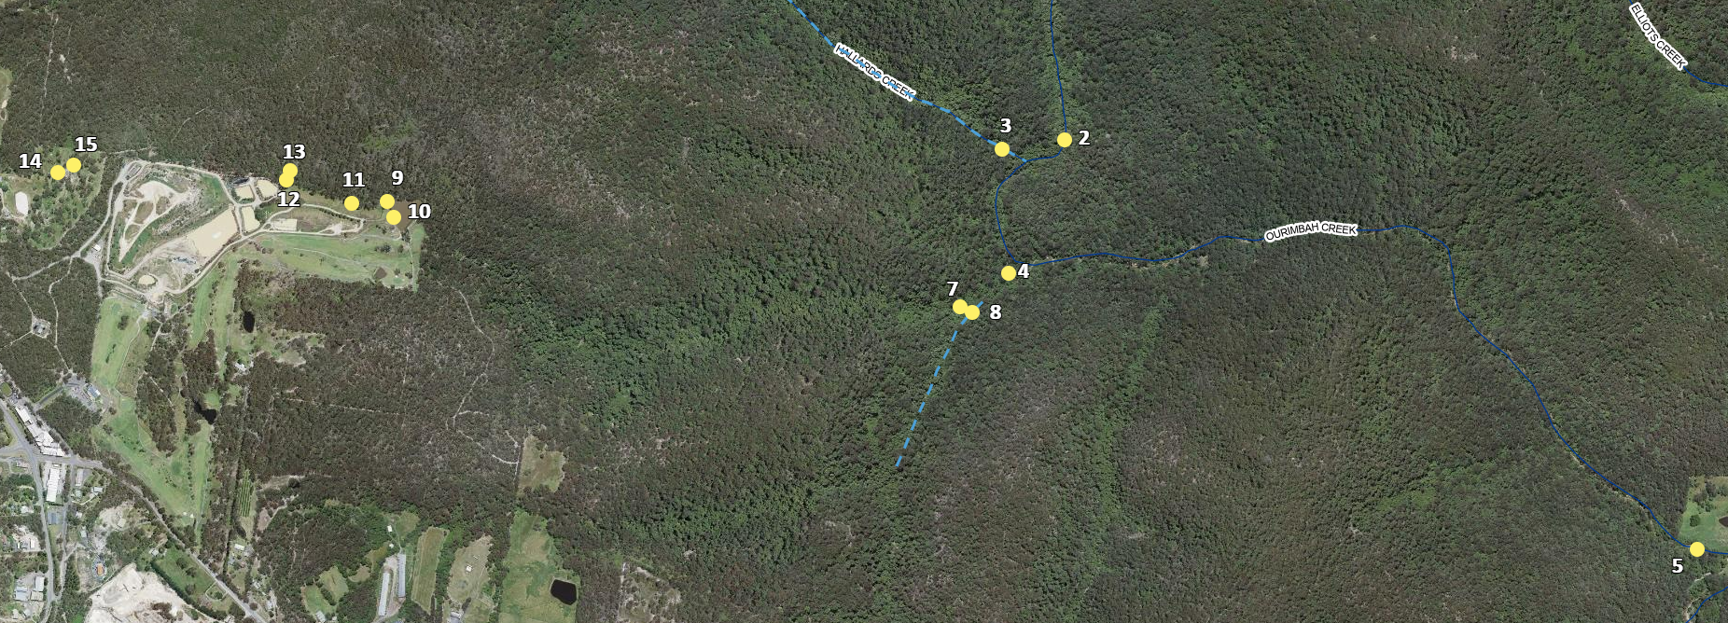

**Figure 1: Sample sites for Ourimbah Creek catchment (north-western sites, excluding Springs Road at far north of catchment).**

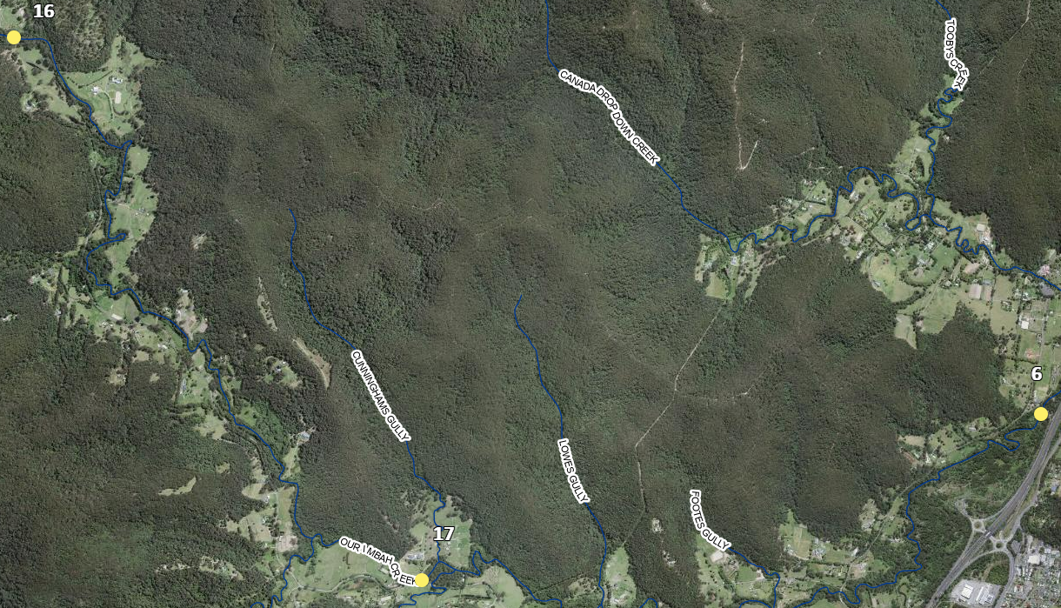

Figure 2: Sample sites for Ourimbah Creek catchment (south-easten sites)

|  |  |
| --- | --- |
| **Site No** | **Location** |
| 1 | Stringybark Creek downstream of Mangrove Mountain Golf Course |
| 2 | Ourimbah Creek most upstream point |
| 3 | Most downstream point of Hallards Creek |
| 4 | Stringybark Creek upstream of Ourimbah Creek confluence (connection) |
| 5 | Mid Ourimbah creek in proximity of 40 Acres |
| 6 | Water Pump Station 11 north / west of Ourimbah interchange of M1 |
| 7 | Northern arm of Stringybark Creek downstream from site 1 |
| 8 | Southern arm of Stringybark Creek upstream from site 4 |
| 9 | Upstream of Stringybark Creek – Mangrove Mountain Golf Course |
| 10 | Mangrove Mountain Golf Course Northern pond |
| 11 | Stringybark Creek upstream of site 9 |
| 12 | Stringybark Creek Southern arm adjacent to Mangrove Mountain Landfill |
| 13 | Northern arm of Stringybark Creek upstream of Mangrove Mountain Landfill |
| 14 | Hallards Creek upstream of site 3 |
| 15 | Stormwater runoff adjacent to Mangrove Mountain Landfill site |
| 16 | Ourimbah Creek upstream from site 17 |
| 17 | Ourimbah Creek upstream from site 6 |

*Sites are ordered from bottom of catchment to the upper reaches of the catchment

** Units are in micrograms per litre

| **Site** | **Month** | **PFAS Substance** | **Notes** |
| --- | --- | --- | --- |
| 6 | 8 August 2024 | N/D |  |
| 2 | N/D |  |
| 3 | N/D |  |
| 5 | N/D |  |
| 7 | N/D |  |
| 8 | N/D |  |
| 6 | 13 November 2024 | PFHxS (0.002)  PFBS (0.001) | Detection below both current and proposed Australian Drinking Water Guidelines |
| 2 | N/D |  |
| 3 | N/D |  |
| 5 | PFHxS (0.002)  PFBS (0.002) | Detection below both current and proposed Australian Drinking Water Guidelines |
| 8 | N/D |  |
| 7 | PFOS (0.006)  PFHxS (0.047)  PFOA (0.019)  PFBS (0.065) | PFOA and PFBS below both current Australian Drinking Water Guidelines. PFOS and PFHxS below current Guidelines only. |
| 6 | 12 December 2024 | PFOS (0.002)  PFHxS (0.002)  PFOA (0.002)  PFBS (0.001) | Detection below both current and proposed Australian Drinking Water Guidelines |
| 2 | N/D |  |
| 3 | N/D |  |
| 5 | PFHxS (0.002)  PFOA (0.002)  PFBS (0.001) | Detection below both current and proposed Australian Drinking Water Guidelines |
| 8 | N/D |  |
| 7 | PFOS (0.007)  PFHxS (0.039)  PFOA (0.039)  PFBS (0.04) | PFOA and PFBS below both current Australian Drinking Water Guidelines. PFOS and PFHxS below current Guidelines only. |
| 1 | 15 January 2025 | N/D |  |
| 6 | PFHxS (0.002) | Detection below both current and proposed Australian Drinking Water Guidelines |
| 2 | N/D |  |
| 3 | N/D |  |
| 5 | PFHxS (0.002)  PFBS (0.002) | Detection below both current and proposed Australian Drinking Water Guidelines |
| 8 | N/D |  |
| 7 | PFOS (0.007)  PFHxS (0.046)  PFOA (0.015)  PFBS (0.048) | PFOA and PFBS below both current Australian Drinking Water Guidelines. PFOS and PFHxS below current Guidelines only. |
| 9 | PFOS (0.033)  PFHxS (0.211)  PFOA (0.086)  PFBS (0.145) | PFOA and PFBS below both current Australian Drinking Water Guidelines. PFOS and PFHxS above both current and proposed Guidelines. |
| 10 | PFOS (0.023)  PFHxS (0.157)  PFOA (0.074)  PFBS (0.121) | PFOA and PFBS below both current Australian Drinking Water Guidelines. PFOS and PFHxS above both current and proposed Guidelines. |
| 6 | 23 January 2025 | PFOS (0.001)  PFHxS (0.003)  PFOA (0.001)  PFBS (0.002) | Detection below both current and proposed Australian Drinking Water Guidelines |
| 2 | N/D |  |
| 3 | N/D |  |
| 5 | PFHxS (0.003)  PFOA (0.001)  PFBS (0.002) | Detection below both current and proposed Australian Drinking Water Guidelines |
| 6 | N/D |  |
| 8 | N/D |  |
| 7 | PFOS (0.007)  PFHxS (0.039)  PFOA (0.018)  PFBS (0.039) | PFOA and PFBS below both current Australian Drinking Water Guidelines. PFOS and PFHxS below current Guidelines only. |
| 9 | PFOS (0.061)  PFHxS (0.254)  PFOA (0.139)  PFBS (0.175) | PFOA and PFBS below both current Australian Drinking Water Guidelines. PFOS and PFHxS above both current and proposed Guidelines. |
| 10 | PFOS (0.031)  PFHxS (0.163)  PFOA (0.093)  PFBS (0.134) | PFOA and PFBS below both current Australian Drinking Water Guidelines. PFOS and PFHxS above both current and proposed Guidelines. |
| 11 | PFOS (0.051)  PFHxS (0.297)  PFOA (0.168)  PFBS (0.22) | PFOA and PFBS below both current Australian Drinking Water Guidelines. PFOS and PFHxS above both current and proposed Guidelines. |
| 12 | PFOS (0.068)  PFHxS (0.234)  PFOA (0.197)  PFBS (0.168) | PFOA and PFBS below both current Australian Drinking Water Guidelines. PFOS and PFHxS above both current and proposed Guidelines. |
| 13 | N/D |  |
| 14 | N/D |  |
| 15 | PFOS (0.005) | Detection below both current and proposed Australian Drinking Water Guidelines |
| 6 | 6 February 2025 | PFHxS (0.002)  PFBS (0.001) | Detection below both current and proposed Australian Drinking Water Guidelines |
| 2 | N/D |  |
| 3 | N/D |  |
| 5 | PFHxS (0.002)  PFOA (0.001)  PFBS (0.001) | Detection below both current and proposed Australian Drinking Water Guidelines |
| 8 | N/D |  |
| 7 | PFOS (0.01)  PFHxS (0.042)  PFOA (0.019)  PFBS (0.031) | PFOA and PFBS below both current and proposed Australian Drinking Water Guidelines. PFOS and PFHxS below current Guidelines only. |
| 9 | PFOS (0.021)  PFHxS (0.168)  PFOA (0.076)  PFBS (0.105) | PFOA and PFBS below both current and proposed Australian Drinking Water Guidelines. PFOS and PFHxS above both current and proposed Guidelines. |
| 10 | PFOS (0.038)  PFHxS (0.207)  PFOA (0.119)  PFBS (0.119) | PFOA and PFBS below both current and proposed Australian Drinking Water Guidelines. PFOS and PFHxS above both current and proposed Guidelines. |
| 11 | PFOS (0.018)  PFHxS (0.151)  PFOA (0.075)  PFBS (0.103) | PFOA and PFBS below both current and proposed Australian Drinking Water Guidelines. PFOS and PFHxS above both current and proposed Guidelines. |
| 12 | PFOS (0.111)  PFHxS (0.74)  PFOA (0.417)  PFBS (0.57) | PFBS below both current and proposed Australian Drinking Water Guidelines. PFOA below current guidelines only. PFOS and PFHxS above both current and proposed Guidelines. |
| 13 | N/D |  |
| 14 | N/D |  |
| 15 | PFOS (0.007)  PFHxS (0.011)  PFOA (0.007)  PFBS (0.01) | PFOS below current Australian Drinking Water Guidelines only. PFHxS, PFOA and PFBS detection below both current and proposed Guidelines |
| 6 | 13 February 2025 | PFHxS (0.002) | Detection below both current and proposed Australian Drinking Water Guidelines |
| 2 | N/D |  |
| 3 | N/D |  |
| 5 | PFHxS (0.001)  PFBS (0.001) | Detection below both current and proposed Australian Drinking Water Guidelines |
| 8 | N/D |  |
| 7 | PFOS (0.01)  PFHxS (0.042)  PFOA (0.018)  PFBS (0.031) | PFOA and PFBS below both current and proposed Australian Drinking Water Guidelines. PFOS and PFHxS below current Guidelines only. |
| 9 | PFOS (0.015)  PFHxS (0.138)  PFOA (0.065)  PFBS (0.096) | PFOA and PFBS below both current and proposed Australian Drinking Water Guidelines. PFOS and PFHxS above both current and proposed Guidelines. |
| 10 | PFOS (0.039)  PFHxS (0.183)  PFOA (0.113)  PFBS (0.088) | PFOA and PFBS below both current and proposed Australian Drinking Water Guidelines. PFOS and PFHxS above both current and proposed Guidelines. |
| 11 | PFOS (0.012)  PFHxS (0.148)  PFOA (0.062)  PFBS (0.084) | PFOA and PFBS below both current and proposed Australian Drinking Water Guidelines. PFOS and PFHxS above both current and proposed Guidelines. |
| 12 | PFOS (0.1)  PFHxS (0.643)  PFOA (0.351)  PFBS (0.217) | PFBS below both current and proposed Australian Drinking Water Guidelines. PFOA below current guidelines only. PFOS and PFHxS above both current and proposed Guidelines. |
| 13 | N/D |  |
| 14 | N/D |  |
| 15 | PFOS (0.005)  PFHxS (0.009)  PFOA (0.004)  PFBS (0.01) | PFOS below current Australian Drinking Water Guidelines only. PFHxS, PFOA and PFBS detection below both current and proposed Guidelines |
| 6 | 18 March 2025 | PFHxS (0.002)  PFOA (0.001) | Detection below both current and proposed Australian Drinking Water Guidelines |
| 2 | N/D |  |
| 3 | N/D |  |
| 5 | PFHxS (0.002)  PFBS (0.001) | Detection below both current and proposed Australian Drinking Water Guidelines |
| 8 | N/D |  |
| 7 | PFOS (0.008)  PFHxS (0.04)  PFOA (0.018)  PFBS (0.034) | PFOA and PFBS below both current and proposed Australian Drinking Water Guidelines. PFOS and PFHxS below current Guidelines only. |
| 9 | PFOS (0.012)  PFHxS (0.143)  PFOA (0.06)  PFBS (0.103) | PFOA and PFBS below both current and proposed Australian Drinking Water Guidelines. PFOS and PFHxS above both current and proposed Guidelines. |
| 10 | PFOS (0.032)  PFHxS (0.176)  PFOA (0.106)  PFBS (0.12) | PFOA and PFBS below both current and proposed Australian Drinking Water Guidelines. PFOS and PFHxS above both current and proposed Guidelines. |
| 11 | PFOS (0.013)  PFHxS (0.135)  PFOA (0.063)  PFBS (0.105) | PFOA and PFBS below both current and proposed Australian Drinking Water Guidelines. PFOS and PFHxS above both current and proposed Guidelines. |
| 12 | PFOS (0.053)  PFHxS (0.553)  PFOA (0.31)  PFBS (0.635) | PFBS below both current and proposed Australian Drinking Water Guidelines. PFOA below current guidelines only. PFOS and PFHxS above both current and proposed Guidelines. |
| 13 | N/D |  |
| 14 | N/D |  |
| 15 | PFOS (0.002)  PFHxS (0.003)  PFOA (0.002)  PFBS (0.007) | Detection below both current and proposed Australian Drinking Water Guidelines. |
| 6 | 9 April 2025 | PFHxS (0.002)  PFOA (0.002) | Detection below Australian Drinking Water Guidelines |
| 2 | N/D |  |
| 3 | N/D |  |
| 17 | PFHxS (0.001) | Detection below both current and proposed Australian Drinking Water Guidelines. |
| 16 | PFHxS (0.001) | Detection below both current and proposed Australian Drinking Water Guidelines. |
| 5 | PFHxS (0.002)  PFBS (0.001) | Detection below Australian Drinking Water Guidelines |
| 8 | N/D |  |
| 7 | PFOS (0.008)  PFHxS (0.039)  PFOA (0.016)  PFBS (0.031) | PFOA and PFBS below Australian Drinking Water Guidelines. PFOS and PFHxS above proposed Australian Drinking Water Guidelines. |
| 9 | PFOS (0.017)  PFHxS (0.134)  PFOA (0.058)  PFBS (0.106) | PFOA and PFBS below both current and proposed Australian Drinking Water Guidelines. PFOS and PFHxS above both current and proposed Guidelines. |
| 10 | PFOS (0.035)  PFHxS (0.168)  PFOA (0.092)  PFBS (0.138) | PFOA and PFBS below both current and proposed Australian Drinking Water Guidelines. PFOS and PFHxS above both current and proposed Guidelines. |
| 11 | PFOS (0.013)  PFHxS (0.155)  PFOA (0.069)  PFBS (0.146) | PFOA and PFBS below both current and proposed Australian Drinking Water Guidelines. PFOS and PFHxS above both current and proposed Guidelines. |
| 12 | PFOS (0.06)  PFHxS (0.565)  PFOA (0.243)  PFBS (0.383) | PFBS below both current and proposed Australian Drinking Water Guidelines. PFOA below current guidelines only. PFOS and PFHxS above both current and proposed Guidelines. |
| 13 | N/D |  |
| 6 | 8 May 2025 | PFOS (0.001)  PFHxS (0.002) | Detection below Australian Drinking Water Guidelines |
| 2 | N/D |  |
| 3 | N/D |  |
| 17 | N/D |  |
| 16 | N/D |  |
| 5 | PFHxS (0.001) | Detection below Australian Drinking Water Guidelines |
| 8 | N/D |  |
| 7 | PFOS (0.006)  PFHxS (0.022)  PFOA (0.011)  PFBS (0.011) | PFOA and PFBS below Australian Drinking Water Guidelines. PFOS and PFHxS above proposed Australian Drinking Water Guidelines. |
| 9 | PFOS (0.009)  PFHxS (0.093)  PFOA (0.043)  PFBS (0.045) | PFOA and PFBS below both current and proposed Australian Drinking Water Guidelines. PFOS and PFHxS above both current and proposed Guidelines. |
| 10 | PFOS (0.016)  PFHxS (0.084)  PFOA (0.052)  PFBS (0.038) | PFOA and PFBS below both current and proposed Australian Drinking Water Guidelines. PFOS and PFHxS above both current and proposed Guidelines. |
| 11 | PFOS (0.009)  PFHxS (0.088)  PFOA (0.045)  PFBS (0.047) | PFOA and PFBS below both current and proposed Australian Drinking Water Guidelines. PFOS and PFHxS above both current and proposed Guidelines. |
| 12 | PFOS (0.057)  PFHxS (0.366)  PFOA (0.167)  PFBS (0.187) | PFBS below both current and proposed Australian Drinking Water Guidelines. PFOA below current guidelines only. PFOS and PFHxS above both current and proposed Guidelines. |
| 13 | N/D |  |
| 6 | June 2025 | PFHxS (0.001) | Detection below Australian Drinking Water Guidelines |
| 2 | N/D |  |
| 3 | N/D |  |
| 17 | N/D |  |
| 16 | N/D |  |
| 5 | N/D |  |
| 8 | N/D |  |
| 7 | PFOS (0.004)  PFHxS (0.015)  PFOA (0.008)  PFBS (0.007) | PFOA and PFBS below Australian Drinking Water Guidelines. PFOS and PFHxS above proposed Australian Drinking Water Guidelines. |
| 9 | PFOS (0.009)  PFHxS (0.093)  PFOA (0.043)  PFBS (0.045) | PFOA and PFBS below both current and proposed Australian Drinking Water Guidelines. PFOS and PFHxS above both current and proposed Guidelines. |
| 10 | PFOS (0.016)  PFHxS (0.084)  PFOA (0.052)  PFBS (0.038) | PFOA and PFBS below both current and proposed Australian Drinking Water Guidelines. PFOS and PFHxS above both current and proposed Guidelines. |
| 11 | PFOS (0.009)  PFHxS (0.088)  PFOA (0.045)  PFBS (0.047) | PFOA and PFBS below both current and proposed Australian Drinking Water Guidelines. PFOS and PFHxS above both current and proposed Guidelines. |
| 12 | PFOS (0.057)  PFHxS (0.366)  PFOA (0.167)  PFBS (0.187) | PFBS below both current and proposed Australian Drinking Water Guidelines. PFOA below current guidelines only. PFOS and PFHxS above both current and proposed Guidelines. |
| 13 | N/D |  |
| 6 | 10 July 2025 | PFHxS (0.001) | Detection below Australian Drinking Water Guidelines |
| 2 | N/D |  |
| 3 | N/D |  |
| 17 | N/D |  |
| 16 | N/D |  |
| 5 | N/D |  |
| 8 | N/D |  |
| 7 | PFOS (0.005)  PFOA (0.008)  PFBS (0.015) | Detections below Australian Drinking Water Guidelines |
| 9 | PFOS (0.015)  PFHxS (0.437)  PFOA (0.178)  PFBS (0.043) | PFOA and PFBS below Australian Drinking Water Guidelines. PFOS and PFHxS above Guidelines. |
| 10 | PFOS (0.018)  PFOA (0.051)  PFBS (0.055) | PFOA and PFBS below Australian Drinking Water Guidelines. PFOS above Guidelines. |
| 11 | PFOS (0.013)  PFHxS (0.905)  PFOA (0.385)  PFBS (1.04) | All above Australian Drinking Water Guidelines. |
| 12 | PFOS (0.026)  PFHxS (1.76)  PFOA (0.635)  PFBS (1.67) | All above Australian Drinking Water Guidelines. |
| 13 | N/D |  |
| 6 | 7 August 2025 | PFHxS (0.001) | Detection below Australian Drinking Water Guidelines |
| 2 | N/D |  |
| 3 | N/D |  |
| 17 | N/D |  |
| 16 | N/D |  |
| 5 | N/D |  |
| 8 | N/D |  |
| 7 | PFOS (0.004)  PFHxS (0.015)  PFOA (0.007)  PFBS (0.004) | Detections below Australian Drinking Water Guidelines |
| 9 | PFOS (0.023)  PFHxS (0.107)  PFOA (0.053)  PFBS (0.02) | PFOA and PFBS below Australian Drinking Water Guidelines. PFOS and PFHxS above Guidelines. |
| 10 | PFOS (0.019)  PFHxS (0.073  PFOA (0.041)  PFBS (0.015) | PFOA and PFBS below Australian Drinking Water Guidelines. PFOS and PFHxS above Guidelines. |
| 11 | PFOS (0.028)  PFHxS (0.109)  PFOA (0.059)  PFBS (0.025) | PFOA and PFBS below Australian Drinking Water Guidelines. PFOS and PFHxS above Guidelines. |
| 12 | PFOS (0.05)  PFHxS (0.166)  PFOA (0.092)  PFBS (0.029) | PFOA and PFBS below Australian Drinking Water Guidelines. PFOS and PFHxS above Guidelines. |
| 13 | N/D |  |