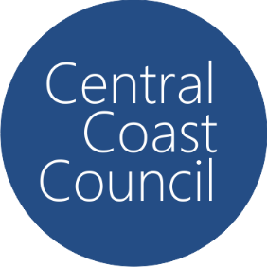Central Coast Council

PFAS Monitoring Results

## August 2024 - September 2025

# Mangrove Creek Dam Catchment

* N/D = Nil Detection in the analysis, noting that the detection limit is <0.001ug/L

** Units are in micrograms per litre

| **Site** | **Month** | **PFAS Substance** | **Notes** |
| --- | --- | --- | --- |
| MCD Junction Top | 17 December 2024 | N/D |  |
| MCD Tower | 18 February 2025 | N/D |  |
| MCD Portal | N/D |  |
| MCD Homestead | N/D |  |
| MCD Junction Top | 6 May 2025 | N/D |  |
| MCD Junction Top | 12 August 2025 | N/D |  |