Central Coast Council

PFAS Monitoring Results

## August 2024 - September 2025

# Mangrove Creek Weir Catchment

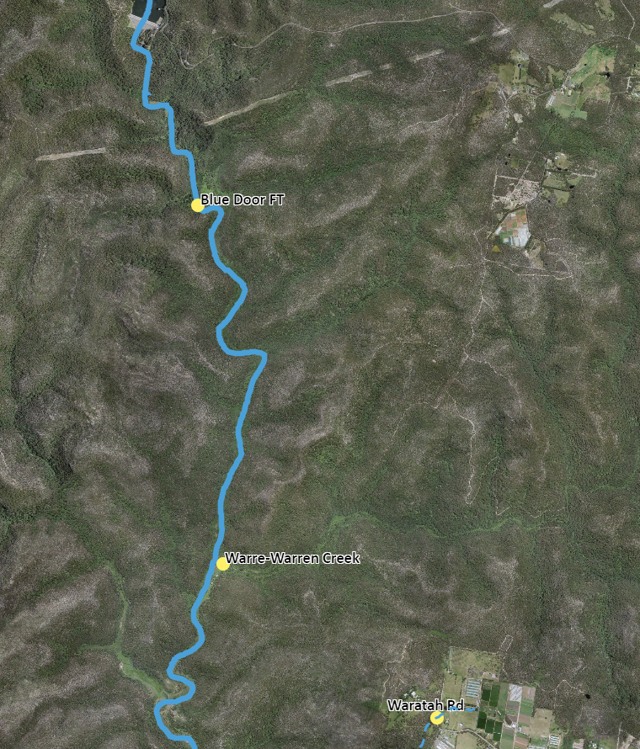

Figure 1 Sample sites for Mangrove Creek Weir catchment (northern sites).

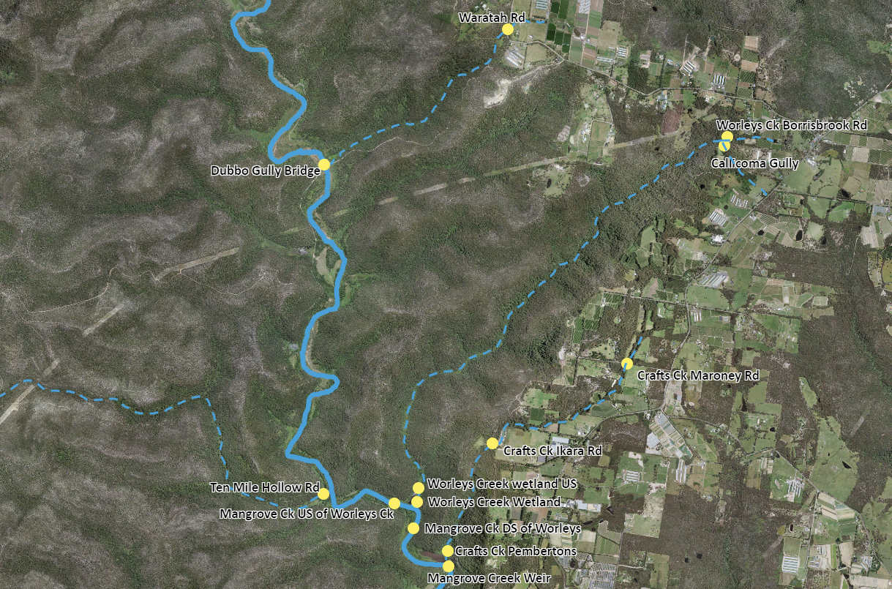

Figure 2 Sample sites for Mangrove Creek Weir catchment (southern sites).

* N/D = Nil Detection in the analysis, noting that the detection limit is <0.001ug/L

** Units are in micrograms per litre

| **Site** | **Date** | **PFAS Substance** | **Notes** |
| --- | --- | --- | --- |
| Mangrove Creek Weir | 17 December 2024 | PFHxS 0.002  PFBS 0.001 | Detection below Australian Drinking Water Guidelines |
| Mangrove Creek Weir | 18 February 2025 | PFHxS 0.002  PFBS 0.001 | Detection below Australian Drinking Water Guidelines |
| Ten Mile Hollow Rd | N/D |  |
| Dubbo Gully Bridge | N/D |  |
| Waratah Rd | N/D |  |
| Warre-Warren Creek | N/D |  |
| Blue Door FT | N/D |  |
| Mangrove Creek Weir | 2 April 2025 | PFHxS 0.001 | Detection below Australian Drinking Water Guidelines |
| Crafts Ck Pembertons | N/D |  |
| Crafts Ck Ikara Rd | N/D |  |
| Crafts Ck Maroney Rd | N/D |  |
| Mangrove Ck DS of Worleys Ck | PFHxS 0.001 |  |
| Ten Mile Hollow | N/D |  |
| Worleys Ck Borrisbrook Rd | PFOS 0.009  PFHxS 0.1  PFBS 0.049 | PFOS and PFHxS Detection above Australian Drinking Water Guidelines  PFBS Detection below Australian Drinking Water Guidelines |
| Callicoma Gully | N/D |  |
| Dubbo Gully Bridge | N/D |  |
| Mangrove Creek Weir | 16 April 2025 | N/D |  |
| Crafts Ck Pembertons | N/D |  |
| Crafts Ck Ikara Rd | N/D |  |
| Crafts Ck Maroney Rd | N/D |  |
| Mangrove Ck DS of Worleys Ck | N/D |  |
| Worleys Creek Wetland | PFHxS 0.004  PFBS 0.003 | Detection below Australian Drinking Water Guidelines |
| Worleys Ck Borrisbrook Rd | PFOS 0.007  PFHxS 0.095  PFBS 0.049 | PFHxS Detection above Australian Drinking Water Guidelines  PFOS and PFBS Detection below Australian Drinking Water Guidelines |
| Callicoma Gully | N/D |  |
| Dubbo Gully Bridge | N/D |  |
| Mangrove Creek Weir | 6 May 2025 | N/D |  |
| Mangrove Creek Weir | 26 May 2025 | N/D |  |
| Worleys Ck Borrisbrook Rd | PFOS 0.008  PFHxS 0.028  PFOA 0.001  PFBS 0.007 | PFOS Detection at the Australian Drinking Water Guidelines  PFHxS, PFOA and PFBS Detection below Australian Drinking Water Guidelines |
| Dubbo Gully Bridge | N/D |  |
| Mangrove Creek Weir | 5 June 2025 | N/D |  |
| Crafts Ck Pembertons | N/D |  |
| Crafts Ck Ikara Rd | N/D |  |
| Crafts Ck Maroney Rd | N/D |  |
| Mangrove Ck DS of Worleys Ck | N/D |  |
| Worleys Creek Wetland | PFHxS 0.003 | Detection below Australian Drinking Water Guidelines |
| Worleys Creek Wetland US | PFHxS 0.003 | Detection below Australian Drinking Water Guidelines |
| Mangrove Ck US of Worleys Ck | N/D |  |
| Worleys Ck Borrisbrook Rd | PFOS 0.007  PFHxS 0.046  PFBS 0.017 | PFHxS Detection above Australian Drinking Water Guidelines  PFOS and PFBS Detection below Australian Drinking Water Guidelines |
| Callicoma Gully | N/D |  |
| Dubbo Gully Bridge | N/D |  |
| Mangrove Creek Weir | 29 July 2025 | N/D |  |
| Crafts Ck Pembertons | N/D |  |
| Crafts Ck Ikara Rd | N/D |  |
| Crafts Ck Maroney Rd | N/D |  |
| Mangrove Ck DS of Worleys Ck | PFHxS 0.001 | Detection below Australian Drinking Water Guidelines |
| Mangrove Ck US of Worleys Ck | N/D |  |
| Worleys Creek Wetland | PFHxS 0.006  PFBS 0.001 | Detection below Australian Drinking Water Guidelines |
| Worleys Creek Wetland US | PFHxS 0.005  PFBS 0.001 | Detection below Australian Drinking Water Guidelines |
| Dubbo Gully Bridge | N/D |  |
| Mangrove Creek Weir | 12 August 2025 | PFHxS 0.001 | Detection below Australian Drinking Water Guidelines |
| Mangrove Creek Weir | 20 August 2025 | PFHxS 0.001 | Detection below Australian Drinking Water Guidelines |
| Crafts Ck Pembertons | N/D |  |
| Mangrove Ck DS of Worleys Ck | N/D |  |
| Mangrove Ck US of Worleys Ck | N/D |  |
| Worleys Creek Wetland | PFHxS 0.004 | Detection below Australian Drinking Water Guidelines |
| Worleys Creek Wetland US | PFHxS 0.004 | Detection below Australian Drinking Water Guidelines |
| Dubbo Gully Bridge | N/D |  |
| Mangrove Creek Weir | 15 September 2025 | PFHxS 0.001 | Detection below Australian Drinking Water Guidelines |
| Crafts Ck Pembertons | N/D |  |
| Mangrove Ck DS of Worleys Ck | PFHxS 0.001 | Detection below Australian Drinking Water Guidelines |
| Mangrove Ck US of Worleys Ck | N/D |  |
| Worleys Creek Wetland | PFHxS 0.008  PFBS 0.002 | Detection below Australian Drinking Water Guidelines |
| Worleys Creek Wetland US | PFHxS 0.006  PFBS 0.002 | Detection below Australian Drinking Water Guidelines |
| Dubbo Gully Bridge | N/D |  |