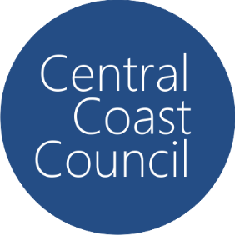Central Coast Council

PFAS Monitoring Results

## August 2024 – September 2025

# Mardi Dam Catchment

* N/D = Nil Detection in the analysis, noting that the detection limit is <0.001ug/L

** Units are in micrograms per litre

| **Site** | **Month** | **PFAS Substance** | **Notes** |
| --- | --- | --- | --- |
| Mardi Dam | 2 December 2024 | N/D |  |
| Mardi Dam | 13 February 2025 | N/D |  |
| Mardi Dam | 18 February 2025 | N/D |  |
| Mardi Dam Wyong River inlet | N/D |  |
| Mardi Dam Ourimbah Creek inlet |  |  |
| Mardi Dam | 22 May 2025 | N/D |  |
| Mardi Dam | 5 August 2025 | N/D |  |