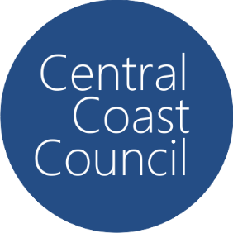Central Coast Council

PFAS Monitoring Results

## August 2024 – September 2025

# Wyong River Catchment

* N/D = Nil Detection in the analysis, noting that the detection limit is <0.001ug/L

** Units are in micrograms per litre

| **Site** | **Date** | **PFAS Substance** | **Notes** |
| --- | --- | --- | --- |
| PS1A | 2 December 2024 | N/D |  |
| PS1A | 13 February 2025 | N/D |  |
| PS1A | 18 February 2025 | N/D |  |
| Gracemere | N/D |  |
| Macadamia Lane | N/D |  |
| Bunning Creek Rd | N/D |  |
| Kingtree Lane | N/D |  |
| Ravensdale Rd | N/D |  |
| Jilliby Rd | N/D |  |
| Durren Rd | N/D |  |
| Dooralong Rd | N/D |  |
| PS1A | 22 May 2025 | N/D |  |
| PS1A | 5 August 2025 | N/D |  |