Budgewoi District
Development Contributions Plan 2014

October 2014

Contents
Summary Schedule 1
1 Administration and Operation of this Plan 2
1.1 Name of this Plan 2
1.2 Land to which this Plan Applies 2
1.3 Purpose of this Plan 2
1.4 Commencement of this Plan 2
1.5 Relationship with other Plans and Policies 2
1.6 Definitions 4
1.7 What Types of Development will be Levied? 4
1.8 When is the Contribution Payable? 4
1.9 Complying Development and Obligation of Accredited Certifiers 6
1.10 Construction Certificates and Obligation of Accredited Certifiers 6
1.11 Deferred and Periodic Payments 6
1.12 Can the Contribution be Settled “In-Kind”? 7
1.13 Exemptions 8
1.14 Review of Contribution Rates 8
1.15 How are Contributions Adjusted at the Time of Payment? 9
1.16 Are there Allowances for Existing Development? 9
1.17 Pooling of Contributions 10
1.18 Savings and Transitional Arrangements 10
1.19 Timing of Works 10
1.20 Dedication / Transfer of Land 10
1.21 Revision of this Plan 11
2 Urban Characteristics and Population 12
2.1 Expected Future Development 12
2.2 Population Increase 12
2.3 Occupancy Rates 12
2.4 Meeting Population Needs 12
3 Community Infrastructure and Contributions 13
3.1 Roadworks and Traffic Management 13
3.1.1 Nexus between Development and Demand 13
3.1.2 Apportionment of Costs 13
3.1.3 Calculation of the Contribution Rate 13
3.1.4 Program for Works and Funding 13
3.2 Open Space and Recreational Facilities 15
3.2.1 Nexus between Development and Demand 15
3.2.2 Open Space Land Requirements 16
3.2.3 Apportionment of Costs 16
3.2.4 Calculation of the Contribution Rate 17
3.3 Community Facilities 19
3.3.1 Nexus between Development and Demand 19
3.3.2 Community Facilities Land Requirements 20
3.3.3 Calculation of the Contribution Rate 20
3.4 Administration 21
3.4.1 Nexus between Development and Demand 21
3.4.2 Apportionment of Costs 21
3.4.3 Calculation of the Contribution Rate 22
Appendix A References 23
Appendix B Schedule of Works 24

Tables

Table 1 Summary Schedule – Contributions Rates Per DU by Category 1
Table 2 Types of Development Required to Contribute towards the Various Contribution Categories 5
Table 3 Plan Amendments 11
Table 4 Development and Population Potential 12
Table 5 Minimum Open Space Areas 15
Table 6 Apportionment Open Space Areas 16
Table 7 Embellishment Rates per Square Metre 17
Table 8 Open Space Embellishment Costs 17
Table 9 Community Facilities 20
Table 10 Costs to be Recovered by this Plan 21
Table 11 Percentage of DUs Apportioned to this Plan Area 22

Figures

Figure 1 Contributions Plan Area 3
Figure 2 Roads and Traffic Management – Vincent Close, Buff Point 14

Summary Schedule

The following summary schedules are included in this plan:

- Schedule of Works (contained in Appendix B) and
- Contributions rates per DU by category (Table 1)
Table 1 Summary Schedule – Contributions Rates Per DU by Category

Category | Rate
Roadworks and Traffic Management | $6,604
Open Space and Recreational Facilities Works | $3,549
Community Facilities Works | $2,965
Administration | $458

Refer to Section 3 for details of how these rates are calculated.

1 Administration and Operation of this Plan

1.1 Name of this Plan

This plan is called the Budgewoi District Development Contributions Plan dated September 2013.

1.2 Land to which this Plan Applies

This plan applies to land within the Budgewoi Social Planning District, as shown in Figure 1.

1.3 Purpose of this Plan

The purpose of this plan is to:

- provide an administrative framework under which specific public facilities strategies may be implemented and coordinated
- ensure that adequate public facilities are provided for as part of any new development
- authorise Council to impose conditions under section 94 (s94) of the Environmental Planning and Assessment (“EP&A”) Act 1979 when granting consent to development on land to which this plan applies
- provide a comprehensive strategy for the assessment, collection, expenditure accounting and review of development contributions on an equitable basis
- ensure that the existing community is not burdened by the provision of public amenities and public services required as a result of future development, and
- enable Council to be both publicly and financially accountable in its assessment and administration of this plan

1.4 Commencement of this Plan

This plan has been prepared pursuant to the provisions of s94 of the EP&A Act and Part 4 of the EP&A Regulation and takes effect from the date on which public notice was published, pursuant to clause 31(4) of the EP&A Regulation.

1.5 Relationship with other Plans and Policies

This Plan repeals all previous versions of the Budgewoi District Development Contributions Plan.

This plan should be read in conjunction with Wyong Local Environmental Plan 1991, relevant Development Control Plans, Contributions Plans, Council’s Management Plan and Council’s Codes and Policies.

This plan replaces any requirements and details related to Section 94 Contributions that exist within any Development Control Plan prepared by Council for this area.

This plan takes precedence over any of Council’s Codes and Policies where there are any inconsistencies in relation to Section 94 Contributions.
Other contributions plans may also apply to development covered by this plan (for example, the Shire-Wide Contributions Plan).

Figure 1 Contributions Plan Area
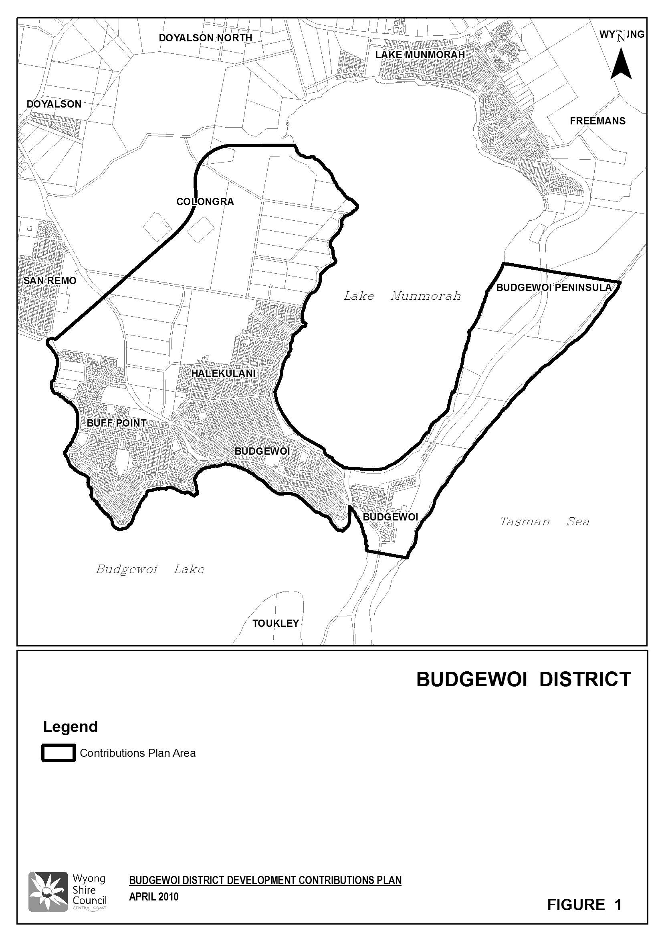

1.6 Definitions

For the purposes of this plan, a “Development Unit (DU)” is defined as being equivalent to a three bedroom residential dwelling. Where development other than a three bedroom dwelling is proposed, an equivalent contribution factor based on a proportion of DU will need to be calculated in accordance with Table 2.

For the purposes of this plan, “Net Developable Area (NDA)” is expressed in hectares and is the actual area on which a development could be sited. NDA excludes land for trunk drainage, roads, open space, community facilities, noise buffers, undevelopable lands and certain major non-residential land uses.

“Secondary dwelling means a self-contained dwelling that:

- is established in conjunction with another dwelling (the principal dwelling), and
- is on the same lot of land as the principal dwelling, and
- is located within, or is attached to, or is separate from, the principal dwelling, and
- has a total floor area (excluding any area used for parking) that does not exceed 60m².
Note: As per definition in the draft Wyong Local Environmental Plan 2012.

1.7 What Types of Development will be Levied?

Unless otherwise stated within the various schemes, the contribution rates contained within this plan will be levied upon any type of development or subdivision of land within the relevant catchment.

Table 2 summarises the types of development which will be required to contribute towards the various contribution categories.

1.8 When is the Contribution Payable?

A contribution must be paid to the Council at the time specified in the condition that imposes the contribution. If no such time is specified, the timing of the payment of the contribution is as follows:

- development applications involving subdivision – prior to release of subdivision certificates
- development applications involving building works – prior to the release of the construction certificate
- development applications where no building approval is required – at the time of development consent
In regard to the latter case, the applicant may make a cash payment of contributions prior to issue of the development consent or alternatively lodge a suitable bank guarantee, also prior to issue of the consent. This bank guarantee will be called up upon commencement of the consent.

Table 2 Types of Development Required to Contribute towards the Various Contribution Categories

Development Types | Factor | Open Space | Community Facilities | Roads | Administration
Residential Flats & Dual Occupancies
(including private self contained dwelling and infill self care housing as defined under SEPP – Seniors Living)
Secondary Dwelling | 0.35/unit | √ | √ | √ | √
1 bedroom unit | 0.52/unit | √ | √ | √ | √
2 bedroom unit | 0.73/unit | √ | √ | √ | √
3 bedroom unit | 1/unit | √ | √ | √ | √
4 bedroom unit | 1.28/unit | √ | √ | √ | √
Residential Subdivision | 1/lot | √ | √ | √ | √
Shops/Offices | 0.005/m² |  |  | √ | √
Rural Subdivision | 1/lot | √ |  |  | √
Rural Dual Occupancies
Secondary Dwelling | 0.35/unit | √ | √ | √ | √
1 bedroom unit | 0.52/unit | √ | √ | √ | √
2 bedroom unit | 0.73/unit | √ | √ | √ | √
3 bedroom unit | 1/unit | √ | √ | √ | √
4 bedroom unit | 1.28/unit | √ | √ | √ | √
Industrial Subdivision | NDA |  |  | √ | √
Industrial Development | NDA |  |  | √ | √
Shopping Centre | 0.001/m² GFA |  |  | √ | √
Restaurants | 0.008/m² GFA |  |  | √ | √
Tourist Developments
1 bedroom unit | 0.52/unit |  |  | √ | √
2 bedroom unit | 0.73/unit |  |  | √ | √
3 bedroom unit | 1/unit |  |  | √ | √
4 bedroom unit | 1.28/unit |  |  | √ | √
Motel Suite | 0.26/suite |  |  | √ | √
Caravan Park – Holiday Site | 0.52/site |  |  | √ | √
Caravan Park – Long Term | 0.73/site |  |  | √ | √
Schools | 0.04/pupil |  |  | √ | √
Licensed Club | 0.04/occpt |  |  | √ | √
Hotel | 0.01/m² GFA |  |  | √ | √
Hospital Bed | 1/bed |  |  | √ | √
Nursing Home Bed | 0.4/bed |  |  | √ | √
Hostel Bed | 0.125/bed |  |  | √ | √
Pre Schools/Child Care Centres | 0.0625/pupils & staff |  |  | √ | √
Note: √ contribution is applicable to development

1.9 Complying Development and Obligation of Accredited Certifiers

In accordance with Section 94EC(1) of the EP&A Act:

- Accredited certifiers must in issuing a complying development certificate impose a condition under Section 94 that requires the payment of monetary contributions calculated in accordance with this development contributions plan. The condition of consent shall also require the payment to be made prior to the commencement of works where building works are involved or prior to the commencement of use where no building works are involved.
- This plan authorises accredited certifiers to impose such a condition. The condition must include a notation that the contribution amounts are indexed on a quarterly basis.
- The amount of contributions and timing of payment shall be strictly in accordance with the provisions of this contributions plan.

It is the responsibility of accredited certifiers to:

- accurately calculate the quantum of contributions or alternatively seek advice and assistance directly from Council; and
- apply the Section 94 condition correctly.

1.10 Construction Certificates and Obligation of Accredited Certifiers

In accordance with Clause 146 of the EP&A Regulation, a certifying authority must not issue a construction certificate for building work or subdivision work under a development consent unless it has verified that each condition requiring the payment of monetary contributions has been satisfied.

In particular, the certifier must ensure that the applicant provides a receipt(s) confirming that contributions have been fully paid and copies of such receipts must be included with copies of the certified plans provided to the Council in accordance with clause 142(2) of the EP&A Regulation. Failure to follow this procedure may render such a certificate invalid.

The only exceptions to the requirement are where a works in kind or dedication of land has been agreed by Council. In such cases, Council will issue a letter confirming that an alternative payment method has been agreed with the developer.

1.11 Deferred and Periodic Payments

Council will generally not accept arrangements for the periodic payment of contributions required under this plan. Notwithstanding this position, an application for periodic payments may be made to Council, and Council after giving consideration to it may in extenuating circumstances accede to such a request subject to conditions that it considers appropriate. Such conditions may include the confirmation of the payment schedule via a legal agreement and the payment of fee.

Council will generally only consider permitting the deferred payment of contributions in accordance with its “Deferred Payment of Section 94 Contributions Policy” current at the time of application.

1.12 Can the Contribution be Settled “In-Kind”?

Council may accept an offer by the developer to provide an “in-kind” contribution (i.e. the developer completes part or all of work/s identified in this plan) in lieu of the developer satisfying its obligations under this plan.

Council may accept such alternatives in the following circumstances:

- the developer making a formal application to carry out the works, and
- the standard of the works is to Council’s full satisfaction
The value of the works to be substituted will be the value assigned to it under this plan. If there is a dispute between Council and the developer over the value of the works, the developer must provide to Council for consideration documented evidence of the value by an independently certified Quantity Surveyor who is registered with the Australian Institute of Quantity Surveyors or a person who can demonstrate equivalent qualifications.

Council will require the developer to enter into a written Works In Kind Agreement for the provision of the works prior to the commencement of the works.

Acceptance of any such alternative is at the sole discretion of Council. Council may review the valuation of works and may seek the services of an independent person to verify their value. In these cases, all costs and expenses borne by Council in determining the value of the works or land will be paid by the developer.

Offsetting of contributions will not be automatic. Applications will be considered on their merits. Water and sewerage contributions (under the Water Management Act) will not be offset against contributions determined in accordance with this plan; rather they will be offset against the contributions determined in accordance with the relevant Development Servicing Plan. Offsetting of contributions, if considered appropriate, will also only be permitted to occur within the same contributions plan area and against the same category (e.g. dedication of open space land can only be used to offset contributions for open space land and/or works).

Council offset contributions where such a situation is likely to lead to a delay in the provision of land or facilities to the detriment of the incoming population.

Where the value of a particular work in kind exceeds the contribution due for that work, this excess value may (subject to Council’s concurrence) form a credit to the developer. The timing for the repayment of the credit is to be included in the Works In Kind Agreement. Unless otherwise agreed, the credit will be repaid once all of the following criteria have been met:

- all of the developer’s land within the area serviced by a contributions plan covering that area has been developed and all relevant contributions have been offset against the credit value
- 75% of the areas benefiting from the credited land have contributed to the scheme
- sufficient funds exist in the fund ensuring the refund will not impact on Council’s ability to carry out works contained on its rolling works programme

It may be feasible to provide temporary measures to service initial stages of development in lieu of constructing major works up front. Such proposals will need to be assessed at the time of application and provision of such works will be the sole responsibility and cost of the particular developer, except where they form part of the final work identified in this Plan, in which case that part will be treated as works in kind.

The cost of temporary works not recognised as works in kind cannot be offset against any other contributions required under this plan.

1.13 Exemptions

Council does not have a policy that exempts any development from payment of monetary contributions levied under this plan, except in the following circumstances:

- the Crown as a private developer (e.g. Landcom subdivision of land) – contributions will apply in the same manner as they would for a private development
- developments provided by the Crown which provide a public service (e.g. school, court house, hospital) – contributions will be assessed based on the demand for community infrastructure
- in accordance with any direction issued by the Minister under Section 94(e) of the EP&A Act

1.14 Review of Contribution Rates

To ensure that the value of contributions are not eroded over time by movements in the Consumer Price Index, land value changes, the capital costs of administration of this plan or through changes in the costs of studies used to support this plan, Council will review the contribution rates.

The contribution rates will be reviewed by reference to the following specific indices: roadworks and traffic management facilities, open space and recreational facilities, community facilities and administration by the Consumer Price Index, Australia for Sydney as published by the Australian Bureau of Statistics (Source: ABS 6401.0 Table 1).

In accordance with clause 32(3)(b) of the EP&A Regulation, the following sets out the means that Council will make changes to the rates set out in this plan. For changes to the Consumer Price Index, the contribution rates within this plan will be reviewed on a quarterly basis in accordance with the following formula:

$C_{A} + $C_{A} x ([Current Index – Base Index]) ÷ [Base Index]

Where:

$C_{A} is the contribution at the time of adoption of this plan expressed in dollars

Current Index is the Consumer Price Index, Australia for Sydney as published by the Australian Bureau of Statistics available at the time of review of the contribution rate

Base Index is the Consumer Price Index, Australia for Sydney as published by the Australian Bureau of Statistics used in the preparation of this plan which is 169.1 (February 2010)

Note: In the event that the Current Consumer Price Index is less than the previous Consumer Price Index, the Current Consumer Price Index shall be taken as not less than the previous Consumer Price Index.

1.15 How are Contributions Adjusted at the Time of Payment?

The contributions stated in development consents are calculated on the basis of the s94 contribution rates determined in accordance with this plan. If the contributions are not paid within the quarter in which consent is granted, the contributions payable will be adjusted and the amount payable will be calculated on the basis of the contribution rates that are applicable at time of payment in the following manner:

$C_{P} = $ C_{DC} + [$ C_{DC} x ($ C_{Q} -$ C_{C})] ÷ $ C_{C}

Where:

$ C_{P} is the amount of the contribution calculated at the time of payment

$ C_{DC} is the amount of the original contribution as set out in the development consent

$ C_{Q} is the contribution rate applicable at the time of payment

$ C_{C} is the contribution rate applicable at the time of the original consent

The current contribution rates are published by Council and are available from Council offices or Council’s web page.

1.16 Are there Allowances for Existing Development?

Contributions will be levied according to the estimated increase in demand. An amount equivalent to the contribution attributable to any existing (or approved) development on the site of a proposed new development will be allowed for in the calculation of contributions. For example:

- dwelling houses and single vacant allotments – 1.00 DU
- other dwellings:
  - 4 bedroom units – 1.28 DU
  - 3 bedroom units – 1.00 DU
  - 2 bedroom units – 0.73 DU
  - 1 bedroom units – 0.52 DU
  - secondary dwellings – 0.35 DU
Where a development does not fall within any of the items noted above, Council will determine the credit on the basis of the likely demand that the existing development will create.

1.17 Pooling of Contributions

To provide a strategy for the orderly delivery of the infrastructure, this plan authorises monetary community infrastructure contributions paid:

- for different purposes in accordance with the conditions of various development consents authorised by this plan, and
- for different purposes under any other contributions plan approved by the Council
to be pooled and applied progressively for those purposes.

The priorities for the expenditure of pooled monetary community infrastructure contributions under this plan are the priorities for works as set out in the relevant works schedules (Appendix B).

In deciding whether to pool and progressively apply contributions funds, Council is satisfied that this action will not unreasonably prejudice the carrying into effect, within a reasonable time, of the purposes for which the money was originally paid.

1.18 Savings and Transitional Arrangements

A development application which has been submitted prior to the adoption of this plan but not determined shall be determined in accordance with the provisions of the plan which applied at the date of determination of the application.

1.19 Timing of Works

Council is generally not able to bankroll proposed works required as a consequence of development proposed under this Plan and will only be able to provide works and services when sufficient funds have been provided by way of contributions.

Priority spending of contributions may, however, be directed to particular items identified in this Plan and this has been considered in formulating works schedules. Actual timing of the works will be dependent on development patterns and funds available from Section 94 contributions.

1.20 Dedication / Transfer of Land

Subject to prior agreement with Council, land may be dedicated/transferred in lieu of making a contribution towards the acquisition of land and in some cases; Council may require dedication/transfer of particular land as a condition of consent. Council will only accept land dedication/transfer where that land is of a suitable nature for the purpose for which it is being dedicated/transferred. All land to be dedicated/transferred to Council is to be free of any improvements, structures or other impediments which would restrict or hinder its future use or development for the purposes for which it is being acquired, unless otherwise agreed by Council. The land is also to be dedicated/transferred in an appropriate state, free of any refuse, contamination, or the like, unless otherwise agreed by Council.

1.21 Revision of this Plan

This Plan may be revised if the extent or nature of the proposed development varies and these variations lead to a change in the demand for public services and amenities.

Costings of works identified in this Plan are based on preliminary and detailed designs and changes to cost estimates as a result of detailed design may also necessitate a revision to this Plan. Table 3 outlines the amendments to this Plan.

Table 3 Plan Amendments

Adoption Date | Effective Date | Nature of Revision
 | October 1992 | No previous versions
 | September 1995 | Amended
 | December 2001 | Amended
13 December 2006 | 11 January 2007 | Amended
11 August 2010 | 1 September 2010 | Amended
24 July 2013 | 7 August 2013 | Insertion of specific clauses relating to complying development and deferred payment (and minor formatting changes)
24 July 2013 | 18 September 2013 | Insertion of “Secondary Dwelling” clause
27 August 2014 | 29 October 2014 | Incorporate revised costs for Vincent Close road reserve

2 Urban Characteristics and Population

2.1 Expected Future Development

This plan relates to demand for public facilities and services created by residential and industrial development within the Budgewoi District of the Wyong Local Government Area.

It is forecast that a further 48 lots will be developed within the plan area. These development assumptions are based on an assessment of the areas, known rezoning proposals and historic rates of development.

In addition, an allowance has been given to further subdivision of existing zoned properties within each area based on the size of the property and the characteristics of surrounding development. Details of the proposed development potential within the area are shown in Table 4.

Table 4 Development and Population Potential

Location | Future Lots (a) | Medium Density DUs (c) | Total DUs (a + c) | Estimated Population  (@ 2.5 people per DU)
Budgewoi | 10 | 93 | 103 | 258
Buff Point | 26 | 243 | 269 | 673
Halekulani | 12 | 100 | 112 | 280
TOTAL | 48 | 436 | 484 | 1211

2.2 Population Increase

The population increase for the plan area is anticipated to be 1,211. This is based on an occupancy rate of 2.5 persons per dwelling unit (DU).

2.3 Occupancy Rates

Occupancy rates for this Contributions Plan are based on the average occupancy rates for the areas of Blue Haven, Budgewoi, Budgewoi Peninsula, Buff Point, Colongra, Doyalson, Halekulani and San Remo areas. This data is from the Census conducted in 2006.

Council will continue to monitor the occupancy rates during the life of this plan and will amend this plan to align with the updated occupancy rate as required. The current occupancy rate of 2.5 persons per dwelling unit (DU) will be applied to determine the contribution rate for a residential development. The applicable DU factor will then be applied to determine the contribution rate for other types of development.

2.4 Meeting Population Needs

The incoming population will be distributed across the district. This additional population will create increased demand for a range of services including roadworks and traffic management, open space facilities and community facilities.

3 Community Infrastructure and Contributions

3.1 Roadworks and Traffic Management

This section considers the road and traffic management requirements generated as a result of the development in the Vincent Close area.

The general area and elements of this scheme are described below:

- a 110 metre section of Vincent Close to link with Elouera Road to a 6 metre wide standard
- drainage associated with the construction of Vincent Close

3.1.1 Nexus between Development and Demand

A small section of Vincent Close has been constructed on the eastern end of the area as shown in Figure 2 and further sections will be constructed progressively to the west as development of adjoining lots proceed. The remaining section through to Elouera Road is the subject of this scheme.

The road and drainage requirements are based on a technical report completed by Council's Design Section (Report No 443, June 1992) and as updated in 2014 (quotation/D10189654, design plans/D10190120).

3.1.2 Apportionment of Costs

The cost of works has been based on an estimate by Council’s Design Section. The cost of works has been estimated at $283,432 (August 2014)

3.1.3 Calculation of the Contribution Rate

Contribution Rate = Cost per DU
= $283,432 ÷ 25
= $11,337 per DU

3.1.4 Program for Works and Funding

Commencement of work on Vincent Close has been scheduled for 2014-2015.

3.1.5 Program for Works and Funding

The land required to extend and connect the two parts of Vincent Lane shall be dedicated free of cost as part of the development of any development of that land.
Figure 2 Roads and Traffic Management – Vincent Close, Buff Point

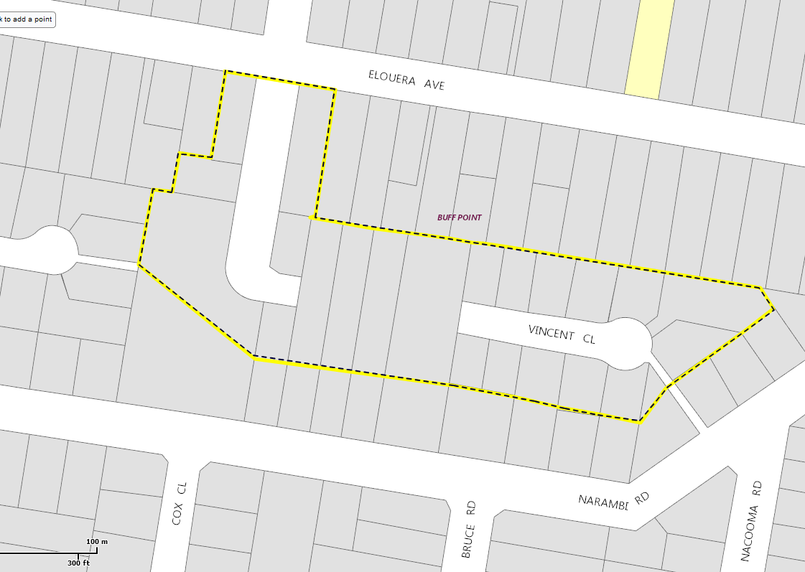

3.2 Open Space and Recreational Facilities

Wyong Shire Council’s goal for open space is to implement an open space system which conserves a sustainable natural character for the Shire and provides a variety of settings for recreation to meet identified community needs.

Council requires that local open space for residential areas be provided at the standard of 3.0ha per 1,000 persons.

There are various categories of open space within Wyong Shire as follows:

- Regional Open Space which includes Semi Natural Open Space, Regional Parks and Field/Courts
- District Open Space which includes Large Parks, Fields and Courts
- Local Open Space which includes Local Parks
- Ancillary Open Space which is open space that has a dual use such as a drainage corridor and passive open space or a visual use
Wyong Shire Council’s Open Space Principles Plan (2005a) provides minimum areas for the different types of open space; however there is flexibility where it can be proven that the open space purpose can be achieved. The minimum area for each of the types is outlined in Table 5.

Table 5 Minimum Open Space Areas

Type of Open Space | Minimum Area (ha)
Field | 4.0
Large Park | 2.0
Semi Natural Open Space | 2.0
Court | 1.0
Small Park | 0.5

3.2.1 Nexus between Development and Demand

It is proposed to levy contributions based on the standard provision of 3.0ha per 1,000 persons. Therefore, 3.633ha of open space are required to meet the demands of the new population growth of 1,211 persons. Embellishment will improve the quality of the open space and recreational facilities to allow additional use.

The Principles Plan also provides how open space should be proportioned against the different types of open space. Table 6 outlines this proportion and the amount of the different types of open space for the plan area.
Table 6 Apportionment Open Space Areas

Type of Open Space | Notional Proportion (%) | Notional Area Required (ha)
Local and Large Parks | 35 | 1.27
Courts | 5 | 0.18
Fields | 30 | 1.09
Semi Natural Open Space | 25 | 0.91
Cycleways (not part of this plan – see Shire Wide Contributions Plan) | 5 | 0.18
TOTAL | 100 | 3.63

The Open Space Principles Plan sets out the requirements for location of open space and recreational facilities such as: locating fields and courts adjacent to each other, locating small parks within 500m of all consolidated residential areas and co-location of facilities wherever possible.

Facilities have been located in areas to meet the needs of the new residential development and taking advantage of existing facilities. Contributions are levied on a per DU basis so that only the open space required to meet the demands of the new population is levied. Council will continue to identify facilities that will meet the needs of the future population. These projects will be identified through the revision of this plan and/or Council’s annual Management Plan.

A detailed Schedule of Works is provided in Appendix B.

Wyong Council has undertaken various open space reports such as the Local Parks Resource Report for Action Plan 2005, Local Parks Strategy 2005, Recreation Facilities Strategy 2009 and the Local Parks Action Plan 2005 which outline the required actions and priorities for open space projects. These reports have been used to identify the priority of the proposed projects. Contribution funds for the open space projects will be pooled to allow the open space projects to be undertaken in accordance with prioritisation as outlined in the Schedule of Works (Appendix B).

3.2.2 Open Space Land Requirements

Assessment of existing open space land shows that there is an excess of land for the existing population and that there is no significant shortfall due to the requirements generated by the future development. Further, there is no concentrated location for this future development for which specific open space sites can be provided. Hence, there will be no requirement for land due to the future development.

3.2.3 Apportionment of Costs

Future development predicted within the District will be spread throughout the area and so all future development will be required to share the costs for open space embellishment on a proportional basis.

3.2.4 Calculation of the Contribution Rate

Embellishment costs have been determined based on the average costs for previous works undertaken by Council as follows:

Local Parks - $51m² (average of the following areas)

Owl Park by AVJ developments indexed to March 2010 - $208,759 for 5,000m² park = $42/m²
Mataram Road small park by Council indexed to March 2010 - $238,199 for 3,992m² park = $60/m²

Courts - $144/m²

Value of courts in Warnervale contributions plan indexed to March 2010 - $4,492,217 for 31,200m² = $144/m²

Fields - $67/m² (average of the following examples)

Pat Morley Oval indexed to March 2010 -$2,154,619 for 92,000m² = $23/m²
Jubilee Oval indexed to March 2010 - $3,699,664 for 34,644m² = $107/m²
Wadalba Sporting Fields indexed to October 2009 -$6,627,347 for 95,525m² = $69/m²

Semi Natural Areas - $9/m²

Wadalba Corridor embellishment quotes 2007 indexed to March 2010

Table 7 provides a summary of the current rates for embellishment of open space based on the above.

Table 7 Embellishment Rates per Square Metre

Open Space Facility | Embellishment Costs
Local and Large Parks | $51/m²
Courts | $144/m²
Fields | $67/m²
Semi Natural | $9/m²

The above cost estimates are applied to the area requirements to determine the overall embellishment costs for open space within the Budgewoi District.

Table 8 Open Space Embellishment Costs

Open Space Facility | Area Required  (m²) | Embellishment Rate  ($ per m²) | Embellishment Cost
Local Parks | 12,716 | 51 | $647,066
Courts | 1,817 | 144 | $261,580
Fields | 10,899 | 67 | $731,637
Semi Natural | 9,083 | 9 | $78,671
TOTAL |  |  | $1,718,954

Contributions for Open Space and Recreational Facilities will be fully apportioned to future development. The contribution rate is determined as follows (all rates are determined to the nearest dollar):

C = $Facility Cost ÷ Demand

Where:

C is the contribution rate per DU

$Facility Cost is the total Open Space and Recreational Facilities costs

Demand is the total DU predicted in the District

Local Parks

Contribution Rate = $647,066 ÷ 484 DU
= $1,336 per DU

Courts

Contribution Rate = $261,580 ÷ 484 DU
= $540 per DU

Sporting Fields

Contribution Rate = $731,637 ÷ 484 DU
= $1510 per DU

Semi Natural

Contribution Rate = $78,671 ÷ 484 DU
= $162 per DU

Combined = $3,549 per DU

3.3 Community Facilities

Wyong Council has prepared Guidelines for the Planning and Provision of Community Facilities in Wyong Shire (2000, updated in July 2002) which determines the requirements to specify the scope and level of community need for facilities and in identifying location, siting, design and other criteria.

Wyong Council provides a network of community facilities as a focus for community activities and as venues for the delivery of community support services and programs. These facilities function as both specific purpose and multi-function community facilities including libraries, public halls, youth, child care and senior citizens centres and general purpose neighbourhood/community centres. They incorporate spaces and rooms for large public meetings/private functions, group activities, workshops, interviews/counselling services, office accommodation and the provision of a diverse range of health, education, welfare and leisure services and programs.

The Guidelines adopt a flexible approach through the construction of multi-purpose facilities and the co-location of services. This also includes the embellishment of existing facilities where feasible to increase the functionality of halls and centres and develop more multi-purpose facilities. The development of multi-purpose facilities presents the opportunity to establish a major focus for community services delivery through the co-location of a number of services in the one facility. This flexible approach also encourages joint venture projects with community based and voluntary sector organisations as well as schools.

3.3.1 Nexus between Development and Demand

It is not proposed to construct any new facilities within the District at this time. Rather, an assessment of the usage patterns and catchments of existing facilities has resulted in a recommendation to embellish existing facilities to ensure that they can cater for the demand created by the future population.

Council’s Guidelines recommend that an additional 0.314m² per person of community floor space is provided. This amount of floor space has been determined based on average sizes for community facilities and the standard provision for each type of facility. An additional 380m² of community floor space is required to meet the needs of the additional 1,211 persons within the plan area.

The required area of 380m² is then calculated by the cost per square metre to provide additional community facilities. The cost of $3,776 per m² has been used. This cost has been derived by Council based on the detailed design and development of a number of community facilities within the Shire as outlined below:

- Blue Haven Community Centre Construction Cost $4,627,898 for 1,092m² = $4,238 per m²
- Southern Lakes Community Centre Construction Cost $1,932,174 for 583m² = $3,314 per m²
- Average = $3,776 per m²

An amount of $1,434,932 will be apportioned to future development to embellish existing community centres and halls to meet the additional demand.

The District provides a number of existing community halls and centres. It is proposed that these existing facilities will be embellished to increase the capacity to meet the demand from the new population growth. Table 9 identifies the Community Facility project to be undertaken for this District.
Council will continue to identify projects that will meet the needs of the future population. These projects will be identified through the revision of this development contributions plan and/or Council’s annual Management Plan.

Table 9 Community Facilities

Item | Proposed Community Facility to be Embellished | Timeframe
1 | Embellishment of Halekulani Hall | 2016 – 2020

Contribution funds for the Community Facilities will be pooled to allow projects to be undertaken in accordance with the prioritisation as outlined in the Schedule of Works (Appendix B).

3.3.2 Community Facilities Land Requirements

Assessment of existing community facilities that there is an excess of land for the existing population and that there is no significant shortfall due to the requirements generated by the future development. Further, there is no concentrated location for this future development for which specific community facilities sites can be provided. Hence, there will be no requirement for land due to the future development.

3.3.3 Calculation of the Contribution Rate

The contribution rate is determined as follows (all rates are determined to the nearest dollar):

C = $Facility Cost ÷ Demand

Where:

C is the contribution rate per DU

$Facility Cost is the total Community Facilities costs

Demand is the total DU predicted in the District

Contribution Rate = $1,434,932 ÷ 484 DU
= $2,965 per DU

3.4 Administration

The costs to be recovered under this plan include:

- the salary and operating costs over a 5 year period for the coordination of the development contribution process
- a salary component over a five year period for other Council officers who are directly involved in preparing plans and carrying out other development contribution functions
- on-costs, vehicles and award increases over a 5-year period
Table 10 provides details of the administration costs to be recovered under this plan based on the apportioned number of DUs identified in Table 11.

3.4.1 Nexus between Development and Demand

The effective administration and management of the development contribution process is crucial to achieving the objectives of the Section 94 process. To ensure that contribution funds are managed effectively and that services and facilities are provided within a reasonable time, Council has a number of staff that are directly involved in the contribution process. The administration and management costs to be recovered under this plan only partly cover the full costs of the process; however the Department of Planning recognises that these costs are a legitimate cost able to be recovered under Section 94. The administration costs will be included in all of Council’s contributions plans. Based on the coverage of, and time taken to administer, this contributions plan, 2.5 percent of the total administration costs are included (as shown in Table 10).

3.4.2 Apportionment of Costs

The apportioned estimated cost of administering development contributions is assessed as follows:

Table 10 Costs to be Recovered by this Plan

Description | Total Salary & On Costs for 5 year Period | Percentage to be Recovered by S94 | Amount to be Recovered across All Contribution Plans | Amount to be Recovered by this Plan Based on 2.5% of Total Costs
Development Contributions Staff | $1,423,661 | 100% | $1,423,661 | $35,592
Accounting Staff | $429,605 | 20% | $85,921 | $2,148
Development Design Staff | $2,456,104 | 35% | $859,636 | $21,491
Subdivision Supervision Staff | $1,397,045 | 20% | $279,409 | $6,985
TOTAL |  |  | $2,648,627 | $66,216

Divide the amount to be recovered by this plan by percentage of DUs apportioned to this Plan area, as shown in Table 11.

Table 11 Percentage of DUs Apportioned to this Plan Area

Total No of Predicted DUs Across the Shire in 5 year Period | Percentage of DUs Apportioned to this Plan | 2.5% of DUs Apportioned to this Plan
5,789 | 2.5% | 145

3.4.3 Calculation of the Contribution Rate

Contributions will be collected from residential and non residential development in Ourimbah toward the cost of administering and managing development contributions.

The monetary contribution per DU is calculated as follows:

C = AC(CPA) ÷ DU

Where:

C is the contribution rate per DU

AC(CPA) is 2.5% of the estimated cost of administering development contributions in the Shire of Wyong over the life of this plan (i.e. $66,216 rounded).

DU is 2.5% of the total DUs predicted across the Shire over an example 5 year period, as shown in Table 11. (i.e. 145 DU).

Contribution Rate = $66,216 ÷ 145
= $458 per DU (rounded)

Appendix A References

The following references have been used to formulate this Plan. A supporting document of this background information is available. This document includes all documents prepared by or on behalf of Council to support this plan. Other documentation such as the Practice Notes and CPI are available on the relevant website.

Australian Bureau of Statistics 6401.0 Consumer Price Index, Australia All Groups, Percentage Change (from previous financial year) for Sydney (www.abs.gov.au).

ID Consulting (2010) 2001-2031 Population and Household Forecasts for Budgewoi / San Remo Social Planning District. Prepared for Wyong Shire Council.

NSW Department of Planning Development Contributions Practice Notes. www.planning.nsw.gov.au.

Wyong Shire Council 2002 Guidelines for the Planning and Provision of Community Facilities in Wyong Shire. Section 94 Background Report. Final Report prepared by Strategic Planning Department June 2000.

Wyong Shire Council 2005b Local Parks Strategy Prepared by Strategic Planning Department August 2005.

Wyong Shire Council 2005c Local Parks Resource Report for Action Plan Strategic Planning Department November 2005.

Wyong Shire Council 2005d Local Parks Action Plan Strategic Planning December 2005.

Wyong Shire Council 2005a Draft Wyong Open Space Principles Plan. Prepared by the Strategic Planning Department. Amendment No 4 June 2005.

Wyong Shire Council 2008 Draft Community Facilities Strategy

Wyong Shire Council 2009 Recreational Facilities Strategy October 2009.

Wyong Shire Council 2011 Final Design Plans – Vincent Road, Buff Point – 8/9/11 (D1090120)

Wyong Shire Council 2014 Vincent Road, Buff Point – Quotation - 4/7/14 (D10189654)

Appendix B Schedule of Works

Schedule of Works | Cost Summary | Existing Funds @ 30/6/2009 | Total Funds | Predicted Timing
Roadworks and Traffic Management
Vincent Close Roadworks | $283,432 | $0 | $283,432 | 2014-15
Open Space and Recreation Facilities
Local Parks | $647,066 | $21,357 | $668,423 | Funds to be expended in accordance with the rolling works program within Council’s Management Plan and the Local Parks Strategy and Recreation Facilities Strategy
Courts | $261,580 | $3,051 | $264,631
Sporting Fields | $731,637 | $18,306 | $749,943
Semi Natural | $78,671 | $15,255 | $93,926
Community Facilities
Embellishment of Halekulani Hall | $1,434,932 | $1,314,662 | $1,749,594 | Funds to be expended in accordance with the rolling works program within Council’s Management Plan and the Community Facilities Strategy
TOTAL COSTS OF WORKS | $3,437,318 |  | $3,809,949

