Northern Districts
Development Contributions Plan

September 2013

Contents
Summary Schedule 1
1 Administration and Operation of this Plan 2
1.1 Name of this Plan 2
1.2 Land to which this Plan Applies 2
1.3 Purpose of this Plan 2
1.4 Commencement of this Plan 2
1.5 Relationship with other Plans and Policies 2
1.6 Definitions 3
1.7 What Types of Development will be Levied? 3
1.8 When is the Contribution Payable? 3
1.9 Complying Development and Obligation of Accredited Certifiers 4
1.10 Construction Certificates and Obligation of Accredited Certifiers 4
1.11 Deferred and Periodic Payments 4
1.12 Can the Contribution be Settled “In-Kind” or through a Material Public Benefit? 6
1.13 Exemptions 7
1.14 Review of Contribution Rates 7
1.15 How are Contributions Adjusted at the Time of Payment? 8
1.16 Are there Allowances for Existing Development? 8
1.17 Pooling of Contributions 8
1.18 Savings and Transitional Arrangements 9
1.19 Timing of Works 9
1.20 Dedication / Transfer of Land 9
1.21 Revision of this Plan 9
2 Urban Characteristics and Population 10
2.1 Area 10
2.2 Expected Development 10
2.3 Population Increase 11
2.4 Occupancy Rates 11
2.5 Meeting Population Needs 11
3 Community Infrastructure and Contributions 13
3.1 Roadworks and Traffic Management 13
3.1.1 Nexus between Development and Demand 13
3.1.2 Calculation of the Contribution Rate 14
3.2 Open Space and Recreational Facilities 17
3.2.1 Nexus between Development and Demand 17
3.2.2 Calculation of Contribution Rates 19
3.3 Community Facilities 22
3.3.1 Nexus between Development and Demand 22
3.3.2 Calculation of Contribution Rates 24
3.4 Administration 26
3.4.1 Apportionment of Costs 26
3.4.2 Program for Works and Funding 27
3.4.3 Contribution Rate Calculation 27
Appendix A Schedule of Works 28
Appendix B Detailed Work Cost Breakdowns 29
Appendix C References 32

Tables

Table 1 Summary Schedule – Contributions Rates Per DU by Area and Category 1
Table 2 Types of Development Required to Contribute towards the Various Contribution Categories 5
Table 3 Plan Amendments 9
Table 4 Development and Population Potential 10
Table 5 Proposed Roadworks and Traffic Management 13
Table 6 Roadworks and Traffic Management Apportionment 14
Table 7 Apportioned Costs 15
Table 8 Minimum Open Space Areas 17
Table 9 Apportionment Open Space Areas 18
Table 10 Open Space and Recreational Facilities 18
Table 11 Open Space Land Requirements 18
Table 12 Embellishment Rates per Square Metre 20
Table 13 Open Space Embellishment Costs 20
Table 14 Community Facilities 23
Table 15 Costs to be Recovered under this Plan 26
Table 16 Forecasted New Development 2007-2011 27
Table 17 Schedule of Works 28
Table 18 Roads and Traffic Management – Kanangra Drive between Pacific Hwy and Summerland Road 29
Table 19 Roads and Traffic Management 30
Table 20 Community Facilities 31

Figures

Figure 1 Contributions Plan Area for Northern Districts 12
Figure 2 Proposed Roadworks and Traffic Management 16
Figure 3 Open Space and Recreational Facilities 21
Figure 4 Community Facilities 25

Summary Schedule

The following summary schedules are included in this plan:

- Schedule of Works (contained in Appendix A) and
- Contributions rates per person by area and category (Table 1)
Table 1 Summary Schedule – Contributions Rates Per DU by Area and Category

Northern Districts Sub-Plan |  | Catchment
Facility | Base | A | B | C | D | E
Roads and Traffic Management | Per DU | $Nil | $4,671.00 | $3,633.00 | $3,633.00 | $4,875.00
Open Space and Recreational Facilities | Per DU | $3,828.00 | $3,828.00 | $3,828.00 | $3,828.00 | $3,828.00
Community Facilities | Per DU | $3,238.00 | $3,238.00 | $3,238.00 | $3,238.00 | $3,238.00
Administration | Per DU | $451.00 | $451.00 | $451.00 | $451.00 | $451.00
TOTAL | Per DU | $7,517.00 | $12,188.00 | $11,150.00 | $11,150.00 | $12,392.00

Note: Refer to Figure 1 for catchment areas.

1 Administration and Operation of this Plan

1.1 Name of this Plan

This development contributions plan is called the Northern Districts Development Contributions Plan dated September 2013.

1.2 Land to which this Plan Applies

This plan applies to land within the Local Government Area of Wyong Shire as shown on Figure 1.

1.3 Purpose of this Plan

The purpose of this development contributions plan is to:

- provide an administrative framework under which specific public facilities strategies may be implemented and coordinated;
- ensure that adequate public facilities are provided for as part of any new development;
- authorise Council to impose conditions under section 94 (s94) of the Environmental Planning and Assessment (“EP&A”) Act 1979 when granting consent to development on land to which this plan applies;
- provide a comprehensive strategy for the assessment, collection, expenditure accounting and review of development contributions on an equitable basis;
- ensure that the existing community is not burdened by the provision of public amenities and public services required as a result of future development; and
- enable Council to be both publicly and financially accountable in its assessment and administration of the development contributions plan.

1.4 Commencement of this Plan

This development contributions plan has been prepared pursuant to the provisions of s94 of the EP&A Act and Part 4 of the EP&A Regulation and takes effect from the date on which public notice was published, pursuant to clause 31(4) of the EP&A Regulation.

1.5 Relationship with other Plans and Policies

This Plan repeals all previous versions of the Northern Districts Development Contributions Plan.

This Plan should be read in conjunction with Wyong Local Environmental Plan 1991, relevant Development Control Plans, Contributions Plans, Council’s Management Plan and Council’s Codes and Policies.

This Plan replaces any requirements and details related to Section 94 Contributions that exist within any Development Control Plan prepared by Council for this area.

This Plan takes precedence over any of Council’s Codes and Policies where there are any inconsistencies in relation to Section 94 Contributions.

Other contributions plans may also apply to development covered by this plan. (For example, Shire-Wide Contributions Plan)

1.6 Definitions

For the purposes of this plan, a “Development Unit (DU)” is defined as being equivalent to a three bedroom residential dwelling. Where development other than a three bedroom dwelling is proposed, an equivalent contribution factor based on a proportion of DU will need to be calculated in accordance with Table 2.

For the purposes of this plan, “Net Developable Area (NDA)” is expressed in hectares and is the actual area on which a development could be sited. NDA excludes land for trunk drainage, roads, open space, community facilities, noise buffers, undevelopable lands and certain major non-residential land uses.

“Secondary dwelling means a self-contained dwelling that:

- is established in conjunction with another dwelling (the principal dwelling), and
- is on the same lot of land as the principal dwelling, and
- is located within, or is attached to, or is separate from, the principal dwelling, and
- has a total floor area (excluding any area used for parking) that does not exceed 60m2.
Note: As per definition in the draft Wyong Local Environmental Plan 2012.

1.7 What Types of Development will be Levied?

Unless otherwise stated within the various schemes, the contribution rates contained within this plan will be levied upon any type of development or subdivision of land within the relevant catchment.

Table 2 summarises the types of development which will be required to contribute towards the various contribution categories.

1.8 When is the Contribution Payable?

A contribution must be paid to the Council at the time specified in the condition that imposes the contribution. If no such time is specified, the timing of the payment of the contribution is as follows:

- development applications involving subdivision – prior to release of subdivision certificates
- development applications involving building works – prior to the release of the construction certificate
- development applications where no building approval is required – at the time of development consent
In regard to the latter case, the applicant may make a cash payment of contributions prior to issue of the development consent or alternatively lodge a suitable bank guarantee, also prior to issue of the consent. This bank guarantee will be called up upon commencement of the consent.

1.9 Complying Development and Obligation of Accredited Certifiers

In accordance with Section 94EC(1) of the EP&A Act:

- Accredited certifiers must in issuing a complying development certificate impose a condition under Section 94 that requires the payment of monetary contributions calculated in accordance with this development contributions plan. The condition of consent shall also require the payment to be made prior to the commencement of works where building works are involved or prior to the commencement of use where no building works are involved.
- This plan authorises accredited certifiers to impose such a condition. The condition must include a notation that the contribution amounts are indexed on a quarterly basis.
- The amount of contributions and timing of payment shall be strictly in accordance with the provisions of this contributions plan.

It is the responsibility of accredited certifiers to:

- accurately calculate the quantum of contributions or alternatively seek advice and assistance directly from Council; and
- apply the Section 94 condition correctly.

1.10 Construction Certificates and Obligation of Accredited Certifiers

In accordance with Clause 146 of the EP&A Regulation, a certifying authority must not issue a construction certificate for building work or subdivision work under a development consent unless it has verified that each condition requiring the payment of monetary contributions has been satisfied.

In particular, the certifier must ensure that the applicant provides a receipt(s) confirming that contributions have been fully paid and copies of such receipts must be included with copies of the certified plans provided to the Council in accordance with clause 142(2) of the EP&A Regulation. Failure to follow this procedure may render such a certificate invalid.

The only exceptions to the requirement are where a works in kind or dedication of land has been agreed by Council. In such cases, Council will issue a letter confirming that an alternative payment method has been agreed with the developer.

1.11 Deferred and Periodic Payments

Council does not permit deferred or periodic payments of developer contributions.

Table 2 Types of Development Required to Contribute towards the Various Contribution Categories

Development Types | Factor | Open Space | Community Facilities | Roads | Administration
Residential Flats & Dual Occupancies
(including private self contained dwelling and infill self care housing as defined under SEPP – Seniors Living)
Secondary Dwelling | 0.35/unit | √ | √ | √ | √
1 bedroom unit | 0.52/unit | √ | √ | √ | √
2 bedroom unit | 0.73/unit | √ | √ | √ | √
3 bedroom unit | 1/unit | √ | √ | √ | √
4 bedroom unit | 1.28/unit | √ | √ | √ | √
Residential Subdivision | 1/lot | √ | √ | √ | √
Shops/Offices | 0.005/m² |  |  | √ | √
Rural Subdivision | 1/lot | √ |  |  | √
Rural Dual Occupancies
Secondary Dwelling | 0.35/unit | √ | √ | √ | √
1 bedroom unit | 0.52/unit | √ | √ | √ | √
2 bedroom unit | 0.73/unit | √ | √ | √ | √
3 bedroom unit | 1/unit | √ | √ | √ | √
4 bedroom unit | 1.28/unit | √ | √ | √ | √
Industrial Subdivision | NDA |  |  | √ | √
Industrial Development | NDA |  |  | √ | √
Shopping Centre | 0.001/m² GFA |  |  | √ | √
Restaurants | 0.008/m² GFA |  |  | √ | √
Tourist Developments
1 bedroom unit | 0.52/unit |  |  | √ | √
2 bedroom unit | 0.73/unit |  |  | √ | √
3 bedroom unit | 1/unit |  |  | √ | √
4 bedroom unit | 1.28/unit |  |  | √ | √
Motel Suite | 0.26/suite |  |  | √ | √
Caravan Park – Holiday Site | 0.52/site |  |  | √ | √
Caravan Park – Long Term | 0.73/site |  |  | √ | √
Schools | 0.04/pupil |  |  | √ | √
Licensed Club | 0.04/occpt |  |  | √ | √
Hotel | 0.01/m² GFA |  |  | √ | √
Hospital Bed | 1/bed |  |  | √ | √
Nursing Home Bed | 0.4/bed |  |  | √ | √
Hostel Bed | 0.125/bed |  |  | √ | √
Pre Schools/Child Care Centres | 0.0625/pupils & staff |  |  | √ | √
Note: √ contribution is applicable to development

1.12 Can the Contribution be Settled “In-Kind” or through a Material Public Benefit?

Council may accept an offer by the applicant to provide an “in-kind” contribution (i.e. The applicant completes part or all of work/s identified in the plan) or through provision of another material public benefit in lieu of the applicant satisfying its obligations under this plan.

Council may accept such alternatives in the following circumstances:

- the applicant making a formal application to carry out the works; and
- the standard of the works is to Council’s full satisfaction; and
- the provision of the material public benefit will not prejudice the timing or the manner of the provision of public facilities included in the works program.
The value of the works to be substituted will be the value assigned to it under this contributions plan. If there is a dispute between Council and the developer over the value of the works, the developer must provide documented evidence of the value by an independently certified Quantity Surveyor who is registered with the Australian Institute of Quantity Surveyors or a person who can demonstrate equivalent qualifications.

Council will require the applicant to enter into a written agreement for the provision of the works prior to the commencement of the works.

Acceptance of any such alternative is at the sole discretion of Council. Council may review the valuation of works and may seek the services of an independent person to verify their value. In these cases, all costs and expenses borne by Council in determining the value of the works or land will be paid by the applicant.

Offsetting of contributions will not be automatic. Applications will be considered on their merits. Water and sewerage contributions (under the Water management Act) will not be offset against contributions determined in accordance with this plan, rather they will be offset against the contributions determined in accordance with the relevant Development Servicing Plan. Nor will Council offset contributions where such a situation is likely to lead to a delay in the provision of land or facilities to the detriment of the incoming population.

Where the value of a particular work in kind exceeds the contribution due for that work, this excess value may (subject to Council’s concurrence) form a credit to the developer. The timing for the repayment of the credit is to be included in the above written agreement. Unless otherwise agreed, the credit will be repaid once all of the following criteria have been met:

- The credit will not be refunded until such time as all of the developer’s land within the area serviced by the subject land has been developed and all relevant contributions have been offset against the credit value.
- The credit will not be refunded until such time as 75% of the areas benefiting from the credited land have contributed to the scheme.
- The credit will not be refunded if insufficient funds exist in the fund meaning the refund will impact on Council’s ability to carry out works contained on its rolling works programme.

It may be feasible to provide temporary measures to service initial stages of development in lieu of constructing major works up front. Such proposals will need to be assessed at the time of application and provision of such works will be the sole responsibility and cost of the particular applicant, except where they form part of the final work identified in this contribution plan (in which case that part will be treated as works in kind).

The cost of temporary works not recognised as works in kind cannot be offset against any other contributions required under this Plan.

1.13 Exemptions

Council does not have a policy that exempts development from payment of contributions under this plan.

1.14 Review of Contribution Rates

To ensure that the value of contributions are not eroded over time by movements in the Consumer Price Index, land value increases, the capital costs of administration of the plan or through changes in the costs of studies used to support the Plan, Council will review the contribution rates.

The contribution rates will be reviewed by reference to the following specific indices: Roadworks and traffic management facilities, open space and recreational facilities, community facilities and administration by the Consumer Price Index, Australia for Sydney as published by the Australian Bureau of Statistics (Source: ABS 6401.0 Table 1).

In accordance with clause 32(3)(b) of the EP&A Regulation, the following sets out the means that Council will make changes to the rates set out in this plan.

For changes to the Consumer Price Index, the contribution rates within the plan will be reviewed on a quarterly basis in accordance with the following formula:

$C_{A} + $C_{A} x ([Current Index – Base Index]) ÷ [Base Index]

Where:

$C_{A} is the contribution at the time of adoption of the plan expressed in dollars

Current Index is the Consumer Price Index, Australia for Sydney as published by the Australian Bureau of Statistics available at the time of review of the contribution rate

Base Index is the Consumer Price Index, Australia for Sydney as published by the Australian Bureau of Statistics used in the preparation of this plan which is 157.4 (June 2007)

Note: In the event that the Current Consumer Price Index is less than the previous Consumer Price Index, the Current Consumer Price Index shall be taken as not less than the previous Consumer Price Index.

1.15 How are Contributions Adjusted at the Time of Payment?

The contributions stated in development consents are calculated on the basis of the s94 contribution rates determined in accordance with this plan. If the contributions are not paid within the quarter in which consent is granted, the contributions payable will be adjusted and the amount payable will be calculated on the basis of the contribution rates that are applicable at time of payment in the following manner:

$C_{P} = $ C_{DC} + [$ C_{DC} x ($ C_{Q} -$ C_{C})] ÷ $ C_{C}

Where:

$ C_{P} is the amount of the contribution calculated at the time of payment

$ C_{DC} is the amount of the original contribution as set out in the development consent

$ C_{Q} is the contribution rate applicable at the time of payment

$ C_{C} is the contribution rate applicable at the time of the original consent

1.16 Are there Allowances for Existing Development?

Contributions will be levied according to the estimated increase in demand. An amount equivalent to the contribution attributable to any existing (or approved) development on the site of a proposed new development will be allowed for in the calculation of contributions. In assessing the allowance to be given to existing development the factors contained in Table 3 will be used. For example:

- dwelling houses and single vacant allotments – 1.00 DU
- other dwellings:
  - 4 bedroom units – 1.28 DU
  - 3 bedroom units – 1.00 DU
  - 2 bedroom units – 0.73 DU
  - 1 bedroom units – 0.52 DU
  - secondary dwellings – 0.35 DU
Where a development does not fall within any of the items noted above, Council will determine the credit on the basis of the likely demand that the existing development will create.

1.17 Pooling of Contributions

This plan expressly authorises monetary s94 contributions paid for different purposes to be pooled and applied (progressively or otherwise) for those purposes. The priorities for the expenditure of the levies are generally shown in the Schedule of Works in Part E.

1.18 Savings and Transitional Arrangements

A development application which has been submitted prior to the adoption of this plan but not determined shall be determined in accordance with the provisions of the plan which applied at the date of determination of the application.

1.19 Timing of Works

Council is generally not able to bankroll proposed works required as a consequence of development proposed under this Plan and will only be able to provide works and services when sufficient funds have been provided by way of contributions.

Priority spending of contributions may, however, be directed to particular items identified in this Plan and this has been considered in formulating works schedules. Actual timing of the works will be dependent on development patterns and funds available from Section 94 contributions.

1.20 Dedication / Transfer of Land

Subject to prior agreement with Council, land may be dedicated/transferred in lieu of making a contribution towards the acquisition of land and in some cases, Council may require dedication/transfer of particular land as a condition of consent. Council will only accept land dedication/transfer where that land is of a suitable nature for the purpose for which it is being dedicated/transferred. All land to be dedicated/transferred to Council is to be free of any improvements, structures or other impediments which would restrict or hinder its future use or development for the purposes for which it is being acquired, unless otherwise agreed by Council. The land is also to be dedicated/transferred in an appropriate state, free of any refuse, contamination, or the like, unless otherwise agreed by Council.

1.21 Revision of this Plan

This Plan may be revised if the extent or nature of the proposed development varies and these variations lead to a change in the demand for public services and amenities.

Costings of works identified in this Plan are based on preliminary designs and changes to cost estimates as a result of detailed design may also necessitate a revision to this Plan. The following table outlines the amendments to this Plan.

Table 3 Plan Amendments

Adoption Date | Effective Date | Nature of Revision
23 January 2008 | 1 February 2008 | No previous versions
24 July 2013 | 7 August 2013 | Insertion of specific clauses relating to complying development and deferred payment (and minor formatting changes)
24 July 2013 | 18 September | Insertion of the “Secondary Dwelling” clause

2 Urban Characteristics and Population

2.1 Area

The area of the plan is shown on Figure 1. The District has been divided into five catchments being Catchments A, B, C, D and E. The catchments are necessary as the proposed roadworks and traffic management are only applicable to Catchments B, C, D and E. The catchments are mapped on Figure 1.

2.2 Expected Development

This plan relates to demand for public facilities and services created by residential development within the Northern Districts of the Wyong Local Government Area.

It is forecast that a further 3,017ots will be developed within the Plan area. These development assumptions are based on an assessment of the areas, known rezoning proposals and historic rates of development.

In addition, an allowance has been given to further subdivision of existing zoned properties within each area based on the size of the property and the characteristics of surrounding development. Details of the proposed development potential within the area are shown in Table 4.

Table 4 Development and Population Potential

Location | Lots | Dwellings on New Lots (a) | Medium Density Lots (b) | Medium Density DUs (c) | Total DUs (a + c) | Estimated Population  (@ 2.92 people per DU)
Gwandalan
Catchment E | 187 | 177 | 10 | 20 | 197 | 575
Catchment D | 700 | 665 | 35 | 70 | 735 | 2,146
Subdivision of existing zoned land | 5 | 5 | 0 | 0 | 5 | 15
Medium Density Development | 30 | 0 | 30 | 60 | 60 | 175
Sub Total | 922 | 847 | 75 | 150 | 997 | 2,911
Summerland Point
Medium Density Development | 21 | 0 | 21 | 42 | 42 | 123
Subdivision of existing zoned land | 40 | 38 | 2 | 4 | 42 | 123
Sub Total | 61 | 38 | 23 | 46 | 84 | 246
Lake Munmorah
Medium Density Development | 74 | 0 | 74 | 148 | 148 | 432
Subdivision of existing zoned land | 30 | 29 | 1 | 2 | 31 | 91
Sub Total | 104 | 29 | 75 | 150 | 179 | 523
Mannering Park
Medium Density Development | 65 | 0 | 65 | 130 | 130 | 380
Subdivision of existing zoned land | 20 | 19 | 1 | 2 | 21 | 61
Sub Total | 85 | 19 | 66 | 132 | 151 | 441
Chain Valley Bay
Precinct 2 | 1,773 | 1,684 | 89 | 178 | 1,862 | 5,437
Medium Density Development | 57 | 0 | 57 | 114 | 114 | 333
Subdivision of existing zoned land | 15 | 15 | 0 | 0 | 15 | 44
Sub Total | 1,845 | 1,699 | 146 | 292 | 1,991 | 5,814
GRAND TOTAL | 3,017 | 2,632 | 385 | 770 | 3,402 | 9,935

2.3 Population Increase

The population increase for the Plan area is anticipated to be 9,935. This is based on an occupancy rate of 2.92 persons per dwelling unit (DU).

2.4 Occupancy Rates

Occupancy rates for this Contributions Plan are based on the average occupancy rates for the urban release areas of Blue Haven, Hamlyn Terrace and Woongarrah areas. This data is from the Census conducted in 2006.

Council will continue to monitor the occupancy rates during the life of this plan and will amend the plan to align with the updated occupancy rate as required. The current occupancy rate of 2.92 persons per dwelling unit (DU) will be applied to determine the contribution rate for a residential development. The applicable DU factor will then be applied to determine the contribution rate for other types of development.

2.5 Meeting Population Needs

The incoming population will be distributed across the district. This additional population will create increased demand for a range of services including roadworks and traffic management, open space facilities and community facilities.

The incoming population will be distributed across the district. This additional population will create increased demand for a range of services including roadworks and traffic management, open space facilities and community facilities.
Figure 1 Contributions Plan Area for Northern Districts

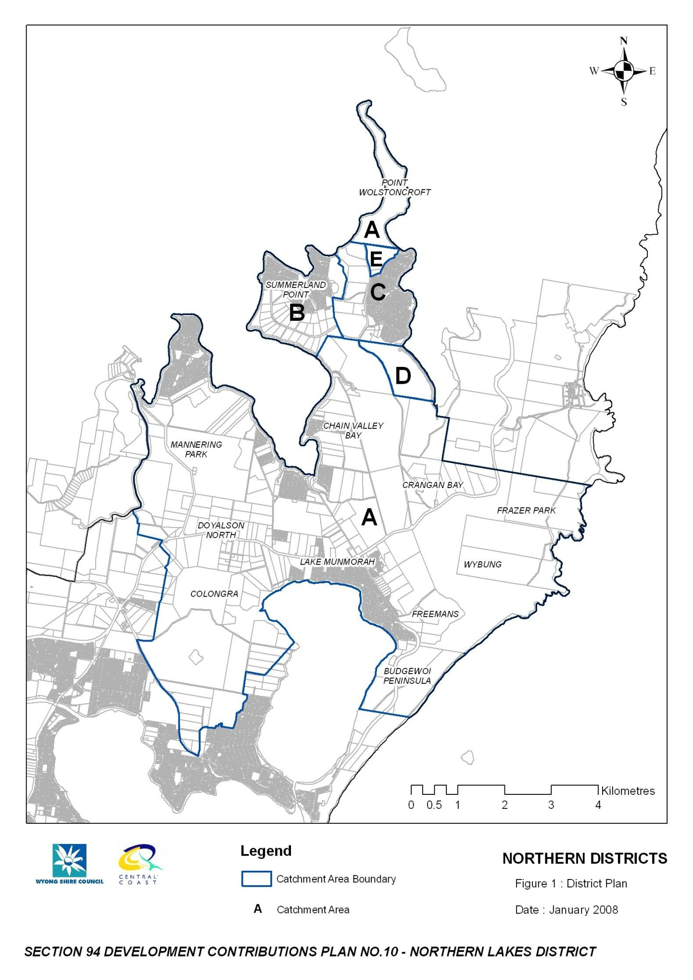

3 Community Infrastructure and Contributions

3.1 Roadworks and Traffic Management

Roadworks and traffic management requirements are based on a traffic report completed by Gutteridge, Haskins & Davey (June 1990), a technical report completed by Council's Design Section (Report No 424, June 1992) (contained in the supporting documentation) and comments by Council’s Senior Transport Engineer.

The proposed works to be undertaken include the following.

Table 5 Proposed Roadworks and Traffic Management

Item | Proposed Roadworks and Traffic Management
1 | Improvement of the curves along Kanangra Drive between the Pacific Highway and Summerland Road
2 | The realignment and widening of Summerland Road
3 | The widening of Kanangra Drive between Parraweena and Orana Road
4 | The widening of Kanangra Drive between Summerland and Parraweena Road
5 | Minor intersection improvements to Summerland Point

A detailed schedule of works and costs is provided in Part F – Detailed Work Cost Breakdowns. These costings are based on 2007 costs and have been indexed in accordance with the Consumer Price Index published by the Australian Bureau of Statistics. Refer to Part G for the indices use to update these costings.

3.1.1 Nexus between Development and Demand

Causal Nexus

The traffic study completed for this area indicated that the existing roads and intersections are adequate to cater for existing development and future low density development (detached dwellings) on existing residential lots. It also identified that upgrading of certain roads and intersections will be required to cater for the proposed development within Catchments B, C, D and E.

The traffic investigations used the following approach to establish road and intersection requirements for this area:

- identify existing road hierarchy and traffic flows;
- predict future road hierarchy and traffic flows generated by existing development or existing zoned areas for which no contributions may be sought when development does proceed, but excluding the proposed development;
- identify road and intersection improvements necessary to cater for these predicted flows;
- predict future road hierarchy and traffic flows generated by all future development including the proposed development;
- identify additional road and intersection improvements necessary to cater for these predicted flows; and
- where necessary, apportion costs of improvements based on traffic flows.

Spatial Nexus

The traffic investigations concluded that the above proposed works are required to meet the demands of new development within Catchments B, C, D and E. Roadworks will not be levied on Catchment A.

Traffic works are based on the development within these areas. Therefore, the costs of the works have been apportioned to the relevant development that attributes to the roadworks as follows.

Table 6 Roadworks and Traffic Management Apportionment

Traffic Item | 1 | 2 | 3 | 4 | 5
Catchment B Summerland Point | 7.8% | 6.4% | 0% | 0% | 100%
Catchment C Gwandalan | 6.0% | 0% | 0% | 0% | 0%
Catchment D | 68.0% | 0% | 0% | 0% | 0%
Catchment E | 18.2% | 0% | 34.3% | 11.6% | 0%
Existing Development (Council) | 0% | 93.6% | 65.7% | 88.4% | 0%
TOTAL | 100% | 100% | 100% | 100% | 100%

The above apportionment factors will be used to calculate the costs of works to be levied for each of the Catchments.

Figure 2 outlines the proposed roadworks and traffic management for the Northern Districts.

Temporal Nexus

Wyong Council will undertake the works in accordance with priorities as outlined in the schedule of works.

The works will commence either in conjunction with surrounding new development or when the traffic volumes at various locations warrant the works to be completed. An indicative time frame for the commencement of the works is shown in Appendix A.

3.1.2 Calculation of the Contribution Rate

The above apportionment factors have been used to determine the costs of works to be levied for each catchment. That is, the above percentage has been applied to the total cost to determine the costs applicable to each Catchment. The following table outlines the costs for the roadworks and traffic management for each Catchment.

Table 7 Apportioned Costs

Traffic Item | Total Cost ($) | Apportioned Cost ($)
 |  | Catchment B | Catchment C | Catchment D | Catchment E | Existing Development (Council)
1 | 3,927,700 | 305,205 | 236,171 | 2,670,545 | 715,779 | 0
2 | 581,500 | 37,174 | 0 | 0 | 0 | 544,326
3 | 648,000 | 0 | 0 | 0 | 222,397 | 425,603
4 | 192,000 | 0 | 0 | 0 | 22,289 | 169,712
5 | 50,000 | 50,000 | 0 | 0 | 0 | 0
TOTAL | 5,379,200 | 392,379 | 236,171 | 2,670,545 | 960,465 | 1,139,641

All rates are determined to the nearest dollar.

The following calculation is used to determine the levy per person for each of the Catchments.

C = $Facility Cost ÷ Demand

Where:

C is the contribution rate per person

$Facility Costs is the total cost of the proposed works to the Catchment

Demand is the total new development proposed in the Catchment

Catchment B – Summerland Point

Contribution Rate = $392,379 ÷ 84 DU
= $4,671 per DU

Catchment C – Gwandalan

Contribution Rate = $236,171 ÷ 65 DU
= $3,633 per DU

Catchment D

Contribution Rate = $2,670,545 ÷ 735 DU
= $3,633 per DU

Catchment E

Contribution Rate = $960,465 ÷ 197 DU
= $4,875 per DU

Figure 2 Proposed Roadworks and Traffic Management

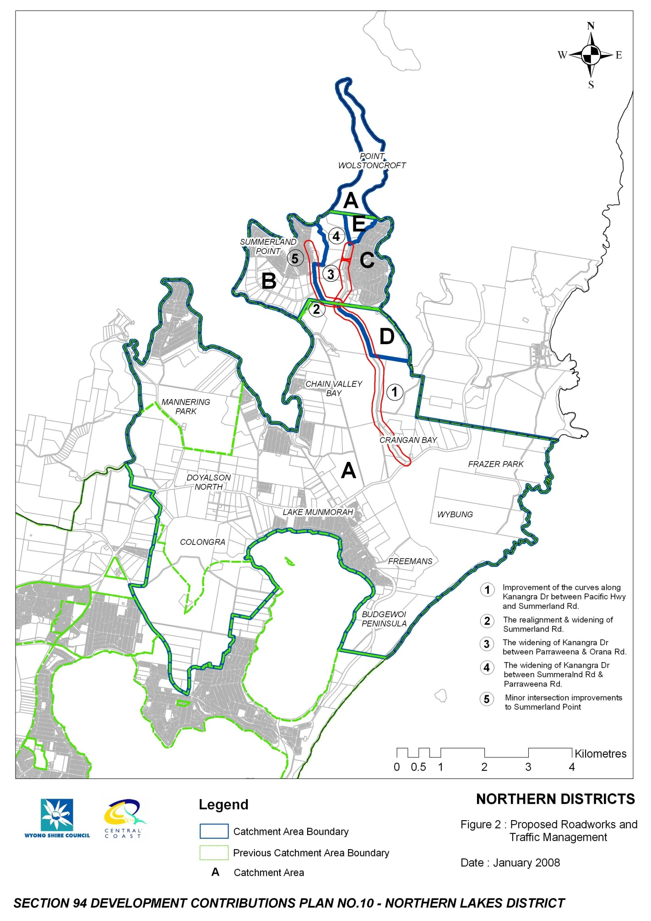

3.2 Open Space and Recreational Facilities

Wyong Shire Council’s goal for open space is to implement an open space system, which conserves a sustainable natural character for the Shire and provides a variety of settings for recreation to meet identified community needs.

Council requires that local open space for residential areas be provided at the standard of 3.0ha per 1,000 persons.

There are various categories of open space within Wyong Shire as follows:

- Regional Open Space which includes Semi Natural open space, Regional Parks and Field/Courts;
- District Open Space which includes Large Parks, Fields and Courts;
- Local Open Space which includes Local Parks;
- Ancillary Open Space which is open space that has a dual use such as a drainage corridor and passive open space or a visual use.
Wyong Shire Council’s Open Space Principles Plan (2005a) provides minimum areas for the different types of open space, however there is flexibility where it can be proven that the open space purpose can be achieved. The minimum area for each of the types is as follows:

A contribution towards open space works will still be required and this is addressed below.

Table 8 Minimum Open Space Areas

Type of Open Space | Minimum Area (ha)
Field | 4.0
Large Park | 2.0
Semi Natural Open Space | 2.0
Court | 1.0
Small Park | 0.5

3.2.1 Nexus between Development and Demand

Causal Nexus

It is proposed to levy contributions based on the standard provision of 3.0ha per 1,000 persons. Therefore, 29.805ha of open space are required to meet the demands of the new population growth of 9,935 persons. Embellishment will improve the quality of the open space and recreational facilities to allow additional use.

The Principles Plan also provides how open space should be proportioned against the different types of open space. The following table outlines this proportion and the amount of the different types of open space for the Plan area.
Table 9 Apportionment Open Space Areas

Type of Open Space | Notional Proportion (%) | Notional Area Required (ha)
Local and Large Parks | 35 | 10.4318
Courts | 5 | 1.4903
Fields | 30 | 8.9415
Semi Natural | 25 | 7.4513
Cycleways (not part of this plan – see Shire Wide Contributions Plan) | 5 | 1.4903
TOTAL | 100 | 29.8052

Spatial Nexus

The Open space Principles Plan sets out the requirements for location of open space and recreational facilities such as locating fields and courts adjacent to each other, locating small parks within 500m of all consolidated residential areas and co-location of facilities wherever possible.

Projects have been located in areas to meet the needs of the new residential development and taking advantage of existing facilities. Contributions are levied on a per capita basis so that only the open space required to meet the demands of the new population is levied. Table 10 and Figure 3 identify some of the Open Space and Recreational Facility projects to be undertaken for this District. Council will continue to identify projects that will meet the needs of the future population. These projects will be identified through the revision of this Section 94 Development Contributions Plan and/or Council’s annual Management Plan.

Table 10 Open Space and Recreational Facilities

Item | Open Space and Recreational Facilities | Open Space Type
1 | Embellishment of Tunkawallin Sporting Facility Gwandalan | Fields / Local Park
2 | Embellishment of Sandy Beach Reserve Summerland Point | Local Park
3 | Embellishment and Oval development at Colongra Bay Reserve Lake Munmorah | Fields

A detailed schedule of works is provided in Part E – Schedule of Works and Part F – Detailed Work Cost Breakdowns.

Open Space Land – New Release Areas

There are two major rezoning proposals covered by the contributions plan and they are to provide the minimum hectares of useable open space as shown in Table 11.

Table 11 Open Space Land Requirements

Location | Estimated Population | Area
Coal & Allied (Gwandalan – Catchment D) | 2,146 people | 6.44ha
Rosecorp (Gwandalan – Catchment E) | 575 people | 1.725ha
TOTAL | 2,721 people | 8.165ha
As permitted under section 94(1) of the EP&A Act, Council requires dedication of land to satisfy the demand generated for open space within the locality. Having regard to the calculations above, Council requires the dedication of 8.165 hectares of land for open space purposes within these catchments.

Conditions to require this dedication will be imposed upon relevant development consents.

The dedication of the land will be at no cost to Council, and will satisfy the increased demand generated by the development of these localities for open space land.

In relation to open space works, these are separate, and will be dealt with by way of contributions.

Temporal Nexus

Wyong Council has undertaken various open space reports such as the ‘Draft Local Parks Resource Report for Action Plan’, Local Parks Strategy’ and the ‘Draft Local Parks Action Plan’ which outlines the required actions and priorities for open space projects. These reports have been used to identify the priority of the proposed projects. Contribution funds for the open space projects will be pooled together. This allows the open space projects to be undertaken in accordance with its prioritisation as outlined in the Schedule of Works.

3.2.2 Calculation of Contribution Rates

Embellishment costs have been determined based on the average costs for previous works undertaken by Council as follows:

Local Parks - $47/m² (average of the following examples)

Owl Park by AVJ developments indexed to 17 July 2007 – $192,809 for 5,000m² park = $39/m²
Mataram Road small park by Council 2007 – $220,000 for 3,992m² park = $55/m²

Courts - $133/m²

Value of courts in Warnervale contributions plan indexed to 17 July 2007 – $4,149,000 for 31,200m² = $133/m²

Fields - $62/m² (average of the following examples)

Pat Morley Oval indexed to 17 July 2007 -$1,990,000 for 92,000m² = $22/m²
Jubilee Oval indexed to 17 July 2007 - $3,417,000 for 34,644m² = $99/m²
Wadalba Sporting Fields indexed to 17 July 2007 -$6,121,000 for 95,525m² = $64/m²

Semi Natural Areas - $8/m²

Wadalba Corridor embellishment quotes 2007

The following table provides a summary of the current rates for embellishment of open space based on the above.

Table 12 Embellishment Rates per Square Metre

Open Space Facility | Embellishment Costs
Local Parks | $47/m²
Courts | $133/m²
Fields | $62/m²
Semi Natural | $8/m²

The above cost estimates are applied to the area requirements to determine the overall embellishment costs for open space within the District.

Table 13 Open Space Embellishment Costs

Open Space Facility | Area Required  (m²) | Embellishment Rate  ($ per m²) | Embellishment Cost
Local Parks | 104,318 | 47 | $4,902,923
Courts | 14,903 | 133 | $1,982,032
Fields | 89,415 | 62 | $5,543,730
Semi Natural | 74,513 | 8 | $596,100
TOTAL |  |  | $13,024,785

All rates are determined to the nearest dollar.

The Open space and Recreational Facilities will be fully levied on new development. The contribution rate is determined as follows:

C = $Facility Cost ÷ Demand

Where:

C is the contribution rate per person

$Facility Costs is the total Open Space and Recreational Facilities costs

Demand is the total DU proposed in the District

Local Parks

Contribution Rate = $4,902,923 ÷ 3,402 DU
= $1,441 per DU

Sporting Fields, Courts & Semi Natural

Contribution Rate = $8,121,863 ÷ 3,425 DU
= $2,387 per DU

Combined = $3,828 per DU

Figure 3 Open Space and Recreational Facilities

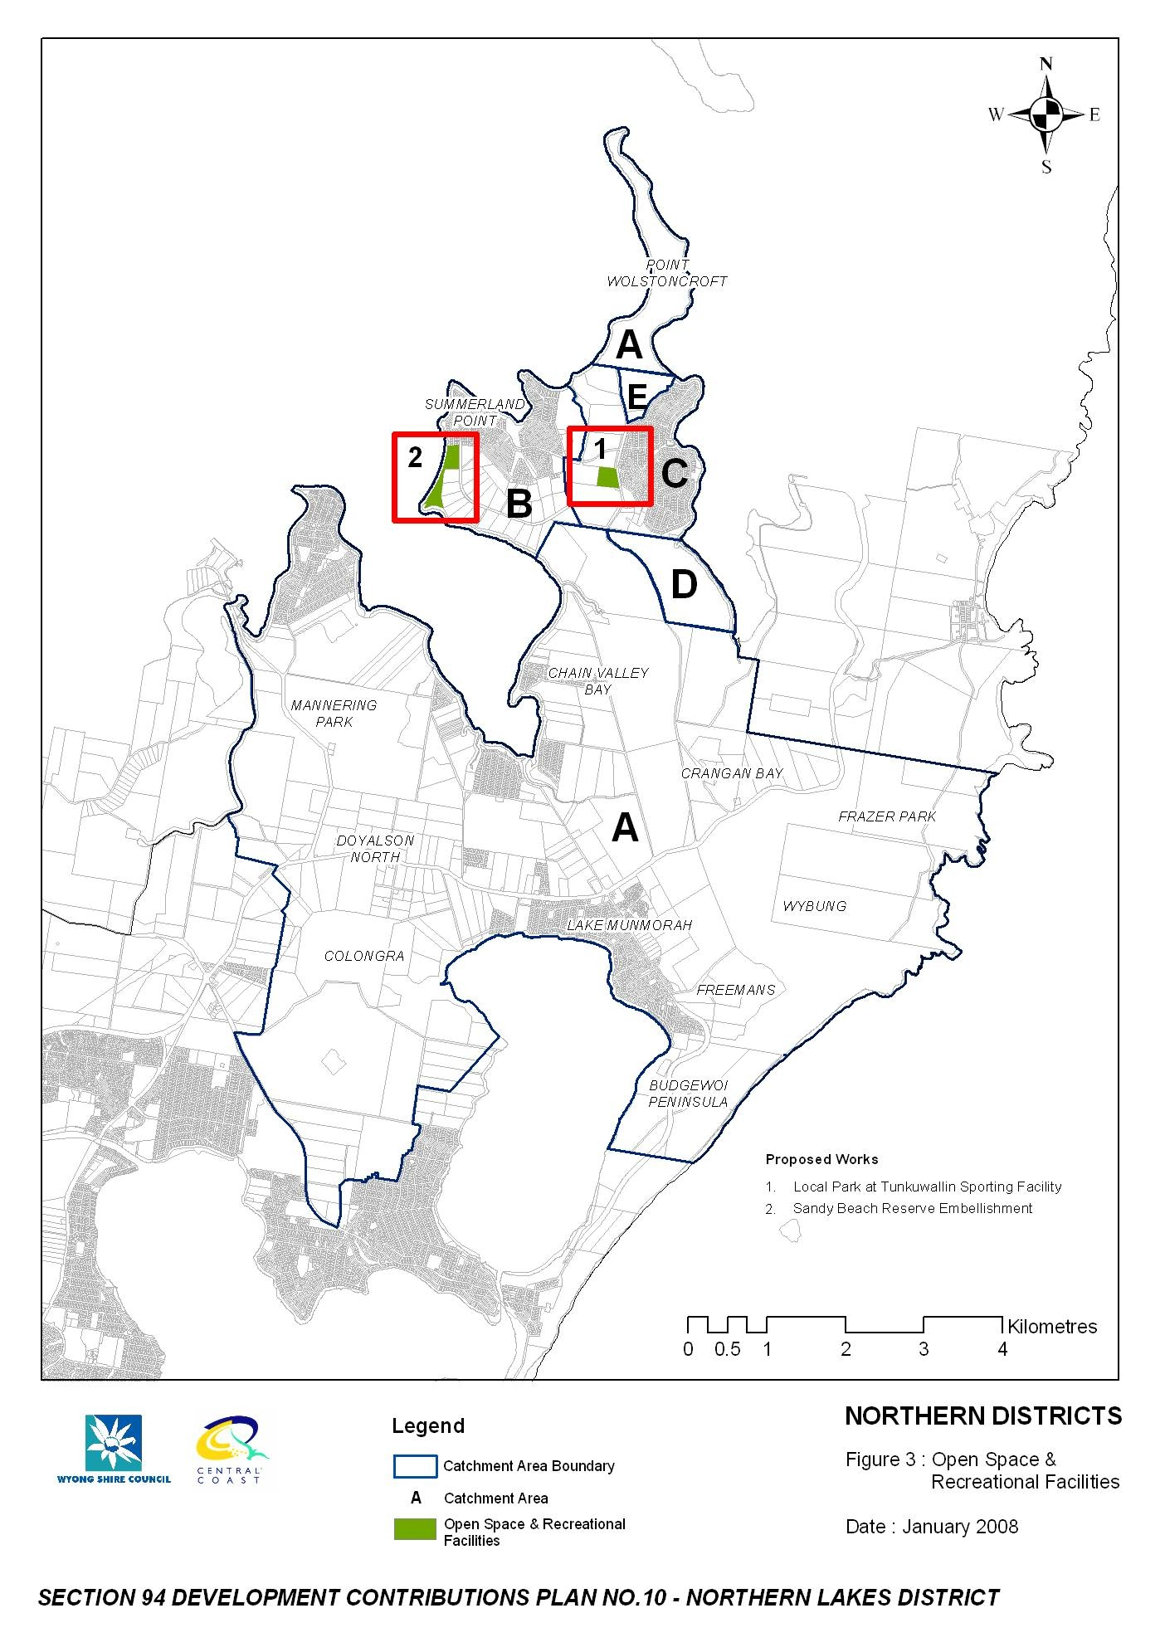

3.3 Community Facilities

Wyong Council has prepared Guidelines for the Planning and Provision of Community Facilities in Wyong Shire (2000) which determines the requirements to specify the scope and level of community need for facilities and in identifying location, siting, design and other criteria.

Wyong Council provides a network of community facilities as a focus for community activities and as venues for the delivery of community support services and programs. These facilities function as both specific purpose and multi-function community facilities including libraries, public halls, youth, child care and senior citizens centres and general purpose neighbourhood/community centres. They incorporate spaces and rooms for large public meetings/private functions, group activities, workshops, interviews/counselling services, office accommodation and the provision of a diverse range of health, education, welfare and leisure services and programs (Wyong Shire Council 2000).

The Guidelines (2000) adopt a flexible approach through the construction of multi-purpose facilities and the co-location of services. This also includes the embellishment of existing facilities where feasible to increase the functionality of halls and centres and develop more multi-purpose facilities. The development of multi-purpose facilities presents the opportunity to establish a major focus for community services delivery through the co-location of a number of services in the one facility. This flexible approach also encourages joint venture projects with community based and voluntary sector organisations as well as schools.

3.3.1 Nexus between Development and Demand

Causal Nexus

The Northern Districts is characterised by a number of small isolated communities including Chain valley Bay, Summerland Point, Gwandalan, Mannering Park and Lake Munmorah. In each of these communities, Council provides a number of local community facilities in the form of small halls. Council also provides a hall used as a district senior citizens centre at Lake Munmorah and a facility at Tunkawallin which was originally designed as an indoor recreation centre for young people.

Most of the halls were built in the last 10 to 20 years and are in varying levels of condition. Typically these halls comprise one main room with associated kitchen and toilet facilities.

Despite the regular usage of most of the facilities being quite low, special consideration needs to be given to the relatively isolated position of the Northern Districts in the Shire and the lack and range of any higher order services and facilities available to the population of this district. These facilities are serving localised communities and have the potential to be key focal points of activity.

The population report shows that this community is experiencing strong growth and one that is characterised by young families and retirees.

A model of localised community facility provision is considered to be the best model of provision in this district given a range of factors including the geography of the area and nature of settlement, lack of public transport and localised use of most facilities.

It is not proposed to construct any new facilities within the district at this time. Rather, an assessment of the usage patterns and catchments of existing facilities has resulted in a recommendation to embellish these existing facilities to ensure that they can cater for the demand created by the future population.

Council’s Guidelines (2000) recommend that an additional 0.314m² per person of community floor space is provided. This amount of floor space has been determined based on average sizes for community facilities and the standard provision for each type of facility. An additional 3,120m² of community floor space is required to meet the needs of the additional 9,935 persons within the Plan area.

The required area of 3,120m² is then calculated by the cost per square metre to provide additional community facilities. The cost of $3,531 per m² has been used. This cost has been derived by Council based on the detailed design and development of a number of community facilities within the Shire as outlined below:

- Blue Haven Community Centre Construction Cost $4,327,466 for 1,092m² = $3,962.88 per m²
- Southern Lakes Community Centre Construction Cost $1,806,742 for 583m² = $3,099 per m²
- Average $3,531 per m²
An amount of $11,016,401 will be levied on the new population to embellish existing community centres and halls to meet the additional demand.

Spatial Nexus

The District provides a number of existing community halls and centres. It is proposed that these existing facilities will be embellished to increase the capacity to meet the demand from the new population growth. A Joint Venture has also been entered into with the Lake Munmorah High School to provide additional community space for the public. Contributions are levied on a per DU basis so that only the Community Facilities required to meet the demands of the new population is levied. Table 14 and Figure 4 identify some of the Community Facility projects to be undertaken for this District. Council will continue to identify projects that will meet the needs of the future population. These projects will be identified through the revision of this Section 94 Development Contributions Plan and/or Council’s annual Management Plan.

Table 14 Community Facilities

Item | Proposed Community Facilities
1 | Joint Venture of Community Space at Lake Munmorah High School
2 | Chain Valley Bay Embellishment
3 | Summerland Point Hall Embellishment
4 | Lake Munmorah Hall Embellishment
5 | Gwandalan Community Hall Embellishment
6 | Mannering Park Hall Embellishment
7 | Tunkawallin Hall Embellishment

Temporal Nexus

Contribution funds for the Community Facilities will be pooled together. This allows these projects to be undertaken in accordance with the prioritisation as outlined in the Schedule of Works.

3.3.2 Calculation of Contribution Rates

All rates are determined to the nearest dollar.

The contribution rate is determined as follows:

C = $Facility Cost ÷ Demand

Where:

C is the contribution rate per person\

$Facility Costs is the total Community Facilities costs

Demand is the total DU in the District

Contribution Rate = $11,016,401 ÷ 3,402 DU
= $3,238 per DU
Figure 4 Community Facilities

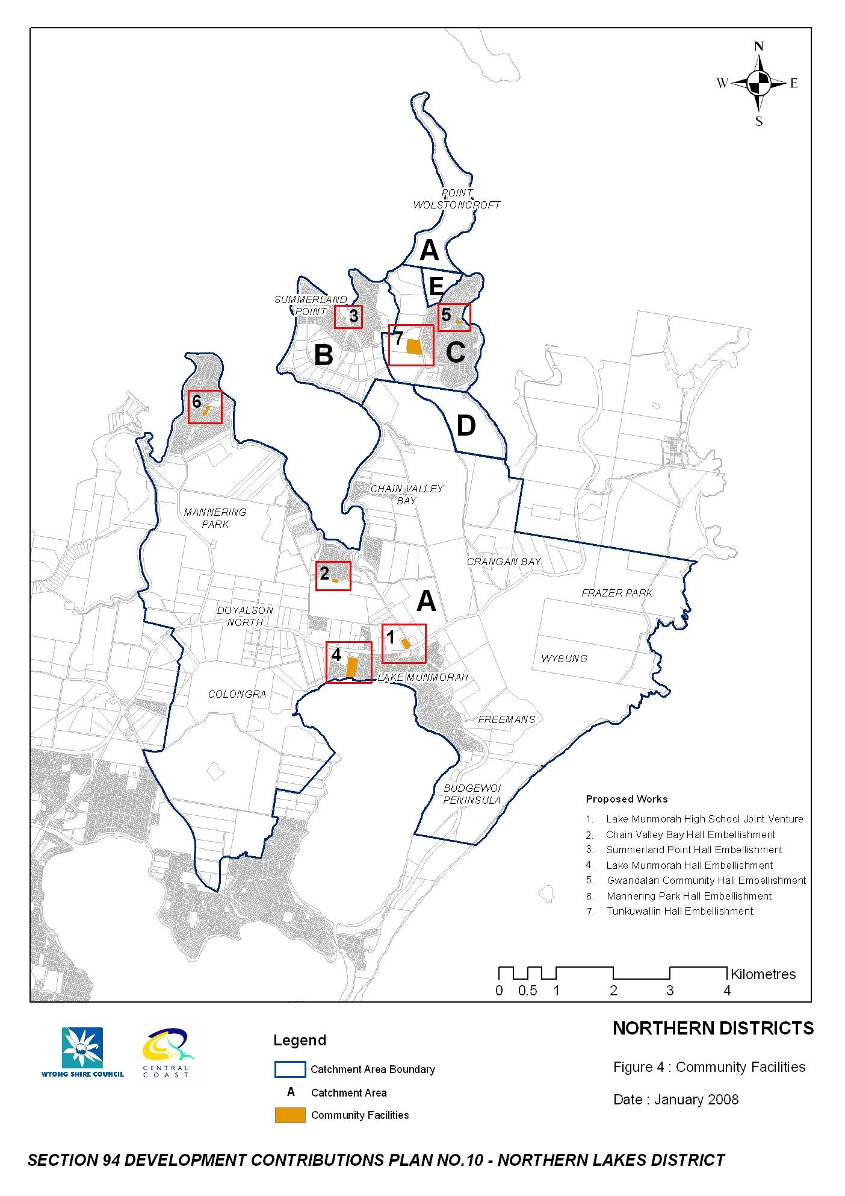

3.4 Administration

The effective administration and management of the development contribution process is crucial to achieving the objectives of the Section 94 process. To ensure that contribution funds are managed effectively and that services and facilities are provided within a reasonable time, Council has a number of staff that are directly involved in the contribution process. The administration and management costs to be recovered under this plan only partly cover the full costs of the process; however the Department of Planning recognises that these costs are a legitimate cost able to be recovered under Section 94. The administration costs will be included in all of Council’s contributions plans. Based on the coverage of this contributions plan, 12.5% of the total administration costs are included.

The costs to be recovered under this plan include:

- the salary and operating costs over a 5 year period for the coordination of the contribution process;
- a salary component over a 5 year period for other Council officers who are directly involved in preparing plans and carrying out other Section 94 functions; and
- on-costs, vehicles and award increases over a 5 year period;
Table 15 provides details of the costs to be recovered under this section of the plan.

Table 15 Costs to be Recovered under this Plan

Description | Total Salary & On Costs for 5 year Period | Percentage to be Recovered by S94 | Amount to be Recovered across All Contribution Plans | Amount to be Recovered by this Plan Based on 12.5% of Total Costs
Development Contributions Staff | $1,366,898 | 100% | $1,366,898 | $170,862
Accounting Staff | $430,367 | 20% | $86,073 | $10,759
Development Design Staff | $2,065,821 | 35% | $723,037 | $90,380
Subdivision Supervision Staff | $1,382,307 | 20% | $276,461 | $34,558
TOTAL |  |  | $2,452,470 | $306,559

3.4.1 Apportionment of Costs

Costs will be shared by all developments on an equivalent dwelling unit basis. The costs of this scheme have been calculated based on a five-year period - for the purpose of this calculation, the years 2007-2011 inclusive has been used. The total costs over that five-year period have been apportioned over new development forecasted for the same five-year period.

Table 16 provides details of new development forecasted for the period 2007-2011.

Table 16 Forecasted New Development 2007-2011

Development | Equivalent Dwelling Units or Tenements per Year
 | 2007 | 2008 | 2009 | 2010 | 2011 | Total
Development Units | 136 | 136 | 136 | 136 | 136 | 680

3.4.2 Program for Works and Funding

Income from administration contributions will be allocated annually to the salaries of the relevant staff in conjunction with Council’s Management Plan.

3.4.3 Contribution Rate Calculation

The contribution for new development is calculated using the following formula:

Contribution Rate = Annual salary costs for staff involved in S94 x 5 years ÷
Future Equivalent DU in next five years

= $306,559 per 680 DU

= $451 per DU

Appendix A Schedule of Works

Table 17 Schedule of Works

Catchment | Schedule of Works | Cost Summary | Priority
B, C, D & E | Improvement of the curves along Kanangra Drive between the Pacific Highway and Summerland Road | $3,927,700 | Medium
B | The realignment and widening of Summerland Road between Kanangra Drive and Government Road (Stages 1 and 2) | $581,500 | Long
E | The widening of Kanangra Drive between Parraweena and Orana Road | $648,000 | Medium
E | The widening of Kanangra Drive between Summerland and Parraweena Road | $192,000 | Medium
B | Minor intersection adjustments to Summerland Point | $50,000 | Short
All | Embellishment of Open Space | $4,935,987 | Medium to Long
All | Embellishment of Existing Centres | $13,477,437 | Medium to Long

Appendix B Detailed Work Cost Breakdowns

The following outlines the detailed cost breakdowns for each of the projects outlined in the Works Schedule. The costs for the Open Space and Recreational Facilities and Community Facilities are based on 2006 costs. The costs for Roads and Traffic Management are based on 2007 costs and have been indexed in accordance with 6401.0 Consumer Price Index, Australia (www.abs.gov.au).

Table 18 Roads and Traffic Management – Kanangra Drive between Pacific Hwy and Summerland Road

Works
Curve 2
Distance from highway | 0.4km
Area | 2,475
Pavement cost | $297,000
Services | $0
Traffic/Supervision/Contingencies | $163,350
TOTAL | $460,350
Curve 3
Distance from highway | 0.7km
Area | 2,800
Pavement cost | $336,000
Services | $178,000
Traffic/Supervision/Contingencies | $184,800
TOTAL | $698,800
Curve 4
Distance from highway | 1.2km
Area | 2,000
Pavement cost | $240,000
Services | $0
Traffic/Supervision/Contingencies | $132,000
TOTAL | $372,000
Curve 5
Distance from highway | 2.3km
Area | 3,135
Pavement cost | $376,200
Services | $218,000
Traffic/Supervision/Contingencies | $206,910
TOTAL | $801,110

Works
Curve 6
Distance from highway | 2.7km
Area | 935
Pavement cost | $112,200
Services | $0
Traffic/Supervision/Contingencies | $61,710
TOTAL | $173,910
Curve 7
Distance from highway | 3.5km
Area | 605
Pavement cost | $72,600
Services | $62,000
Traffic/Supervision/Contingencies | $39,930
TOTAL | $174,530
Curve 8
Distance from highway | 3.8km
Area | 5,500
Pavement cost | $660,000
Services | $224,000
Traffic/Supervision/Contingencies | $363,000
TOTAL | $1,247,000

Table 19 Roads and Traffic Management

Works | Costs
Summerland Road
Realignment and Widening of Summerland Road between Kanangra Drive and Government Road Stage 1 | $581,500
TOTAL | $581,500
Kanangra Drive between Summerland Road and Orana Road
The Widening of Kanangra Drive between Summerland Road and Orana Road ($840,000 – 2007) | $840,000
TOTAL | $840,000
Gwandalan/Summerland Point – Minor Intersection Works
Minor Intersection adjustments at Summerland Point (complete $30,000 – 2007) | $50,000
TOTAL | $50,000

Table 20 Community Facilities

Works | Costs
Chain Valley Bay Community Hall
Subject to findings of Community Facilities Strategy 07/08 | TBA
TOTAL | TBA
Summerland Point Community Hall
Subject to findings of Community Facilities Strategy 07/08 | TBA
TOTAL | TBA
Lake Munmorah Hall
Subject to findings of Community Facilities Strategy 07/08 | TBA
TOTAL | TBA
Gwandalan Community Hall
Subject to findings of Community Facilities Strategy 07/08 | TBA
TOTAL | TBA

Appendix C References

The following references have been used to formulate this Plan. A supporting document of this background information is available. This document includes all documents prepared by or on behalf of Council to support this Section 94 Development Contributions Plan. Other documentation such as the Practice Notes and CPI are available on the relevant website.

Australian Bureau of Statistics, 6401.0 Consumer Price Index, Australia All Groups, Percentage Change (from previous financial year) for Sydney (www.abs.gov.au)

Gutteridge, Haskins & Davey 1990, Traffic Report, June 1990

ID Consulting 2006, 2001-2031 Population and Household Forecasts for Northern Lakes. Prepared for Wyong Shire Council, 2006

NSW Department of Planning, Development Contributions Practice Notes. www.dipnr.nsw.gov.au. NSW Planning Reforms

Wyong Shire Council 2000, Guidelines for the Planning and Provision of Community Facilities in Wyong Shire. Section 94 Background Report. Final Report prepared by Strategic Planning Department, June 2000

Wyong Shire Council 2005, Development Control Plan 2005 – Complying Development

Wyong Shire Council 2005a, Draft Wyong Open Space Principles Plan. Prepared by the Strategic Planning Department Amendment No 4, June 2005

Wyong Shire Council 2005b, Draft Local Parks Strategy Prepared by Strategic Planning Department, 8 August 2005

Wyong Shire Council 2005c, Local Parks Resource Report for Action Plan Strategic Planning Department, November 2005

Wyong Shire Council 2005d, Local Parks Action Plan Strategic Planning, December 2005

Wyong Shire Council 2006(a), Contributions Plan No 10 Lake Munmorah District, December 2006

Wyong Shire Council 2006(b), Contributions Plan No 11 Mannering Park District, December 2006

Wyong Shire Council 2006(c), Contributions Plan No 12 Gwandalan District, December 2006

Wyong Shire Council 1992, Technical Report No 424 prepared for Contributions Plan No 12 Gwandalan and Summerland Point Roads and Intersections completed by Council's Design Section, June 1992

