The Entrance District
Development Contributions Plan No 3

September 2013

Contents
Summary Schedule 5
1 Administration and Operation of this Plan 6
1.1 Introduction 6
1.2 Relationship to Other Plans 6
1.3 Area of the Plan 6
1.4 List of Abbreviations / Terms 9
1.5 Complying Development and Obligation of Accredited Certifiers 9
1.6 Construction Certificates and Obligation of Accredited Certifiers 10
1.7 Deferred and Periodic Payments 10
1.8 Current Contribution Rates 10
1.9 Estimated Costs 10
1.10 Timing of Works 11
1.11 Works In Kind / Material Public Benefit 11
1.12 Dedication of Land 11
1.13 Timing and Method of Payment 12
1.14 Method of Increasing Contributions 12
1.14.1 Cost Indexation Increase 12
1.15 Revision of Plan 13
1.16 Pooling of Funds 13
2 Urban Characteristics and Population 14
2.1 Population Predictions 14
3 Community Infrastructure and Contributions 16
3.1 Community Facilities 16
3.1.1 Introduction 16
3.1.2 Area of the Scheme 16
3.1.3 General 16
3.1.4 Guidelines 16
3.1.5 Report Detail 17
3.1.6 Determination of Community Facility Requirements 17
3.1.7 Scheme Details 17
3.1.8 Apportionment of Costs 17
3.1.9 Program for Works and Funding 18
3.1.10 Contribution Rates 18
3.2 Public Open Space 19
3.2.1 Introduction 19
3.2.2 Area of the Scheme 19
3.2.3 Zone 1: The Entrance/North Entrance/Long Jetty Precincts 19
3.2.4 Zone 2: Bateau Bay Precinct 22
3.3 Carparking – The Entrance Town Centre 26
3.3.1 Area of Scheme 26
3.3.2 Report Detail 26
3.3.3 Scheme Details 26
3.3.4 Estimate of Cost 26
3.3.5 Apportionment of Cost 26
3.3.6 Program for Works and Funding 26
3.4 Roads and Intersections – North Entrance to Bateau Bay 28
3.4.1 Introduction 28
3.4.2 Report Detail 28
3.4.3 Scheme Details 28
3.4.4 Estimated Costs 31
3.4.5 Nexus and Apportionment of Cost 31
3.4.6 Contribution Rate 32
3.5 Drainage Improvements – The Entrance North 36
3.5.1 Introduction 36
3.5.2 Area of Scheme 36
3.5.3 Nexus and Apportionment of Cost 36
3.5.4 Apportionment of Cost and Contribution Rate 37
3.5.5 Program for Works and Funding 37
Appendix A Schedule of Works 38

Tables

Table 1 Summary Schedule – Summary of Contribution Rates (indexed to June 2004) 5
Table 2 Plan Amendments 13
Table 3 Population Growth Projection for The Entrance District Area 14
Table 4 Population and Dwelling Unit Data for The Entrance District 15
Table 5 Categories of Open Space 20
Table 6 Categories of Open Space 23
Table 7 Volume of Traffic Generated 31
Table 8 Relationship of Land Use to Daily Vehicle Trips 32
Table C1 Schedule of Works: Community Facilities Floor Space – The Entrance District 38
Table C1 Schedule of Works: Community Facilities Land – The Entrance District 39
Table S1 Schedule of Works: Open Space Works - North Entrance / The Entrance / Long Jetty 40
Table S1 Schedule of Works: Open Space Land – North Entrance / The Entrance / Long Jetty 41
Table S2 Schedule of Works: Open Space Works – Bateau Bay 42
Table D1 Schedule of Works: Carparking 43
Table D1 Schedule of Works: Drainage Improvements - North Entrance 44
Table R2 Schedule of Works: The Entrance District, Roads & Intersections 45

Figures

Figure 1 Social Plan Districts 7
Figure 2 The Entrance District 8
Figure 3 Public Open Space – Areas for Contributions 25
Figure 4 Carparking – The Entrance Town Centre 27
Figure 5 Roads and Intersections – North Entrance to Bateau Bay 33
Figure 6 Roads and Intersections – North Entrance to Bateau Bay 34
Figure 7 Roads and Intersections – North Entrance to Bateau Bay 35

Summary Schedule

Table 1 Summary Schedule – Summary of Contribution Rates (indexed to June 2004)

Community Facilities |  | Open Space |  |  | Carparking $/Space | Drainage | Roads and Intersections
Land $/DU | Works $/DU |  | Land $/DU | Works $/DU | The Entrance Town Centre | $/m³ of site filled up to RL 1.4 | $/DVT
1,807 | 1,911 | The Entrance  North Entrance  Long Jetty Precincts | 384 | 1,854 | 17,512 | 14 | 893
 |  | Bateau Bay Precinct | Nil | 2,285

1 Administration and Operation of this Plan

1.1 Introduction

The purpose of this Contributions Plan is to determine the contribution rates and means of providing the following public services and amenities necessary as a consequence of proposed development within The Entrance District:

- Community Facilities
- Public Open Space
- Carparking
- Roads and Intersection Improvements
- Drainage Improvements
Contributions from the proposed development will not be used to address any backlog in the provision of works and services for the existing population, for development which has already obtained development consent at the date of preparation of this Plan, or for development not requiring consent (such as single dwellings) in existing urban zones. Contribution funds are not utilised for the maintenance of existing works or facilities.

This Plan has been prepared in accordance with the requirements of Section 94 of the Environmental Planning and Assessment Act.

1.2 Relationship to Other Plans

This Plan should be read in conjunction with Wyong Local Environmental Plan 1991, relevant Development Control Plans and Council's Codes and Policies.

This Plan replaces any requirements and details related to Section 94 Contributions that exists within any Development Control Plan previously prepared by Council for this area.

This Plan takes precedence over any of Council's Codes and Policies where there are any inconsistencies in relation to Section 94 Contributions.

1.3 Area of the Plan

This Plan covers all of The Entrance Social Plan District as shown in Figures 1 and 2.
Figure 1 Social Plan Districts

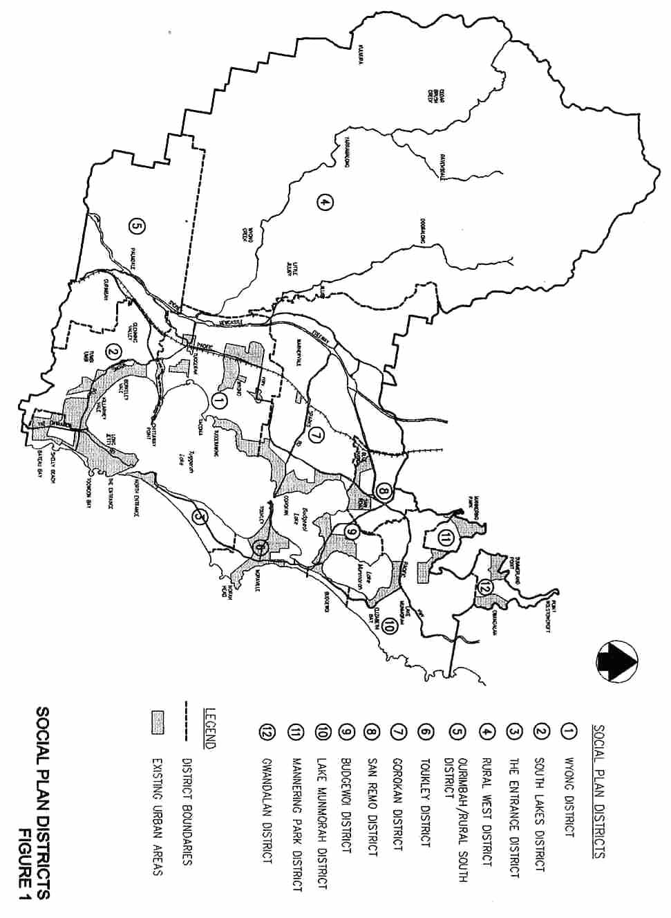
Figure 2 The Entrance District

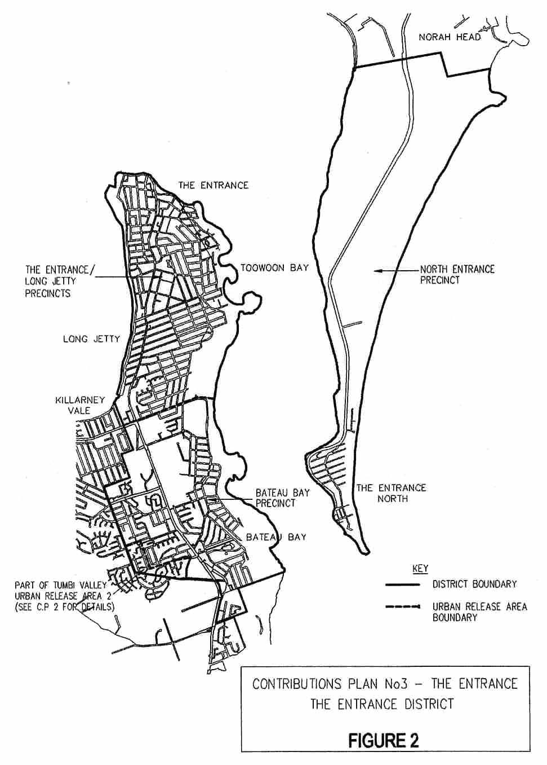

1.4 List of Abbreviations / Terms

DU – Dwelling Unit (see Section 2.1 for definition).

District – A Social Planning District within Wyong Shire (see Figures 1 and 2).

NDA (Net Developable Area) – this is the total area of the residential lots within a land subdivision and is used to calculate contributions on an area basis.

Secondary dwelling means a self-contained dwelling that:

- is established in conjunction with another dwelling (the principal dwelling), and
- is on the same lot of land as the principal dwelling, and
- is located within, or is attached to, or is separate from, the principal dwelling, and
- has a total floor area (excluding any area used for parking) that does not exceed 60m².
Note: As per definition in the draft Wyong Local Environmental Plan 2012.

A secondary dwelling shall be assessed as 0.35 DU.

1.5 Complying Development and Obligation of Accredited Certifiers

In accordance with Section 94EC(1) of the EP&A Act:

- Accredited certifiers must in issuing a complying development certificate impose a condition under Section 94 that requires the payment of monetary contributions calculated in accordance with this development contributions plan. The condition of consent shall also require the payment to be made prior to the commencement of works where building works are involved or prior to the commencement of use where no building works are involved.
- This plan authorises accredited certifiers to impose such a condition. The condition must include a notation that the contribution amounts are indexed on a quarterly basis.
- The amount of contributions and timing of payment shall be strictly in accordance with the provisions of this contributions plan.

It is the responsibility of accredited certifiers to:

- accurately calculate the quantum of contributions or alternatively seek advice and assistance directly from Council; and
- apply the Section 94 condition correctly.

1.6 Construction Certificates and Obligation of Accredited Certifiers

In accordance with Clause 146 of the EP&A Regulation, a certifying authority must not issue a construction certificate for building work or subdivision work under a development consent unless it has verified that each condition requiring the payment of monetary contributions has been satisfied.

In particular, the certifier must ensure that the applicant provides a receipt(s) confirming that contributions have been fully paid and copies of such receipts must be included with copies of the certified plans provided to the Council in accordance with clause 142(2) of the EP&A Regulation. Failure to follow this procedure may render such a certificate invalid.

The only exceptions to the requirement are where a works in kind or dedication of land has been agreed by Council. In such cases, Council will issue a letter confirming that an alternative payment method has been agreed with the developer.

1.7 Deferred and Periodic Payments

Council will generally not accept arrangements for the periodic payment of contributions required under this plan. Notwithstanding this position, an application for periodic payments may be made to Council, and Council after giving consideration to it may in extenuating circumstances accede to such a request subject to conditions that it considers appropriate. Such conditions may include the confirmation of the payment schedule via a legal agreement and the payment of fee.

Council will generally only consider permitting the deferred payment of contributions in accordance with its “Deferred Payment of Section 94 Contributions Policy” current at the time of application.

1.8 Current Contribution Rates

The contribution rates contained within this plan are the "base" rates for the plan.

Details of current indexed rates may be obtained from Council.

1.9 Estimated Costs

The following points should be noted in regard to cost estimates contained in this Plan:

- Cost details and contribution rates in this Plan unless otherwise specified are based on June 1992 values and will be adjusted periodically as detailed in Clause 12.
- Estimated costs for land components are based on:
Existing serviced land: $90/square metre
Englobo land: $20/square metre
- Where specific valuations are available, these values have been used.
- Full details of the cost estimates for works are contained in the relevant technical reports.

1.10 Timing of Works

Council is not able to bankroll works required as a consequence of development proposed under this Plan and will only be able to provide works and services when sufficient funds have been provided by way of contributions.

Priority spending of contributions may, however, be directed to particular items identified in this Plan and this has been considered in formulating works schedules.

In relation to the provision of any Plan requirements, the years shown in the Plan are indicative only. The provision of any item will be dependent on the threshold criteria established for the need for that item, and not necessarily the year shown in the Plan.

1.11 Works In Kind / Material Public Benefit

Developer contributions made in accordance with this plan will usually be in the form of monetary payments, however alternative "in kind" contributions may be accepted if they are deemed by Council to represent an "equivalent material public benefit”. In the case of alternative payments being proffered, a developer is required to make prior written representations to Council at which time the proposal may be considered and/or negotiated.

Where the value of a particular work in kind exceeds the contribution due for that work, this excess value may (subject to Council's concurrence) be offset against other contributions due under this plan. This offset can only be applied to those works which are not required immediately to service the initial development, but which can be delayed to a later stage when further development proceeds.

Alternatively, a credit may be granted to the developer which will be repaid upon uncommitted contribution funds becoming available.

The value of a particular work will be the value assigned to it under this Contribution Plan.

It may be feasible to provide temporary measures to service initial stages of a development in lieu of constructing major works up front. Such proposals will need to be assessed at the time of application and provision of such works will be the sole responsibility of the particular applicant, except where any part of them forms part of a work identified in this contribution plan (in which case that part will be treated as works in kind).

The cost of temporary works not recognised as works in kind cannot be offset against any other contributions required under this Plan.

1.12 Dedication of Land

Subject to prior agreement with Council, land may be dedicated in lieu of making a contribution towards the acquisition of land and in some cases, Council may require dedication of particular land as a condition of consent where the value of land dedicated exceeds the contribution due for provision of this particular type of land. This excess value may (subject to Council's concurrence) form a credit to the developer which will be repaid upon uncommitted contribution funds becoming available.

The value of a particular parcel of land will be the value assigned to it under this Contribution Plan.

Council will only accept land dedication where that land is of a suitable nature for the purpose for which it is being dedicated. All land to be transferred to Council is to be free of any improvements, structures or other impediments which would restrict or hinder its future use or development for the purposes for which it is being acquired, unless otherwise agreed by Council. The land is also to be transferred in an appropriate state, free of any refuse, contamination, or the like, unless otherwise agreed by Council.

1.13 Timing and Method of Payment

General practice in relation to the timing of payments for Section 94 contributions is as follows:

- development applications involving subdivision - prior to release of linen plans;
- development applications involving building works - prior to the release of construction certificate; and
- development applications where no building approval is required - at the time of development consent.
In regard to the latter case, the applicant may make a cash payment of contributions prior to issue of the development consent or alternatively lodge a suitable bank guarantee, also prior to issue of the consent. This bank guarantee will be called up upon commencement of the consent.

1.14 Method of Increasing Contributions

Increases to the contribution rate will apply in accordance with the following:

1.14.1 Cost Indexation Increase

Land Component

Increase will be by revaluation of land values using an actual site valuation or by use of the annual valuation review carried out by the Valuer General for Land Tax Office use.

Works Component

The Consumer Price Index (CPI) will be used to increase contribution rates as follows:

Current Rate = Old Rate x (Current CPI ÷ Base CPI)

Where:

The Base CPI is calculated as the most recently published quarterly figure for the Consumer Price Index, Australia for Sydney prior to the date of preparing this version of the plan. (Source: ABS 6401.0).

The Current CPI is calculated as the most recently published quarterly figure for the Consumer Price Index, Australia for Sydney prior to the date of payment.

All costs have been indexed to the June 2004 quarter (base CPI 145.5).

1.15 Revision of Plan

This Plan may be revised if the extent or nature of the proposed development varies and these variations lead to a change in the demand for public services and amenities.

Costings of works identified in this Plan are based on preliminary designs and changes to cost estimates as a result of detailed design may also necessitate a revision to this Plan.

Any revision of this Plan will be carried out in accordance with the provisions of Section 94.

Table 2 Plan Amendments

Adoption Date | Effective Date | Nature of Revision
 | October 1992 | No previous versions
 | September 1995 | Amended
 | September 1996 | Amended
 | May 1997 | Amended
 | November 1997 | Amended
 | December 1997 | Amended
 | March 2000 | Amended
 | January 2001 | Amended
 | March 2001 | Amended
 | May 2002 | Amended
 | 20 October 2004 | Amended
November 2006 | 11 January 2007 | Amended
24 July 2013 | 7 August 2013 | Insertion of specific clauses relating to complying development and deferred payment (and minor formatting changes)
24 July | 18 September 2013 | Insertion of “Secondary Dwelling” clause

1.16 Pooling of Funds

In accordance with Clause 27(3) of the Environmental Planning and Assessment Act Regulation, this clause authorises the pooling of funds by Council to provide priority works and land.

2 Urban Characteristics and Population

2.1 Population Predictions

The following table gives details of expected growth in resident population within The Entrance Social Plan District.

Table 3 Population Growth Projection for The Entrance District Area

Year | Projected Population | Additional Persons | Additional DU @ 2.2 persons per DU
1996 | 20,845
1997 | 21,090 | 245 | 111
1998 | 21,331 | 241 | 110
1999 | 21,573 | 242 | 110
2000 | 21,820 | 247 | 112
2001 | 22,075 | 255 | 116
2002 | 22,343 | 268 | 122
2003 | 22,629 | 286 | 130
2004 | 22,936 | 307 | 140
2005 | 23,268 | 332 | 151
2006 | 23,630 | 362 | 165
2007 | 24,085 | 455 | 207
2008 | 24,509 | 424 | 193
2009 | 24,906 | 397 | 180
2010 | 25,279 | 373 | 170
2000-2010 |  | 3,706 | 1,685

Source: Wyong Shire Population Projections 1998: The Entrance District.

Notes:
- It should be noted that the population projections are indicative only and are used to provide a guide for demand generated over time. The actual development rate may differ significantly in terms of generation of DU and the permanent occupation of the DU.
- A Dwelling Unit (DU) is the basic unit used for planning purposes for this Plan and is defined as a dwelling with an occupancy rate of 2.2 persons. Where other than three bedroom dwellings are proposed, an equivalent number of dwelling units should be calculated and used as the basis for determining needs and contributions. This will be calculated in accordance with Council's Policy.
- The occupancy rate for The Entrance District has been calculated from data contained within the 1996 ABS Census. To acknowledge the distinctive occupancy characteristics of the District, the occupancy rate utilised is that for population housed in total dwellings rather than just occupied dwellings.
- This provides an allowance for the lower than average occupancy rates within the area whilst still allowing an estimation of the total demand generated by future development in the District.
- It should be noted that the number of DU generated per annum may differ from the estimated population and equivalent DU table above. Contributions will be determined on the number of DU generated and not solely on expected population growth per annum. Through levying the total additional permanent DU created the total potential demand and peak demand scenarios are provided for. As such, the provision of amenities and services will be planned and delivered in a manner that the total potential demand will be met over time.
Table 4 Population and Dwelling Unit Data for The Entrance District

Locality | Projected Population | Projected DU 2000-2010
North Entrance | 535 | 243
Bateau Bay | 96 | 44
Remainder of District | 3,075 | 1,398
Total | 3,706 | 1,685

3 Community Infrastructure and Contributions

3.1 Community Facilities

3.1.1 Introduction

This section considers the human service requirements generated as a result of the development in the area of this Plan.

3.1.2 Area of the Scheme

The assessment of human services requirements has been carried out for all of the Social Plan District shown in Figure 2.

For the purposes of determination of community facility requirements for this Plan, the following have been excluded:

- existing development;
- single dwellings on existing residential lots; and
- developments for which consent has already been issued.
When these developments are excluded from the population predictions contained in Table 3, the predicted growth in population, for which community facilities contributions may be sought is 3,706 (equivalent to 1,685 DU's).

3.1.3 General

The approach to establishing human services requirements for this area has been:

- identify existing community facilities and associated land;
- identify requirements to service existing population, future single dwelling development on existing allotments for which no contribution can be sought and developments for which consent has already been issued; and
- determine the additional community facilities and land requirements, if any, needed to service the future development being considered.

3.1.4 Guidelines

A report has been prepared by the Strategic Planning Department to review the Strategic Social Planning Framework and Guidelines used by Council in the planning, provision and development of community facilities.

A report titled “Guidelines for the Planning and Provision of Community Facilities in Wyong Shire” - May 2000 recommends the following amounts to be used as the basis of determining requirements for a baseline level of provision:

- Land for Community Facilities: 4.95m² per DU
- Community Facilities Floor Space: 0.8m² per DU

3.1.5 Report Detail

This Plan is based on Council's Social Plan (1992) with details specific to this area prepared by Council's Community Services Planner contained in Report No CF15-1 (1992).

Assessment of existing services indicates there is no spare capacity in these facilities to meet the need generated by the future development considered in the Plan. Therefore, additional land and facilities will need to be provided to cater for the proposed population increase.

3.1.6 Determination of Community Facility Requirements

Community facility requirements for the area of this Plan are as follows:

Land Requirements

For an additional 1,685 DU's, a total of 8,341 square metres of land is required.

Current contributions in hand will enable this land area to be increased by an additional 1,566 square metres making a total land area of 9,907 square metres to be acquired.

Note: Specific land acquisitions have not yet been identified, however, it is likely acquisitions will be in the vicinity of commercial and service centres in The Entrance. As such a specific valuation has been utilised which reflects current (1999/00) land values for properties in these areas.

Community Facilities Requirements

For an additional 1,685 DU’s a total of 1,348 square metres of floor space is required.

Current contributions in hand will enable this floor space to be increased by an additional 408 square metres making a total of 1,756 square metres of floor space to be constructed.

3.1.7 Scheme Details

A total of 1,756 square metres of community facilities floor space is to be provided in accordance with needs identified within Council's Community Plan and through ongoing community consultation.

Community facility floor space will be utilised to provide Local Multi-Purpose Community Centres incorporating such facilities as childcare, neighbourhood centres, youth centres, senior citizens facilities and the like.

The timing for the provision of the floor space will generally be driven by the rate of future development in the locality, and the demand generated by such.

Further details including costs are shown in Table C1.

3.1.8 Apportionment of Costs

Costs will be shared by all developments on a population basis.

3.1.9 Program for Works and Funding

Land

An indicative time for the acquisition of land is shown in Table C1 although this may vary depending on the rate of development and acquisition opportunities.

Facilities

An indicative time for the provision of each facility is shown in Table C1 although this may vary depending on the rate of development.

The actual time for provision of the various facilities will be dictated by development thresholds, with:

- Land for Community Facilities: to be provided in conjunction with provision of floor space or as acquisition opportunities arise.
- Community Facilities Floor Space: approximately 300 square metres of floor space provided when 25%, 50%, 75% and 100% of development identified under the plan has been completed.

3.1.10 Contribution Rates

The contribution rate will be calculated by dividing the total estimated costs as shown in Table C1 by the estimated number of dwelling units.

Land Component

Cost = 8,341m² @ $365 per m²
= $3,044,465

Contribution Rate = Cost ÷ No of DU's
= $3,044,465 ÷ 1,685
= $1,807 per DU

Works Component

Cost = 1,348m² @ $2,389 per m²
= $3,220,230 (Jun 2004)

Contribution Rate = Cost ÷ No of DU's
= $3,220,230 ÷ 1,685
= $1,911 per DU

3.2 Public Open Space

3.2.1 Introduction

This section considers the open space requirements generated as a result of the development in the area of this Plan.

3.2.2 Area of the Scheme

For the purposes of Open Space planning this District has been divided into two zones as follows:

- Zone 1: The Entrance/North Entrance/Long Jetty Precincts.
- Zone 2: Bateau Bay Precinct.

3.2.3 Zone 1: The Entrance/North Entrance/Long Jetty Precincts

Proposed Development

The proposed development covers medium density development in the suburbs of North Entrance, The Entrance and Long Jetty and is predicted to yield a total population increase of 3,610 (equivalent to 1,641 DU's) over the 10 year planning period as shown in Table 3 of this Plan.

Nexus and Apportionment of Cost

General

The methodology adopted for this Plan is based on the Wyong Open Space Plan.

The approach to establishing requirements for this area has been:

- identify existing open space land and improvements, and land acquisition opportunities;
- identify requirements to service existing population and future single dwelling development on existing allotments for which no contributions can be sought;
- determine land requirements, if any, needed for the future development;
- determine embellishment requirements, if any, needed for the future development.

Report Detail

This Plan is based on the Wyong Open Space Plan with details specific to this area prepared by Council's Landscape Planner, contained in Report No POS 16-2 (September 1992).

Determination of Open Space Requirements

The Wyong Open Space Plan generally requires a minimum provision of open space of 3.00 hectares per thousand people (as well as requirements relating to different types of open space, size, distribution, etc.). For a population growth of 3,610 people, a minimum area of 10.83 hectares would be required.

The Wyong Open Space Plan indicates the various categories of open space as a proportion of total open space requirements as shown in the table below.

Table 5 Categories of Open Space

Open Space Type | Notional Proportion (%) | Notional Area Required (ha)
Small Park | 20 | 2.166
Large Park | 25 | 2.7075
Semi-Natural Area | 23 | 2.4909
Cycleway | 5 | 0.5415
Courts | 2 | 0.2166
Sports Fields | 25 | 2.7075
TOTAL OPEN SPACE | 100 | 10.83

Open Space requirements for the area of this Plan are as follows:

Land Requirements

The Wyong Open Space Plan 1991 indicated that at that stage, no further land acquisitions were to be undertaken within the Entrance District, for the provision of:

- Small and Large Parks; and
- Cycleways.
Previous studies had indicated an oversupply of land for these types of open space, therefore no acquisition of open space land for these types is proposed at this stage, pending a comprehensive review of demand and supply within The Entrance District. An ongoing review of open space land supply and acquisition opportunities will be undertaken, however at this time only the costs of acquisitions for fields and foreshore open space have been included.

To meet part of the open space needs for the provision of Courts and Sports Fields as identified under the Wyong Open Space Plan, Council proposes to acquire lands in the Kitchener Street locality that will facilitate the consolidation of the existing Jubilee Park and Baden Powell Park. A total of 0.87 hectares is proposed to be acquired at this stage at an estimated total cost of $1,740,000.

The consolidation of the two parks will enable the augmentation of existing facilities to meet the demands generated by new development.

At this stage no additional site acquisitions have been identified, however, further investigations will be undertaken to identify acquisition opportunities that will meet the demands generated by The Entrance District.

The need to acquire a parcel of semi-natural open space land fronting the lake foreshore at North Entrance has also been identified, where this land remained in private ownership. The acquisition providing a link with other publicly held lands in the North Entrance area. To this end Council acquired Lot 22 DP 881850 in 1998 for a total of $245,000.

Embellishment

While there is sufficient open space land within The Entrance District to meet some of the land requirements as identified above, the level of improvements on all types of open space is insufficient to cater for the future development being considered. Accordingly, contributions towards embellishment of existing open space for the future development area is justified. Cash estimates for embellishment of various types of open space have been calculated as follows:

Small or Large Parks: $26.39 per square metre
Semi-Natural Areas: $10.99 per square metre
Cycleways: $48.38 per square metre
Courts: $109.94 per square metre
Sports Fields: $36.28 per square metre

(Cost estimates indexed to June 2004)

These cost estimates have been applied to the area requirements in the table above to establish the contributions shown in Table S1.

Apportionment of Costs

Future development being considered is expected to be spread throughout the zone and so all development will be required to share the costs for open space embellishment on a proportional basis.

Program for Works and Funding

Land

An indicative time for the acquisition of land is shown in Table S1 although this may vary depending on the rate of development and acquisition opportunities.

Facilities

An indicative time for the provision of each improvement is shown in Table S1, although this may vary depending on the rate of development. The actual time for provision of the various improvements will be dedicated by the following thresholds:

- Courts: to be provided in stages when 50% and 100% of development is completed (subject to necessary land acquisition);
- Fields: to be provided in stages when 75% and 100% of development is completed (subject to necessary land acquisition);
- Parks and Cycleways: to be provided in stages when 25%, 50%, 75% and 100% of the development is completed;
- Semi-Natural: to be provided when 25% of the development is completed;
- Land: to be provided in conjunction with development.

Contribution Rates

The contribution rates will be calculated by dividing the total estimated costs by the estimated number of Dwelling Units as follows:

Land Component

Contribution = Cost of Jubilee Acquisition + Foreshore Acquisition (less total of funds held and acquisitions at February 2000) + Balance of Fields and Courts Acquisitions (2.379ha @ $90/sq m)
= [($1,740,000 + $245,000) - ($985,000 + $370,000)]
= $630,000

Contribution Rate = $630,000 ÷ 1,641
= $384 per DU

Works (Embellishment) Component

Contribution Rate = $3,042,142 ÷ 1,641
= $1,854 per DU

3.2.4 Zone 2: Bateau Bay Precinct

Proposed Development

The proposed development covers medium density development in the suburb of Bateau Bay, which is predicted to provide an additional population of 96 (equivalent to 44 DU).

The boundaries are shown in Figure 3.

Nexus and Apportionment of Cost

General

The methodology adopted for this Plan is based on the Wyong Open Space Plan.

The approach to establishing requirements for this area has been:

- identify existing open space land and improvements;
- identify requirements to service existing population and future single dwelling development on existing allotments for which no contributions can be sought;
- determine land requirements, if any, needed for the future development; and
- determine embellishment requirements, if any, needed for the future development.

Report Detail

This Plan is based on the Wyong Open Space Plan with details specific to this area prepared by Council's Landscape Planner, contained in Report No POS 15-2 (September 1992).

Determination of Open Space Requirements

The Wyong Open Space Plan requires a minimum provision of open space of 3.00 hectares per thousand people (as well as requirements relating to different types of open space, size, distribution, etc.). For a population growth of 96 people, a minimum area of 0.288 hectares would be required.

The Wyong Open Space Plan indicates the various categories of open space as proportions of total open space requirements into various categories as shown in the table below:

Table 6 Categories of Open Space

Open Space Type | Notional Proportion (%) | Notional Area Required (ha)
Parks, Fields and Cycleways | 75 | 0.216
Courts | 5 | 0.0144
Semi-Natural | 20 | 0.0576
TOTAL OPEN SPACE | 100 | 0.288

Open Space requirements for the area of this Plan are as follows:

Land Requirements

Assessment of existing open space land shows that there is an excess of land for the existing population and that there is no significant shortfall due to the requirements generated by the future development. Further, there is no concentrated location for this future development for which specific open space sites can be provided. Hence, there will be no requirements for land due to the proposed development.

Embellishment

While there is sufficient open space land within The Entrance District, the level of improvements is not sufficient to cater for the future development being considered. Accordingly, contributions towards embellishment of existing open space for the future development area is justified.

Cost estimates for embellishment of various types of open space have been calculated as follows:

Courts: $109.94 per square metre
Cycleways, Parks and Fields: $36.28 per square metre
Semi-Natural Areas: $10.99 per square metre

(Indexed to June 2004)

These cost estimates have been applied to the area requirements in the table above to establish the contributions shown in Table S2.

Apportionment of Costs

Future development being considered is expected to be spread throughout the zone and so all development will be required to share the costs for open space embellishment on a proportional basis.

Program for Works and Funding

An indicative time for the provision of each improvement is shown in Table S2, although this may vary depending on the rate of development. The actual time for provision of the various improvements will be dictated by the following thresholds:

- Court Improvements: to be provided when 25% of the future population is established;
- Embellishment of Semi-Natural Areas: to be provided when 5% of the future population is established;
- Embellishment of Cycleways, Parks and Fields: to be provided on completion of the future development.

Contribution Rates

The contribution rates will be calculated by dividing the total estimated costs by the estimated number of Dwelling Units as follows:

Land Component

Nil.

Works (Embellishment) Component

Contribution Rate = $100,533 ÷ 44
= $2,285 per DU
Figure 3 Public Open Space – Areas for Contributions

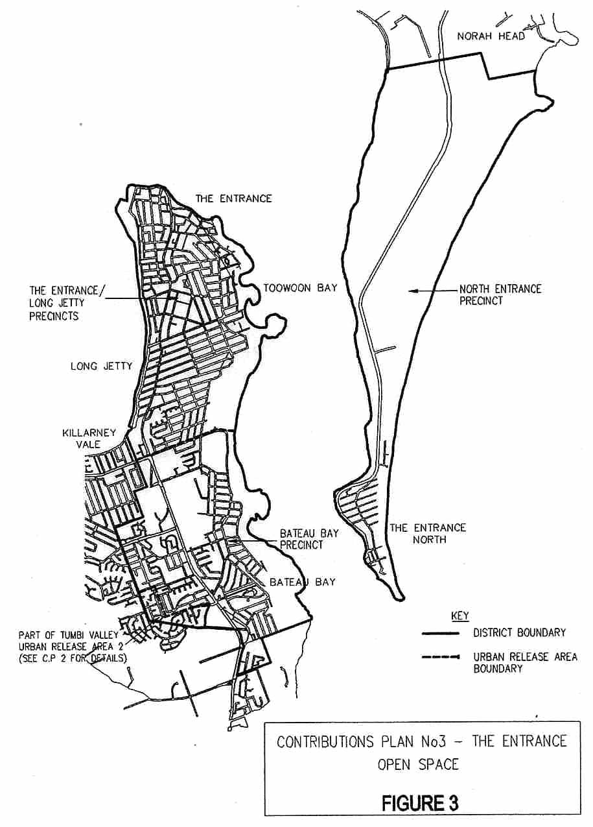

3.3 Carparking – The Entrance Town Centre

3.3.1 Area of Scheme

The area of the scheme is shown on the attached plan (Figure 4), and generally relates to the commercially zoned area of the Entrance Town Centre.

3.3.2 Report Detail

Assessment of the carparking facilities within The Entrance Town Centre indicates that adequate facilities exist to meet the demands of existing developments.

To meet the carparking demands for future development within The Entrance Town Centre, the provision of a multi storey carpark has been identified.

It is proposed to construct the carpark at the corner of Coral Street/Duffys Lane/Wilfred Barrett Drive, The Entrance.

The multi storey carpark is based on Technical Report No 01713 completed by Council's Strategic Planning Department and tenders received and assessed by Council at its meeting held on October 11 2000.

3.3.3 Scheme Details

The proposed works are described below with further details in Technical Report No 01713:

The existing ground level carpark provides 154 carparking spaces. A four level multi deck carpark will provide an additional 470 carparking spaces giving a total of 624 spaces for the site.

3.3.4 Estimate of Cost

The estimate of cost for the multi storey carpark, excluding land, is $8,230,639 (indexed to June 2004).

3.3.5 Apportionment of Cost

The cost of the works is to be apportioned between the proposed developments shown on Figure 4.

The apportionment of cost based on number of additional carparking spaces required is $17,512 for each carparking space.

3.3.6 Program for Works and Funding

At its meeting held on October 11 2000, Council resolved to accept a tender from a developer to construct a four level public carpark with accommodation units above.

It is anticipated that construction of the carpark will commence in June/July 2001 (subject to development and construction approval) and be completed and handed over to Council in 2002.
Figure 4 Carparking – The Entrance Town Centre
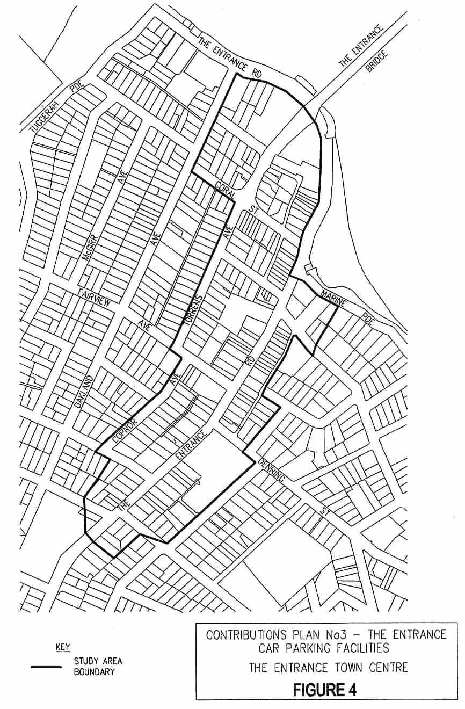

3.4 Roads and Intersections – North Entrance to Bateau Bay

3.4.1 Introduction

The purpose of this amendment is to include contributions for additional intersection works, pedestrian facilities and streetscape improvements required to cater for additional traffic that will be generated by increased development in The Entrance area over the next 20 to 30 years. This increased development has been identified in The Entrance Precinct Study.

The contribution area and works to be undertaken are shown in Figures 5, 6 and 7.

3.4.2 Report Detail

The works detailed in this Plan are based on Technical Report No 202 completed in September 1997 and Technical Report No 1938(a) completed in January 2000 and amended in March 2002 by Council’s Strategic Planning Department.

3.4.3 Scheme Details

The following intersection works and pedestrian facilities are required to cater for the expected additional traffic on the existing road network as a result of increased development in The Entrance District.

1 Wilfred Barrett Drive/Link Road, The Entrance North:
- Stage 1: construction of a “Type C” intersection incorporating 60 metre long deceleration / storage lanes in both directions (See Technical Report No. 202);
- Stage 2: installation of Traffic Control Signals.
2 Wilfred Barrett Drive/Mini Street, The Entrance North:
- Construction of a “Type C” intersection incorporating a right turn deceleration / storage lane (80 metres long) and a left turn deceleration lane (70 metres long) on Wilfred Barrett Drive. An acceleration / merging lane (180 metres long) on Wilfred Barrett Drive for the right turn movement from Mini Street is also required.
3 Oakland Avenue / Coral Street / Manning Road, The Entrance:
- Re-alignment of the eastern end of Manning Road to form a four-way intersection with Oakland Avenue and Coral Street;
- Installation of Traffic Signals at this new intersection.

4 Single Lane Roundabouts:
- Oakland Avenue/The Entrance Road (northern end)
- Oakland Avenue/Ashton Avenue
- Ocean Parade/Fairport Avenue
- Boondilla Road/Warrigal Street
- Boondilla Road/Bay Road
- Ocean Parade/Richard Road
- Ocean Parade/Boondilla Road
- Toowoon Bay Road/Watkins Street
- Toowoon Bay Road/Nirvana Street
- Toowoon Bay Road/Bay Road
- Tuggerah Parade/Archbold Road
- Tuggerah Parade/Toowoon Bay Road
- Tuggerah Parade/Pacific Street
- Tuggerah Parade/Gladstan Avenue
- Tuggerah Parade/Boat Ramp/Carpark
- Grandview Street/Bonnieview Street
- Grandview Street/Oaks Avenue
- Bellevue Street/Bonnieview Street
- Bellevue Street/McLachlan Street
- Lindsay Street/Bonnieview Street
- Lindsay Street/Waterview Street
- Swadling Street/Lindsay Street
- Swadling Street/Bellevue Street
- Nirvana Street/Stella Street
- Nirvana Street/Pacific Street

5 Channelisation - provision of concrete medians and/or linemarking to regulate vehicle speed and to control vehicle turning movements:
- Tuggerah Parade/Manning Road
- Tuggerah Parade/Fairview Avenue
- Tuggerah Parade/Stella Street
- Tuggerah Parade/Minto Avenue
- Dening Street/Bay Road
- Torrens Avenue/Fairview Avenue
- Warrigal Street/Taylor Street/Gosford Avenue
- Boondilla Road/Gosford Avenue
- Lakeside Parade/Ashton Avenue
- Lakeside Parade/Lentara Walk
6 Pedestrian Refuges:
- Coral Street – between Oakland Ave and Torrens Avenue
- Bay Road - between Yamba Street and Richard Road
- Bay Road - between Ocean Parade and Yethonga Avenue
- Bay Road - between Karooah Avenue and Moorah Avenue
- Bay Road – north of Pacific Street
- Bay Road – south of access to Swadling Park
- Koongara Street – east of caravan park entry
- Grandview Street - between McLachlan Avenue and Liddell Street
- Grandview Street – south of Waterview Street
7 Road Closures:
- Gilbert Street – south side of Anzac Road
- Boomerang Road – east of Warrigal Street
- Campbell Avenue – west side of Oakland Avenue
- Oaks Avenue – east side of Lindsay Street
- Liddell Street – east side of Lindsay Street
- Bellevue Street – south side of Liddell Street
8 Streetscape improvements along the distributor and collector routes.

3.4.4 Estimated Costs

The above works have been estimated to cost $15,657,000.

3.4.5 Nexus and Apportionment of Cost

The apportionment of cost is based on the additional volume of traffic generated (vehicle trips per day) by developments in The Entrance and North Entrance. It is also based on the assumption that 50% of existing properties that have potential for redevelopment will be developed over the next 20 to 30 years. Added to this are the following future major residential/tourist developments:

- The Entrance Road between Oakland Avenue and The Entrance Bridge (El Lago Site)
- The Entrance Road between Oakland Avenue and Tuggerah Parade (Caravan Park Site)
- The intersection of Marine Parade and The Entrance Road (Key Site)
- The Entrance Plaza (Pacific Waterfront Resort)
- Hutton Road, North Entrance (2 developments both with existing consents)
- Wilfred Barrett Drive (residential/tourist resort near old tip site)
The volume of traffic generated by these developments for calculation of costs is as follows.

Table 7 Volume of Traffic Generated

Development | Daily Vehicle Trips
Residential Redevelopment - The Entrance (50%) | 8,521
Residential Redevelopment - The Entrance North (50%), Hutton Rd (X2), Wilfred Barrett Drive Resort | 4,410
El Lago Site and Caravan Park Site | 1,865
Key Site | 190
Pacific Waterfront Resort | 435
TOTAL DAILY VEHICLE TRIPS | 15,421

The above figure of 15,421 daily vehicle trips represents an estimate of the additional traffic that will be generated within the Contributions Plan area by future developments in The Entrance and North Entrance. As discussed in Section 4 (Traffic Analysis – Technical Report No. 1938A) the traffic generated by future developments constitutes 88% of the total additional traffic expected to be generated in this area over the next 20 years. The remaining 12% is expected to consist of background traffic due to a general increase in population. Therefore total additional traffic is calculated as:

Development Traffic (88%) = 15,421 +
Background Traffic (12%) = 2,103
Total = 17,524

Apportionment of Cost

Cost per Trip = $15,657,000 ÷ 17,524 vehicle trips
= $893 per daily vehicle trip

The following table indicates the relationship of land use to daily vehicle trips.

Table 8 Relationship of Land Use to Daily Vehicle Trips

Land Use | Daily Vehicle Trips
Residential Dwelling Houses/Lots | 10/dwelling
Medium Density Residential Flat Building:
Secondary Dwelling | 2.5/dwelling
One Bedroom | 3/flat (unit)
Two Bedrooms | 5/flat (unit)
Three Bedrooms | 6.5/flat (unit)
Four or more Bedrooms | 10/flat (unit)
Tourist Accommodation | 3/unit
Office and Commercial | 10/100m² GFA
Retail | 121/100m² GLFA
Restaurant | 60/100m² GFA
Source: Roads & Traffic Authority - "Guide to Traffic Generating Developments "1993

A discount of 25% applies to retail development to account for linked and multi-purpose trips.

3.4.6 Contribution Rate

Apportionment of Cost

Cost per Trip = $15,657,000 ÷ 17,524 vehicle trips
= $893 per daily vehicle trip

Figure 5 Roads and Intersections – North Entrance to Bateau Bay

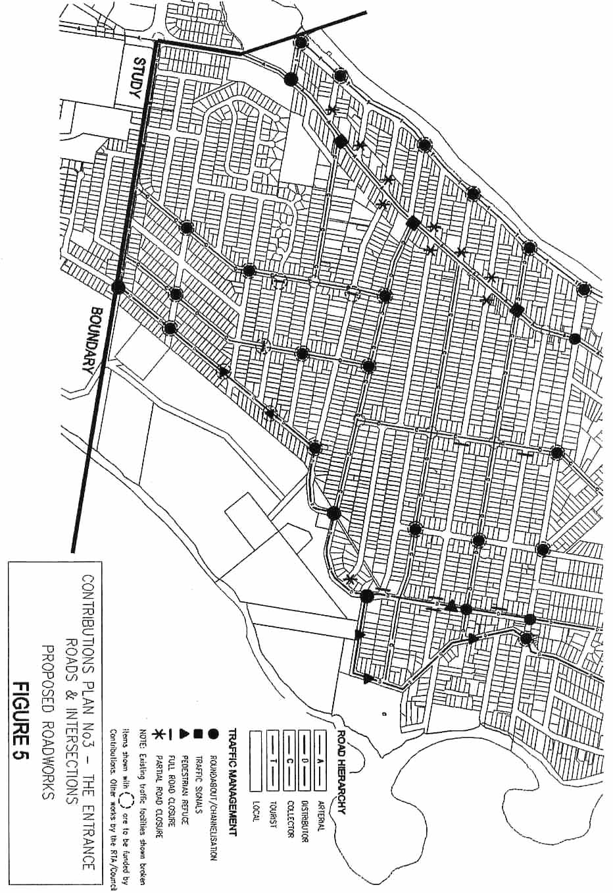
Figure 6 Roads and Intersections – North Entrance to Bateau Bay

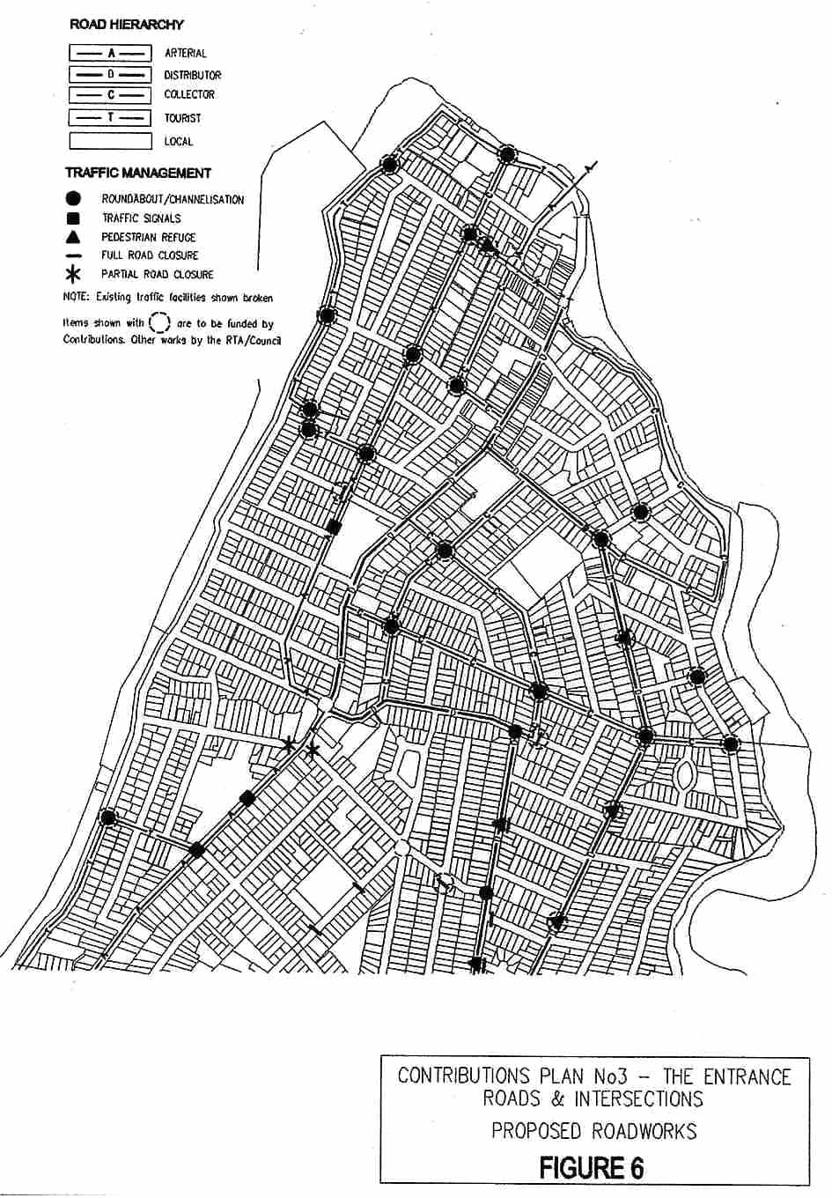
Figure 7 Roads and Intersections – North Entrance to Bateau Bay

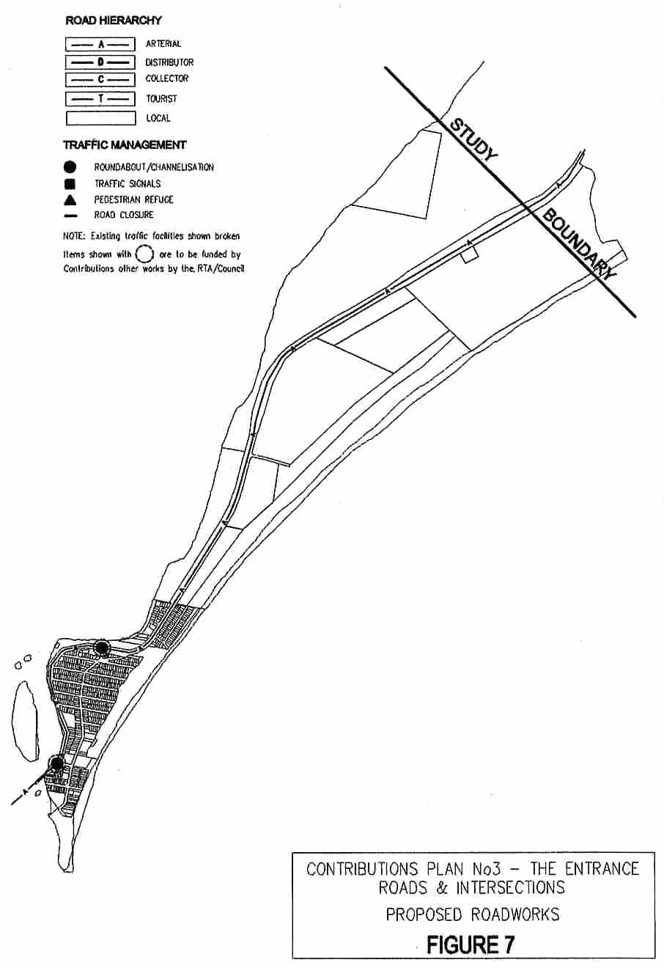

3.5 Drainage Improvements – The Entrance North

3.5.1 Introduction

This section covers drainage improvements in The Entrance North as a result of filling of flood effected land.

3.5.2 Area of Scheme

The contribution will apply to land:

- Below RL 1.4 metres AHD:
- Within the approximate 43 hectares drainage area bounded by Wilfred Barrett Drive, Link Road, Denis Street, the Pacific Ocean fore dune and Curtis Parade. This area (as indicated on Map 5) drains to the Shore of Tuggerah Lake between Link Road and the Boat Hire building (formerly Fish Co-Op).

3.5.3 Nexus and Apportionment of Cost

General

The Entrance North area is subject to flooding from either of two possible sources. Firstly from flooding of Tuggerah Lakes and independently from a storm over the local catchment.

The local area is separated from the lake by a levee formed by Wilfred Barrett Drive. There are pipelines under the road which drain the area into the lake. The pipes have floodgates fitted to protect the area from lake flooding in the absence of large local rainfall.

Filling for various developments within the area will cause increases to flood levels in the case of a local storm event (not a lake flood). This would adversely affect existing properties and require compensatory works in the form of extra pipelines.

Determination of Drainage Improvement Requirements

It is anticipated 25% of the area will progressively be redeveloped in the future. For building to be above the estimated local flood level (RL 1.4) the volume of fill required has been estimated to be 8,100m3. The placement of this fill would subsequently raise local flood levels by up to 67mm.

Pipework Requirements

Three additional 600mm pipes including flood gates would be required to offset the expected 67mm rise in local flood levels due to fill.

3.5.4 Apportionment of Cost and Contribution Rate

Cost

The cost of the required pipework has been estimated to be $100,000 (September 1997). Indexed to June 2004 = $110,313.

Contribution Rate

Contribution rate has been calculated as follows:

Cost/m³ = $110,313 ÷ 8,100m³
= $14 per m³ (of site fill or equivalent building volume up to RL 1.4)

3.5.5 Program for Works and Funding

Works will be undertaken when sufficient funds are available from development and within a reasonable time at receipt of contributions which has been estimated as follows:

- Pipe 1: to be provided when 33% of the development is complete;
- Pipe 2: to be provided when 66% of the development is complete;
- Pipe 3: to be provided when 100% of the development is complete.

Appendix A Schedule of Works

Table C1 Schedule of Works: Community Facilities Floor Space – The Entrance District

 |  |  |  | Forecast Development (DU)
 | Area | Rate | Est Cost | ($ x 1000)
Item | (m²) | ($) | ($ x 1000) | 0 | 169 | 337 | 506 | 674 | 843 | 1011 | 1180 | 1348 | 1517 | 1685
Works Expenditure
Multi-Purpose Floor Space | 1348 | 2389 | 3220 | 0 | 0 | 0 | 0 | 0 | 1500 | 0 | 0 | 0 | 0 | 1720
Total Expenditure |  |  | 3220 | 0 | 0 | 0 | 0 | 0 | 1500 | 0 | 0 | 0 | 0 | 1720
Income ($ x 1000)
Developer Contributions Under This Plan |  |  |  | 0 | 322 | 322 | 322 | 322 | 322 | 322 | 322 | 322 | 322 | 322
Council Contribution Required |  |  |  | 0 | 0 | 0 | 0 | 0 | 0 | 0 | 0 | 0 | 0 | 0
Other Income (interest/grants etc.) |  |  |  | 0 | 0 | 0 | 0 | 0 | 0 | 0 | 0 | 0 | 0 | 0
Contributions on Hand (incl. old funds) |  |  |  | 0 | 0 | 0 | 0 | 0 | 0 | 0 | 0 | 0 | 0 | 0
Contributions From Existing Consents |  |  |  | 0 | 0 | 0 | 0 | 0 | 0 | 0 | 0 | 0 | 0 | 0
Total Income |  |  |  | 0 | 322 | 322 | 322 | 322 | 322 | 322 | 322 | 322 | 322 | 322
Contribution Cash Flow |  |  |  | 0 | 322 | 644 | 966 | 1288 | 110 | 432 | 754 | 1076 | 1398 | 0
Council Bankrolling |  |  |  | 0 | 0 | 0 | 0 | 0 | 0 | 0 | 0 | 0 | 0 | 0
Developer Bankrolling |  |  |  | 0 | 0 | 0 | 0 | 0 | 0 | 0 | 0 | 0 | 0 | 0
Total Bankrolling |  |  |  | 0 | 0 | 0 | 0 | 0 | 0 | 0 | 0 | 0 | 0 | 0
Adjusted Period Balance |  |  |  | 0 | 322 | 644 | 966 | 1288 | 110 | 432 | 754 | 1076 | 1398 | 0
Contribution Rate ('000s) | 1.911
Current/Approved DU (if applic) | 0
Remaining DU | 1685
Total Scheme DU | 1685

Table C1 Schedule of Works: Community Facilities Land – The Entrance District

 |  |  |  | Forecast Development (DU)
 | Area | Rate | Est Cost | ($ x 1000)
Item | (m²) | ($) | ($ x 1000) | 0 | 169 | 337 | 506 | 674 | 843 | 1011 | 1180 | 1348 | 1517 | 1685
Land Expenditure
Land Acquisition | 8341 | 365 | 3044 | 0 | 0 | 0 | 761 | 0 | 761 | 0 | 0 | 761 | 0 | 761
Total Expenditure |  |  | 3044 | 0 | 0 | 0 | 761 | 0 | 761 | 0 | 0 | 761 | 0 | 761
Income ( $ x 1000)
Developer Contributions Under This Plan |  |  |  | 0 | 304 | 304 | 304 | 304 | 304 | 304 | 304 | 304 | 304 | 304
Council Contribution Required |  |  |  | 0 | 0 | 0 | 0 | 0 | 0 | 0 | 0 | 0 | 0 | 0
Other Income (interest/grants etc.) |  |  |  | 0 | 0 | 0 | 0 | 0 | 0 | 0 | 0 | 0 | 0 | 0
Contributions on Hand (incl. old funds) |  |  |  | 0 | 0 | 0 | 0 | 0 | 0 | 0 | 0 | 0 | 0 | 0
Contributions From Existing Consents |  |  |  | 0 | 0 | 0 | 0 | 0 | 0 | 0 | 0 | 0 | 0 | 0
Total Income |  |  |  | 0 | 304 | 304 | 304 | 304 | 304 | 304 | 304 | 304 | 304 | 304
Contribution Cash Flow |  |  |  | 0 | 304 | 609 | 152 | 457 | 0 | 305 | 609 | 153 | 457 | 1
Council Bankrolling |  |  |  | 0 | 0 | 0 | 0 | 0 | 0 | 0 | 0 | 0 | 0 | 0
Developer Bankrolling |  |  |  | 0 | 0 | 0 | 0 | 0 | 0 | 0 | 0 | 0 | 0 | 0
Total Bankrolling |  |  |  | 0 | 0 | 0 | 0 | 0 | 0 | 0 | 0 | 0 | 0 | 0
Adjusted Period Balance |  |  |  | 0 | 304 | 609 | 152 | 457 | 0 | 305 | 609 | 153 | 457 | 1
Contribution Rate ('000s) | 1.807
Current/Approved DU (if applic) | 0
Remaining DU | 1685
Total Scheme DU | 1685

Table S1 Schedule of Works: Open Space Works - North Entrance / The Entrance / Long Jetty

 |  |  |  | Forecast Development (DU)
 | Area | Rate | Est Cost | ($ x 1000)
Item | (m²) | ($) | ($ x 1000) | 0 | 164 | 328 | 492 | 656 | 821 | 985 | 1149 | 1313 | 1477 | 1641
Works Expenditure
Courts | 2166 | 109.94 | 238 | 0 | 0 | 0 | 0 | 0 | 119.1 | 0 | 0 | 0 | 0 | 119.07
Small Parks | 21660 | 26.39 | 572 | 0 | 0 | 0 | 142.9 | 0 | 142.9 | 0 | 0 | 142.9 | 0 | 142.9
Large Parks | 27075 | 26.39 | 715 | 0 | 0 | 0 | 178.6 | 0 | 178.6 | 0 | 0 | 178.6 | 0 | 178.63
Cycleways | 5415 | 48.38 | 262 | 0 | 0 | 0 | 65.49 | 0 | 65.49 | 0 | 0 | 65.49 | 0 | 65.494
Fields | 27075 | 36.28 | 982 | 0 | 0 | 0 | 0 | 0 | 0 | 0 | 0 | 491.1 | 0 | 491.14
Semi-natural | 24909 | 10.99 | 274 | 0 | 0 | 0 | 274 | 0 | 0 | 0 | 0 | 0 | 0 | 0
Total Expenditure | 108300 |  | 3042 | 0 | 0 | 0 | 661 | 0 | 506 | 0 | 0 | 878 | 0 | 997
Income ( $ x 1000)
Developer Contributions Under This Plan |  |  | 3042 | 0 | 304 | 304 | 304 | 304 | 304 | 304 | 304 | 304 | 304 | 304
Council Contribution Required |  |  |  | 0 | 0 | 0 | 0 | 0 | 0 | 0 | 0 | 0 | 0 | 0
Other Income (interest/grants etc.) |  |  |  | 0 | 0 | 0 | 0 | 0 | 0 | 0 | 0 | 0 | 0 | 0
Contributions on Hand (incl. old funds) |  |  |  | 0 | 0 | 0 | 0 | 0 | 0 | 0 | 0 | 0 | 0 | 0
Contributions From Existing Consents |  |  |  | 0 | 0 | 0 | 0 | 0 | 0 | 0 | 0 | 0 | 0 | 0
Total Income |  |  |  | 0 | 304 | 304 | 304 | 304 | 304 | 304 | 304 | 304 | 304 | 304
Contribution Cash Flow |  |  |  | 0 | 304 | 608 | 252 | 556 | 354 | 659 | 963 | 389 | 693 | 0
Council Bankrolling |  |  |  | 0 | 0 | 0 | 0 | 0 | 0 | 0 | 0 | 0 | 0 | 0
Developer Bankrolling |  |  |  | 0 | 0 | 0 | 0 | 0 | 0 | 0 | 0 | 0 | 0 | 0
Total Bankrolling |  |  |  | 0 | 0 | 0 | 0 | 0 | 0 | 0 | 0 | 0 | 0 | 0
Adjusted Period Balance |  |  |  | 0 | 304 | 608 | 252 | 556 | 354 | 659 | 963 | 389 | 693 | 0
Contribution Rate ('000s) | 1.854
Current/Approved DU (if applic) | 0
Remaining DU | 1641
Total Scheme DU | 1641

Table S1 Schedule of Works: Open Space Land – North Entrance / The Entrance / Long Jetty

 |  |  |  | Forecast Development (DU)
 | Area | Rate | Est Cost | ($ x 1000)
Item | (m²) | ($) | ($ x 1000) | 0 | 164 | 328 | 492 | 656 | 821 | 985 | 1149 | 1313 | 1477 | 1641
Land Expenditure
Cost of Jubilee acquisition | 8700 | 200 | 1740 | 370 | 269.2 | 269.2 | 269.2 | 269.2 | 269.2 | 269.2 | 0 | 0 | 0 | 0
Foreshore acquisition |  |  | 245 | 245 | 0 | 0 | 0 | 0 | 0 | 0 | 0 | 0 | 0 | 0
Total Expenditure |  |  | 1985 | 615 | 269 | 269 | 269 | 269 | 269 | 269 | 0 | 0 | 0 | 0
Income ( $ x 1000)
Developer Contributions Under This Plan |  |  |  | 0 | 63 | 63 | 63 | 63 | 63 | 63 | 63 | 63 | 63 | 63
Council Contribution Required |  |  |  | 0 | 0 | 0 | 0 | 0 | 0 | 0 | 0 | 0 | 0 | 0
Other Income (interest/grants etc.) |  |  |  | 0 | 0 | 0 | 0 | 0 | 0 | 0 | 0 | 0 | 0 | 0
Contributions on Hand (incl. old funds) |  |  |  | 985 | 0 | 0 | 0 | 0 | 0 | 0 | 0 | 0 | 0 | 0
Contributions From Existing Consents |  |  |  | 615 | 0 | 0 | 0 | 0 | 0 | 0 | 0 | 0 | 0 | 0
Total Income |  |  |  | 1600 | 63 | 63 | 63 | 63 | 63 | 63 | 63 | 63 | 63 | 63
Contribution Cash Flow |  |  |  | 985 | 779 | 573 | 367 | 160 | -46 | -252 | -189 | -126 | -63 | 0
Council Bankrolling |  |  |  | -985 | 0 | 0 | 0 | 0 | 0 | 0 | 0 | 0 | 0 | 0
Developer Bankrolling |  |  |  | 0 | 0 | 0 | 0 | 0 | 0 | 0 | 0 | 0 | 0 | 0
Total Bankrolling |  |  |  | -985 | 0 | 0 | 0 | 0 | 0 | 0 | 0 | 0 | 0 | 0
Adjusted Period Balance |  |  |  | 0 | 779 | 573 | 367 | 160 | -46 | -252 | -189 | -126 | -63 | 0
Contribution Rate ('000s) | 0.384
Current/Approved DU (if applic) | 0
Remaining DU | 1641
Total Scheme DU | 1641

Table S2 Schedule of Works: Open Space Works – Bateau Bay

 |  |  |  | Forecast Development (DU)
 | Area | Rate | Est Cost | ($ x 1000)
Item | (m²) | ($) | ($ x 1000) | 0 | 4 | 9 | 13 | 18 | 22 | 26 | 31 | 35 | 40 | 44
Works Expenditure
Courts | 144 | 109.94 | 16 | 0 | 0 | 0 | 16 | 0 | 0 | 0 | 0 | 0 | 0 | 0
Cycleways, Parks & Fields | 2160 | 36.28 | 78 | 0 | 0 | 0 | 0 | 0 | 0 | 0 | 0 | 0 | 0 | 78
Semi-natural | 576 | 10.99 | 6 | 0 | 3 | 0 | 0 | 3 | 0 | 0 | 0 | 0 | 0 | 0
Total Expenditure | 2880 |  | 101 | 0 | 3 | 0 | 16 | 3 | 0 | 0 | 0 | 0 | 0 | 78
Income ( $ x 1000)
Developer Contributions Under This Plan |  |  | 101 | 0 | 10 | 10 | 10 | 10 | 10 | 10 | 10 | 10 | 10 | 10
Council Contribution Required |  |  |  | 0 | 0 | 0 | 0 | 0 | 0 | 0 | 0 | 0 | 0 | 0
Other Income (interest/grants etc.) |  |  |  | 0 | 0 | 0 | 0 | 0 | 0 | 0 | 0 | 0 | 0 | 0
Contributions on Hand (incl. old funds) |  |  |  | 0 | 0 | 0 | 0 | 0 | 0 | 0 | 0 | 0 | 0 | 0
Contributions From Existing Consents |  |  |  | 0 | 0 | 0 | 0 | 0 | 0 | 0 | 0 | 0 | 0 | 0
Total Income |  |  | 101 | 0 | 10 | 10 | 10 | 10 | 10 | 10 | 10 | 10 | 10 | 10
Contribution Cash Flow |  |  |  | 0 | 7 | 17 | 11 | 18 | 28 | 38 | 49 | 59 | 69 | 0
Council Bankrolling |  |  |  | 0 | 0 | 0 | 0 | 0 | 0 | 0 | 0 | 0 | 0 | 0
Developer Bankrolling |  |  |  | 0 | 0 | 0 | 0 | 0 | 0 | 0 | 0 | 0 | 0 | 0
Total Bankrolling |  |  |  | 0 | 0 | 0 | 0 | 0 | 0 | 0 | 0 | 0 | 0 | 0
Adjusted Period Balance |  |  |  | 0 | 7 | 17 | 11 | 18 | 28 | 38 | 49 | 59 | 69 | 0
Contribution Rate ('000s) | 2.285
Current/Approved DU (if applic) | 0
Remaining DU | 44
Total Scheme DU | 44

Table D1 Schedule of Works: Carparking

 |  |  |  | Forecast Development (cubic metres of fill)
 |  | Rate | Est Cost | ($ x 1000)
Item |  | ($) | ($ x 1000) | 0 | 47 | 94 | 141 | 188 | 235 | 282 | 329 | 376 | 423 | 470
Works Expenditure
Coral Street Multi Storey Carpark |  |  | 8231 | 0 | 0 | 8231 | 0 | 0 | 0 | 0 | 0 | 0 | 0 | 0
Total Expenditure |  |  | 8231 | 0 | 0 | 8231 | 0 | 0 | 0 | 0 | 0 | 0 | 0 | 0
Income ($ x 1000)
Developer Contributions Under This Plan |  |  |  | 0 | 823 | 823 | 823 | 823 | 823 | 823 | 823 | 823 | 823 | 823
Council Contribution Required |  |  |  | 0 | 0 | 0 | 0 | 0 | 0 | 0 | 0 | 0 | 0 | 0
Other Income (interest/grants etc.) |  |  |  | 0 | 0 | 0 | 0 | 0 | 0 | 0 | 0 | 0 | 0 | 0
Contributions on Hand (incl. old funds) |  |  |  | 0 | 0 | 0 | 0 | 0 | 0 | 0 | 0 | 0 | 0 | 0
Contributions From Existing Consents |  |  |  | 0 | 0 | 0 | 0 | 0 | 0 | 0 | 0 | 0 | 0 | 0
Total Income |  |  |  | 0 | 823 | 823 | 823 | 823 | 823 | 823 | 823 | 823 | 823 | 823
Contribution Cash Flow |  |  |  | 0 | 823 | -6585 | -5761 | -4938 | -4115 | -3292 | -2469 | -1646 | -823 | 0
Council Bankrolling |  |  |  | 0 | 0 | 0 | 0 | 0 | 0 | 0 | 0 | 0 | 0 | 0
Developer Bankrolling |  |  |  | 0 | 0 | 0 | 0 | 0 | 0 | 0 | 0 | 0 | 0 | 0
Total Bankrolling |  |  |  | 0 | 0 | 0 | 0 | 0 | 0 | 0 | 0 | 0 | 0 | 0
Adjusted Period Balance |  |  |  | 0 | 823 | -6585 | -5761 | -4938 | -4115 | -3292 | -2469 | -1646 | -823 | 0
Contribution Rate ('000s) | 17.512
Current/Approved cu m (if applic) | 0
Remaining cu m | 470
Total Scheme cu m | 470

Table D1 Schedule of Works: Drainage Improvements - North Entrance

 | Rate  ($) |  |  | Forecast Development (cubic metres of fill)
 |  |  | Est Cost | ($ x 1000)
Item |  |  | ($ x 1000) | 0 | 810 | 1620 | 2430 | 3240 | 4050 | 4860 | 5670 | 6480 | 7290 | 8100
Works Expenditure
600 mm pipe with flood gates |  |  | 36.77 | 0 | 0 | 0 | 36.77 | 0 | 0 | 0 | 0 | 0 | 0 | 0
600 mm pipe with flood gates |  |  | 36.77 | 0 | 0 | 0 | 0 | 0 | 0 | 36.77 | 0 | 0 | 0 | 0
600 mm pipe with flood gates |  |  | 36.77 | 0 | 0 | 0 | 0 | 0 | 0 | 0 | 0 | 0 | 0 | 36.77
Total Expenditure |  |  | 110 | 0 | 0 | 0 | 37 | 0 | 0 | 37 | 0 | 0 | 0 | 37
Income ( $ x 1000)
Developer Contributions Under This Plan |  |  |  | 0 | 11 | 11 | 11 | 11 | 11 | 11 | 11 | 11 | 11 | 11
Council Contribution Required |  |  |  | 0 | 0 | 0 | 0 | 0 | 0 | 0 | 0 | 0 | 0 | 0
Other Income (interest/grants etc.) |  |  |  | 0 | 0 | 0 | 0 | 0 | 0 | 0 | 0 | 0 | 0 | 0
Contributions on Hand (incl. old funds) |  |  |  | 0 | 0 | 0 | 0 | 0 | 0 | 0 | 0 | 0 | 0 | 0
Contributions From Existing Consents |  |  |  | 0 | 0 | 0 | 0 | 0 | 0 | 0 | 0 | 0 | 0 | 0
Total Income |  |  |  | 0 | 11 | 11 | 11 | 11 | 11 | 11 | 11 | 11 | 11 | 11
Contribution Cash Flow |  |  |  | 0 | 11 | 23 | -3 | 9 | 20 | -6 | 6 | 17 | 29 | 3
Council Bankrolling |  |  |  | 0 | 0 | 0 | 0 | 0 | 0 | 0 | 0 | 0 | 0 | 0
Developer Bankrolling |  |  |  | 0 | 0 | 0 | 0 | 0 | 0 | 0 | 0 | 0 | 0 | 0
Total Bankrolling |  |  |  | 0 | 0 | 0 | 0 | 0 | 0 | 0 | 0 | 0 | 0 | 0
Adjusted Period Balance |  |  |  | 0 | 11 | 23 | -3 | 9 | 20 | -6 | 6 | 17 | 29 | 3
Contribution Rate ('000s) | 0.014
Current/Approved cu m (if applic) | 0
Remaining cu m | 8100
Total Scheme cu m | 8100

Table R2 Schedule of Works: The Entrance District, Roads & Intersections

 |  | ($ x 1000)
 | Est Cost | Forecast Development (estimated vehicle trips)
Item | ($ x 1000) | 0 | 1752 | 3505 | 5257 | 7010 | 8762 | 10514 | 12267 | 14019 | 15772 | 17524
Works Expenditure
Intersections
Oakland / Ashton (RBT) | 750 | 0 | 750 | 0 | 0 | 0 | 0 | 0 | 0 | 0 | 0 | 0
Boondilla / Warrigal (RBT) | 200 | 0 | 200 | 0 | 0 | 0 | 0 | 0 | 0 | 0 | 0 | 0
Wilfred Barrett / Mini | 350 | 0 | 350 | 0 | 0 | 0 | 0 | 0 | 0 | 0 | 0 | 0
Grandview / Oaks (RBT) | 204 | 0 | 0 | 204 | 0 | 0 | 0 | 0 | 0 | 0 | 0 | 0
Swadling / Lindsay (RBT) | 350 | 0 | 0 | 350 | 0 | 0 | 0 | 0 | 0 | 0 | 0 | 0
Dening / Bay / Fairport (Channelisation) | 100 | 0 | 0 | 100 | 0 | 0 | 0 | 0 | 0 | 0 | 0 | 0
Bay / Boondilla (RBT) | 350 | 0 | 0 | 350 | 0 | 0 | 0 | 0 | 0 | 0 | 0 | 0
Warrigal / Taylor / Gosford (Channelisation) | 638 | 0 | 0 | 638 | 0 | 0 | 0 | 0 | 0 | 0 | 0 | 0
Oakland / Fairview (RBT) | 0 | 0 | 0 | 0 | 0 | 0 | 0 | 0 | 0 | 0 | 0 | 0
Ocean / Boondilla (RBT) | 250 | 0 | 0 | 0 | 250 | 0 | 0 | 0 | 0 | 0 | 0 | 0
Toowoon Bay Rd /Watkins (RBT) | 350 | 0 | 0 | 0 | 350 | 0 | 0 | 0 | 0 | 0 | 0 | 0
Torrens / Fairview (Channelisation) | 100 | 0 | 0 | 0 | 100 | 0 | 0 | 0 | 0 | 0 | 0 | 0
Wilfred Barrett / Link | 675 | 0 | 0 | 0 | 675 | 0 | 0 | 0 | 0 | 0 | 0 | 0
Toowoon Bay / Nirvana / Archbold (RBT) | 350 | 0 | 0 | 0 | 0 | 350 | 0 | 0 | 0 | 0 | 0 | 0
Bay / Toowoon Bay (RBT) | 350 | 0 | 0 | 0 | 0 | 350 | 0 | 0 | 0 | 0 | 0 | 0
Ocean / Fairport (RBT) | 350 | 0 | 0 | 0 | 0 | 350 | 0 | 0 | 0 | 0 | 0 | 0
Boondilla / Gosford (Channelisation) | 100 | 0 | 0 | 0 | 0 | 100 | 0 | 0 | 0 | 0 | 0 | 0
Tuggerah / Archbold (RBT) | 350 | 0 | 0 | 0 | 0 | 0 | 350 | 0 | 0 | 0 | 0 | 0
Tuggerah / Boat Ramp / Carpark (RBT) | 250 | 0 | 0 | 0 | 0 | 0 | 250 | 0 | 0 | 0 | 0 | 0
Grandview / Bonnieview (RBT) | 350 | 0 | 0 | 0 | 0 | 0 | 350 | 0 | 0 | 0 | 0 | 0
Ocean / Richard (RBT) | 350 | 0 | 0 | 0 | 0 | 0 | 350 | 0 | 0 | 0 | 0 | 0
Oakland / Coral (Signals) | 3500 | 0 | 0 | 0 | 0 | 0 | 0 | 3500 | 0 | 0 | 0 | 0
Tuggerah / Pacific (RBT) | 250 | 0 | 0 | 0 | 0 | 0 | 0 | 250 | 0 | 0 | 0 | 0
Toowoon Bay / Tuggerah (RBT) | 250 | 0 | 0 | 0 | 0 | 0 | 0 | 250 | 0 | 0 | 0 | 0
Nirvana / Stella (RBT) | 350 | 0 | 0 | 0 | 0 | 0 | 0 | 350 | 0 | 0 | 0 | 0
Lindsay / Waterview (RBT) | 350 | 0 | 0 | 0 | 0 | 0 | 0 | 0 | 350 | 0 | 0 | 0
Lindsay / Bonnieview (RBT) | 250 | 0 | 0 | 0 | 0 | 0 | 0 | 0 | 250 | 0 | 0 | 0
Tuggerah / Fairview (Channelisation) | 100 | 0 | 0 | 0 | 0 | 0 | 0 | 0 | 100 | 0 | 0 | 0
Tuggerah / Gladstan (RBT) | 250 | 0 | 0 | 0 | 0 | 0 | 0 | 0 | 250 | 0 | 0 | 0
Lakeside / Ashton (Channelisation) | 100 | 0 | 0 | 0 | 0 | 0 | 0 | 0 | 100 | 0 | 0 | 0
Nirvana / Pacific (RBT) | 250 | 0 | 0 | 0 | 0 | 0 | 0 | 0 | 0 | 250 | 0 | 0
Intersections (cont’d)
Bellevue / McLachlan (RBT) | 250 | 0 | 0 | 0 | 0 | 0 | 0 | 0 | 0 | 250 | 0 | 0
Tuggerah / Stella (Channelisation) | 70 | 0 | 0 | 0 | 0 | 0 | 0 | 0 | 0 | 70 | 0 | 0
Tuggerah / Minto (Channelisation) | 100 | 0 | 0 | 0 | 0 | 0 | 0 | 0 | 0 | 100 | 0 | 0
Swadling / Bellevue (RBT) | 350 | 0 | 0 | 0 | 0 | 0 | 0 | 0 | 0 | 0 | 350 | 0
Bellevue / Bonnieview (RBT) | 250 | 0 | 0 | 0 | 0 | 0 | 0 | 0 | 0 | 0 | 250 | 0
Oakland / The Entrance Nth (RBT) | 250 | 0 | 0 | 0 | 0 | 0 | 0 | 0 | 0 | 0 | 250 | 0
Tuggerah / Manning (Channelisation) | 100 | 0 | 0 | 0 | 0 | 0 | 0 | 0 | 0 | 0 | 100 | 0
Pedestrian Facilities
Coral St, between Oakland & Torrens | 20 | 0 | 20 | 0 | 0 | 0 | 0 | 0 | 0 | 0 | 0 | 0
Bay Rd, between Yamba & Richard | 20 | 0 | 0 | 20 | 0 | 0 | 0 | 0 | 0 | 0 | 0 | 0
Bay Rd, between Ocean & Yethonga | 20 | 0 | 0 | 0 | 20 | 0 | 0 | 0 | 0 | 0 | 0 | 0
Bay Rd, between Karooah & Moorah | 20 | 0 | 0 | 0 | 0 | 20 | 0 | 0 | 0 | 0 | 0 | 0
Bay Rd, sth of access to Swadling Park | 20 | 0 | 0 | 0 | 0 | 0 | 20 | 0 | 0 | 0 | 0 | 0
Bay Rd, nth of Pacific | 20 | 0 | 0 | 0 | 0 | 0 | 0 | 20 | 0 | 0 | 0 | 0
Grandview St, sth of McLachlan | 20 | 0 | 0 | 0 | 0 | 0 | 0 | 0 | 20 | 0 | 0 | 0
Grandview St, sth of Waterview | 20 | 0 | 0 | 0 | 0 | 0 | 0 | 0 | 0 | 20 | 0 | 0
Koongara St, east of entry to caravan park | 20 | 0 | 0 | 0 | 0 | 0 | 0 | 0 | 0 | 0 | 20 | 0
Road Closures
Anzac / Gilbert | 100 | 0 | 100 | 0 | 0 | 0 | 0 | 0 | 0 | 0 | 0 | 0
Boomerang / Warrigal | 100 | 0 | 100 | 0 | 0 | 0 | 0 | 0 | 0 | 0 | 0 | 0
Oakland / Campbell | 100 | 0 | 100 | 0 | 0 | 0 | 0 | 0 | 0 | 0 | 0 | 0
Lindsay / Oaks | 100 | 0 | 0 | 0 | 0 | 0 | 0 | 0 | 0 | 0 | 100 | 0
Lindsay / Liddell | 100 | 0 | 0 | 0 | 0 | 0 | 0 | 0 | 0 | 0 | 100 | 0
Bellevue / Liddell | 100 | 0 | 0 | 0 | 0 | 0 | 0 | 0 | 0 | 0 | 100 | 0
Streetscape Improvements - Tree Planting | 990 | 0 | 99 | 99 | 99 | 99 | 99 | 99 | 99 | 99 | 99 | 99
Total Expenditure | 15557 | 0 | 1719 | 1761 | 1494 | 1269 | 1419 | 4469 | 1169 | 789 | 1369 | 99
Income ($ x 1000)
Developer Contributions Under This Plan | 13771 | 0 | 1377 | 1377 | 1377 | 1377 | 1377 | 1377 | 1377 | 1377 | 1377 | 1377
Council Contribution Required | 1878 | 0 | 188 | 188 | 188 | 188 | 188 | 188 | 188 | 188 | 188 | 188
Other Income (interest/grants etc.) | 0 | 0 | 0 | 0 | 0 | 0 | 0 | 0 | 0 | 0 | 0 | 0
Contributions on Hand (incl. old funds) | 0 | 0 | 0 | 0 | 0 | 0 | 0 | 0 | 0 | 0 | 0 | 0
Contributions From Existing Consents | 0 | 0 | 0 | 0 | 0 | 0 | 0 | 0 | 0 | 0 | 0 | 0
Total Income | 15649 | 0 | 1565 | 1565 | 1565 | 1565 | 1565 | 1565 | 1565 | 1565 | 1565 | 1565
Contribution Cash Flow |  | 0 | -154 | -350 | -279 | 17 | 162 | -2742 | -2346 | -1570 | -1374 | 92
Council Bankrolling |  | 0 | 0 | 0 | 0 | 0 | 0 | 0 | 0 | 0 | 0 | 0
Developer Bankrolling |  | 0 | 0 | 0 | 0 | 0 | 0 | 0 | 0 | 0 | 0 | 0
Total Bankrolling |  | 0 | 0 | 0 | 0 | 0 | 0 | 0 | 0 | 0 | 0 | 0
Adjusted Period Balance |  | 0 | -154 | -350 | -279 | 17 | 162 | -2742 | -2346 | -1570 | -1374 | 92
Contribution Rate ('000s) | 0.893
Current/Approved (veh. trips) | 0
Remaining veh. trips | 17524
Total Scheme veh. trips | 17524

