

**Toukley District**

**Development Contributions Plan No 6**

**September 2013**

Contents

1 Administration and Operation of this Plan 5

1.1 Introduction 5

1.2 Relationship to Other Plans 5

1.3 Area of the Plan 5

1.4 List of Abbreviations / Terms 7

1.5 Complying Development and Obligation of Accredited Certifiers 7

1.6 Construction Certificates and Obligation of Accredited Certifiers 8

1.7 Deferred and Periodic Payments 8

1.8 Summary of Contribution Rates 8

1.9 Estimated Costs 8

1.10 Timing of Works 9

1.11 Works In Kind 9

1.12 Dedication of Land 9

1.13 Timing and Method of Payment 10

1.14 Method of Updating Contributions 10

1.14.1 Cost Indexation Adjustment 10

1.15 Revision of Plan 11

1.16 Pooling of Funds 11

2 Urban Characteristics and Population 12

2.1 Population Predictions 12

3 Community Infrastructure and Contributions 14

3.1 Community Facilities 14

3.1.1 Introduction 14

3.1.2 Area of the Scheme 14

3.1.3 Nexus and Apportionment of Cost 14

3.1.4 Determination of Community Facility Requirements 15

3.1.5 Scheme Details 15

3.1.6 Apportionment of Costs 15

3.1.7 Program for Works and Funding 15

3.1.8 Contribution Rates 15

3.2 Public Open Space 17

3.2.1 Introduction 17

3.2.2 Area of the Scheme 17

3.2.3 Proposed Development 17

3.2.4 General 17

3.2.5 Report Detail 17

3.2.6 Determination of Open Space Requirements 17

3.2.7 Apportionment of Costs 18

3.2.8 Program for Works and Funding 18

3.2.9 Contribution Rates 19

3.3 Carparking – Toukley Town Centre 20

3.3.1 Area Scheme 20

3.3.2 Nexus and Apportionment of Cost 20

3.3.3 Program for Works and Funding 20

3.3.4 Contribution Rate 20

3.4 Service Access – Ray Street to Heador Street, East Toukley 22

3.4.1 Area of the Scheme 22

3.4.2 Scheme Details 22

3.4.3 Nexus and Apportionment of Costs 22

3.4.4 Report Detail 22

3.4.5 Program for Works and Funding 22

3.4.6 Contribution Rate 22

3.5 Drainage – James Road, Toukley 24

3.5.1 Area of the Scheme 24

3.5.2 Report Detail 24

3.5.3 Scheme Details 24

3.5.4 Apportionment of Costs 24

3.5.6 Program for Works and Funding 24

3.5.7 Contribution Rate 24

Appendix A Schedule of Works 26

Tables

Table 1 Plan Amendments 11

Table 2 Population Growth Projection for the Toukley District 12

Table 3 Remaining Development Potential 13

Table 4 Breakdown of Open Space Requirements 18

Table 5 Schedule of Works, Estimates and Program 22

Table C1 Schedule of Works: Community Facilities Land – Toukley District 26

Table C2 Schedule of Works: Community Facilities Works – Toukley District 27

Table D1 Schedule of Works: Drainage – James Road 28

Table D1 Schedule of Works: Service Access – East Toukley 29

Table S1 Schedule of Works: Open Space Works – Toukley District 30

Figures

Figure 1 Contributions Plan Area 6

Figure 2 Carparking – Toukley Town Centre 21

Figure 3 Service Access – Ray Street to Heador Street, East Toukley 23

Figure 4 Drainage – James Road, Toukley 25

# 

# 1 Administration and Operation of this Plan

## 1.1 Introduction

The purpose of this Contributions Plan is to determine the contribution rates and means of providing the following public services and amenities necessary as a consequence of proposed development within the Toukley District:

* Community Facilities
* Public Open Space
* Carparking
* Service Access
* Drainage

Contributions from the proposed development will not be used to address any backlog in the provision of works and services for the existing population, for development which has already obtained development consent at the date of preparation of this Plan, or for development not requiring consent.

This Plan has been prepared in accordance with the requirements of Section 94 of the Environmental Planning and Assessment Act.

## 1.2 Relationship to Other Plans

This Plan should be read in conjunction with Wyong Local Environmental Plan 1991, relevant Development Control Plans and Council's Codes and Policies.

This Plan replaces any requirements and details related to Section 94 Contributions that exists within any Development Control Plan previously prepared by Council for this area.

This Plan takes precedence over any of Council's Codes and Policies where there are any inconsistencies in relation to Section 94 Contributions.

## 1.3 Area of the Plan

This Plan covers all of the Toukley Social Plan District as shown in Figure 1 and include the following:

* Medium Density Development, and
* Potential additional residential lots in the district.

Figure 1 Contributions Plan Area

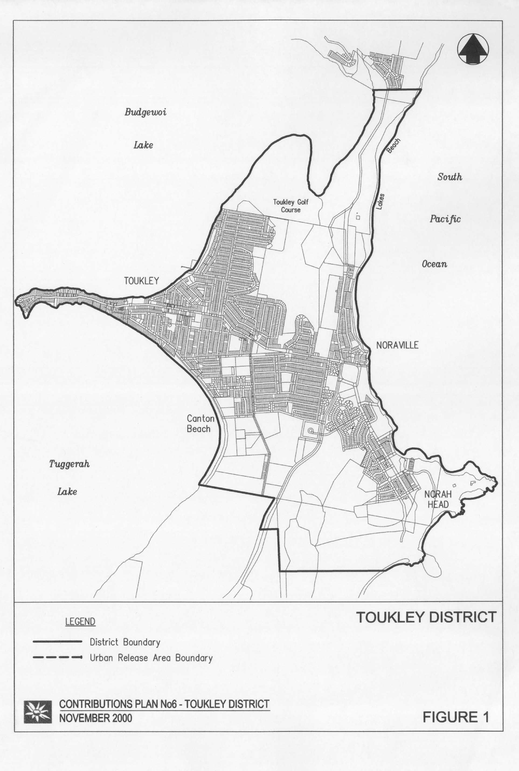

## 1.4 List of Abbreviations / Terms

**Committed Population** – That population which relates to existing development being considered within the Plan and to approved development.

**DU** (Dwelling Unit) – (see Section 2.1 for definition).

**District** – A District within the Wyong Shire Social Plan District (see Figure 1).

**Ha** (Hectares) – area used for contributions (see specific report detail for actual area included in calculation).

**Medium Density Development** – See Section 2.1 for definition.

**NDA** (Net Developable Area) – this is the total area of the residential lots within a land subdivision and is used to calculate contributions on an area basis.

**Secondary dwelling** means a self-contained dwelling that:

1. is established in conjunction with another dwelling (the **principal dwelling**), and
2. is on the same lot of land as the principal dwelling, and
3. is located within, or is attached to, or is separate from, the principal dwelling, and
4. has a total floor area (excluding any area used for parking) that does not exceed 60m2.

***Note:*** *As per definition in the draft Wyong Local Environmental Plan 2012.*

A secondary dwelling shall be assessed as 0.35 DU.

## 1.5 Complying Development and Obligation of Accredited Certifiers

In accordance with Section 94EC(1) of the EP&A Act:

1. Accredited certifiers must in issuing a complying development certificate impose a condition under Section 94 that requires the payment of monetary contributions calculated in accordance with this development contributions plan. The condition of consent shall also require the payment to be made prior to the commencement of works where building works are involved or prior to the commencement of use where no building works are involved.
2. This plan authorises accredited certifiers to impose such a condition. The condition must include a notation that the contribution amounts are indexed on a quarterly basis.
3. The amount of contributions and timing of payment shall be strictly in accordance with the provisions of this contributions plan.

It is the responsibility of accredited certifiers to:

* accurately calculate the quantum of contributions or alternatively seek advice and assistance directly from Council; and
* apply the Section 94 condition correctly.

## 1.6 Construction Certificates and Obligation of Accredited Certifiers

In accordance with Clause 146 of the EP&A Regulation, a certifying authority must not issue a construction certificate for building work or subdivision work under a development consent unless it has verified that each condition requiring the payment of monetary contributions has been satisfied.

In particular, the certifier must ensure that the applicant provides a receipt(s) confirming that contributions have been fully paid and copies of such receipts must be included with copies of the certified plans provided to the Council in accordance with clause 142(2) of the EP&A Regulation. Failure to follow this procedure may render such a certificate invalid.

The only exceptions to the requirement are where a works in kind or dedication of land has been agreed by Council. In such cases, Council will issue a letter confirming that an alternative payment method has been agreed with the developer.

## 1.7 Deferred and Periodic Payments

Council will generally not accept arrangements for the periodic payment of contributions required under this plan. Notwithstanding this position, an application for periodic payments may be made to Council, and Council after giving consideration to it may in extenuating circumstances accede to such a request subject to conditions that it considers appropriate. Such conditions may include the confirmation of the payment schedule via a legal agreement and the payment of fee.

Council will generally only consider permitting the deferred payment of contributions in accordance with its “Deferred Payment of Section 94 Contributions Policy” current at the time of application.

## 1.8 Summary of Contribution Rates

Contributions applicable at December 2001:

* Community Facilities Land $864 per DU
* Community Facilities Works $2,574 per DU
* Open Space Works $3,059 per DU
* Carparking (Toukley Commercial Centre) $9,330 per space
* Service Access (East Toukley Shopping Centre) $1,265 per space
* Drainage (James Rd) $1,765 per space

## 1.9 Estimated Costs

The following points should be noted in regard to cost estimates contained in this Plan:

* unless mentioned otherwise, cost details and contribution rates in this Plan are based on June 2001 values and will be increased periodically as detailed in Clause 12;
* where specific valuations are available, these values have been used;
* full details of the cost estimates for works are contained in the relevant technical reports.

## 1.10 Timing of Works

Council is not able to bankroll works required as a consequence of development proposed under this Plan and will only be able to provide works and services when sufficient funds have been provided by way of contributions.

Priority spending of contributions may, however, be directed to particular items identified in this Plan and this has been considered in formulating works schedules.

The provision of any item will be dependent on the threshold criteria established for the need for that item, and not necessarily the year shown in the Plan.

## 1.11 Works In Kind

Developer contributions made in accordance with this plan may be in the form of monetary payments, however alternative “in kind” contributions may be accepted if they deemed by Council to represent an “equivalent public benefit”. In the case of alternative payments being preferred, a developer is required to make prior written representations to Council at which time the proposal may be considered.

Council encourages developers to provide works in kind in lieu of making cash contributions provided prior agreement is reached with Council.

Offsetting of contributions will not be automatic. Applications will be considered on their merits. Water and Sewer contributions will not be offset against contributions determined in accordance with this plan. Nor will Council offset contributions against community facilities to the detriment of the incoming population.

Where the value of a particular work in kind exceeds the contribution due for that work, this excess value may (subject to Council's concurrence) form a credit to the developer which will be repaid upon uncommitted contribution funds becoming available. The value of a particular work will be the value assigned to it under this Contribution Plan.

It may be feasible to provide temporary measures to service initial stages of a development in lieu of constructing major works upfront. Such proposals will need to be assessed at the time of application and provision of such works will be the sole responsibility of the particular applicant, except where any part of them forms part of a work identified in this contribution plan (in which case that part will be treated as works in kind).

The cost of temporary works not recognised as works in kind cannot be offset against any other contributions required under this Plan.

## 1.12 Dedication of Land

Subject to prior agreement with Council land may be dedicated in lieu of making a contribution towards the acquisition of land and, in some cases, Council may require dedication of particular land as a condition of consent. Where the value of land dedicated exceeds the contribution due for provision of this particular type of land, this excess value may (subject to Council's concurrence) be offset against other contributions in a similar matter to works in kind.

## 1.13 Timing and Method of Payment

General practice in relation to the timing of payments for Section 94 contributions is as follows:

* development applications involving subdivision – at release of linen plans;
* development applications involving building works – at the time of construction certificate approval; and
* development applications where no building approval is required – at the time of development consent.

In regard to the latter case, the applicant may make a cash payment of contributions prior to issue of the development consent or alternatively lodge a suitable bank guarantee, also prior to issue of the consent. This bank guarantee will be called up upon commencement of the consent.

## 1.14 Method of Updating Contributions

Adjustments to the contribution rate will apply in accordance with the following:

### 1.14.1 Cost Indexation Adjustment

#### For Land Components

Adjustment will be by revaluation of land values using an actual site valuation or by use of the annual valuation review carried out by the Valuer General for Land Tax Office use.

#### For Works

The Construction Cost Index (CCI) will be used to adjust contribution rates as follows:

Current Rate = Old Rate x (Current CCI ÷ Base CCI)

Where:

The **Base CCI** is calculated as the most recently published quarterly figures for the Price Index of Materials in Building Other than House Building for Sydney prior to the date of estimating. (Source: ABS 6427.0 Table 19).

The **Current CCI** is calculated as the most recently published quarterly figures for the Price Index of Materials Used in Building Other than House Building for Sydney prior to the date of payment.

## 1.15 Revision of Plan

This Plan may be revised if the extent or nature of the proposed development varies and these variations lead to a change in the demand for public services and amenities.

Costings of works identified in this Plan are based on preliminary designs and changes to cost estimates as a result of detailed design may also necessitate a revision to this Plan.

Any revision of this Plan will be carried out in accordance with the provisions of Section 94.

Table 1 Plan Amendments

| **Adoption Date** | **Effective Date** | **Nature of Revision** |
| --- | --- | --- |
|  | October 1992 | No previous versions |
|  | September 1995 | Amended |
|  | December 2001 | Amended |
|  | 11 January 2007 | Amended |
| 24 July 2013 | 7 August 2013 | Insertion of specific clauses relating to complying development and deferred payment (and minor formatting changes) |
| 24 July 2013 | 18 September 2013 | Insertion of “Secondary Dwelling” clause |

## 1.16 Pooling of Funds

In accordance with Clause 27(3) of the Environmental Planning and Assessment Act Regulation, this clause authorises the pooling of funds by Council to provide priority works and land.

# 2 Urban Characteristics and Population

## 2.1 Population Predictions

The following table gives details of expected growth in resident population within the Toukley Social Plan District.

Table 2 Population Growth Projection for the Toukley District

| **Year** | **Projected Population** |
| --- | --- |
| 1996 | 8,734 |
| 1997 | 8,781 |
| 1998 | 8,827 |
| 1999 | 8,873 |
| 2000 | 8,920 |
| 2001 | 8,969 |
| 2002 | 9,020 |
| 2003 | 9,074 |
| 2004 | 9,132 |
| 2005 | 9,195 |
| 2006 | 9,264 |
| 2007 | 9,304 |
| 2008 | 9,346 |
| 2009 | 9,391 |
| 2010 | 9,438 |
| 2011 | 9,488 |

A summary of the remaining development potential is shown in Table 3.

Table 3 Remaining Development Potential

| **Year** | **Remaining DU** | **Medium Density** | **Total** |
| --- | --- | --- | --- |
| 2001 | 1 | 8 | 4 |
| 2002 | 1 | 8 | 4 |
| 2003 | 1 | 8 | 4 |
| 2004 | 1 | 8 | 4 |
| 2005 | 1 | 8 | 4 |
| 2006 | 1 | 8 | 4 |
| 2007 | 1 | 8 | 4 |
| 2008 | 1 | 8 | 4 |
| 2009 | 1 | 8 | 4 |
| 2010 | 1 | 8 | 4 |
| 2011 | 1 | 8 | 5 |
| **Total** | **11** | **86** | **97** |

The population is expected to increase by 568 people by 2011. Whilst 310 of these people are included in the remaining lots and future medium density development, the balance of 258 will be located on existing vacant and unoccupied properties.

***Notes:***

* *A Dwelling Unit (DU) is the basic unit used for planning purposes for this Plan and is defined as a dwelling with an occupancy rate of 3.2 persons. Where other than three bedroom dwellings are proposed, an equivalent number of dwelling units should be calculated and used as the basis for determining needs and contributions.*
* *For the purposes of this Plan, Medium Density Development is defined as development that leads to a demand on works or services greater than that which would be required by a single dwelling unit on each existing lot.*

# 3 Community Infrastructure and Contributions

## 3.1 Community Facilities

### 3.1.1 Introduction

This section considers the human service requirements generated as a result of the development in the area covered by this Plan.

### 3.1.2 Area of the Scheme

The assessment of human services requirements has been carried out for all of the Social Plan District shown in Figure 1.

### 3.1.3 Nexus and Apportionment of Cost

#### **General**

The approach to establishing human services requirements for this area has been:

* identify existing community facilities and associated land;
* identify requirements to service existing population, future single dwelling development on existing allotments for which no contribution can be sought and developments for which consent has already been issued;
* from the above, determine if there is any spare capacity for future development;
* determine the additional community facilities and land requirements, if any, needed to service the future development being considered.

#### **Guidelines**

A report has been prepared by the Strategic Planning Department to review the Strategic Social Planning Framework and Guidelines used by Council in the planning, provision and development of community facilities.

The report titled ‘Guidelines for the Planning and Provision of Community Facilities in Wyong Shire’ - May 2000 recommends the following amounts to be used as the basis for determining requirements for a basic level of provision:

* Land for Community Facilities: 7.2m² per DU
* Community Facilities Floor Space: 1.15m² per DU

This Plan is alsobased on Council's Social Plan (1992) with details specific to this area prepared by Council's Community Services Planner contained in Report No CF7‑1 (1992).

Assessment of existing services indicates there is no spare capacity in these facilities to meet the need generated by the future development considered in the plan. Therefore, additional community land and facilities will need to be provided to cater for the proposed population increase.

### 3.1.4 Determination of Community Facility Requirements

Community facility requirements for the area of this Plan are as follows:

#### **Land Requirements**

With an expected additional population of 310 (97 DU x 3.2), a total of 698 square metres of land is required.

Current contributions in hand and amounts committed in development consents issued prior to the preparation of this Plan will enable this floor space to be increased by an additional 1253 square metres making a total of 1951 square metres of floor space to be constructed.

#### **Community Facilities – All Areas within the District**

With an expected additional population of 310 (97 DU x 3.2), a total of 112 square metres of floor space is required.

Current contributions in hand and amounts committed in development consents issued prior to the preparation of this Plan will enable this floor space to be increased by an additional 173 square metres making a total of 285 square metres of floor space to be constructed.

### 3.1.5 Scheme Details

Council proposes to construct a community arts centre on the Heador/Ray Street Reserve.

### 3.1.6 Apportionment of Costs

Costs will be shared by all developments on a proportionalbasis.

### 3.1.7 Program for Works and Funding

#### **Land / Facilities**

The community arts centre is proposed to be constructed in 2008.

### 3.1.8 Contribution Rates

#### **Land Component**

The contribution rate will be calculated by dividing the total estimated costs as shown in Table C1 by the estimated number of dwelling units.

Cost = 698m² @ $120/m²

= $83,760

Contribution Rate = Cost ÷ No of DUs

= $83,760 ÷ 97 DU

= $864 per DU

#### **Works Component**

The contribution rate will be calculated by dividing the total estimated costs as shown in Table C1 by the estimated number of dwelling units.

Cost = 112m² @ $2,229/m²

= $249,648

Contribution Rate = Cost ÷ No of DUs

= $249,648 ÷ 97 DU

= $2,574 per DU

## 3.2 Public Open Space

### 3.2.1 Introduction

This section considers the open space requirements generated as a result of the development in the area of this Plan.

### 3.2.2 Area of the Scheme

The assessment of open space requirements has been carried out for all of the Social Plan District shown in Figure 1.

### 3.2.3 Proposed Development

The proposed development covers medium density development and the remaining lot potential which is predicted to provide an additional population of 310 (equivalent to 97 DU). Low density development (detached dwellings) in existing urban zones are not covered by this Plan.

### 3.2.4 General

The methodology adopted for this Plan is based on the Wyong Open Space Plan.

The approach to establishing requirements for this area has been:

* identify existing open space land and improvements;
* identify requirements to service existing population and future single dwelling development on existing allotments for which no contributions can be sought;
* determine land requirements, if any, needed for the future medium density development;
* determine embellishment requirements, if any, needed for the future medium density development.

### 3.2.5 Report Detail

This Plan is based on the Wyong Open Space Plan with details specific to this area prepared by Council's Landscape Planner, contained in Report No POS28‑1 (September 1992).

### 3.2.6 Determination of Open Space Requirements

The Wyong Open Space Plan requires a minimum provision of open space of 3.00 hectares per thousand people (as well as requirements relating to different types of open space, size, distribution, etc). For a population growth of 310 people, a minimum area of 0.93 hectares would be required.

The Wyong Open Space Principles Plan indicates a breakdown of total open space requirements into various categories as shown in Table 4.

Table 4 Breakdown of Open Space Requirements

| **Open Space Type** | **Notional Proportion (%)** | **Notional Area Required (Ha)** |
| --- | --- | --- |
| Parks, Fields and Cycleways | 75 | 0.69 |
| Courts | 5 | 0.05 |
| Semi Natural | 20 | 0.19 |
| **Total: Open Space** | **100** | **0.93** |

Open Space requirements for the area of this Plan are as follows.

**Land Requirements**

Assessment of existing open space land shows that there is an excess of land for the existing population and that there is no significant shortfall due to the requirements generated by the future development. Further, there is no concentrated location for this future development for which specific open space sites can be provided. Hence, there will be no requirements for land due to the proposed development.

**Embellishment**

While there is sufficient open space land within the area of the zone, the level of improvements is not sufficient to cater for the future development being considered. Accordingly, contributions towards embellishment of existing open space for this future development are reasonable.

Cost estimates for embellishment of various types of open space have been calculated as follows:

Courts $100 per square metre

Cycleways, Parks and Fields $33 per square metre

Semi Natural Areas $10 per square metre

These cost estimates have been applied to the area requirements in the table above to establish the contributions shown in Table S1.

### 3.2.7 Apportionment of Costs

Future development being considered is expected to be spread throughout the zone and so all development will be required to share the costs for open space embellishment on a proportional basis.

### 3.2.8 Program for Works and Funding

An indicative time for the provision of each improvement is shown in Table S1, although this may vary depending on the rate of development. The actual time for provision of the various improvements will be dictated by the following thresholds:

* Courts Improvements: to be provided when 25% of the future population is established.
* Embellishment of Semi-Natural Areas: to be provided when 25% of the future population is established.
* Embellishment of Cycleways, Parks and Fields: to be provided on completion of the future development.

### 3.2.9 Contribution Rates

The contribution rates will be calculated by dividing the total estimated costs as shown in the attached table by the estimated number of Dwelling Units as follows:

**Land Component**

Nil.

**Works (Embellishment) Component**

Contribution Rate = $296,700 ÷ 97

= $3,059 per DU

## 3.3 Carparking – Toukley Town Centre

### 3.3.1 Area Scheme

Development in the commercially zoned area of Toukley Town Centre (Figure 2) may require provision of public carparking where all parking is not provided on site by developments. This Plan establishes the basis for payment of contributions for provision of public parking provided in lieu of on site parking in Toukley Town Centre.

### 3.3.2 Nexus and Apportionment of Cost

As the quantity of parking required cannot be determined in advance of development, the approach to identifying and apportioning costs for parking has been:

* identify land which may be acquired for parking on the fringe of the commercial area or adjacent to existing parking facilities in accordance with Council's parking development strategy;
* identify a land cost per parking space based on 30 square metres of land per space for parking circulation and landscaping;
* where a range of values exist for fringe land it is assumed that cheaper land will be acquired in preference to more expensive land by a ratio of 3:1;
* allow $2,730 per space for construction.

### 3.3.3 Program for Works and Funding

Land acquisition for parking will be undertaken when sufficient funds are available from development and within a reasonable time of receipt of contributions, generally being for a minimum 20 space parking area.

Construction of the parking area will follow immediately after land acquisition.

### 3.3.4 Contribution Rate

The contribution rate will be calculated based on the average value per square metre for fringe land (including acquisition on costs of 10%) and a construction cost of $2,730 per space:

Contribution Rate = $220 x 30 + $2,730

= $9,330 per space

Figure 2 Carparking – Toukley Town Centre

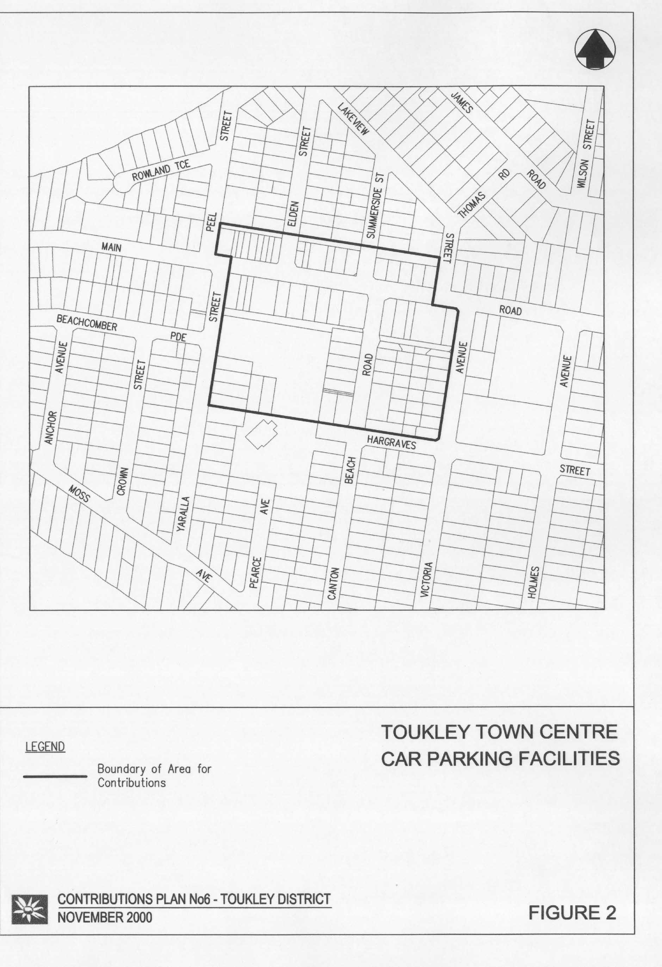

## 3.4 Service Access – Ray Street to Heador Street, East Toukley

### 3.4.1 Area of the Scheme

Commercial development on land zoned 3(c) Neighbourhood Business south of Main Road between Heador and Ray Streets (Lots 87-93 DP 20482) (Figure 3) is to be serviced by a rear laneway and carparking area. This scheme provides for contributions for construction of the parking spaces.

### 3.4.2 Scheme Details

The works are described as follows, with further details shown in Table 5: carparking area for 28 cars.

Table 5 Schedule of Works, Estimates and Program

| **Description** | **Cost ($)** | **Year** |
| --- | --- | --- |
| 28 space carpark construction | 35,410 | June 2011 |

### 3.4.3 Nexus and Apportionment of Costs

Where development or redevelopment occurs on Lots 87-93 DP 20482 and parking requirements cannot be satisfied on site, up to three spaces per lot may be provided by contribution to the proposed carpark. The maximum three spaces are already committed for Lot 91. Costs will be apportioned per space up to the maximum of 18 spaces available for the remaining six lots.

### 3.4.4 Report Detail

The investigation was completed by Council's Design Section with a Technical Report No 428 dated July 1992. See Plan No 9182 for detail design information.

### 3.4.5 Program for Works and Funding

Where possible, construction of parking will be co-ordinated with construction of the laneway by individual developers and within a reasonable time of receipt of contributions.

### 3.4.6 Contribution Rate

The contribution rate for carparking will be calculated by dividing the total cost of construction by the number of spaces:

Contribution Rate = $35,410 ÷ 28

= $1,265 per space

Figure 3 Service Access – Ray Street to Heador Street, East Toukley

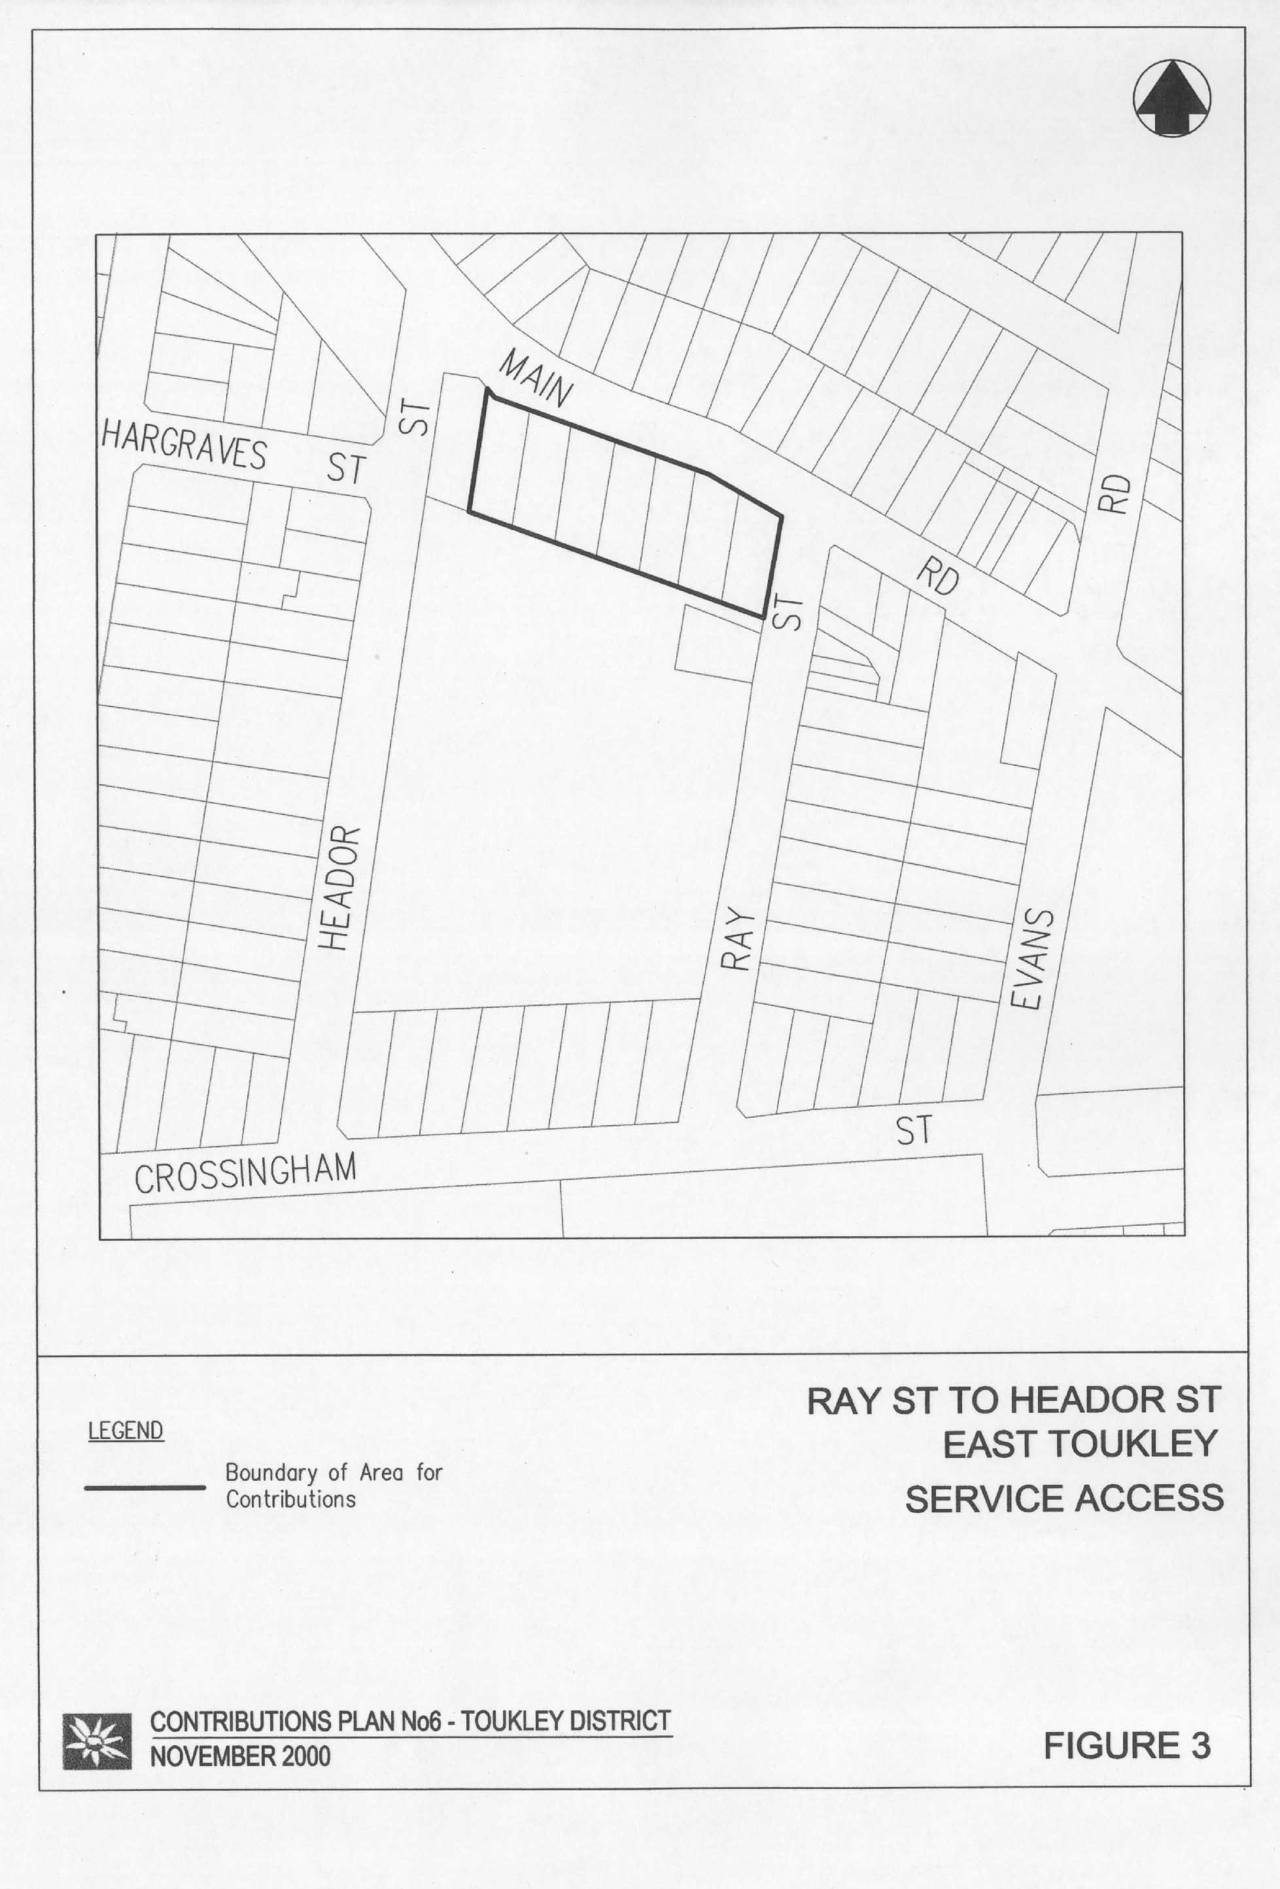

## 3.5 Drainage – James Road, Toukley

### 3.5.1 Area of the Scheme

The area of the scheme includes Lots 33 to 40 DP 21761 James Road as shown in Figure 4.

### 3.5.2 Report Detail

The drainage requirements are based on a report dated August 30 1993.

### 3.5.3 Scheme Details

The proposed works are described as follows with further details in Table D1: drainage line from the rear of Lots 33 to 40 extending into Wilson Street.

### 3.5.4 Apportionment of Costs

Apportionment of costs will be based on drainage catchment. However, as the lots within the drainage scheme are of a similar size, contribution rates will be calculated on a dwelling unit basis.

### 3.5.6 Program for Works and Funding

The works have been completed in 1993 in conjunction with the first development in this area.

### 3.5.7 Contribution Rate

The contribution rate will be calculated by dividing the total cost of the drainage works by the number of lots:

Contribution Rate = Cost ÷ No of Lots

= $14,124 ÷ 8

= $1,765 per DU

Figure 4 Drainage – James Road, Toukley

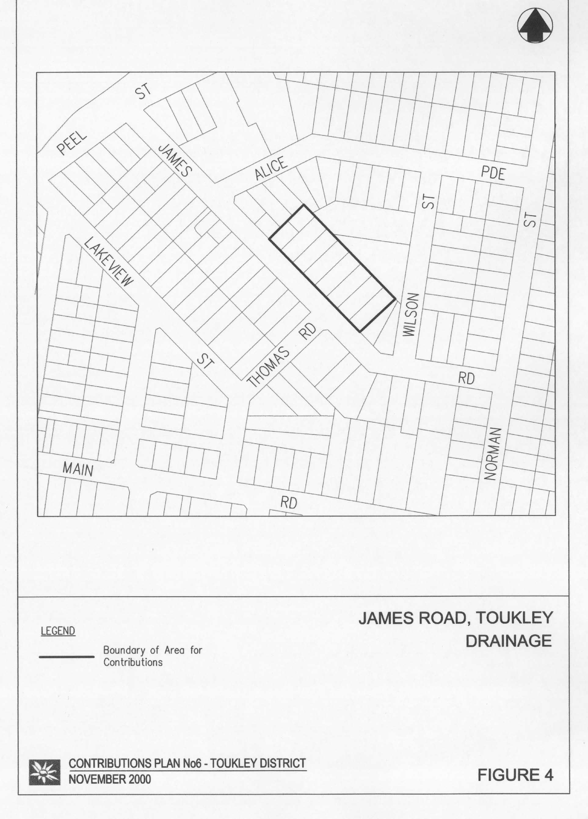

# Appendix A Schedule of Works

Schedule of Works:  Community Facilities Land – Toukley DistrictTable C1 Schedule of Works: Community Facilities Land – Toukley District

Table C2 Schedule of Works: Community Facilities Works – Toukley District

Table C2

Table D1 Schedule of Works: Drainage – James Road

Table D1

Table D1 continuedTable D1 Schedule of Works: Service Access – East Toukley

Table S1 Schedule of Works: Open Space Works – Toukley DistrictTable S1