Wyong District
Development Contributions Plan No 1

October 2014

Contents
1 Administration and Operation of this Plan 6
1.1 Introduction 6
1.2 Relationship to Other Plans 6
1.3 Area of the Plan 6
1.4 List of Abbreviations / Terms 7
1.5 Complying Development and Obligation of Accredited Certifiers 7
1.6 Construction Certificates and Obligation of Accredited Certifiers 8
1.7 Deferred and Periodic Payments 8
1.8 Current Contribution Rates – Wyong District 8
1.9 Estimated Costs 11
1.10 Timing of Works 11
1.11 Works In Kind and Material Public Benefit 11
1.12 Dedication of Land 12
1.13 Timing and Method of Payment 12
1.14 Method of Increasing Contributions 12
1.15 Revision of Plan 13
1.16 Pooling of Funds 13
2 Urban Characteristics and Population 14
2.1 Population Predictions 14
3 Community Infrastructure and Contributions 16
3.1 Community Facilities 16
3.1.1 Introduction 16
3.1.2 General 16
3.1.3 Guidelines 16
3.1.4 Area of the Scheme 17
3.1.5 Zone 1: Mardi Urban Release Area 17
3.1.6 Zone 2: Watanobbi and West Wyong Urban Release Areas 20
3.1.7 Zone 3: Remaining Area of the District 23
3.2 Public Open Space 26
3.2.1 Introduction 26
3.2.2 General 26
3.2.3 Area of the Scheme 26
3.2.4 Zone 1: The Mardi Urban Release Area 26
3.2.5 Zone 2: The Mardi South Urban Release Area 30
3.2.6 Zone 3: Watanobbi Urban Release Area 34
3.2.7 Zone 4: West Wyong Urban Release Area 36
3.2.8 Zone 5: Remaining Area of the District 38
3.3 Carparking – Wyong Town Centre 40
3.3.1 Area of Scheme 40
3.3.2 Nexus and Apportionment of Cost 40
3.3.3 Program for Works and Funding 40
3.3.4 Contribution Rate 40
3.4 Local Roads and Intersections 42
3.4.1 Introduction 42
3.4.2 General 42
3.4.3 Area of the Scheme 42
3.4.4 Zone 1: Mardi Urban Release Area (Westfield Area) 43
3.4.5 Zone 2: Watanobbi Urban Release Area 46
3.4.6 Zone 3: West Wyong Urban Release Area 47
3.4.7 Zone 4: Hue Hue Road Area 49
3.4.8 Zone 5: Leewood Close Area, Yarramalong 52
3.4.9 Zone 6: Mardi South Urban Release Area 54
3.4.10 Zone 7: Wyong Road and Bryant Drive and Pacific Highway, Wyong Road and Cobbs Road 56
3.4.11 Zone 8: Tuggerah Industrial Estate Stage 3 – Roadworks 59
3.5 Drainage 62
3.5.1 Mardi Creek Drainage 62
10.4.2 Tuggerah Industrial Estate Stage 3 Drainage 67
3.6 Planning Studies 72
3.6.1 Introduction 72
3.6.2 Area of Scheme 72
3.6.3 Scheme Details 72
3.6.4 Appointment of Costs 72
3.6.5 Program of Works 72
3.6.6 Contribution Rate 72
Appendix A Schedule of Works 73

Tables

Table 1 Plan Amendments 13
Table 2 Population Growth Projections for Wyong District Urban Release Area 14
Table 3 Population and Dwelling Unit Data for Wyong District 14
Table 4 Categories of Open Space 28
Table 5 Categories of Open Space 38
Table 6 Summary of Costs – Construction of Road Works 59
Table 7 Total Area of Land to be Developed 59
Table 8 Value of Works in each Segment 66
Table 9 Segment A 66
Table 10 Segment B 66
Table 11 Segment C 67
Table 12 Segment D 67
Table 13 Segment E 67
Table 14 Trunk Drainage and Water Quality Facilities – Summary of Costs 70
Table R1 Schedule of Works: Roads and Intersections – Mardi 73
Table R2 Schedule of Works: Roads & Intersections - Watanobbi 74
Table R3 Schedule of Works: Roads & Intersections - West Wyong 75
Table R5 Schedule of Works: Roads & Intersections - Leewood Close 77
Table R6 Schedule of Works: Roads & Intersections - Mardi South 78
Table R6 Schedule of Works: Roads & Intersections - Wyong Road / Bryant Drive 79
Table R6 Schedule of Works: Roads & Intersections - Tuggerah Industrial Area Stage 3 80
Table C1A Schedule of Works: Community Facilities – Mardi 81
Table C1B Schedule of Works: Community Facilities Land - Mardi 82
Table C2A Schedule of Works: Community Facilities Works - Watanobbi & West Wyong 83
Table C2B Schedule of Works: Community Facilities Land - Watanobbi & West Wyong 84
Table C3A Schedule of Works: Community Facilities Works - Remainder of District 85
Table C3B Schedule of Works: Community Facilities Land - Remainder of District 86
Table S1A Schedule of Works: Open Space Works - Mardi URA 87
Table S1B Schedule of Works: Open Space Land - Mardi URA 88
Table S2A Schedule of Works: Open Space Works - Mardi South 89
Table S2B Schedule of Works:Open Space Land - Mardi South 90
Table S3A Schedule of Works: Open Space Works – Watanobbi 91
Table S3B Schedule of Works: Open Space Land - Watanobbi 92
Table S4A Schedule of Works: Open Space Works - West Wyong 93
Table S4B Schedule of Works: Open Space Land - West Wyong 94
Table S5 Schedule of Works:Open Space Works - Remainder of District 95
Table D1 Schedule of Works: Drainage - Mardi Creek 96
Table P1 Schedule of Works: Planning Studies - Mardi URA 97
Table P1 Schedule of Works: Drainage Tuggerah Stage 3 98

Figures

Figure 1 Wyong Shire Social Planning Districts 9
Figure 2 Wyong District Contributions Plan Area 10
Figure 3 Community Facilities – Mardi and Mardi South Urban Release Area 19
Figure 4 Community Facilities – West Wyong / Watanobbi Urban Release Area 22
Figure 5 Public Open Space – Mardi and Mardi South Urban Release Area 27
Figure 6 Public Open Space – West Wyong / Watanobbi Urban Release Area 32
Figure 7 Carparking Facilities – Wyong Town Centre 41
Figure 8 Roads and Intersections – Mardi Urban Release Area 44
Figure 9 Roads and Intersections – West Wyong / Watanobbi Urban Release Area 47
Figure 10 Roads and Intersections – Hue Hue Road Rural Residential Release Area 51
Figure 11 Roads and Intersections – Leewood Close, Yarramalong 53
Figure 12 Roads and Intersections – Mardi South Urban Release Area 55
Figure 13 Roads and Intersections – Wyong Road / Bryant Drive / Pacific Highway and Wyong Road / Cobbs Road 58
Figure 14 Road Construction – Bryant Drive / Lake Road 60
Figure 15 Drainage – Part Precinct 16, Tuggerah 63
Figure 16 Drainage and Water Quality – Tuggerah Industrial Estate 69

1 Administration and Operation of this Plan

1.1 Introduction

The purpose of this Contributions Plan is to determine the contribution rates and means of providing the following public services and amenities necessary as a consequence of proposed development within the Wyong District and part of the Rural West area.

- Roads and Intersections
- Community Facilities
- Public Open Space
- Drainage and Water Quality
- Carparking
- Planning Studies
Contributions from the proposed development will not be used to address any backlog in the provision of works and services for the existing population, for development which has already obtained development consent at the date of preparation of this Plan, or for development not requiring consent.

This Plan has been prepared in accordance with the requirements of Section 94 of the Environmental Planning and Assessment Act.

1.2 Relationship to Other Plans

This Plan should be read in conjunction with Wyong Local Environmental Plan 1991, relevant Development Control Plans and Council's Codes and Policies.

This Plan replaces any requirements and details related to Section 94 Contributions that exists within any Development Control Plan previously prepared by Council for this area.

This Plan takes precedence over any of Council's Codes and Policies where there are any inconsistencies in relation to Section 94 Contributions.

1.3 Area of the Plan

This Plan covers the following:

1 All of the Wyong Social Plan District as shown in Figure 2 and includes:
- Medium density development within the Wyong area
- New Urban Release Area at Mardi
- A new commercial/retail area at Mardi
- A new Urban Release Area at Watanobbi
- A new Urban Release Area at West Wyong
- Tuggerah Industrial Area Stage 3
2 Two specific areas within the Rural West District:
- Rural residential development in the area of Hue Hue Road
- Urban development at Leewood Close, Yarramalong

1.4 List of Abbreviations / Terms

DU (Dwelling Unit) – see Section 2.1 for definition.

Ha (Hectares) – area used for contributions (see specific report detail for actual area included in calculation).

District – a District within the Wyong Shire Social Plan District (see Figures 1 and 2).

Medium Density Development – see Section 2.1 for definition.

Committed Population – that population which relates to existing development being considered within the Plan and to approved development.

NDA (Net Developable Area – this is the total area of the residential lots within a land subdivision and is used to calculate contributions on an area basis. When referring to the drainage and water quality scheme for the Tuggerah Industrial Site 3 area, NDA refers to the total site area of land being developed

Secondary dwelling means a self-contained dwelling that:

- is established in conjunction with another dwelling (the principal dwelling), and
- is on the same lot of land as the principal dwelling, and
- is located within, or is attached to, or is separate from, the principal dwelling, and
- has a total floor area (excluding any area used for parking) that does not exceed 60m².
Note: As per definition in the draft Wyong Local Environmental Plan 2012.

A secondary dwelling shall be assessed as 0.35 DU.

1.5 Complying Development and Obligation of Accredited Certifiers

In accordance with Section 94EC(1) of the EP&A Act:

- Accredited certifiers must in issuing a complying development certificate impose a condition under Section 94 that requires the payment of monetary contributions calculated in accordance with this development contributions plan. The condition of consent shall also require the payment to be made prior to the commencement of works where building works are involved or prior to the commencement of use where no building works are involved.
- This plan authorises accredited certifiers to impose such a condition. The condition must include a notation that the contribution amounts are indexed on a quarterly basis.
- The amount of contributions and timing of payment shall be strictly in accordance with the provisions of this contributions plan.

It is the responsibility of accredited certifiers to:

- accurately calculate the quantum of contributions or alternatively seek advice and assistance directly from Council; and
- apply the Section 94 condition correctly.

1.6 Construction Certificates and Obligation of Accredited Certifiers

In accordance with Clause 146 of the EP&A Regulation, a certifying authority must not issue a construction certificate for building work or subdivision work under a development consent unless it has verified that each condition requiring the payment of monetary contributions has been satisfied.

In particular, the certifier must ensure that the applicant provides a receipt(s) confirming that contributions have been fully paid and copies of such receipts must be included with copies of the certified plans provided to the Council in accordance with clause 142(2) of the EP&A Regulation. Failure to follow this procedure may render such a certificate invalid.

The only exceptions to the requirement are where a works in kind or dedication of land has been agreed by Council. In such cases, Council will issue a letter confirming that an alternative payment method has been agreed with the developer.

1.7 Deferred and Periodic Payments

Council will generally not accept arrangements for the periodic payment of contributions required under this plan. Notwithstanding this position, an application for periodic payments may be made to Council, and Council after giving consideration to it may in extenuating circumstances accede to such a request subject to conditions that it considers appropriate. Such conditions may include the confirmation of the payment schedule via a legal agreement and the payment of fee.

Council will generally only consider permitting the deferred payment of contributions in accordance with its “Deferred Payment of Section 94 Contributions Policy” current at the time of application.

1.8 Current Contribution Rates – Wyong District

The contribution rates contained within this plan are the "base" rates for the plan. Details of current indexed rates may be obtained from Council.

Figure 1 Wyong Shire Social Planning Districts
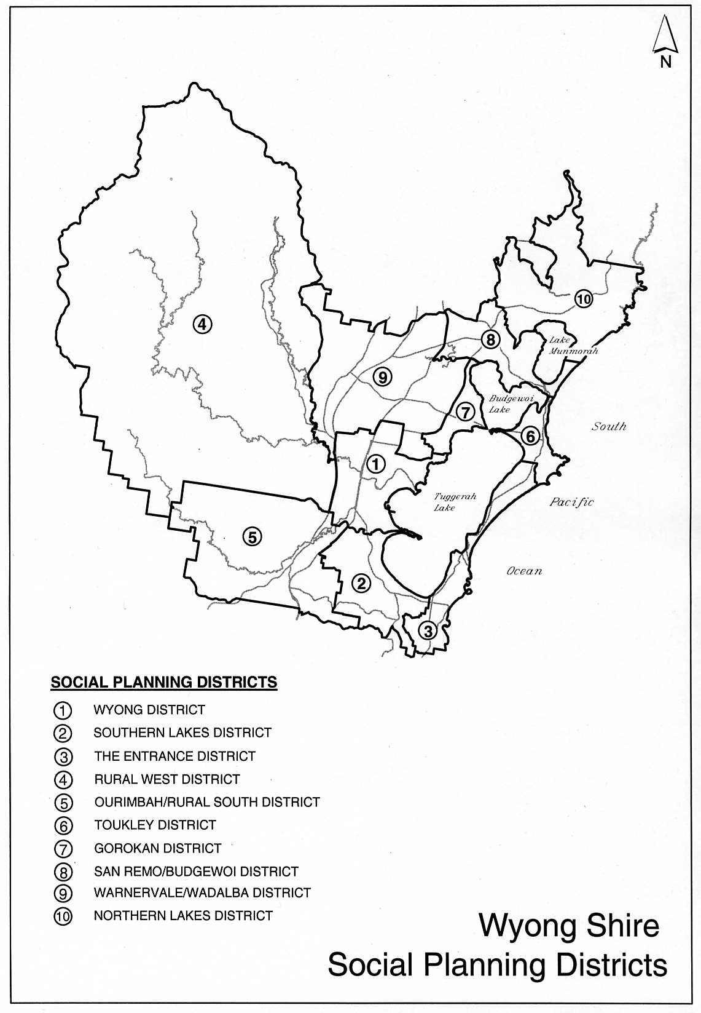
Figure 2 Wyong District Contributions Plan Area

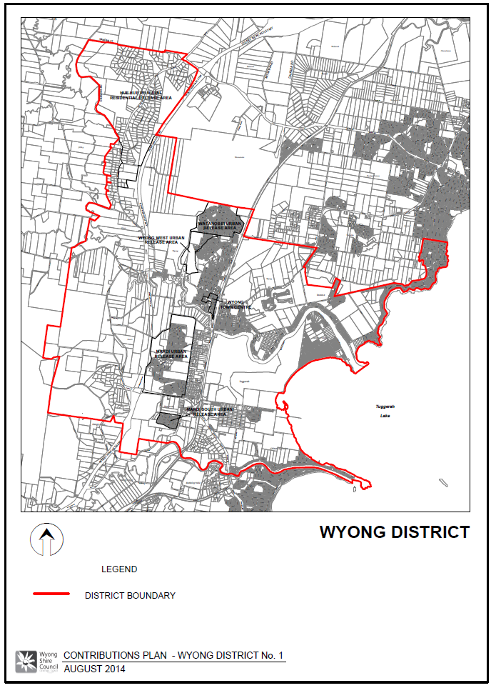

1.9 Estimated Costs

The following points should be noted in regard to cost estimates contained in this Plan:

- Unless otherwise stated, cost details and contribution rates in this Plan are based on June 2002 values and will be adjusted periodically as detailed in Clause 12.
- Estimated costs for land components are based on:
Existing serviced land: $180/square metre
Englobo land: $20/square metre
- Where specific valuations are available, these values have been used.
- Full details of the cost estimates for works are contained in the relevant technical reports.

1.10 Timing of Works

Council is not able to bankroll works required as a consequence of development proposed under this Plan and will only be able to provide works and services when sufficient funds have been provided by way of contributions.

Priority spending of contributions may, however, be directed to particular items identified in this Plan and this has been considered in formulating works schedules.

In relation to the provision of any Plan requirements, the years shown in the Plan are indicative only. The provision of any item will be dependent on the threshold criteria established for the need for that item, and not necessarily the year shown in the Plan.

1.11 Works In Kind and Material Public Benefit

Developer contributions made in accordance with this plan will usually be in the form of monetary payments, however alternative "in kind" contributions may be accepted if they are deemed by Council to represent an "equivalent material public benefit". In the case of alternative payments being proffered, a developer is required to make prior written representations to Council at which time the proposal may be considered.

Where the value of a particular work exceeds the contributions due for that work, this excess value may (subject to Council's concurrence) be offset against other contributions due under this plan. This offset can only be applied where the funds are not required immediately to construct works to service the initial development, but can be delayed to a later stage when further development proceeds.

Alternatively, a credit may be granted to the developer which will be repaid upon uncommitted contribution funds becoming available.

The value of a particular work or land will be the value assigned to it under this contribution plan.

It may be feasible to provide temporary measures to service initial stages of a development in lieu of constructing major works upfront. Such proposals will need to be assessed at the time of application and provision of such works will be the sole responsibility of the particular applicant, except where any works form part of the final works identified in this contribution plan (in which case that part will be treated as works-in-kind).

The cost of any temporary works not recognised as works in kind cannot be offset against any other contributions required under this plan.

1.12 Dedication of Land

Subject to prior agreement with Council, land may be dedicated in lieu of making a contribution towards the acquisition of land and in some cases, where the value of land dedicated exceeds the contribution due for provision of this particular type of land, this excess value may (subject to Council's concurrence) be offset against other contributions in a similar manner to work in kind.

Council will only accept land dedication where that land is of a suitable nature for the purpose for which it is being dedicated. All land to be transferred to Council is to be free of any improvements, structures or other impediments which would restrict or hinder its future use or development for the purposes for which it is being acquired, unless otherwise agreed by Council. The land is also to be transferred in an appropriate state, free of any refuse, contamination, or the like, unless otherwise agreed by Council.

1.13 Timing and Method of Payment

General practice in relation to the timing of payments for Section 94 contributions is as follows:

- development applications involving subdivision prior to issue of a subdivision certificate at release of linen plans;
- development applications involving building works prior to the issue of a construction certificate; and
- development applications where no building approval is required at the time of development consent.
In regard to the latter case, the applicant may make a cash payment of contributions prior to issue of the development consent or alternatively lodge a suitable bank guarantee, also prior to issue of the consent. This bank guarantee will be called up upon commencement of the consent.

1.14 Method of Increasing Contributions

Increases to the contribution rate will apply in accordance with the following:

Cost Indexation Increase

For works, the Construction Cost Index (CCI) will be used to increase contribution rates as follows:

Current Rate = Old Rate x (Current CCI ÷ Base CCI)

Where:

The Base CCI is calculated as the most recently published quarterly figure for the Price Index of Materials in Building Other than House Building for Sydney prior to the date of estimating. (Source: ABS 6427.0 Table 19).

The Current CCI is calculated as the most recently published quarterly figure for the Price Index of Materials Used in Building Other than House Building for Sydney prior to the date of payment.

1.15 Revision of Plan

This Plan may be revised if the extent or nature of the proposed development varies and these variations lead to a change in the demand for public services and amenities.

Costings of works identified in this Plan are based on preliminary designs and changes to cost estimates as a result of detailed design may also necessitate a revision to this Plan.

Any revision of this Plan will be carried out in accordance with the provisions of Section 94.

Table 1 Plan Amendments

Adoption Date | Effective Date | Nature of Revision
 | September 1995 | Amended
 | October 1997 | Amended
 | August 1998 | Amended
 | February 2000 | Amended
 | August 2001 | Amended
 | March 2004 | Amended
 | 11 January 2007 | Amended
24 July 2013 | 7 August 2013 | Insertion of specific clauses relating to complying development and deferred payment (and minor formatting changes)
24 July 2013 | 18 September 2013 | Insertion of “Secondary Dwelling” clause
27 August 2014 | 29 October 2014 | Inclusion of rural area within Wyong District catchment, and removal of areas included in other plans

1.16 Pooling of Funds

In accordance with Clause 27(3) of the Environmental Planning and Assessment Act Regulation, this clause authorises the pooling of funds by Council to provide priority works and land.

2 Urban Characteristics and Population

2.1 Population Predictions

The following table gives details of expected growth in resident population within the Wyong District:

Table 2 Population Growth Projections for Wyong District Urban Release Area

Year | Mardi | Mardi South | Watanobbi | West Wyong | Medium Density | Total
2002 | 3,210 | 787 | 2,762 | 0 | 202 | 6,961
2003 | 78 | 0 | 0 | 0 | 52 | 130
2004 | 78 | 0 | 0 | 0 | 52 | 130
2005 | 78 | 0 | 0 | 183 | 52 | 313
2006 | 79 | 0 | 0 | 183 | 52 | 314
2007 | 0 | 0 | 0 | 183 | 52 | 235
2008 | 0 | 0 | 0 | 183 | 52 | 235
2009 | 0 | 0 | 0 | 183 | 52 | 235
2010 | 0 | 0 | 0 | 0 | 52 | 52
2011 | 0 | 0 | 0 | 0 | 0 | 0
2012 | 0 | 0 | 0 | 0 | 0 | 0
TOTAL | 3,523 | 787 | 2,762 | 915 | 615 | 8,603

A number of development consents have already been issued in the new release areas and the population figures for these consents have generally been excluded in determining contributions under this Plan. However, expenditure of the contributions made under these consents has been included in work schedules. A summary of committed and remaining development potential is shown in the following table.

Table 3 Population and Dwelling Unit Data for Wyong District

Area | Population |  |  | Dwelling Units
 | Committed | Remaining | Total | Committed | Remaining | Total
Medium Density | 202 | 413 | 615 | 85 | 178 | 263
Urban Release Areas
Mardi* | 3,210 | 314 | 3,524 | 1003 | 101 | 1104
Mardi South | 787 | 0 | 787 | 246 | 0 | 246
Watanobbi | 2,762 | 0 | 2,762 | 863 | 0 | 863
West Wyong | 0 | 915 | 915 | 0 | 286 | 286
TOTAL | 6,961 | 1,642 | 8,603 | 2,197 | 565 | 2,762

* Mardi URA includes rezoning of Lot 622 DP 877750 Woodbury Park Drive

Notes:
- A Dwelling Unit (DU) is the basic unit used for planning purposes for this Plan and is defined as a dwelling with an occupancy rate of 3.2 persons. Where other than three bedroom dwellings are proposed, an equivalent number of dwelling units will be calculated and used as the basis for determining needs and contributions. This will be calculated in accordance with Council's Policy.
- For the purposes of this Plan, Medium Density Development is defined as development that leads to a demand on works or services greater than that which would be required by a single dwelling unit on each existing lot (eg. dual occupancies, land subdivision, residential flat development, etc).

3 Community Infrastructure and Contributions

3.1 Community Facilities

3.1.1 Introduction

This section considers the human service requirements generated as a result of the development in the area of this Plan.

3.1.2 General

The approach to establishing human services requirements for this area has been:

- identify existing community facilities and associated land;
- identify requirements to service existing population, future single dwelling development on existing allotments for which no contribution can be sought and developments for which consent has already been issued;
- from the above, determine if there is any spare capacity for future development;
- determine the additional community facilities and land requirements, if any, needed to service the future development being considered.

3.1.3 Guidelines

A report has been prepared by the Strategic Planning Department to review the Strategic Social Planning Framework and Guidelines used by Council in the planning, provision and development of community facilities.

The report titled ‘Guidelines for the Planning and Provision of Community Facilities in Wyong Shire’ - May 2000 (amended in July 2002) recommends the following amounts to be used as the basis for determining requirements for a basic level of provision:

- Land for Community Facilities: 5.6m² per DU
- Community Facilities Floor Space: 0.9m² per DU
This Plan is also based on Council's Social Plan (1984) with details specific to this area prepared by Council's Community Services Planner contained in Report No CF16 (1992).

Assessment of existing services indicates there is no spare capacity in these facilities to meet the need generated by the future development considered in the Plan. Therefore, additional community land and facilities will need to be provided to cater for the proposed population increase.

3.1.4 Area of the Scheme

For the purposes of Community Services planning this District has been divided into zones as follows:

- Zone 1: Mardi Urban Release Area;
- Zone 2: West Wyong and Watanobbi Urban Release Area;
- Zone 3: remaining area of the District.
For the purposes of determination of community facility requirements for development covered by this Plan, the following have been excluded:

- existing development;
- single dwelling development on existing residential lots; and
- developments for which consent has already been issued.
Population details are shown in Table 3.

3.1.5 Zone 1: Mardi Urban Release Area

Report Details

This Plan is also based on Council's Social Plan (1992) with details specific to this area prepared by Council's Community Services Planner contained in Report No CF3-1.

Assessment of existing services indicates there is no spare capacity in these facilities to meet the need generated by the future development considered in this zone. Therefore, additional community land and facilities will need to be provided to cater for the proposed population increase.

Figure 3 shows the area of this zone.

Determination of Community Facility Requirements

The projected number of additional DUs in the area of the Plan is 101 generated from a total additional population of 314.

Community facility requirements for this zone are as follows:

Land Requirements

For an additional 101 DU within the Urban Release Area; the land requirement is 564 square metres.

Current contributions in hand and amounts committed in development consents issued prior to preparation of this Plan will enable this area to be increased by 5,071 square metres making a total of 5,635 square metres of community land to be provided.

Community Facilities

For an additional 101 DU, a total of 91 square metres of floor space is required.

Current contributions in hand and amounts committed in development consents issued prior to preparation of this Plan will enable this floor space to be increased by an additional 106 square metres making a total of 196 square metres of floor space to be constructed.

Scheme Details

A total of 196 square metres of additional community facilities floor space is to be provided in accordance with needs identified within Council's Community Plan, and through ongoing community consultation.

Facilities are to be provided within the Social Planning District or to specifically meet the demands generated within the District. Community facility floor space will be utilised to provide Multi-purpose Community Centres incorporating such facilities such as neighbourhood centres, youth centres, senior citizens facilities, libraries and the like.

The timing of the provision of the floor space will generally be driven by the rate of future development in the locality and the demand generated by such.

Further details including costs are shown in Table C1.

Apportionment of Costs

Costs will be shared by all developments on a population basis with contribution rates being calculated on a per dwelling unit, or equivalent, basis.

Program for Works and Funding

Land

Table C1 shows an indicative time for land acquisition but the actual time will vary depending on the rate of development.

Facilities

An indicative time for the provision of each facility is shown in Table C1 although this may vary depending on the rate of development. The actual time for provision of the various facilities will be dictated by the following thresholds:

Community facility floor space to be provided at intervals of 30%, 65% and 100% of development.

Figure 3 Community Facilities – Mardi and Mardi South Urban Release Area

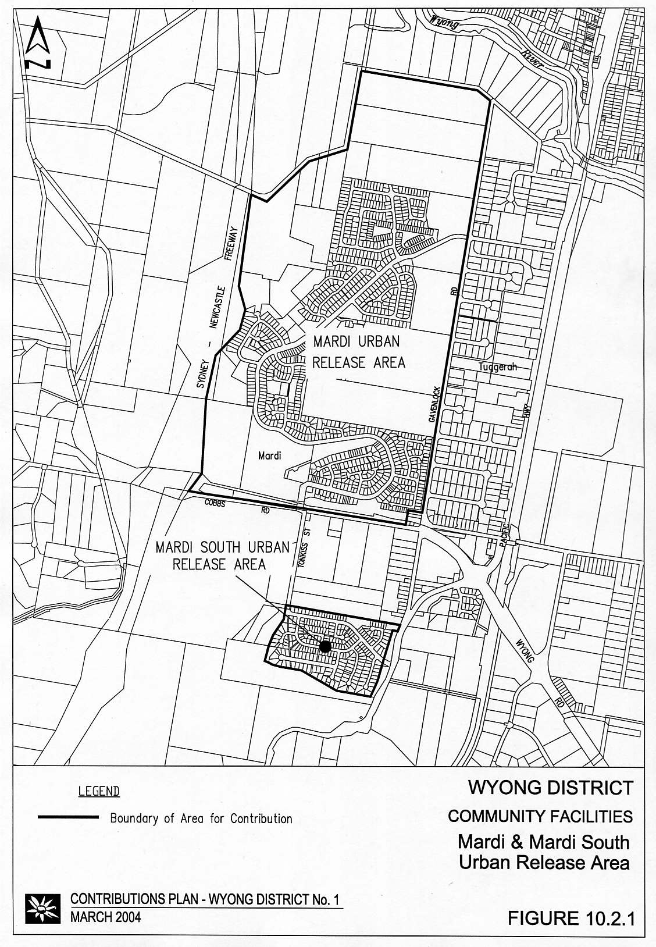
Contribution Rates

The contribution rate will be calculated by dividing the total estimated costs by the estimated number of dwelling units.

Land Component

Cost = 564m² @ $20/m²
= $11,281

Contribution Rate = Cost ÷ No of NDAs
= $11,281 ÷ 3.2 NDA
= $3,525 per NDA

Works Component

Cost = 91m² @ $2,793/m²
= $254,163

Contribution Rate = Cost ÷ No of DUs
= $254,163 ÷ 101
= $2,516 per DU

3.1.6 Zone 2: Watanobbi and West Wyong Urban Release Areas

Report Details

This Plan is based on Council's Social Plan (1992) with details specific to this area prepared by Council's Community Services Planner contained in Report No CF3-2).

Assessment of existing services indicates there is no spare capacity in these facilities to meet the need generated by the future development considered in the Plan. Therefore, additional community land and facilities will need to be provided to cater for the proposed population increase.

Figure 4 shows the area of this zone.

Determination of Community Facility Requirements

The projected number of additional DUs in the area of the Plan is 286 generated from a total additional population of 915

Community facility requirements for the area of this Plan are as follows:

Land Requirements

For a total of 286 DU within the Urban Release Area; the land requirement is 1,602 square metres.

Current contributions in hand and amounts committed in development consents issued prior to preparation of this Plan will enable this area to be increased by an additional 3,504 square metres making a total of 5,106 square metres of community land to be provided.
Community Facilities

For a total of 286 DU, a total of 257 square metres of floor space is required.

Current contributions in hand and amounts committed in development consents issued prior to preparation of this Plan will enable this floor space to be increased by an additional 87 square metres making a total of 344 square metres of floor space to be constructed.

Scheme Details

A total of 344 square metres of community facilities floor space is to be provided in accordance with needs identified within Council's Community Plan, and through ongoing community consultation.

Facilities are to be provided within the Social Planning District. Community facility floor space will be utilised to provide Multi-purpose Community Centres incorporating such facilities such as childcare, neighbourhood centres, youth centres, senior citizens facilities and the like.

The timing of the provision of the floor space will generally be driven by the rate of future development in the locality and the demand generated by such.

Further details including costs are shown in Table C2.

Apportionment of Costs

Costs will be shared by all developments on a population basis with contribution rates being calculated on a per dwelling unit, or equivalent, basis.

Program for Works and Funding

Land

Table C2 shows acquisition of land in 1994/95 but actual time will depend on rate of development as later developments will be required to dedicate land.

Facilities

An indicative time for the provision of each facility is shown in Table C2 although this may vary depending on the rate of development. The actual time for provision of the various facilities will be dictated by the following thresholds:

Community facility floor space to be provided at intervals of 65%, 75% and 100% of development.

Figure 4 Community Facilities – West Wyong / Watanobbi Urban Release Area
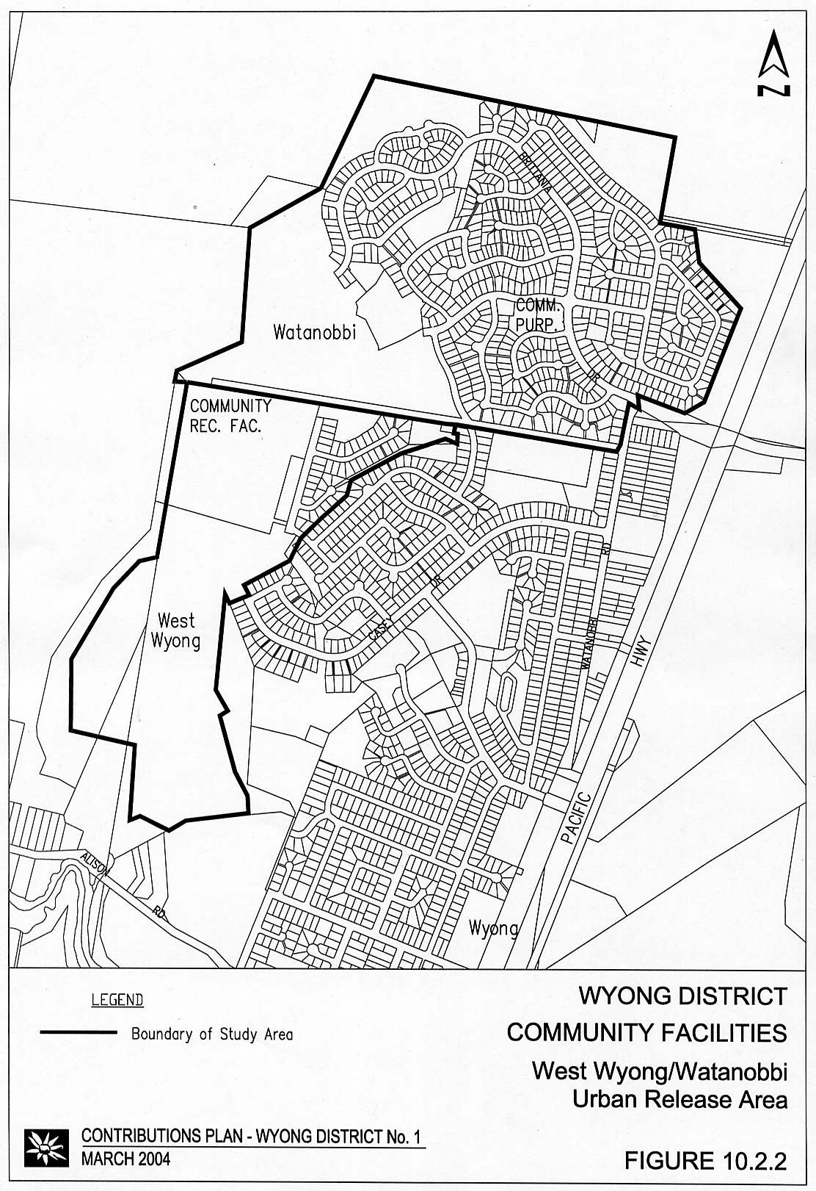

Contribution Rates

The contribution rate will be calculated by dividing the total estimated costs by the estimated number of dwelling units.

Land Component

Cost = 1,602m² @ $20/m²
= $32,032

Contribution Rate = Cost ÷ No of DUs
= $32,032 ÷ 286
= $112 per DU

Works Component

Cost = 257m² @ $2,793m²
= $718,918

Contribution Rate = Cost ÷ No of DUs
= $718,918 ÷ 286
= $2,514 per DU

3.1.7 Zone 3: Remaining Area of the District

Area of the Scheme

The remaining area of the District includes all of the Wyong District except for Zones 1 and 2 above.

Report Details

This Plan is based on Council's Social Plan (1992) with details specific to this area prepared by Council's Community Services Planner contained in Report No CF3-3).

Assessment of existing services indicates there is no spare capacity in these facilities to meet the need generated by the future development considered in the Plan. Therefore, additional community land and facilities will need to be provided to cater for the proposed population increase.

Determination of Community Facility Requirements

The projected number of additional DUs in the area of the Plan is 178 generated from a total additional population of 413.

Community facility requirements for the area of this Plan are as follows:

Land Requirements

For an additional 178 DU, the land requirement is 997 square metres.

Current contributions in hand and amounts committed in development consents issued prior to preparation of this Plan will enable this area to be increased by an additional 200 square metres making a total of 1,197 square metres of community land to be provided.

Community Facilities

For an additional 178 DU, a total of 160 square metres of floor space is required.

Current contributions in hand and amounts committed in development consents issued prior to preparation of this Plan will enable this area to be increased by an additional 83 square metres making a total of 244 square metres of community land to be provided.

Scheme Details

A total of 244 square metres of community facilities floor space is to be provided in accordance with needs identified within Council's Community Plan, and through ongoing community consultation.

Facilities are to be provided within the Social Planning District. Community facility floor space will be utilised to provide Multi-purpose Community Centres incorporating such facilities such as neighbourhood centres, youth centres, senior citizens facilities and the like.

The timing of the provision of the floor space will generally be driven by the rate of future development in the locality and the demand generated by such.

Further details including costs are shown in Table C3.

Apportionment of Costs

Costs will be shared by all developments on a population basis.

Program for Works and Funding

Land

Table C3 shows an indicative time for land acquisition but the actual time will vary depending on the rate of development and acquisition opportunities.

Facilities

An indicative time for the provision of each facility is shown in Table C3 although this may vary depending on the rate of development. The actual time for provision of the various facilities will be dictated by the following thresholds: Community Centre (to be provided when development is completed).

Contribution Rates

The contribution rate will be calculated by dividing the total estimated costs by the estimated number of dwelling units.

Land Component

Cost = 997m² @ $180/m²
= $179,424

Contribution Rate = Cost ÷ No of DUs
= $179,424 ÷ 178
= $1,008 per DU

Works Component

Cost = 160m² @ $2,793/m²
= $447,438

Contribution Rate = Cost ÷ No of DUs
= $447,438 ÷ 178
= $2,514 per DU

3.2 Public Open Space

3.2.1 Introduction

This section considers the open space requirements generated as a result of the development in the area of this Plan.

3.2.2 General

The methodology adopted for this Plan is based on the Wyong Open Space Plan.

The approach to establishing requirements for this area has been:

- identify existing open space land and improvements;
- identify requirements to service existing population and future single dwelling development on existing allotments for which no contributions can be sought;
- determine land requirements, if any, needed for the future development;
- determine embellishment requirements, if any, needed for the future development.

3.2.3 Area of the Scheme

For the purposes of Open Space planning this District has been divided into zones as follows:

- Zone 1: Mardi Urban Release Area;
- Zone 2: Mardi South Urban Release Area;
- Zone 3: Watanobbi Urban Release Area;
- Zone 4: West Wyong Urban Release Area;
- Zone 5: the remaining area of the District.

3.2.4 Zone 1: The Mardi Urban Release Area

Proposed Development

The proposed development covers development of the Mardi Urban Release Area and is predicted to yield a total population of 3523 as shown in Clause 5.0 of this Plan.

Figure 5 shows the area of this zone.

Report Detail

This Plan is based on the Wyong Open Space Plan with details specific to this area prepared by Council's Landscape Planner, contained in Report No POS 9-1 (September 1992).

Figure 5 Public Open Space – Mardi and Mardi South Urban Release Area
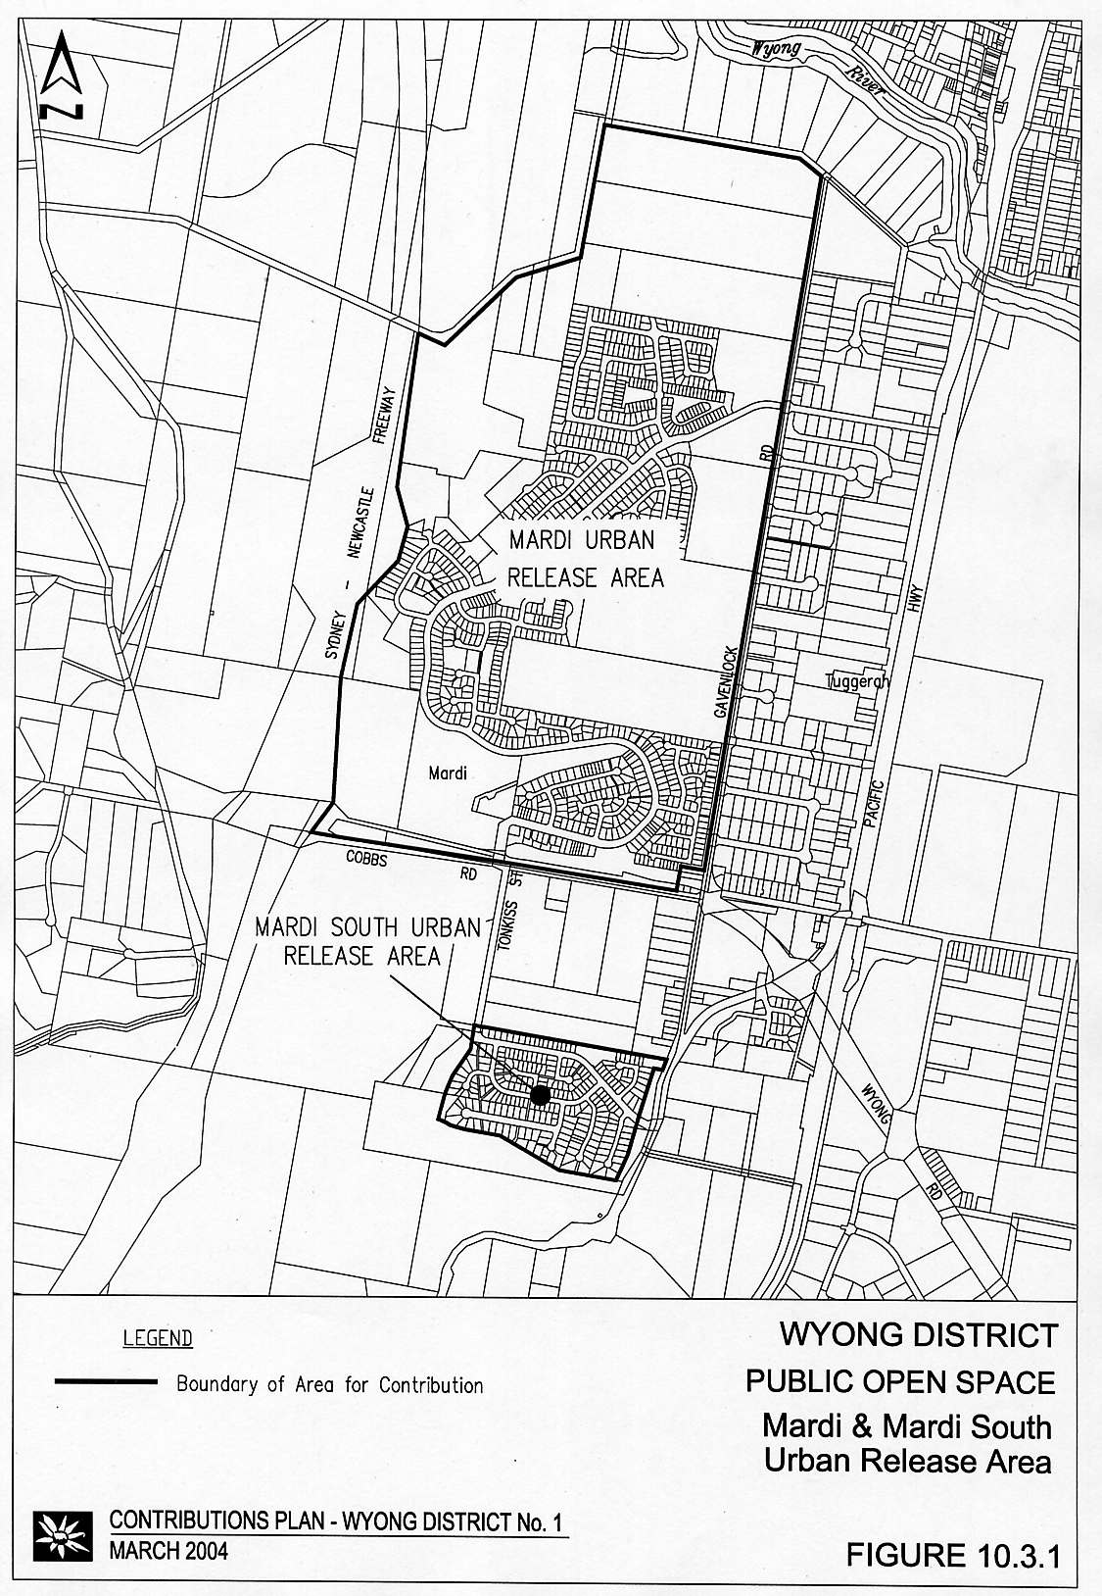

Determination of Open Space Requirements

The Wyong Open Space Plan requires a minimum provision of open space of 3.00 hectares per thousand people (as well as requirements relating to different types of open space, size, distribution, etc). For a population growth of 3523 people, a minimum area of 10.57 hectares would be required.

The Wyong Open Space Plan indicates the various categories of open space as a proportion of total open space requirements as shown in the table below:

Table 4 Categories of Open Space

Open Space Type | Notional Proportion (%) | Notional Area Required (Ha)
Small Park | 20 | 2.11
Large Park | 30 | 3.17
Semi-Natural Area | 20 | 2.11
Courts | 5 | 0.53
Sports Fields | 25 | 2.65
TOTAL OPEN SPACE | 100 | 10.57

Open Space requirements for the area of this Plan are as follows:

Land Requirements

For the following types of open space, assessment of existing open space land shows that there is an excess of land for the existing population and that there is no significant shortfall due to the requirements generated by future development:

- Courts; and
- Sports Fields.
There is therefore no requirement for provision of open space land for these types.

For the other types of open space there is a need for additional land to cater for the proposed development as follows:

- Semi-Natural;
- Small Park; and
- Large Park.
The notational area required (based on 3 ha/1,000 persons) exceeds that to be acquired as shown above. This is a result of the additional demand generated by rezoning of additional residential land in the later stages of the release area development.

The areas shown above are to be provided under the Section 94 process.

Additional land is also to be transferred to Council, at no cost, under the deed of agreement for the rezoning of additional residential land in the north of the precinct. This land will satisfy additional demand generated by development of rezoned areas and the development area as a whole and will perform a number of functions, including active and passive open space.

Land requirements for this zone are to be fully provided within the area of the zone.

Table S1 has been prepared on the basis of contributions in lieu of dedication of land. Any dedication of suitable land will be offset against these costs in a similar manner to works in kind.

Embellishment

While there is sufficient open space land within the Wyong District to meet some of the land requirements as identified above, the level of improvements on all types of open space is insufficient to cater for the future development being considered. Accordingly, contributions towards embellishment of existing open space for the future development area is justified. Cost estimates for embellishment of various types of open space have been calculated as follows:

- Large Parks: $24.82 per square metre
- Semi-Natural Areas: $10.34 per square metre
- Small Parks: $24.82 per square metre
- Courts: $103.42 per square metre
- Sporting Fields: $34.13 per square metre
(indexed December 1999)
An allowance for components of the embellishment of land to be dedicated on at the northern end of the release area is also included. These areas will have a benefit over the wider release area and an indicative costs estimate for the works has been provided at:

- Play structure $25,500
- Kickabout area $40,800
Cost estimates have also been applied to the area requirements in the table above to establish the total estimated costs shown in Table S1.

Apportionment of Costs

Future development being considered is expected to be spread throughout the zone and so all development will be required to share the costs for open space embellishment on a proportional basis.

Program for Works and Funding

An indicative time for the provision of each improvement is shown in Table S1, although this may vary depending on the rate of development. The actual time for provision of the various improvements will be dictated by the following thresholds:

- Small Parks: to be provided in stages at 25% and 60% of development;
- Large Parks: to be provided in stages at 25% and 60% of development;
- Courts: to be provided at 60% of development;
- Sports Fields: to be provided at 100% of development;
- Semi-Natural: to be provided at 30% of development;
- Land: to be provided in conjunction with the development.

Contribution Rates

Land Component

The contribution rate will be calculated by dividing the total estimated costs as shown in the attached tables by the estimated net developable area (NDA).

Contribution Rate = $469,000 ÷ 52.86ha NDA
= $8,872.50 per ha NDA

Works (Embellishment) Component

The contribution rates will be calculated by dividing the total estimated costs as shown in the attached tables by the estimated number of Dwelling Units as follows:

Contribution Rate = $1,636,281 ÷ 1104
= $1,483 per DU (indexed to June 2002)

3.2.5 Zone 2: The Mardi South Urban Release Area

Proposed Development

The proposed development covers development of the Mardi South Urban Release area and is predicted to yield a total population of 788 (equivalent to 284 DUs) as shown in Clause 6.0 of this Plan.

Figure 6 shows the area of this zone.

Report Detail

This Plan is based on the Wyong Open Space Plan with details specific to this area prepared by Council's Landscape Planner, contained in Report No POS 9-2 (September 1992).

Determination of Open Space Requirements

The Wyong Open Space Plan requires a minimum provision of open space of 3.00 hectares per thousand people (as well as requirements relating to different types of open space, size, distribution, etc). For a total population growth of 787 people, a minimum area of 2.36 hectares would be required.

Open Space requirements for the area of this Plan are as follows:

Land Requirements

For the following types of open space, assessment of existing open space land shows that there is an excess of land for the existing population and that there is no significant shortfall due to the requirements generated by future development:

- Courts; and
- Sports Fields.
There is therefore no requirement for provision of open space land for these types. However, for other types of open space there is a need for additional land to cater for the proposed development and this is shown in Table S2.

Embellishment

While there is sufficient open space land within the area of the zone to meet some of the land requirements as identified above, the level of improvements on all types of open space is insufficient to cater for the future development being considered. Accordingly, contributions towards embellishment of existing open space for this future development area reasonable.

Table S2 shows cost estimates for embellishment.

Apportionment of Costs

Future development being considered is expected to be spread throughout the zone and so all development will be required to share the costs for open space embellishment on a proportional basis.
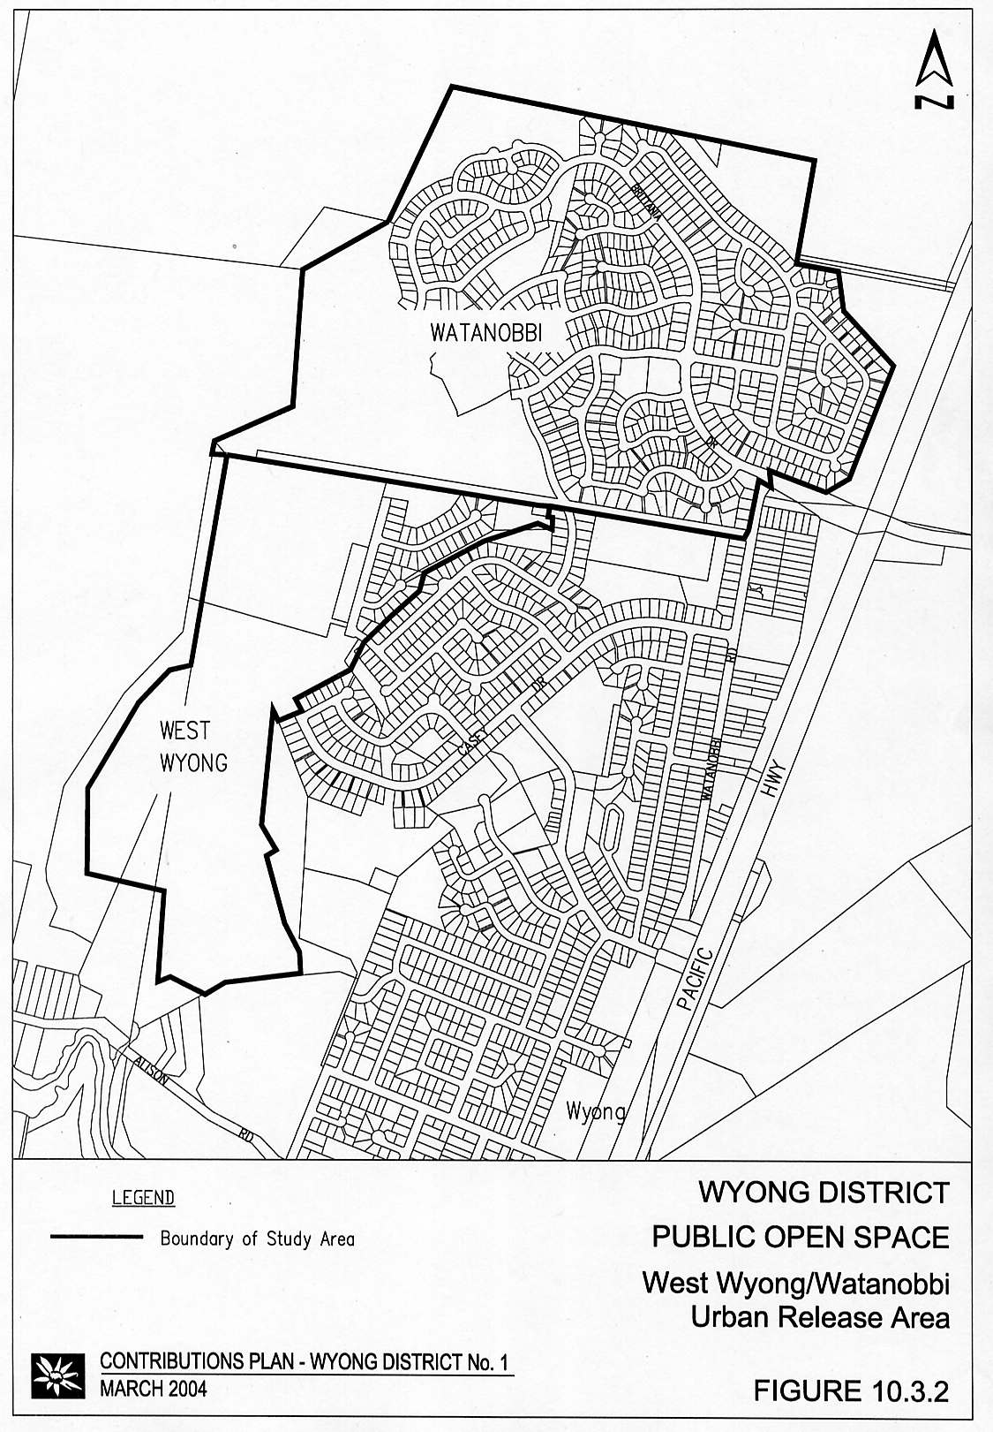
Figure 6 Public Open Space – West Wyong / Watanobbi Urban Release Area

Program for Works and Funding

An indicative time for the provision of each improvement is shown in Table S2, although this may vary depending on the rate of development. The actual time for provision of the various improvements will be dictated by the following thresholds:

Land

To be dedicated as part of the development.

Embellishment

Works to be carried out at the completion of the development.

Contribution Rates

The contribution rates will be calculated by dividing the total estimated costs by the estimated number of Dwelling Units as follows:

Land Component

Contribution Rate = $331,000 ÷ 246
= $1,345 per DU

Works (Embellishment) Component

Contribution Rate = $321,969 ÷ 246
= $1,308 per DU

3.2.6 Zone 3: Watanobbi Urban Release Area

Proposed Development

The proposed development covers development of the Watanobbi Urban Release area and is predicted to yield a total population of 2,762 as shown in Clause 6.0 of this Plan.

Figure 6 shows the area of this zone.

Report Detail

This Plan is based on the Wyong Open Space Plan with details specific to this area prepared by Council's Landscape Planner, contained in Report No POS 3-2 (September 1992).

Determination of Open Space Requirements

The Wyong Open Space Plan requires a minimum provision of open space of 3.00 hectares per thousand people (as well as requirements relating to different types of open space, size, distribution, etc). However, development in this release area commenced some time ago prior to the use of the Open Space Plan and the Development Control Plan stipulates a standard of 2.83 hectares per thousand people. For a population growth of 2,762 people, a minimum area of 7.81 hectare would be required.

Open Space requirements for the area of this Plan are as follows:

Land Requirements

Assessment of existing open space land shows that there is an excess of land for the existing population and that there is no significant shortfall due to the requirements generated by future development for the following types of Open Space:

- Semi-Natural Areas;
- Courts;
- Sports Fields.
There is therefore no requirement for provision of open space land for these types. However, for other types of open space there is a need for additional land to cater for the proposed development as follows:

- Small Park 1.08 hectare
- Large Park 3.38 hectare
Development in the UDP area will be required to dedicate land sufficient to fulfill these requirements or to contribute towards acquisition of suitable land.

Table S3 has been prepared on the basis of contributions in lieu of dedication of land. Any dedication of suitable land will be offset against these costs in a similar manner to works in kind.

Embellishment

While there is sufficient open space land within the area of the zone to meet some of the land requirements as identified above, the level of improvements on certain types of open space is insufficient to cater for the future development being considered. Accordingly, contributions towards embellishment of existing open space for this future development area reasonable.

Table S3 shows details including cost estimates.

Apportionment of Costs

Future development being considered is expected to be spread throughout the zone and so all development will be required to share the costs for open space embellishment on a proportional basis.

Program for Works and Funding

An indicative time for the provision of each improvement is shown in Table S3, although this may vary depending on the rate of development. The actual time for provision of the various improvements will be dictated by the following thresholds:

Land

To be dedicated at various stages of development.

Embellishment

- Small Parks: to be provided in stages when 50% and 100% of development is released;
- Large Parks: to be provided in stages when 60% and 90% of development is released;
- Sports Fields: to be provided when 50% of development is released.

Contribution Rates

The contribution rates will be calculated by dividing the total estimated costs by the estimated number of Dwelling Units as follows:

Land Component

Contribution Rate = $892,000 ÷ 863
= $1,033 per DU

Works (Embellishment) Component

Contribution Rate = $572,946 ÷ 863
= $664 per DU

3.2.7 Zone 4: West Wyong Urban Release Area

Proposed Development

The proposed development covers development of all of the West Wyong Urban Release area and is predicted to yield a total population of 915 (equivalent to 286 DUs) as shown in Clause 5.0 of this Plan.

Figure 6 shows the area of this zone.

Report Detail

This Plan is based on the Wyong Open Space Plan with details specific to this area prepared by Council's Landscape Planner, contained in Report No POS 3-1 (September 1992).

Determination of Open Space Requirements

The Wyong Open Space Plan requires a minimum provision of open space of 3.00 hectares per thousand people (as well as requirements relating to different types of open space, size, distribution, etc). However, development in this release area commenced some time ago prior to the use of the Open Space Plan and the Development Control Plan stipulates a standard of 2.83 hectares per thousand people. For a population growth of 915 people, a minimum area of 2.59 hectare would be required.

Open Space requirements for the area of this Plan are as follows:

Land Requirements

Assessment of existing open space land shows that there is an excess of land for the existing population and that there is no significant shortfall due to the requirements generated by future development for the following types of Open Space:

- Semi-Natural Areas;
- Courts;
- Sports Fields.
There is therefore no requirement for provision of open space land for these types. However, for other types of open space there is a need for additional land to cater for the proposed development as follows:

- Small Park 1.65 hectare
- Large Park 0.60 hectare
Development in the UDP area will be required to dedicate land sufficient to fulfill these requirements or to contribute towards acquisition of suitable land.

Table S4 has been prepared on the basis of contributions in lieu of dedication of land. Any dedication of suitable land will be offset against these costs in a similar manner to works in kind.

Embellishment

While there is sufficient open space land within the area of the zone to meet some of the land requirements as identified above, the level of improvements on certain types of open space is insufficient to cater for the future development being considered. Accordingly, contributions towards embellishment of existing open space for this future development area is reasonable.

Table S4 shows details including cost estimates.

Apportionment of Costs

Future development being considered is expected to be spread throughout the zone and so all development will be required to share the costs for open space embellishment on a proportional basis.

Program for Works and Funding

An indicative time for the provision of each improvement is shown in Table S4, although this may vary depending on the rate of development. The actual time for provision of the various improvements will be dictated by the following thresholds:

Land

To be dedicated at various stages of development.

Embellishment

- Small Parks: to be provided in stages when 25% and 50% of development is released;
- Large Parks: to be provided when all of development is released;
- Sports Fields: to be provided when 70% of development is released.

Contribution Rates

The contribution rates will be calculated by dividing the total estimated costs by the estimated number of Dwelling Units as follows:

Land Component

Contribution Rate = $450,000 ÷ 286
= $1,573 per DU

Works (Embellishment) Component

Contribution Rate = $543,513 ÷ 286
= $1,900 per DU

3.2.8 Zone 5: Remaining Area of the District

Proposed Development

The remaining area of the District includes all of the Wyong District except for Zones 1 to 4 above.

The proposed development covers medium density development which is predicted to provide an additional population of 615 (equivalent to 263 DU). Single dwelling development in existing urban zones do not require development consent and are not covered by this Plan.

Report Detail

This Plan is based on the Wyong Open Space Plan with details specific to this area prepared by Council's Landscape Planner, contained in Report No POS 3-1 (September 1992).

Determination of Open Space Requirements

The Wyong Open Space Plan requires a minimum provision of open space of 3.00 hectares per thousand people (as well as requirements relating to different types of open space, size, distribution, etc). For a population growth of 615 people, a minimum area of an additional 1.85 hectares would be required.

The Wyong Open Space Plan indicates the various categories of open space as a proportion of total open space requirements as shown in the table below:

Table 5 Categories of Open Space

Open Space Type | Notional Proportion (%) | Notional Area Required (Ha)
Parks, Fields and Cycleways | 75 | 1.38
Courts | 5 | 0.09
Semi-Natural Area | 20 | 0.37
TOTAL OPEN SPACE | 100 | 1.85

Open Space requirements for the area of this Plan are as follows:

Land Requirements

Assessment of existing open space land shows that there is an excess of land for the existing population and that there is no significant shortfall due to the requirements generated by the future development. Further, there is no concentrated location for this future development for which specific open space sites can be provided. Hence, there will be no requirements for land due to the proposed development.

Embellishment

While there is sufficient open space land within the area of the zone, the level of improvements is not sufficient to cater for the future development being considered. Accordingly, contributions towards embellishment of existing open space for this future development are reasonable.

Cost estimates for embellishment of various types of open space have been calculated as follows:

- Courts: $103.42 per square metre
- Cycleways, Parks and Fields: 34.13 per square metre
- Semi-Natural Areas: $10.34 per square metre
These cost estimates have been applied to the area requirements in the table above to establish the contributions shown in Table S5.

Current Contributions

There are no current contributions in hand or amounts committed in development consents already issued prior to preparation of this Plan.

Apportionment of Costs

Future development being considered is expected to be spread throughout the zone and so all development will be required to share the costs for open space embellishment on a proportional basis.

Program for Works and Funding

An indicative time for the provision of each improvement is shown in Table S5, although this may vary depending on the rate of development. The actual time for provision of the various improvements will be dictated by the following thresholds:

- Court Improvements: to be provided when 25% of the future population is established;
- Embellishment of Semi-Natural Areas: to be provided when 25% of the future population is established;
- Embellishment of Cycleways, Parks & Fields: to be provided on completion of the future development.

Contribution Rates

The contribution rates will be calculated by dividing the total estimated costs as shown in the attached tables by the estimated number of Dwelling Units as follows:

Land Component

Nil.

Works (Embellishment) Component

Contribution Rate = $406,845 ÷ 178
= $2,286 per DU

3.3 Carparking – Wyong Town Centre

3.3.1 Area of Scheme

Development in the commercially zoned area of Wyong Town Centre may require provision of public carparking where all parking is not provided on site by developments. This Plan establishes the basis for payment of contributions for provision of public parking provided in lieu of on site parking in Wyong Town Centre.

3.3.2 Nexus and Apportionment of Cost

As the quantity of parking required cannot be determined in advance of development, the approach to identifying and apportioning costs for parking has been:

- identify land which may be acquired for parking on the fringe of the commercial area or adjacent to existing parking facilities in accordance with Council's parking development strategy;
- identify a land cost per parking space based on 30 square metres of land per space for parking, circulation and landscaping;
- where a range of values exist for fringe land it is assumed that cheaper land will be acquired in preference to more expensive land by a ratio of 3:1;
- allow $2,500 per space for construction.

3.3.3 Program for Works and Funding

Land acquisition for parking will be undertaken when sufficient funds are available from development and within a reasonable time of receipt of contributions, generally being for a minimum 20 space parking area.

Construction of the parking area will follow immediately after land acquisition.

3.3.4 Contribution Rate

The contribution rate will be calculated based on the average value per square metre for fringe land (including acquisition on costs of 10%) and a construction cost of $2,500 per space:

Contribution Rate = $195 x 30 + $2,500
= $8,350 per space
= $9,154 per space (June 2002)

Figure 7 Carparking Facilities – Wyong Town Centre
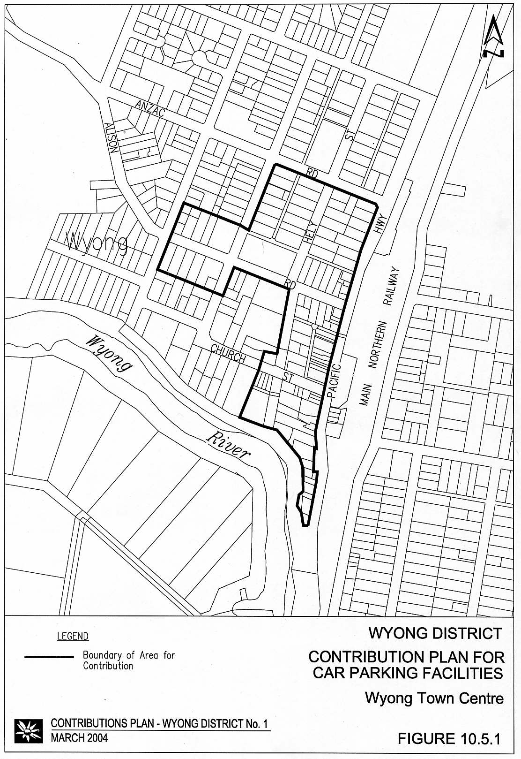

3.4 Local Roads and Intersections

3.4.1 Introduction

This section considers the road and intersection requirements generated as a result of the development in the area of this Plan.

3.4.2 General

The approach to establishing road and intersection requirements for this area has been:

- identify existing road hierarchy and traffic flows;
- predict future road hierarchy and traffic flows generated by existing development or existing zoned areas for which no contributions may be sought when development does proceed, but excluding the proposed development;
- identify road and intersection improvements necessary to cater for these predicted flows;
- predict future road hierarchy and traffic flows generated by all future development including the proposed development;
- identify additional road and intersection improvements necessary to cater for these predicted flows; and
- where necessary, apportion costs of improvements based on traffic flows.

3.4.3 Area of the Scheme

For the purposes of identifying road and intersection improvements this District has been divided into zones as follows:

- Zone 1: Mardi Urban Release Area and Westfield Site
- Zone 2: Watanobbi Urban Release Area
- Zone 3: West Wyong Urban Release Area
- Zone 4: Hue Hue Road Area
- Zone 5: Leewood Close Area, Yarramalong
- Zone 6: Mardi South Urban Release Area
- Zone 7: Wyong Road/Bryant Drive/Pacific Highway and Cobbs Road
- Zone 8: Tuggerah Industrial Estate Stage III

3.4.4 Zone 1: Mardi Urban Release Area (Westfield Area)

Area of the Scheme

This roads scheme relates to all of the Mardi Urban Release Area and to the proposed Westfield Shopping Centre site south of Cobbs Road, as shown in Figure 8.

Report Detail

The road and intersection requirements are based on a traffic report completed by Pak Poy and Kneebone and a technical report completed by Council's Design Section (Report No 363, June 1992).

The traffic study completed for this area indicated that the existing roads and intersections are adequate to cater for existing development and future single dwelling development on existing residential lots.

It also identified that upgrading of certain roads and intersections would be required to cater for the proposed development.

Revised costs for the Johnson Road and Gavenlock Road roundabout and the Johnson Road extension have been based on revised designs and cost estimates prepared by consultants and checked by Council’s Development Design and Strategic Planning Engineers, dated January and February 2000.

Scheme Details

The proposed works are described below with further details shown in Table R1 and Figure 8:

- Extension of Johnson Road west of Gavenlock Road, and the provision of a Roundabout at Johnson and Gavenlock Roads including the construction of the cycleway for the length of the Johnson Road extension, and the internal cycleway link adjoining the artificial wetland on the northern extremity of the release area.
- Installation of traffic lights at the intersection of Johnson Road and Pacific Highway.
- Construction of roundabout at the intersection of Tonkiss Street and Cobbs Road and the distributor road.
- Construction of extra width to form the distributor road through the Mardi Release area.
- Construction of cycleway from Tonkiss Street to Gavenlock Road.
- Land for full width of section of distributor road identified in Item 1.

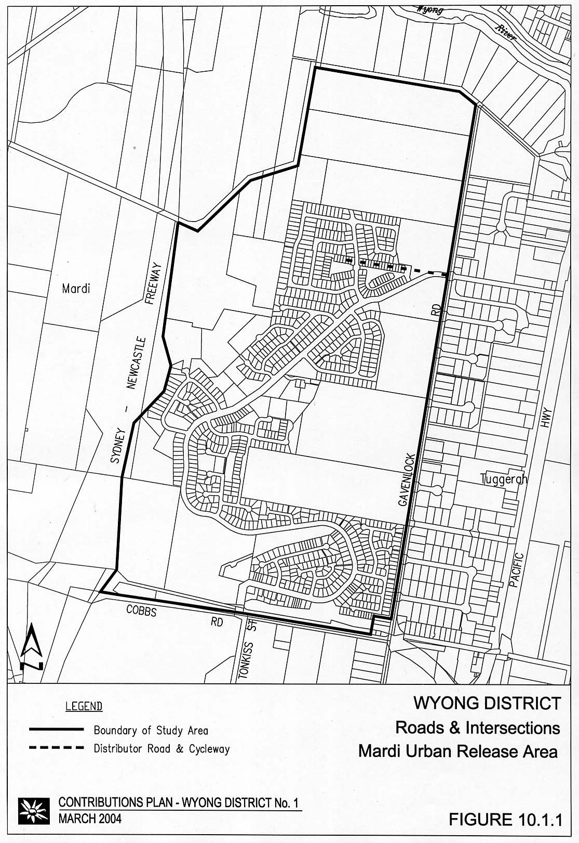
Figure 8 Roads and Intersections – Mardi Urban Release Area

Apportionment of Costs

Apportionment of costs will be on the basis of traffic generated and is summarised as follows (see Table R1 for details):

- Items 1, 4, 5: 100% to Mardi Urban Release Area;
- Item 2: 75% to Mardi Urban Release Area; 25% to Council/RTA;
- Item 3: 16% to Mardi Urban Release Area; 84% to Shopping Centre;
- Item 6: 100% to Mardi Urban Release Area.

Program for Works and Funding

An indicative time for provision of each improvement is shown in Table R1, although this may vary depending on the rate of development. The actual time for provision of the various improvements will be dictated by the following thresholds:

- Johnson Road Extension and Roundabout at Johnson and Gavenlock Roads: to be provided when development of the northern section of the release area is undertaken;
- Johnson Road / Pacific Highway Intersection: to be provided when Johnson Road is completed;
- Tonkiss Street Roundabout: to be provided as part of the first stage of development accessing onto Cobbs Road;
- Distributor Road and Cycleways including Land: to be provided by each developer as development proceeds.

Contribution Rate

Based on the above, cost apportionments are as follows:

Shopping Centre
84% of Item 3 = 84% x $1,537,348
= $1,291,372

Council / RTA
25% of Item 2 = 25% x $258,266
= $64,567

Mardi Urban Release Area
100% of Items 4, 5 & 6
+75% of Item 2
+ 16% of Item 3 = $1,260,886 (indexed June 2002)
+ 100% of Item 1 = $771,677
= $1,260,886 + $771,677
= $2,032,563

Mardi Urban Release Area

Contribution Rate = $2,032,563 per ha NDA
= $2,032,563 ÷ 52.86ha NDA
= $38,452 per ha NDA (revised to June 2002)

3.4.5 Zone 2: Watanobbi Urban Release Area

Report Detail

The road and intersection requirements are based on a traffic report completed by Lyle Marshall & Associates and a technical report completed by Council's Design Section (Report No 431, July 1992).

It identified that upgrading of certain roads and intersections would be required to cater for the proposed development.

Scheme Details

The works identified consisted of construction of a two lane roundabout at the intersection of Britannia Drive and the Pacific Highway, together with part construction of Britannia Drive.

Further details are shown in Table R2 and Figure 9.

Apportionment of Costs

Apportionment of costs will be on the basis of traffic generated and is summarised as follows:

- New Development 82%
- Existing Development (funded by Council) 18%
As development throughout the release area will be similar in nature and will generate similar traffic volumes, contribution rates will be calculated on a dwelling unit, or equivalent basis.

Program for Works and Funding

All works were constructed in 1991/92 as shown in Table R2.

Contribution Rate

Contribution Rate = Cost ÷ No of DUs
= 82% x $1,277,542 ÷ 863
= $1,214 per DU

Figure 9 Roads and Intersections – West Wyong / Watanobbi Urban Release Area

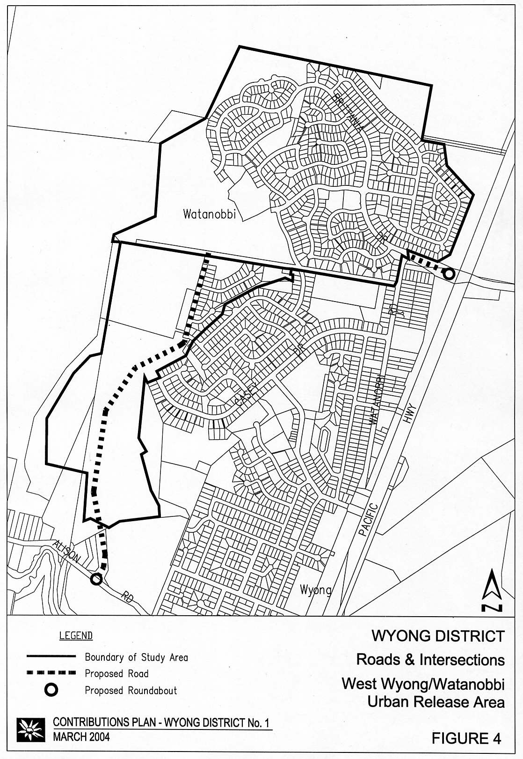
3.4.6 Zone 3: West Wyong Urban Release Area

Report Detail

The road and intersection requirements are based on a traffic report completed by Lyle, Marshall & Associates and a technical report completed by Council's Design Section (Report No 430, July 1992).

The traffic study completed for this area indicated that the existing roads and intersections are adequate to cater for existing development and future single dwelling development on existing residential lots.

It identified that upgrading of certain roads and intersections would be required to cater for the proposed development.

Scheme Details

The proposed works are described below with further details shown in Table R3 and Figure 9:

- additional construction width to local road to form distributor road;
- construction of distributor road in areas where there is no development fronting the road (ie. at drainage reserves, open space, etc);
- roundabout at the intersection of Alison Road and De L'Isle Drive;
- land for section of distributor road from Alison Road to commencement of development.

Apportionment of Costs

Apportionment of costs will be on the basis of traffic generated. However, as development throughout the release area will be similar in nature and will generate similar traffic volumes, contribution rates will be calculated on a dwelling unit, or equivalent basis.

Program for Works and Funding

An indicative time for provision of each improvement is shown in Table R3, although this may vary depending on the rate of development. The actual time for provision of the various improvements will be dictated by the following thresholds:

- works for additional width to form distributor road together with parts of distributor road with no development: to be provided as part of the particular development;
- roundabout: to be provided when the first 150 lots have been released.

Contribution Rate

Contribution Rate = Cost ÷ No of DUs
= 1,701,191 ÷ 286
= $5,948 per DU

3.4.7 Zone 4: Hue Hue Road Area

Area of the Scheme

The area of the scheme is that part of the Hue Hue Road Rural Residential Release Area shown in Figure 10.

Report Detail

The road and intersection requirements are based on a technical report completed by Council's Design Section (Report No 427, July 1992).

It identified that upgrading of certain roads and intersections would be required to cater for the proposed development.

Scheme Details

The proposed works are described below with further details shown in Table R4 and Figure 10:

- upgrading of the intersection of St Johns Road and Hue Hue Road to a Type B "T" intersection;
- upgrading of the intersection of Holloway Drive and Hue Hue Road to a Type B four-way intersection;
- upgrading of the intersection of Sandra Street and Hue Hue Road to a Type B four way intersection.

Apportionment of Costs

Apportionment of costs will be on the basis of traffic generated. However, as development throughout the release area will be similar in nature and will generate similar traffic volumes, contribution rates will be calculated on a dwelling unit, or equivalent, basis. This will be converted to a lot basis, with contributions to be charged at time of subdivision for each additional lot.

Program for Works and Funding

An indicative time for provision of each improvement is shown in Table R4, although this may vary depending on the rate of development. The actual time for provision of the various improvements will be dictated by the following thresholds:

- upgrading of St Johns Road intersection to be provided prior to release of the first development requiring access off St Johns Road;
- upgrading of Holloway Drive intersection to be provided as part of the construction of the first section of Holloway Drive to the west;
- upgrading of Sandra Street intersection has already been completed.

Contribution Rate

Based on traffic apportionment identified above, cost apportionments for the total works are as follows:

Contribution Rate = Cost ÷ No of lots
= $684,086 ÷ 155
= $4,414 per lot*

Note: This rate applies to each additional lot to be created by subdivision.
Figure 10 Roads and Intersections – Hue Hue Road Rural Residential Release Area
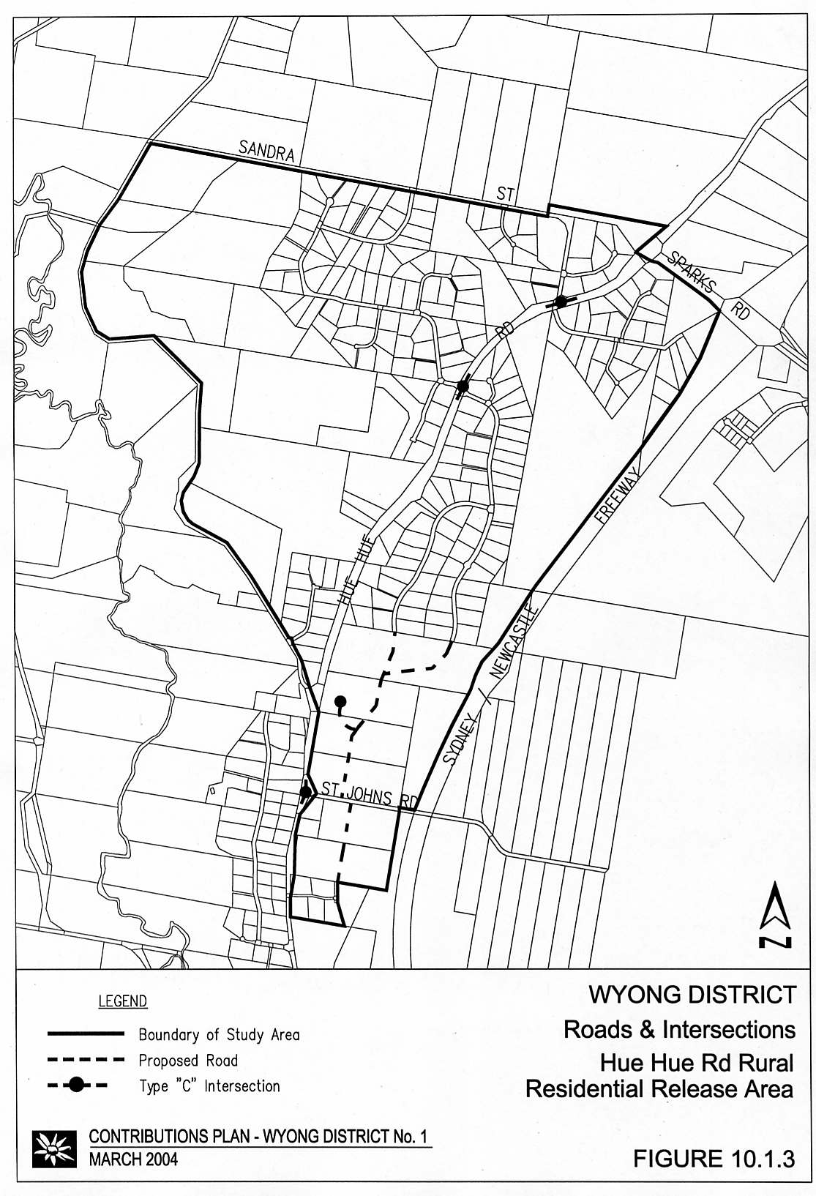

3.4.8 Zone 5: Leewood Close Area, Yarramalong

Report Detail

The road and intersection requirements are based on a technical report completed by Council's Design Section (Report No 444, August 1992).

Scheme Details

The proposed works are described as follows, with further details shown in Table R5 and Figure 11: construction of Leewood Close to a 6 metre width seal with kerb and gutter and associated drainage.

Apportionment of Costs

Apportionment of costs will be on the basis of traffic generated. However, as development throughout the release area will be similar in nature and will generate similar traffic volumes, contribution rates will be calculated on a dwelling unit, or equivalent basis.

Program for Works and Funding

An indicative time for provision of each improvement is shown in Table R5, although this may vary depending on the rate of development.

Contribution Rate

Based on traffic apportionment identified above, cost apportionments for the total works are as follows:

Contribution Rate = Cost ÷ No of DUs
= $88,256 ÷ 16
= $5,516 per DU

Figure 11 Roads and Intersections – Leewood Close, Yarramalong
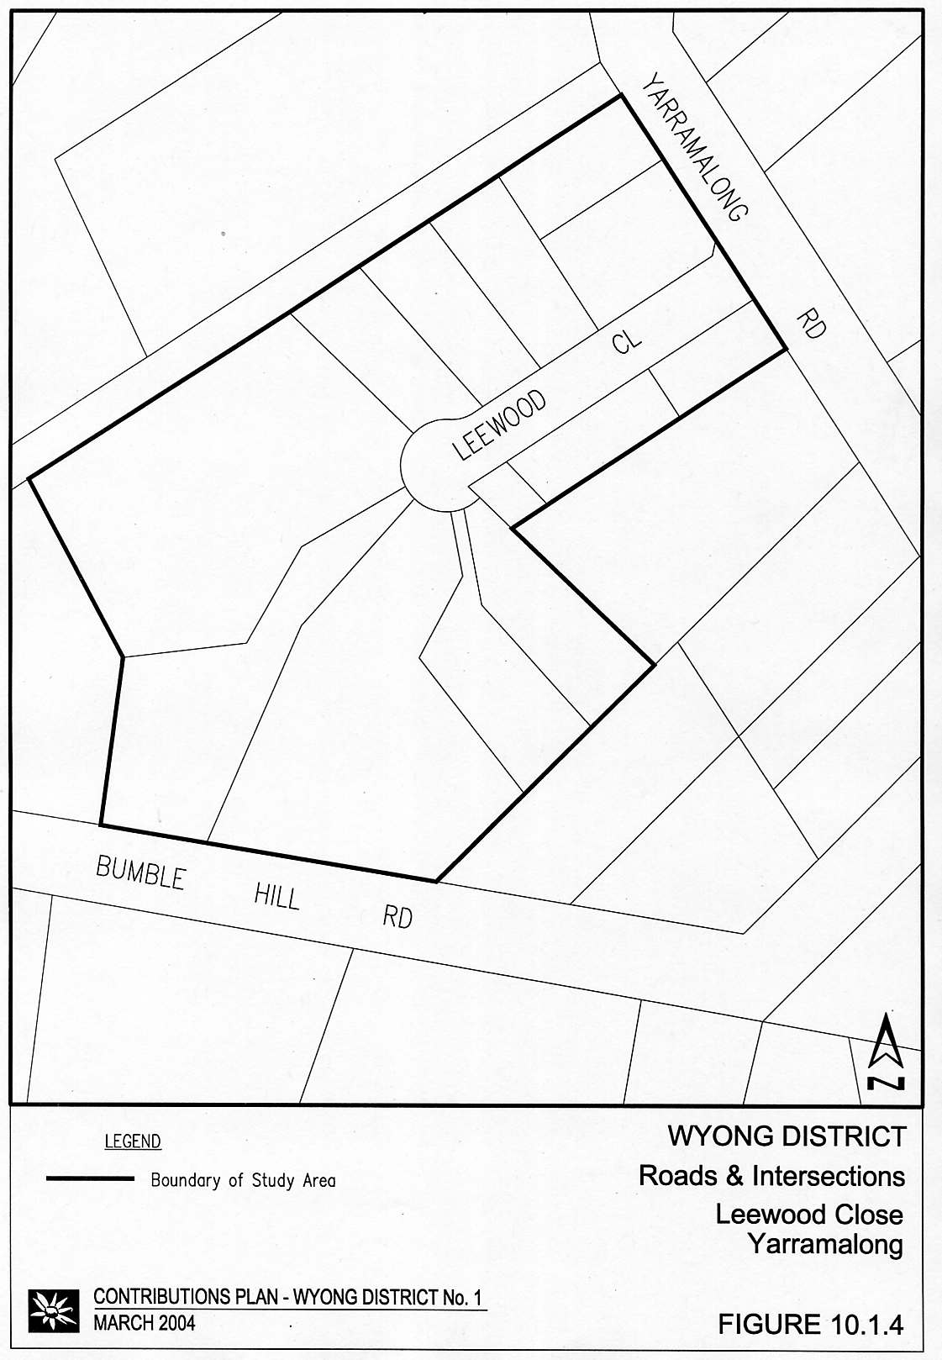

3.4.9 Zone 6: Mardi South Urban Release Area

Area of the Scheme

The area of the scheme is all of the area identified as Mardi South Urban Release Area in Figure 12.

Report Detail

The intersection requirements are based on a technical report completed by Council's Design Section (dated July 1993).

It identified that upgrading of the intersection at the Pacific Highway would be required to cater for the proposed development.

Scheme Details

The proposed works are described as follows with further details shown in Table R6: the provision of a T intersection at the junction of the Pacific Highway Tuggerah and the proposed distributor road into Mardi South Urban Release Area.

Apportionment of Cost

Apportionment of costs will be on the basis of traffic generated. However, as development throughout the release area will be similar in nature and will generate similar traffic volumes, contribution rates will be calculated on a dwelling unit, or equivalent basis.

Program for Works and Funding

An indicative time for the provision of each improvement is shown in Table R5, although this may vary depending on the rate of development.

Contribution Rate

The contribution rate will be calculated by dividing the total estimated costs by the estimated number of dwelling units:

Contribution Rate = Cost ÷ No of DU's
= $193,060 ÷ 246
= $785 per DU

Figure 12 Roads and Intersections – Mardi South Urban Release Area

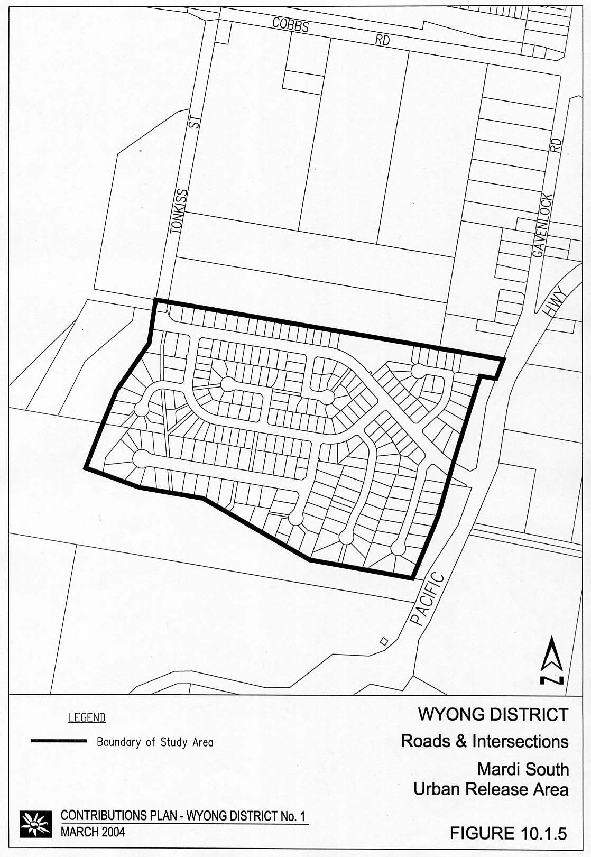

3.4.10 Zone 7: Wyong Road and Bryant Drive and Pacific Highway, Wyong Road and Cobbs Road

Area of the Scheme

The area of the scheme relates to land zoned 4(d) Special Industrial Business generally bounded by Lake Road, Bryant Drive (north), Main Northern Railway Line, Ourimbah Creek, Wyong Road and Titania Avenue, Tuggerah. It also relates to part of land (8.7 hectares) contained within Portion 25 DP 755263, DP 206598 and Lot 11 DP 585324 and land zoned 4(a) General Industrial within Lots 1 and 2 DP 543729 and Portion 25 DP 755263.

Report Detail

The intersection requirements are based on Technical Report No 1652 completed by Council's Strategic Planning Department.

It has been identified that the upgrading of the intersection is required to cater for the proposed development in the Wyong/Tuggerah area as shown in the following plan.

The existing developments on DP 620891 and DP 654119 and part land zoned 4(a) in Lot 2 DP 543729 have been in existence for a considerable number of years. The previous intersection arrangements at Wyong Road/Bryant Drive and Pacific Highway/Wyong Road/Cobbs Road were adequate to cater for these developments.

Scheme Details

The required works are described below with further details in Technical Report No 1652.

- Construction of a roundabout at the intersection of Wyong Road and Bryant Drive, Tuggerah: the cost of the roundabout works is the difference in cost between the roundabout (rigid pavement) and the previously proposed "sea-gull" type intersection. This is estimated at $430,199.

- Construction of left turn slip lane from Pacific Highway (southbound traffic) to Wyong Road at Tuggerah: the estimate of cost for the left turn slip lane from Pacific Highway to Wyong Road is $420,733.

Apportionment of Costs

1 Wyong Road/Bryant Drive Roundabout

The cost of the roundabout at the intersection of Wyong Road and Bryant Drive is to apportioned between the proposed developments shown in Figure 13.

The apportionment of costs (based on predicted traffic generation) to be:

Tuggerah Business Park 52.4%
Supa Centre 19.7%
Other Development (Areas 1, 2 & 3) 27.9%

The cost to be apportioned is $430,199.
2 Left Turn Slip Lane from Pacific Highway to Wyong Road

The cost of the left turn slip lane from Pacific Highway to Wyong Road is to be apportioned between the Westfield's development and the proposed developments shown in Figure 13.

The apportionment of cost (based on predicted traffic generation) to be:

Westfield's Development 49.0%
Tuggerah Business Park 26.7%
Supa Centre 10.1%
Other Developments (Areas 1, 2 & 3) 14.2%

The cost to be apportioned is $420,733.

Program for Works and Funding

The timeframe for the works is:

- Wyong Road/Bryant Drive Roundabout - constructed in 1995 concurrent with the Supa Centre.

- Left Turn Slip Lane form Pacific Highway to Wyong Road - to be carried out concurrent with Wyong Road upgrading by Council/Roads Traffic Authority in 1997.

Contribution Rates

The contribution rates will be calculated as follows.

1 Wyong Road/Bryant Drive Roundabout:

Tuggerah Business Park $225,875
Supa Centre $84,916
Other Development $120,266 ÷ 37.8ha
$3,181 per ha NDA

2 Left Turn Slip Lane from Pacific Highway to Wyong Road:

Westfield's $206,571
Tuggerah Business Park $112,561
Supa Centre $42,578
Other Development $59,864 ÷ 37.8 ha
$1,584 per ha NDA

Figure 13 Roads and Intersections – Wyong Road / Bryant Drive / Pacific Highway and Wyong Road / Cobbs Road
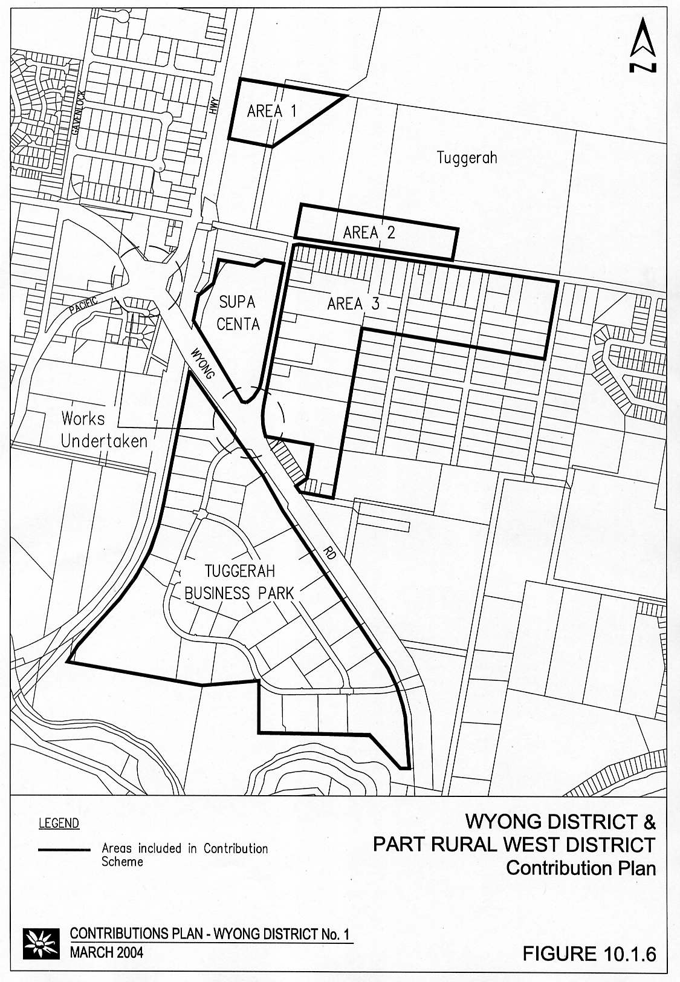

3.4.11 Zone 8: Tuggerah Industrial Estate Stage 3 – Roadworks

Area of the Scheme

The area covered by this scheme is that part of the district as shown in Figure 13.

General

In 1995, development of the Tuggerah Supa Centa initiated the need to construct the western side of Bryant Drive for the length of frontage to the Supa Centa. At that time, Council paid a contribution towards the construction of the eastern side of the road with a view to recouping the cost at a later stage when development of the land on the eastern side of Bryant Drive proceeded. The cost of the work attributable to the land on the eastern side of Bryant Drive has been included in this scheme. The construction of Lake Road for the frontage of the scheme area and part of Church Road and Mooramba Road is also included in this scheme.

Report Detail

The details of this scheme are included in Technical Report No 1991 completed by Council's Strategic Planning Department in October 2000.

Scheme Details

The scheme provides for the construction of road works to service the areas shown in Figure 13, which allow for the development of the land for industrial purposes. A table indicating the summary of costs associated with each catchment is set out below.

Table 6 Summary of Costs – Construction of Road Works

Component | Cost
Half Road Construction of Bryant Drive | $147,588
Construction of Lake Road and part of Church Road and Mooramba Ave | $2,104,392
TOTAL | $2,251,980

The total area of the land that will benefit from the scheme is 52.19/NDA hectares. A split of the total NDA is shown below.

Table 7 Total Area of Land to be Developed

Precinct | NDA
Area 1 | 12.24
Area 2 | 10.00
Area 3 | 21.02
Area 4 | 8.93
TOTAL | 52.19
Figure 14 Road Construction – Bryant Drive / Lake Road
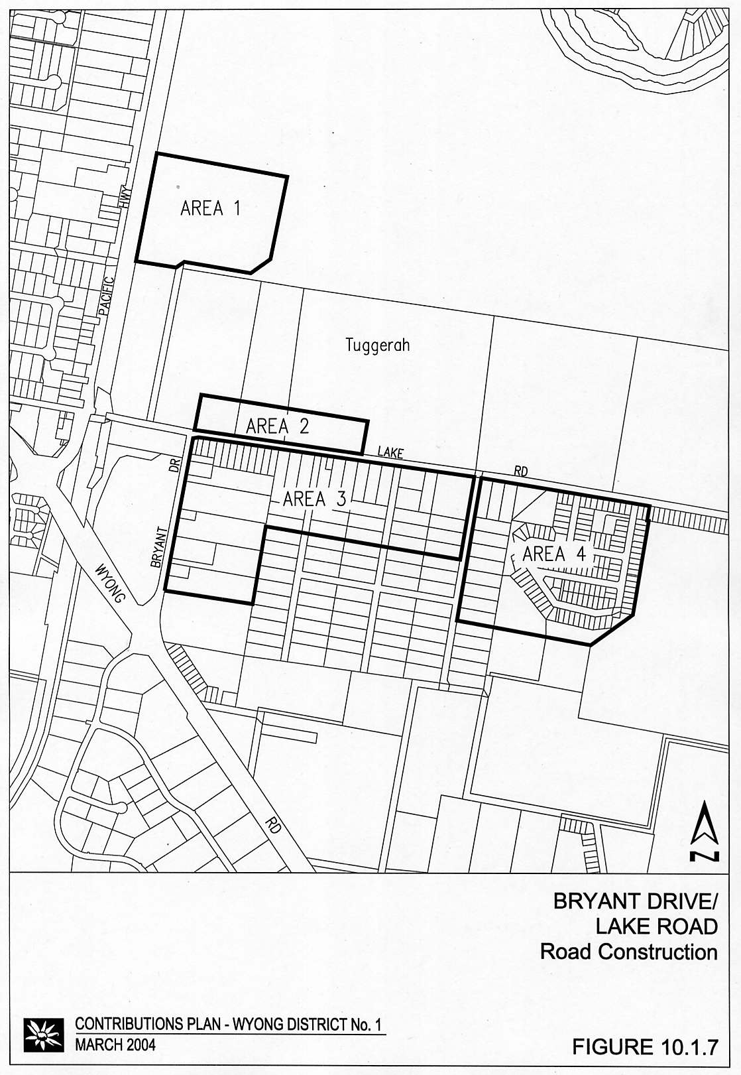

Apportionment of Costs

The total cost of the works is to be met by the area shown in Figure 13.

Program for Works and Funding

The construction of Bryant Drive has already occurred. The remaining works under this scheme will occur as development proceeds.

Contribution Rates

The cost of works associated with each component is divided by the net developable area of the scheme.

Contribution (in December 2000 dollars)

Contribution Rate = Total cost of works ÷ Net Developable Area
= $2,251,980 ÷ 52.19 NDA
= $43,149 per NDA

3.5 Drainage

3.5.1 Mardi Creek Drainage

Introduction

This section considers the drainage requirements generated as a result of the development in the area of this Plan.

Area of the Scheme

The area covered by this drainage scheme is that part of the District within the Mardi Creek catchment as shown in Figure 15.

It includes the following areas:

- part of the Mardi Urban Release Area;
- Mardi South Urban Release Area;
- proposed Westfield Shopping Centre;
- proposed Meridian Development;
- some existing areas of Mardi;
- proposed Tuggerah Industrial Area Stage 3;
- future development within the area bounded by Gavenlock, Mildon and Cobbs Roads, and the Pacific Highway.

General

The approach to establishing drainage requirements for this area has been:

- carry out a flood study to establish current flood levels for floods with various probabilities of occurrence (eg. 20%, 2%, 1%, etc.) based on existing levels of development;
- use this study to predict future flood flows and levels for floods within the same probability of occurrence based on existing levels of development and development of existing zoned areas, but excluding the proposed development;
- use the study to predict future flood flows and levels with full development of the catchment, including the proposed development;
- identify drainage improvements necessary to handle the predicted flows; and
- where necessary, apportion costs of improvements based on an area or fill volume basis or, where run off characteristics vary from area to area, on actual run-off flows from each area.
Figure 15 Drainage – Part Precinct 16, Tuggerah

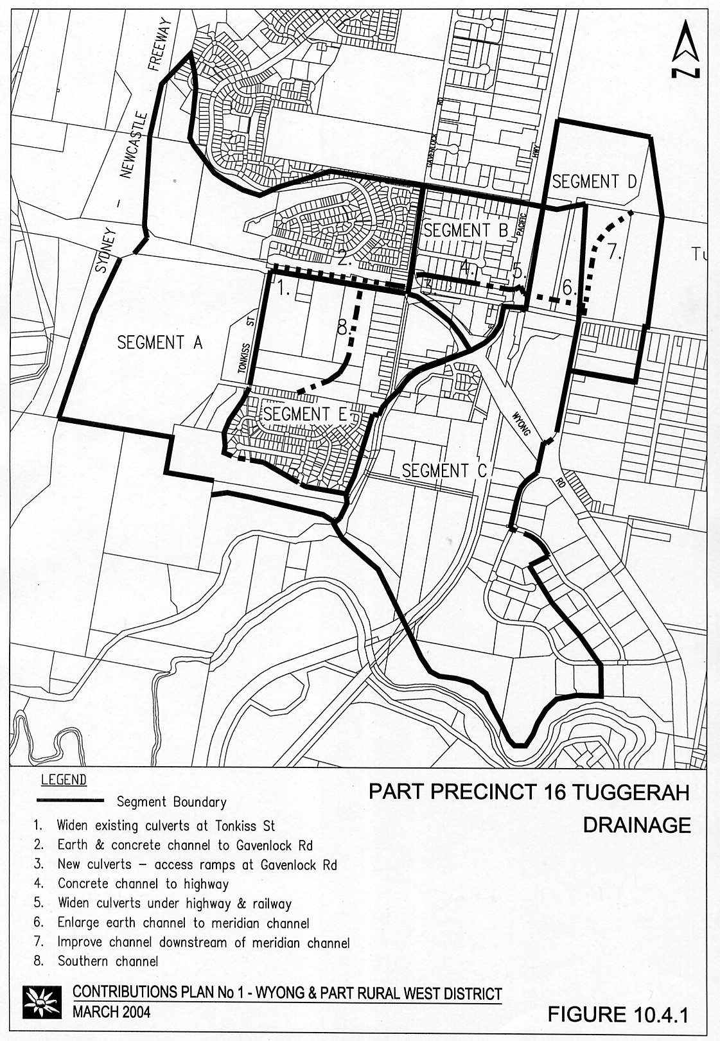
Report Detail

The following reports form the basis for this scheme:

- Upper Wyong River Flood Study, February 1988 - Webb McKeown and Associates Pty Ltd;
- Mardi Creek Flood Study, June 1992 - Webb McKeown and Associates Pty Ltd;
- Lower Wyong River Flood Study Review, June 1992 - Webb McKeown and Associates Pty Ltd;
- Wyong River Flood Plain Management Study, June 1992 - Webb McKeown and Associates Pty Ltd;
- Estimates and Preliminary Designs of Components of "Westfield's Scheme B", April 1992 - Sinclair Knight and Partners;
- Comparison of Eight Proposed Schemes, August 1992 - Webb McKeown and Associates Pty Ltd;
- Mardi Creek, Tuggerah, Investigation and Concept Design of Flood Mitigation Works, May 1997 - Webb McKeown and Associates Pty Ltd;
- Revision of Mardi Drainage Scheme, August 1998 - Webb McKeown and Associates Pty Ltd.
The Mardi Creek Flood Study, June 1992, identifies the existing flood levels within the Tuggerah area due to flooding from Mardi Creek. A somewhat lower level of flooding of the same area can be due to flooding from Wyong River as shown in the Lower Wyong River Flood Study Review, June 1992, and the Upper Wyong River Flood Study, February 1988.

The worsening of flood levels due to various development proposals within Mardi Creek catchment is shown in the Wyong River Flood Plain Management Study, June 1992. This management study also identified feasible schemes of works to overcome these adverse affects and to make some improvement to the existing flood problem.

Due to the overriding flood affects possible from Wyong River, it is not feasible for works within Mardi Creek to protect existing development in that area against flooding from all 1% floods, nor to the 2% standard which are the Council's adopted standards for the Shire generally and for Tuggerah Industrial Area respectively.

However, the proposed works achieve protection to 5% level, and new development can be established above the 1% levels (with the use of fill in some locations).

The 1997 report provided some design details of downstream components of works and provided alternative items of works to achieve the desired results, notably the provision of a basin adjoining the F3 Freeway which is more economical and environmentally favourable solution.

Scheme Details

The proposed works are described below with further details shown in Table D1.

- culverts under Cobbs Road at Tonkiss Street intersection;
- earth channel between Tonkiss Street and Gavenlock Road;
- culverts and utilities adjustments at Gavenlock Road;
- concrete channel between Gavenlock Road and Pacific Highway;
- duplication of culverts under the Pacific Highway and the Railway;
- earth channel improvements downstream of the Railway;
- southern channel through Westfields;
- land acquisition;
- provision of a detention basin adjacent to the F3 Freeway.

Apportionment of Costs

The area of the scheme is divided into five segments of the Mardi Creek Catchment. These segments are shown on Figure 15.

Developments, both existing and proposed, within each of these five segments will contribute on an area basis to the cost of works within that segment and downstream of the segment, but not upstream of the segment.

This apportionment is consistent with earlier development approvals in the area and recognises the affect of developments on downstream flood levels.

In addition, works required to directly offset the impacts of site filling or any equivalent flood-storage displacement within the area bounded by Cobbs Road, Gavenlock Road, Mildon Road and the Pacific Highway, will be levied on a per cubic metre of fill basis.

Total cost for all works is estimated as $3.73 million (June 2002 dollars) made up as shown in Table 8 (further details see list of items in Figure 15).

Table 8 Value of Works in each Segment

Segment | Cost of Works Located in Segment | Apportionment of Costs to Segment
Segment A | $1,352,088 | $1,438,345
Segment B | $1,297,057 | $229,771
Segment C | $229,406 | $138,112
Segment D | $314,846 | $49,881
Segment E | $557,496 | $1,894,786
TOTAL | $3,750,894 | $3,750,894

Note: This excludes the $910,000 towards additional works required to offset the impacts of filling within Segment B.

Contribution Rates

Table 9 Segment A

Location | Gross Hectares
Mardi Urban Release Area (Area within Catchment Only) | 17.7
Old Abattoirs Site west of Tonkiss Street | 25.0
TOTAL | 42.7

Contribution Rate = Cost ÷ Area
= $1,432,920 ÷ 42.7ha
= $33,558 per ha

Table 10 Segment B

Description | Amount
Existing Industrial and Commercial (WSC) | 13.3 hectares
Total Cost to be borne by Council | $229,771
Future Development entailing site fill or equivalent building displacement (area bounded by Cobbs, Gavenlock, Mildon Roads and the Pacific Highway) | 74,000 cubic metres
Specific works to offset impact of filling | $937,351 (June 2002)

Contribution Rate = Cost ÷ cubic metres of fill
= $937,351 ÷ 74,000
= $12.66 per cubic metre of fill or equivalent displacement

Table 11 Segment C

Location | Area
2(b) at Highway | 2.1 hectares
Tuggerah Business Park | 35.0 hectares
TOTAL | 37.1 hectares

Contribution Rate = Cost ÷ Area
= $138,112 ÷ 37.1ha
= $3,723 per ha

Table 12 Segment D

Location | Area
Tuggerah Industrial Estate | 25.0 hectares

Contribution Rate = Cost ÷ Area
= $49,881 ÷ 25
= $1,995 per ha

Table 13 Segment E

Location | Area
Mardi South Urban Release Area | 15.7 hectares
Proposed Westfield Shopping Centre Site | 17.3 hectares
Existing 2(b) in Gavenlock Road (WSC) | 6.7 hectares
TOTAL | 39.7 hectares

Contribution Rate = Cost ÷ Area
= $1,894,786 ÷ 39.7
= $47,728 per ha

10.4.2 Tuggerah Industrial Estate Stage 3 Drainage

Introduction

A drainage scheme incorporating trunk drainage and water quality facilities has been established to facilitate the development of industrial land in the Tuggerah Industrial Estate Stage III.

Area of the Scheme

The area covered by this drainage scheme is that part of the district within the Tuggerah Industrial Area Stage 3 as shown in Figure 16.

General

A drainage concept plan for the industrial area was originally devised in 1990 and presented in a report entitled "Conceptual Report - Tuggerah Industrial Estate - Stage III". A study for Tuggerah Business Park Pty Ltd in 1995 then identified options to upgrade drainage facilities in the area to cater for the Ourimbah Creek overflow.

A review of the previous studies with the aim of formalising the drainage strategies to allow development to proceed in an appropriate manner, was completed in March 2000. The review process established that major trunk drainage works presented some hydraulic and possible environmental problems and were not economically viable.

Consideration of a drainage scheme incorporating water quality facilities was recommended and a further study was initiated to review the key hydraulic and environmental concerns and formalise drainage strategies in order to:

- provide a trunk drainage system for the industrial properties capable of containing the 20% AEP storm;
- treat runoff from industrial areas by provision of a wetland, or series of wetlands, to retain pollutants in accordance with Council's standard policies;
- prepare concept plans and cost estimates for the proposed drainage works to facilitate the compilation of a Section 94 Contribution Plan; and
- ensure that the extent of development does not adversely effect (Ourimbah Creek to Wyong River) flood levels in the area.

Report Detail

Tuggerah Station Industrial Area - Revised Drainage Concept Design - Webb McKeown - October 2000.

Valuation of Land - State Valuation Office - October 2000.

Figure 16 Drainage and Water Quality – Tuggerah Industrial Estate

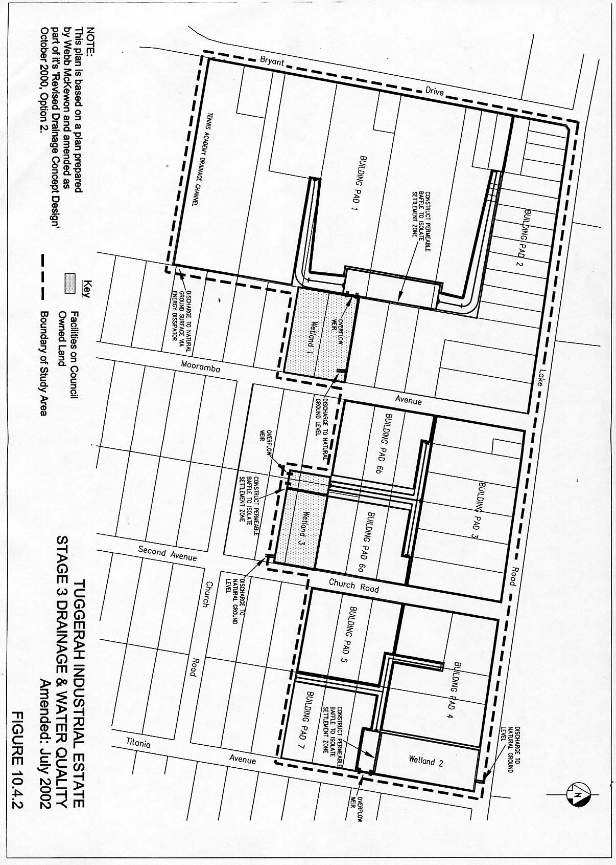

Scheme Details

The scheme provides for the construction of trunk drainage and water quality facilities to service a number of "building pads" which will be filled to allow for the development of the land for industrial purposes. A table indicating the summary of costs is set out below:

Table 14 Trunk Drainage and Water Quality Facilities – Summary of Costs

Component | Total
Preliminaries and Temporary Works | $135,000
Wetlands Construction | $214,600
Drainage Channel Earthworks | $171,300
Structural Concrete | $42,500
Diversion of local (clean) runoff | $21,400
Service Relocation and Miscellaneous Items | $75,000
Design | $32,990
Project Management & Administration | $46,186
Contingencies | $95,980
Studies | $55,059
Sub Total | $890,015
Land
Land Acquisition (including valuation costs) | $532,510
Sub Total | $532,510
TOTAL | $1,422,525  (June 2000)

Several components of the scheme are situated on Council owned operational land. The cost of land acquisition for these Council owned sections has been excluded from the scheme. The remaining area (channels, baffles and wetland No 2 ) have been included. The value for the land has been assessed as $231,000/ha. This figure includes a 5% margin for acquisition costs and valuations. A contingency of $30,000 has been included to cover the possibility of relocating wetland no. 2 to the northern side of Lake Rd.

"Building Pads" have been identified as areas suitable to be filled which will enable them to be developed. These “building pads” have a combined area of 19.03 NDA hectares.

Apportionment of Costs

The costs associated with the scheme will be apportioned over the land, as shown on Figure 16, which benefits from the works of the scheme.

Program for Works and Funding

The trunk drainage and associated water quality facilities are to be constructed as development of the area proceeds. Generally, water quality controls should be the first drainage elements constructed. Channels are to be progressively extended from downstream in conjunction with development phasing.

Contribution Rates

The contribution rate has been calculated separately for land acquisition and works. The cost of works associated with each component is divided by the net developable area of the building pads within the scheme.

Land

Contribution Rate = Total cost of land acquisition ÷ Net Developable Area
= $532,510 ÷ 19.03 NDA
= $27,988 per NDA

Works

Contribution Rate = Total cost of works ÷ Net Developable Area
= $910,565 (June 2002) ÷ 19.03 NDA
= $47,849 per NDA

3.6 Planning Studies

3.6.1 Introduction

Planning studies were undertaken by Council to enable development of an Environmental Study, Local Environmental Plan, Development Control Plan and this Contributions Plan.

3.6.2 Area of Scheme

These studies are specific to the Mardi Urban Release Area.

3.6.3 Scheme Details

The studies include:

- Traffic Study (Pak-Poy and Kneebone, 1990);
- Roadworks Design and Costing (Wyong Shire Council, 1991);
- Urban Capability Survey (Soil Conservation Service of New South Wales, 1991);
- Aesthetics (Land Systems EBC Pty Ltd, 1991); and
- Open Space Land Valuation (Robertson and Robertson, 1993).

3.6.4 Appointment of Costs

The studies relate to the full development of Mardi Urban Release Area and as all development within the Area will contribute on a proportional basis.

3.6.5 Program of Works

All studies have been completed.

3.6.6 Contribution Rate

The contribution rate will be calculated by dividing the total estimated costs as shown in Table P1 by the estimated net developable area (NDA).

Contribution Rate = $37,000 ÷ 52.86ha NDA
= $700 per ha NDA (June 1992)
= $771 (indexed June 2002)

Appendix A Schedule of Works

Table R1 Schedule of Works: Roads and Intersections – Mardi

Item | Est Cost ($ x 1000) | Forecast Development (Ha NDA)
 |  | ($ x 1000)
 |  | 0 | 5 | 11 | 16 | 21 | 26 | 32 | 37 | 42 | 48 | 53
Works Expenditure
(June 1992 & Feb 2000 costs - all indexed to Dec 2001)
1 Johnson Road Extension / RAB / assoc. cycleway | 770 | 0 | 0 | 0 | 0 | 0 | 0 | 770 | 0 | 0 | 0 | 0
2 Johnson Road/Pacific Hwy Intersection (part) | 258 | 0 | 0 | 0 | 0 | 0 | 0 | 0 | 0 | 0 | 0 | 258
3 Tonkiss Street Roundabout | 1537 | 0 | 1537 | 0 | 0 | 0 | 0 | 0 | 0 | 0 | 0 | 0
4 Distributor Road | 646 | 0 | 0 | 0 | 646 | 0 | 0 | 0 | 0 | 0 | 0 | 0
5 Cycleway - Tonkiss to Gavenlock | 120 | 0 | 0 | 0 | 0 | 0 | 0 | 0 | 0 | 0 | 0 | 120
6 Land for Distributor Road | 50 | 0 | 0 | 0 | 0 | 0 | 0 | 50 | 0 | 0 | 0 | 0
Total Expenditure | 3382 | 0 | 1537 | 0 | 646 | 0 | 0 | 820 | 0 | 0 | 0 | 378
Income ($ x 1000)
Developer Contributions Under This Plan | 2029 | 0 | 203 | 203 | 203 | 203 | 203 | 203 | 203 | 203 | 203 | 203
Council Contribution Required | 65 | 0 | 0 | 0 | 0 | 0 | 0 | 0 | 0 | 0 | 0 | 65
Other Income (interest/grants etc.) | 1291 | 0 | 0 | 0 | 0 | 0 | 0 | 0 | 0 | 0 | 0 | 1291
Contributions on Hand (incl. old funds) | 0 | 0 | 0 | 0 | 0 | 0 | 0 | 0 | 0 | 0 | 0 | 0
Contributions From Existing Consents | 0 | 0 | 0 | 0 | 0 | 0 | 0 | 0 | 0 | 0 | 0 | 0
Total Income | 3384 | 0 | 203 | 203 | 203 | 203 | 203 | 203 | 203 | 203 | 203 | 1559
Contribution Cash Flow |  | 0 | -1334 | -1132 | -1575 | -1372 | -1169 | -1787 | -1584 | -1381 | -1178 | 2
Council Bankrolling |  | 0 | 0 | 0 | 0 | 0 | 0 | 0 | 0 | 0 | 0 | 0
Developer Bankrolling |  | 0 | 0 | 0 | 0 | 0 | 0 | 0 | 0 | 0 | 0 | 0
Total Bankrolling |  | 0 | 0 | 0 | 0 | 0 | 0 | 0 | 0 | 0 | 0 | 0
Adjusted Period Balance |  | 0 | -1334 | -1132 | -1575 | -1372 | -1169 | -1787 | -1584 | -1381 | -1178 | 2
Contribution Rate ('000s) | 38.38
Current/Approved ha (if applic) | 0
Remaining ha | 52.86
Total Scheme ha | 52.86
Table R2 Schedule of Works: Roads & Intersections - Watanobbi

 |  |  | Forecast Development (DU)
 |  | Est Cost | ($ x 1000)
Item |  | ($ x 1000) | 0 | 86 | 173 | 259 | 345 | 432 | 518 | 604 | 690 | 777 | 863
Works Expenditure
Roundabout and lead-in road |  | 1275 | 0 | 1275 | 0 | 0 | 0 | 0 | 0 | 0 | 0 | 0 | 0
Total Expenditure |  | 1275 | 0 | 1275 | 0 | 0 | 0 | 0 | 0 | 0 | 0 | 0 | 0
Income ($ x 1000)
Developer Contributions Under This Plan |  | 1046 | 0 | 105 | 105 | 105 | 105 | 105 | 105 | 105 | 105 | 105 | 105
Council Contribution Required |  | 224 | 0 | 0 | 0 | 0 | 0 | 0 | 0 | 0 | 0 | 0 | 224
Other Income (interest/grants etc.) |  | 0 | 0 | 0 | 0 | 0 | 0 | 0 | 0 | 0 | 0 | 0 | 0
Contributions on Hand (incl. old funds) |  | 0 | 0 | 0 | 0 | 0 | 0 | 0 | 0 | 0 | 0 | 0 | 0
Contributions From Existing Consents |  | 0 | 0 | 0 | 0 | 0 | 0 | 0 | 0 | 0 | 0 | 0 | 0
Total Income |  | 1270 | 0 | 105 | 105 | 105 | 105 | 105 | 105 | 105 | 105 | 105 | 329
Contribution Cash Flow |  |  | 0 | -1170 | -1066 | -961 | -857 | -752 | -647 | -543 | -438 | -334 | -5
Council Bankrolling |  |  | 0 | 0 | 0 | 0 | 0 | 0 | 0 | 0 | 0 | 0 | 0
Developer Bankrolling |  |  | 0 | 0 | 0 | 0 | 0 | 0 | 0 | 0 | 0 | 0 | 0
Total Bankrolling |  |  | 0 | 0 | 0 | 0 | 0 | 0 | 0 | 0 | 0 | 0 | 0
Adjusted Period Balance |  |  | 0 | -1170 | -1066 | -961 | -857 | -752 | -647 | -543 | -438 | -334 | -5
Contribution Rate ('000s) | 1.212
Current/Approved DU (if applic) | 0
Remaining DU | 863
Total Scheme DU | 863

Table R3 Schedule of Works: Roads & Intersections - West Wyong

 |  | Forecast Development (DU)
 | Est Cost | ($ x 1000)
Item | ($ x 1000) | 0 | 29 | 57 | 86 | 114 | 143 | 172 | 200 | 229 | 257 | 286
Works Expenditure
(June 1992 Costs indexed to December 2001)
De L'Isle Drive | 977 | 0 | 977 | 0 | 0 | 0 | 0 | 0 | 0 | 0 | 0 | 0
Roundabout | 623 | 0 | 0 | 0 | 623 | 0 | 0 | 0 | 0 | 0 | 0 | 0
Land | 98 | 0 | 0 | 0 | 98 | 0 | 0 | 0 | 0 | 0 | 0 | 0
Total Expenditure | 1698 | 0 | 977 | 0 | 721 | 0 | 0 | 0 | 0 | 0 | 0 | 0
Income ($ x 1000)
Developer Contributions Under This Plan | 1698 | 0 | 170 | 170 | 170 | 170 | 170 | 170 | 170 | 170 | 170 | 170
Council Contribution Required | 0 | 0 | 0 | 0 | 0 | 0 | 0 | 0 | 0 | 0 | 0 | 0
Other Income (interest/grants etc.) | 0 | 0 | 0 | 0 | 0 | 0 | 0 | 0 | 0 | 0 | 0 | 0
Contributions on Hand (incl. old funds) | 0 | 0 | 0 | 0 | 0 | 0 | 0 | 0 | 0 | 0 | 0 | 0
Contributions From Existing Consents | 0 | 0 | 0 | 0 | 0 | 0 | 0 | 0 | 0 | 0 | 0 | 0
Total Income |  | 0 | 170 | 170 | 170 | 170 | 170 | 170 | 170 | 170 | 170 | 170
Contribution Cash Flow |  | 0 | -807 | -637 | -1188 | -1019 | -849 | -679 | -509 | -340 | -170 | 0
Council Bankrolling |  | 0 | 0 | 0 | 0 | 0 | 0 | 0 | 0 | 0 | 0 | 0
Developer Bankrolling |  | 0 | 0 | 0 | 0 | 0 | 0 | 0 | 0 | 0 | 0 | 0
Total Bankrolling |  | 0 | 0 | 0 | 0 | 0 | 0 | 0 | 0 | 0 | 0 | 0
Adjusted Period Balance |  | 0 | -807 | -637 | -1188 | -1019 | -849 | -679 | -509 | -340 | -170 | 0
Contribution Rate ('000s) | 5.936
Current/Approved DU (if applic) | 0
Remaining DU | 286
Total Scheme DU | 286

Table R4 Schedule of Works: Roads & Intersections - Hue Hue Road

 |  |  | Forecast Development (DU)
 |  | Est Cost | ($ x 1000)
Item |  | ($ x 1000) | 0 | 16 | 31 | 47 | 62 | 78 | 93 | 109 | 124 | 140 | 155
Works Expenditure (June 1992 costs)
St Johns Road Intersection |  | 237 | 0 | 0 | 0 | 0 | 0 | 237 | 0 | 0 | 0 | 0 | 0
Holloway Drive Intersection |  | 276 | 0 | 276 | 0 | 0 | 0 | 0 | 0 | 0 | 0 | 0 | 0
Sandra Street |  | 170 | 0 | 0 | 170 | 0 | 0 | 0 | 0 | 0 | 0 | 0 | 0
Total Expenditure |  | 683 | 0 | 276 | 170 | 0 | 0 | 237 | 0 | 0 | 0 | 0 | 0
Income ($ x 1000)
Developer Contributions Under This Plan |  | 683 | 0 | 68 | 68 | 68 | 68 | 68 | 68 | 68 | 68 | 68 | 68
Council Contribution Required |  | 0 | 0 | 0 | 0 | 0 | 0 | 0 | 0 | 0 | 0 | 0 | 0
Other Income (interest/grants etc.) |  | 0 | 0 | 0 | 0 | 0 | 0 | 0 | 0 | 0 | 0 | 0 | 0
Contributions on Hand (incl. old funds) |  | 0 | 0 | 0 | 0 | 0 | 0 | 0 | 0 | 0 | 0 | 0 | 0
Contributions From Existing Consents |  | 0 | 0 | 0 | 0 | 0 | 0 | 0 | 0 | 0 | 0 | 0 | 0
Total Income |  | 683 | 0 | 68 | 68 | 68 | 68 | 68 | 68 | 68 | 68 | 68 | 68
Contribution Cash Flow |  |  | 0 | -208 | -309 | -241 | -173 | -341 | -273 | -205 | -137 | -68 | 0
Council Bankrolling |  |  | 0 | 0 | 0 | 0 | 0 | 0 | 0 | 0 | 0 | 0 | 0
Developer Bankrolling |  |  | 0 | 0 | 0 | 0 | 0 | 0 | 0 | 0 | 0 | 0 | 0
Total Bankrolling |  |  | 0 | 0 | 0 | 0 | 0 | 0 | 0 | 0 | 0 | 0 | 0
Adjusted Period Balance |  |  | 0 | -208 | -309 | -241 | -173 | -341 | -273 | -205 | -137 | -68 | 0
Contribution Rate ('000s) | 4.405
Current/Approved DU (if applic) | 0
Remaining DU | 155
Total Scheme DU | 155

Table R5 Schedule of Works: Roads & Intersections - Leewood Close

 |  | Forecast Development (DU)
 | Est Cost | ($ x 1000)
Item | ($ x 1000) | 0 |  | 2 |  | 3 |  | 5 |  | 6 |  | 8 |  | 10 |  | 11 |  | 13 |  |  | 14 |  | 16
Works Expenditure (June 1992 costs)
Construction of Leewood Close | 88 | 0 |  | 0 |  | 0 |  | 0 |  | 0 |  | 88 |  | 0 |  | 0 |  | 0 |  |  | 0 |  | 0
Total Expenditure | 88 | 0 |  | 0 |  | 0 |  | 0 |  | 0 |  | 88 |  | 0 |  | 0 |  | 0 |  |  | 0 |  | 0
Income ($ x 1000)
Developer Contributions Under This Plan | 88 | 0 |  | 9 |  | 9 |  | 9 |  | 9 |  | 9 |  | 9 |  | 9 |  | 9 |  |  | 9 |  | 9
Council Contribution Required |  | 0 |  | 0 |  | 0 |  | 0 |  | 0 |  | 0 |  | 0 |  | 0 |  | 0 |  |  | 0 |  | 0
Other Income (interest/grants etc.) |  | 0 |  | 0 |  | 0 |  | 0 |  | 0 |  | 0 |  | 0 |  | 0 |  | 0 |  |  | 0 |  | 0
Contributions on Hand (incl. old funds) |  | 0 |  | 0 |  | 0 |  | 0 |  | 0 |  | 0 |  | 0 |  | 0 |  | 0 |  |  | 0 |  | 0
Contributions From Existing Consents |  | 0 |  | 0 |  | 0 |  | 0 |  | 0 |  | 0 |  | 0 |  | 0 |  | 0 |  |  | 0 |  | 0
Total Income |  | 0 |  | 9 |  | 9 |  | 9 |  | 9 |  | 9 |  | 9 |  | 9 |  | 9 |  |  | 9 |  | 9
Contribution Cash Flow |  | 0 |  | 9 |  | 18 |  | 26 |  | 35 |  | -44 |  | -35 |  | -26 |  | -18 |  |  | -9 |  | 0
Council Bankrolling |  | 0 |  | 0 |  | 0 |  | 0 |  | 0 |  | 0 |  | 0 |  | 0 |  | 0 |  |  | 0 |  | 0
Developer Bankrolling |  | 0 |  | 0 |  | 0 |  | 0 |  | 0 |  | 0 |  | 0 |  | 0 |  | 0 |  |  | 0 |  | 0
Total Bankrolling |  | 0 |  | 0 |  | 0 |  | 0 |  | 0 |  | 0 |  | 0 |  | 0 |  | 0 |  |  | 0 |  | 0
Adjusted Period Balance |  | 0 |  | 9 |  | 18 |  | 26 |  | 35 |  | -44 |  | -35 |  | -26 |  | -18 |  |  | -9 |  | 0
Contribution Rate ('000s) | 5.505
Current/Approved DU (if applic) | 0
Remaining DU | 16
Total Scheme DU | 16

Table R6 Schedule of Works: Roads & Intersections - Mardi South

 |  |  | Forecast Development (DU)
 | Est Cost |  | ($ x 1000)
Item | ($ x 1000) |  | 0 |  | 25 |  | 49 |  | 74 |  | 98 |  | 123 |  | 148 |  | 172 |  | 197 |  |  | 221 |  | 246
Works Expenditure
"T" Intersection - Pacific Highway | 193 |  | 0 |  | 0 |  | 0 |  | 193 |  | 0 |  | 0 |  | 0 |  | 0 |  | 0 |  |  | 0 |  | 0
Total Expenditure | 193 |  | 0 |  | 0 |  | 0 |  | 193 |  | 0 |  | 0 |  | 0 |  | 0 |  | 0 |  |  | 0 |  | 0
Income ( $ x 1000)
Developer Contributions Under This Plan |  |  | 0 |  | 19 |  | 19 |  | 19 |  | 19 |  | 19 |  | 19 |  | 19 |  | 19 |  |  | 19 |  | 19
Council Contribution Required |  |  | 0 |  | 0 |  | 0 |  | 0 |  | 0 |  | 0 |  | 0 |  | 0 |  | 0 |  |  | 0 |  | 0
Other Income (interest/grants etc.) |  |  | 0 |  | 0 |  | 0 |  | 0 |  | 0 |  | 0 |  | 0 |  | 0 |  | 0 |  |  | 0 |  | 0
Contributions on Hand (incl. old funds) |  |  | 0 |  | 0 |  | 0 |  | 0 |  | 0 |  | 0 |  | 0 |  | 0 |  | 0 |  |  | 0 |  | 0
Contributions From Existing Consents |  |  | 0 |  | 0 |  | 0 |  | 0 |  | 0 |  | 0 |  | 0 |  | 0 |  | 0 |  |  | 0 |  | 0
Total Income |  |  | 0 |  | 19 |  | 19 |  | 19 |  | 19 |  | 19 |  | 19 |  | 19 |  | 19 |  |  | 19 |  | 19
Contribution Cash Flow |  |  | 0 |  | 19 |  | 39 |  | -135 |  | -116 |  | -96 |  | -77 |  | -58 |  | -39 |  |  | -19 |  | 0
Council Bankrolling |  |  | 0 |  | 0 |  | 0 |  | 0 |  | 0 |  | 0 |  | 0 |  | 0 |  | 0 |  |  | 0 |  | 0
Developer Bankrolling |  |  | 0 |  | 0 |  | 0 |  | 0 |  | 0 |  | 0 |  | 0 |  | 0 |  | 0 |  |  | 0 |  | 0
Total Bankrolling |  |  | 0 |  | 0 |  | 0 |  | 0 |  | 0 |  | 0 |  | 0 |  | 0 |  | 0 |  |  | 0 |  | 0
Adjusted Period Balance |  |  | 0 |  | 19 |  | 39 |  | -135 |  | -116 |  | -96 |  | -77 |  | -58 |  | -39 |  |  | -19 |  | 0
Contribution Rate ('000s) | 0.783
Current/Approved DU (if applic) | 0
Remaining DU | 246
Total Scheme DU | 246

Table R6 Schedule of Works: Roads & Intersections - Wyong Road / Bryant Drive

 |  | Forecast Development (DU)
 | Est Cost | ($ x 1000)
Item | ($ x 1000) | 0 | 4 | 8 | 11 | 15 | 19 | 23 | 26 | 30 | 34 | 38
Works Expenditure
Wyong Rd/Bryant Dr RAB | 430 | 0 | 430 | 0 | 0 | 0 | 0 | 0 | 0 | 0 | 0 | 0
Left Turn slip lane | 421 | 0 | 421 | 0 | 0 | 0 | 0 | 0 | 0 | 0 | 0 | 0
Total Expenditure | 851 | 0 | 851 | 0 | 0 | 0 | 0 | 0 | 0 | 0 | 0 | 0
Income ($ x 1000)
Developer Contributions Under This Plan | 180 | 0 | 18 | 18 | 18 | 18 | 18 | 18 | 18 | 18 | 18 | 18
Council Contribution Required | 0 | 0 | 0 | 0 | 0 | 0 | 0 | 0 | 0 | 0 | 0 | 0
Tuggerah Business Park | 338 | 0 | 338 | 0 | 0 | 0 | 0 | 0 | 0 | 0 | 0 | 0
Supa Centa | 127 | 0 | 127 | 0 | 0 | 0 | 0 | 0 | 0 | 0 | 0 | 0
Westfields | 206 | 0 | 206 | 0 | 0 | 0 | 0 | 0 | 0 | 0 | 0 | 0
Other Income (interest/grants etc.) | 0 | 0 | 0 | 0 | 0 | 0 | 0 | 0 | 0 | 0 | 0 | 0
Contributions on Hand (incl. old funds) | 0 | 0 | 0 | 0 | 0 | 0 | 0 | 0 | 0 | 0 | 0 | 0
Contributions From Existing Consents | 0 | 0 | 0 | 0 | 0 | 0 | 0 | 0 | 0 | 0 | 0 | 0
Total Income | 851 | 0 | 689 | 18 | 18 | 18 | 18 | 18 | 18 | 18 | 18 | 18
Contribution Cash Flow |  | 0 | -162 | -144 | -126 | -108 | -90 | -72 | -54 | -36 | -18 | 0
Council Bankrolling |  | 0 | 0 | 0 | 0 | 0 | 0 | 0 | 0 | 0 | 0 | 0
Developer Bankrolling |  | 0 | 0 | 0 | 0 | 0 | 0 | 0 | 0 | 0 | 0 | 0
Total Bankrolling |  | 0 | 0 | 0 | 0 | 0 | 0 | 0 | 0 | 0 | 0 | 0
Adjusted Period Balance |  | 0 | -162 | -144 | -126 | -108 | -90 | -72 | -54 | -36 | -18 | 0
Contribution Rate ('000s) | 4.76
Current/Approved NDA (if applic) | 0
Remaining NDA | 37.8
Total Scheme NDA | 37.8

Table R6 Schedule of Works: Roads & Intersections - Tuggerah Industrial Area Stage 3

 |  |  |  |  | Forecast Development (DU)
 |  | Est Cost |  |  | ($ x 1000)
Item |  | ($ x 1000) |  |  | 0 |  | 5 |  | 10 |  | 16 |  | 21 |  | 26 |  | 31 |  | 37 |  | 42 |  | 47 |  | 52
Works Expenditure
Half Road Construction of Bryant Dr |  | 147 |  |  | 0 |  | 147 |  | 0 |  | 0 |  | 0 |  | 0 |  | 0 |  | 0 |  | 0 |  | 0 |  | 0
Construction of Lake Rd & Part of Church Rd & Mooramba Ave |  | 2100 |  |  |  |  | 210 |  | 210 |  | 210 |  | 210 |  | 210 |  | 210 |  | 210 |  | 210 |  | 210 |  | 210
Total Expenditure |  | 2247 |  |  | 0 |  | 357 |  | 210 |  | 210 |  | 210 |  | 210 |  | 210 |  | 210 |  | 210 |  | 210 |  | 210
Income ( $ x 1000)
Developer Contributions Under This Plan |  | 2248 |  |  | 0 |  | 225 |  | 225 |  | 225 |  | 225 |  | 225 |  | 225 |  | 225 |  | 225 |  | 225 |  | 225
Council Contribution Required |  |  |  |  | 0 |  | 0 |  | 0 |  | 0 |  | 0 |  | 0 |  | 0 |  | 0 |  | 0 |  | 0 |  | 0
Other Income (interest/grants etc.) |  |  |  |  | 0 |  | 0 |  | 0 |  | 0 |  | 0 |  | 0 |  | 0 |  | 0 |  | 0 |  | 0 |  | 0
Contributions on Hand (incl. old funds) |  |  |  |  | 0 |  | 0 |  | 0 |  | 0 |  | 0 |  | 0 |  | 0 |  | 0 |  | 0 |  | 0 |  | 0
Contributions From Existing Consents |  |  |  |  | 0 |  | 0 |  | 0 |  | 0 |  | 0 |  | 0 |  | 0 |  | 0 |  | 0 |  | 0 |  | 0
Total Income |  | 2248 |  |  | 0 |  | 225 |  | 225 |  | 225 |  | 225 |  | 225 |  | 225 |  | 225 |  | 225 |  | 225 |  | 225
Contribution Cash Flow |  |  |  |  | 0 |  | -132 |  | -117 |  | -103 |  | -88 |  | -73 |  | -58 |  | -44 |  | -29 |  | -14 |  | 1
Council Bankrolling |  |  |  |  | 0 |  | 0 |  | 0 |  | 0 |  | 0 |  | 0 |  | 0 |  | 0 |  | 0 |  | 0 |  | 0
Developer Bankrolling |  |  |  |  | 0 |  | 0 |  | 0 |  | 0 |  | 0 |  | 0 |  | 0 |  | 0 |  | 0 |  | 0 |  | 0
Total Bankrolling |  |  |  |  | 0 |  | 0 |  | 0 |  | 0 |  | 0 |  | 0 |  | 0 |  | 0 |  | 0 |  | 0 |  | 0
Adjusted Period Balance |  |  |  |  | 0 |  | -132 |  | -117 |  | -103 |  | -88 |  | -73 |  | -58 |  | -44 |  | -29 |  | -14 |  | 1
Contribution Rate ('000s) | 43.065
Current/Approved NDA (if applic) | 0
Remaining NDA | 52.19
Total Scheme NDA | 52.19

Table C1A Schedule of Works: Community Facilities – Mardi

 | Area | Rate | Est Cost | Forecast Development (DU)
 | (m²) | ($ x 1000 | ($ x 1000) | ($ x 1000)
Item |  | $/sq m) |  | 0 | 10 | 20 | 30 | 40 | 51 | 61 | 71 | 81 | 91 | 101
Works Expenditure (1992 costs indexed to Nov 1999)
Community Centre Floorspace | 196 | 2.793 | 547 | 0 | 0 | 0 | 547 | 0 | 0 | 0 | 0 | 0 | 0 | 0
Total Expenditure |  |  | 547 | 0 | 0 | 0 | 547 | 0 | 0 | 0 | 0 | 0 | 0 | 0
Income ( $ x 1000)
Developer Contributions Under This Plan |  |  | 254 | 0 | 25 | 25 | 25 | 25 | 25 | 25 | 25 | 25 | 25 | 25
Council Contribution Required |  |  | 0 | 0 | 0 | 0 | 0 | 0 | 0 | 0 | 0 | 0 | 0 | 0
Other Income (interest/grants etc.) |  |  | 0 | 0 | 0 | 0 | 0 | 0 | 0 | 0 | 0 | 0 | 0 | 0
Contributions on Hand (incl. old funds) |  |  | 137 | 0 | 137 | 0 | 0 | 0 | 0 | 0 | 0 | 0 | 0 | 0
Contributions From Existing Consents |  |  | 157 | 0 | 157 | 0 | 0 | 0 | 0 | 0 | 0 | 0 | 0 | 0
Total Income |  |  | 548 | 0 | 319 | 25 | 25 | 25 | 25 | 25 | 25 | 25 | 25 | 25
Contribution Cash Flow |  |  |  | 0 | 319 | 345 | -177 | -152 | -126 | -101 | -76 | -50 | -25 | 1
Council Bankrolling |  |  |  | 0 | 0 | 0 | 0 | 0 | 0 | 0 | 0 | 0 | 0 | 0
Developer Bankrolling |  |  |  | 0 | 0 | 0 | 0 | 0 | 0 | 0 | 0 | 0 | 0 | 0
Total Bankrolling |  |  |  | 0 | 0 | 0 | 0 | 0 | 0 | 0 | 0 | 0 | 0 | 0
Adjusted Period Balance |  |  |  | 0 | 319 | 345 | -177 | -152 | -126 | -101 | -76 | -50 | -25 | 1
Contribution Rate ('000s) | 2.516
Current/Approved DU (if applic) | 1003
Remaining DU | 101
Total Scheme DU | 1104

Table C1B Schedule of Works: Community Facilities Land - Mardi

 |  |  |  | Forecast Development (DU)
 | Area | Rate | Est Cost | ($ x 1000)
Item | (m²) | (x 1000) | ($ x 1000) | 0 | 0 | 1 | 1 | 1 | 2 | 2 | 2 | 3 | 3 | 3
Works Expenditure
Community Facilities Land | 5.635 | 20 | 113 | 0 | 0 | 0 | 0 | 0 | 113 | 0 | 0 | 0 | 0 | 0
Total Expenditure |  |  | 113 | 0 | 0 | 0 | 0 | 0 | 113 | 0 | 0 | 0 | 0 | 0
Income ($ x 1000)
Developer Contributions Under This Plan |  |  | 11 | 0 | 1 | 1 | 1 | 1 | 1 | 1 | 1 | 1 | 1 | 1
Council Contribution Required |  |  | 0 | 0 | 0 | 0 | 0 | 0 | 0 | 0 | 0 | 0 | 0 | 0
Other Income (interest/grants etc.) |  |  | 0 | 0 | 0 | 0 | 0 | 0 | 0 | 0 | 0 | 0 | 0 | 0
Contributions on Hand (incl. old funds) |  |  | 87 | 0 | 87 | 0 | 0 | 0 | 0 | 0 | 0 | 0 | 0 | 0
Contributions From Existing Consents |  |  | 15 | 0 | 15 | 0 | 0 | 0 | 0 | 0 | 0 | 0 | 0 | 0
Total Income |  |  | 113 | 0 | 103 | 1 | 1 | 1 | 1 | 1 | 1 | 1 | 1 | 1
Contribution Cash Flow |  |  |  | 0 | 103 | 104 | 105 | 107 | -5 | -4 | -3 | -2 | -1 | 1
Council Bankrolling |  |  |  | 0 | 0 | 0 | 0 | 0 | 0 | 0 | 0 | 0 | 0 | 0
Developer Bankrolling |  |  |  | 0 | 0 | 0 | 0 | 0 | 0 | 0 | 0 | 0 | 0 | 0
Total Bankrolling |  |  |  | 0 | 0 | 0 | 0 | 0 | 0 | 0 | 0 | 0 | 0 | 0
Adjusted Period Balance |  |  |  | 0 | 103 | 104 | 105 | 107 | -5 | -4 | -3 | -2 | -1 | 1
Contribution Rate ('000s) | 3.525
Current/Approved NDA(if applic) | 49.66
Remaining NDA | 3.2
Total Scheme NDA | 52.86

Table C2A Schedule of Works: Community Facilities Works - Watanobbi & West Wyong

 |  | Rate |  | Forecast Development (DU)
 | Area | ($ x 1000 | Est Cost | ($ x 1000)
Item | (m²) | $/sq m) | ($ x 1000) | 0 | 29 | 57 | 86 | 114 | 143 | 172 | 200 | 229 | 257 | 286
Works Expenditure (June 1992 costs)
Community Centre Floorspace | 344 | 2.793 | 961 | 0 | 0 | 0 | 961 | 0 | 0 | 0 | 0 | 0 | 0 | 0
Total Expenditure |  |  | 961 | 0 | 0 | 0 | 961 | 0 | 0 | 0 | 0 | 0 | 0 | 0
Income ($ x 1000)
Developer Contributions Under This Plan |  |  | 719 | 0 | 72 | 72 | 72 | 72 | 72 | 72 | 72 | 72 | 72 | 72
Council Contribution Required |  |  | 0 | 0 | 0 | 0 | 0 | 0 | 0 | 0 | 0 | 0 | 0 | 0
Other Income (interest/grants etc.) |  |  | 0 | 0 | 0 | 0 | 0 | 0 | 0 | 0 | 0 | 0 | 0 | 0
Contributions on Hand (incl. old funds) |  |  | 4 | 0 | 4 | 0 | 0 | 0 | 0 | 0 | 0 | 0 | 0 | 0
Contributions From Existing Consents |  |  | 239 | 0 | 239 | 0 | 0 | 0 | 0 | 0 | 0 | 0 | 0 | 0
Total Income |  |  | 962 | 0 | 315 | 72 | 72 | 72 | 72 | 72 | 72 | 72 | 72 | 72
Contribution Cash Flow |  |  |  | 0 | 315 | 387 | -502 | -430 | -358 | -286 | -214 | -143 | -71 | 1
Council Bankrolling |  |  |  | 0 | 0 | 0 | 0 | 0 | 0 | 0 | 0 | 0 | 0 | 0
Developer Bankrolling |  |  |  | 0 | 0 | 0 | 0 | 0 | 0 | 0 | 0 | 0 | 0 | 0
Total Bankrolling |  |  |  | 0 | 0 | 0 | 0 | 0 | 0 | 0 | 0 | 0 | 0 | 0
Adjusted Period Balance |  |  |  | 0 | 315 | 387 | -502 | -430 | -358 | -286 | -214 | -143 | -71 | 1
Contribution Rate ('000s) | 2.514
Current/Approved DU (if applic) | 1052
Remaining DU | 286
Total Scheme DU | 1338

Table C2B Schedule of Works: Community Facilities Land - Watanobbi & West Wyong

 |  | Rate |  | Forecast Development (DU)
 | Area | ($ x 1000 | Est Cost | ($ x 1000)
Item | (m²) | $/sq m) | ($ x 1000) | 0 | 29 | 57 | 86 | 114 | 143 | 172 | 200 | 229 | 257 | 286
Works Expenditure
Community Facilities Land | 5.106 | 20 | 102 | 0 | 0 | 0 | 0 | 0 | 0 | 0 | 0 | 0 | 102 | 0
Total Expenditure |  |  | 102 | 0 | 0 | 0 | 0 | 0 | 0 | 0 | 0 | 0 | 102 | 0
Income ($ x 1000)
Developer Contributions Under This Plan |  |  | 32 | 0 | 3 | 3 | 3 | 3 | 3 | 3 | 3 | 3 | 3 | 3
Council Contribution Required |  |  | 0 | 0 | 0 | 0 | 0 | 0 | 0 | 0 | 0 | 0 | 0 | 0
Other Income (interest/grants etc.) |  |  | 0 | 0 | 0 | 0 | 0 | 0 | 0 | 0 | 0 | 0 | 0 | 0
Contributions on Hand (incl. old funds) |  |  | 52 | 0 | 52 | 0 | 0 | 0 | 0 | 0 | 0 | 0 | 0 | 0
Contributions From Existing Consents |  |  | 18 | 0 | 18 | 0 | 0 | 0 | 0 | 0 | 0 | 0 | 0 | 0
Total Income |  |  | 102 | 0 | 73 | 3 | 3 | 3 | 3 | 3 | 3 | 3 | 3 | 3
Contribution Cash Flow |  |  |  | 0 | 73 | 76 | 80 | 83 | 86 | 89 | 92 | 96 | -3 | 0
Council Bankrolling |  |  |  | 0 | 0 | 0 | 0 | 0 | 0 | 0 | 0 | 0 | 0 | 0
Developer Bankrolling |  |  |  | 0 | 0 | 0 | 0 | 0 | 0 | 0 | 0 | 0 | 0 | 0
Total Bankrolling |  |  |  | 0 | 0 | 0 | 0 | 0 | 0 | 0 | 0 | 0 | 0 | 0
Adjusted Period Balance |  |  |  | 0 | 73 | 76 | 80 | 83 | 86 | 89 | 92 | 96 | -3 | 0
Contribution Rate ('000s) | 0.112
Current/Approved DU (if applic) | 1052
Remaining DU | 286
Total Scheme DU | 1338

Table C3A Schedule of Works: Community Facilities Works - Remainder of District

 |  | Rate |  | Forecast Development (DU)
 | Area | ($ x 1000 | Est Cost | ($ x 1000)
Item | (m²) | $/sq m) | ($ x 1000) | 0 | 16 | 33 | 49 | 66 | 82 | 98 | 115 | 131 | 148 | 164
Works Expenditure
Community Centre Floorspace | 224 | 2.793 | 626 | 0 | 0 | 0 | 0 | 0 | 0 | 0 | 0 | 0 | 0 | 626
Total Expenditure |  |  | 626 | 0 | 0 | 0 | 0 | 0 | 0 | 0 | 0 | 0 | 0 | 626
Income ($ x 1000)
Developer Contributions Under This Plan |  |  | 412 | 0 | 41 | 41 | 41 | 41 | 41 | 41 | 41 | 41 | 41 | 41
Council Contribution Required |  |  | 0 | 0 | 0 | 0 | 0 | 0 | 0 | 0 | 0 | 0 | 0 | 0
Other Income (interest/grants etc.) |  |  | 0 | 0 | 0 | 0 | 0 | 0 | 0 | 0 | 0 | 0 | 0 | 0
Contributions on Hand (incl. old funds) |  |  | 177 | 0 | 177 | 0 | 0 | 0 | 0 | 0 | 0 | 0 | 0 | 0
Contributions From Existing Consents |  |  | 37 | 0 | 37 | 0 | 0 | 0 | 0 | 0 | 0 | 0 | 0 | 0
Total Income |  |  | 626 | 0 | 255 | 41 | 41 | 41 | 41 | 41 | 41 | 41 | 41 | 41
Contribution Cash Flow |  |  |  | 0 | 255 | 296 | 338 | 379 | 420 | 461 | 503 | 544 | 585 | 1
Council Bankrolling |  |  |  | 0 | 0 | 0 | 0 | 0 | 0 | 0 | 0 | 0 | 0 | 0
Developer Bankrolling |  |  |  | 0 | 0 | 0 | 0 | 0 | 0 | 0 | 0 | 0 | 0 | 0
Total Bankrolling |  |  |  | 0 | 0 | 0 | 0 | 0 | 0 | 0 | 0 | 0 | 0 | 0
Adjusted Period Balance |  |  |  | 0 | 255 | 296 | 338 | 379 | 420 | 461 | 503 | 544 | 585 | 1
Contribution Rate ('000s) | 2.514
Current/Approved DU (if applic) | 0
Remaining DU | 164
Total Scheme DU | 164

Table C3B Schedule of Works: Community Facilities Land - Remainder of District

 |  | Rate |  | Forecast Development (DU)
 | Area | ($ x 1000 | Est Cost | ($ x 1000)
Item | (m²) | $/sq m) | ($ x 1000) | 0 | 16 | 33 | 49 | 66 | 82 | 98 | 115 | 131 | 148 | 164
Works Expenditure
Community Facilities Land | 1.096 | 180 | 197 | 0 | 0 | 0 | 0 | 0 | 0 | 0 | 0 | 0 | 0 | 138
Total Expenditure |  |  | 197 | 0 | 0 | 0 | 0 | 0 | 0 | 0 | 0 | 0 | 0 | 138
Income ($ x 1000)
Developer Contributions Under This Plan |  |  | 165 | 0 | 17 | 17 | 17 | 17 | 17 | 17 | 17 | 17 | 17 | 17
Council Contribution Required |  |  | 0 | 0 | 0 | 0 | 0 | 0 | 0 | 0 | 0 | 0 | 0 | 0
Other Income (interest/grants etc.) |  |  | 0 | 0 | 0 | 0 | 0 | 0 | 0 | 0 | 0 | 0 | 0 | 0
Contributions on Hand (incl. old funds) |  |  | 20 | 0 | 20 | 0 | 0 | 0 | 0 | 0 | 0 | 0 | 0 | 0
Contributions From Existing Consents |  |  | 12 | 0 | 12 | 0 | 0 | 0 | 0 | 0 | 0 | 0 | 0 | 0
Total Income |  |  | 197 | 0 | 49 | 17 | 17 | 17 | 17 | 17 | 17 | 17 | 17 | 17
Contribution Cash Flow |  |  |  | 0 | 49 | 65 | 82 | 98 | 115 | 131 | 148 | 164 | 181 | 59
Council Bankrolling |  |  |  | 0 | 0 | 0 | 0 | 0 | 0 | 0 | 0 | 0 | 0 | 0
Developer Bankrolling |  |  |  | 0 | 0 | 0 | 0 | 0 | 0 | 0 | 0 | 0 | 0 | 0
Total Bankrolling |  |  |  | 0 | 0 | 0 | 0 | 0 | 0 | 0 | 0 | 0 | 0 | 0
Adjusted Period Balance |  |  |  | 0 | 49 | 65 | 82 | 98 | 115 | 131 | 148 | 164 | 181 | 59
Contribution Rate ('000s) | 1.008
Current/Approved DU (if applic) | 0
Remaining DU | 164
Total Scheme DU | 164

Table S1A Schedule of Works: Open Space Works - Mardi URA

 |  | Rate |  | Forecast Development (DU)
 | Area | ($ x 1000 | Est Cost | ($ x 1000)
Item | (m²) | $/sq m) | ($ x 1000) | 0 | 110 | 221 | 331 | 442 | 552 | 662 | 773 | 883 | 994 | 1104
Works Expenditure
Small Park (P1) | 6000 | 0.011 | 66 | 0 | 0 | 66 | 0 | 0 | 0 | 0 | 0 | 0 | 0 | 0
Small Park (P3) | 6000 | 0.01075 | 66 | 0 | 0 | 0 | 66 | 0 | 0 | 0 | 0 | 0 | 0 | 0
Small Park (P6) | 6000 | 0.01075 | 66 | 0 | 0 | 0 | 66 | 0 | 0 | 0 | 0 | 0 | 0 | 0
Large Park (P2) | 12000 | 0.005 | 61 | 0 | 0 | 0 | 0 | 61 | 0 | 0 | 0 | 0 | 0 | 0
Large Park (P4) | 16000 | 0.001 | 18 | 0 | 0 | 0 | 0 | 18 | 0 | 0 | 0 | 0 | 0 | 0
Large Park (P7) - Playground |  |  | 26 | 0 | 0 | 0 | 0 | 0 | 0 | 0 | 0 | 0 | 0 | 26
Large Park (P7) - Kickaround Area |  |  | 41 | 0 | 0 | 0 | 0 | 0 | 0 | 0 | 0 | 0 | 0 | 41
Semi-natural (P5) | 18000 | 0.0011 | 20 | 0 | 0 | 0 | 0 | 0 | 0 | 0 | 0 | 0 | 20 | 0
Courts | 4207 | 0.103 | 476 | 0 | 0 | 0 | 0 | 0 | 0 | 0 | 0 | 0 | 0 | 476
Fields | 23388 | 0.034 | 798 | 0 | 0 | 0 | 0 | 0 | 0 | 0 | 0 | 0 | 0 | 798
Total Expenditure |  |  | 1636 | 0 | 0 | 66 | 132 | 79 | 0 | 0 | 0 | 0 | 20 | 1340
Income ( $ x 1000)
Developer Contributions Under This Plan |  |  | 1637 | 0 | 164 | 164 | 164 | 164 | 164 | 164 | 164 | 164 | 164 | 164
Council Contribution Required |  |  | 0 | 0 | 0 | 0 | 0 | 0 | 0 | 0 | 0 | 0 | 0 | 0
Other Income (interest/grants etc.) |  |  | 0 | 0 | 0 | 0 | 0 | 0 | 0 | 0 | 0 | 0 | 0 | 0
Contributions on Hand (incl. old funds) |  |  | 0 | 0 | 0 | 0 | 0 | 0 | 0 | 0 | 0 | 0 | 0 | 0
Contributions From Existing Consents |  |  | 0 | 0 | 0 | 0 | 0 | 0 | 0 | 0 | 0 | 0 | 0 | 0
Total Income |  |  | 1637 | 0 | 164 | 164 | 164 | 164 | 164 | 164 | 164 | 164 | 164 | 164
Contribution Cash Flow |  |  |  | 0 | 164 | 261 | 293 | 378 | 542 | 705 | 869 | 1033 | 1177 | 0
Council Bankrolling |  |  |  | 0 | 0 | 0 | 0 | 0 | 0 | 0 | 0 | 0 | 0 | 0
Developer Bankrolling |  |  |  | 0 | 0 | 0 | 0 | 0 | 0 | 0 | 0 | 0 | 0 | 0
Total Bankrolling |  |  |  | 0 | 0 | 0 | 0 | 0 | 0 | 0 | 0 | 0 | 0 | 0
Adjusted Period Balance |  |  |  | 0 | 164 | 261 | 293 | 378 | 542 | 705 | 869 | 1033 | 1177 | 0
Contribution Rate ('000s) | 1.483
Current/Approved DU (if applic) | 0
Remaining DU | 1104
Total Scheme DU | 1104
Table S1B Schedule of Works: Open Space Land - Mardi URA

 |  | Rate |  | Forecast Development (Ha)
 | Area | ($ x 1000 | Est Cost | ($ x 1000)
Item | (m²) | $/sq m) | ($ x 1000) | 0 | 5 | 11 | 16 | 21 | 26 | 32 | 37 | 42 | 48 | 53
Works Expenditure
Small Park (P1) | 6000 |  | 15 | 0 | 0 | 0 | 0 | 0 | 0 | 15 | 0 | 0 | 0 | 0
Small Park (P3) | 6000 |  | 22 | 0 | 0 | 0 | 0 | 0 | 22 | 0 | 0 | 0 | 0 | 0
Small Park (P6) | 6000 |  | 52 | 0 | 52 | 0 | 0 | 0 | 0 | 0 | 0 | 0 | 0 | 0
Large Park (P2) | 12000 |  | 26 | 0 | 0 | 0 | 0 | 0 | 26 | 0 | 0 | 0 | 0 | 0
Large Park (P4) | 16000 |  | 15 | 0 | 0 | 0 | 15 | 0 | 0 | 0 | 0 | 0 | 0 | 0
Semi-Natural (P5) | 18000 |  | 339 | 0 | 0 | 0 | 0 | 0 | 0 | 0 | 339 | 0 | 0 | 0
Total Expenditure |  |  | 469 | 0 | 52 | 0 | 15 | 0 | 48 | 15 | 339 | 0 | 0 | 0
Income ( $ x 1000)
Developer Contributions Under This Plan |  |  | 469 | 0 | 47 | 47 | 47 | 47 | 47 | 47 | 47 | 47 | 47 | 47
Council Contribution Required |  |  | 0 | 0 | 0 | 0 | 0 | 0 | 0 | 0 | 0 | 0 | 0 | 0
Other Income (interest/grants etc.) |  |  | 0 | 0 | 0 | 0 | 0 | 0 | 0 | 0 | 0 | 0 | 0 | 0
Contributions on Hand (incl. old funds) |  |  | 0 | 0 | 0 | 0 | 0 | 0 | 0 | 0 | 0 | 0 | 0 | 0
Contributions From Existing Consents |  |  | 0 | 0 | 0 | 0 | 0 | 0 | 0 | 0 | 0 | 0 | 0 | 0
Total Income |  |  | 469 | 0 | 47 | 47 | 47 | 47 | 47 | 47 | 47 | 47 | 47 | 47
Contribution Cash Flow |  |  |  | 0 | -5 | 42 | 74 | 121 | 120 | 151 | -141 | -94 | -47 | 0
Council Bankrolling |  |  |  | 0 | 0 | 0 | 0 | 0 | 0 | 0 | 0 | 0 | 0 | 0
Developer Bankrolling |  |  |  | 0 | 0 | 0 | 0 | 0 | 0 | 0 | 0 | 0 | 0 | 0
Total Bankrolling |  |  |  | 0 | 0 | 0 | 0 | 0 | 0 | 0 | 0 | 0 | 0 | 0
Adjusted Period Balance |  |  |  | 0 | -5 | 42 | 74 | 121 | 120 | 151 | -141 | -94 | -47 | 0
Contribution Rate ('000s) | 8.8725
Current/Approved ha (if applic) | 0
Remaining ha | 52.86
Total Scheme ha | 52.86
Table S2A Schedule of Works: Open Space Works - Mardi South

 |  | Rate |  | Forecast Development (DU)
 | Area | ($ x 1000 | Est Cost | ($ x 1000)
Item | (m²) | $/sq m) | ($ x 1000) | 0 | 25 | 49 | 74 | 98 | 123 | 148 | 172 | 197 | 221 | 246
Works Expenditure
Small Park |  |  | 56 | 0 | 0 | 0 | 0 | 56 | 0 | 0 | 0 | 0 | 0 | 0
Large Park |  |  | 61 | 0 | 0 | 0 | 0 | 0 | 0 | 0 | 0 | 61 | 0 | 0
Courts |  |  | 49 | 0 | 0 | 0 | 0 | 0 | 0 | 0 | 0 | 0 | 0 | 49
Sports Fields |  |  | 156 | 0 | 0 | 0 | 0 | 0 | 0 | 0 | 0 | 0 | 0 | 156
Total Expenditure |  |  | 321 | 0 | 0 | 0 | 0 | 56 | 0 | 0 | 0 | 61 | 0 | 205
Income ($ x 1000)
Developer Contributions Under This Plan |  |  | 321 | 0 | 32 | 32 | 32 | 32 | 32 | 32 | 32 | 32 | 32 | 32
Council Contribution Required |  |  | 0 | 0 | 0 | 0 | 0 | 0 | 0 | 0 | 0 | 0 | 0 | 0
Other Income (interest/grants etc.) |  |  | 0 | 0 | 0 | 0 | 0 | 0 | 0 | 0 | 0 | 0 | 0 | 0
Contributions on Hand (incl. old funds) |  |  | 0 | 0 | 0 | 0 | 0 | 0 | 0 | 0 | 0 | 0 | 0 | 0
Contributions From Existing Consents |  |  | 0 | 0 | 0 | 0 | 0 | 0 | 0 | 0 | 0 | 0 | 0 | 0
Total Income |  |  | 321 | 0 | 32 | 32 | 32 | 32 | 32 | 32 | 32 | 32 | 32 | 32
Contribution Cash Flow |  |  |  | 0 | 32 | 64 | 96 | 73 | 105 | 137 | 169 | 140 | 173 | 0
Council Bankrolling |  |  |  | 0 | 0 | 0 | 0 | 0 | 0 | 0 | 0 | 0 | 0 | 0
Developer Bankrolling |  |  |  | 0 | 0 | 0 | 0 | 0 | 0 | 0 | 0 | 0 | 0 | 0
Total Bankrolling |  |  |  | 0 | 0 | 0 | 0 | 0 | 0 | 0 | 0 | 0 | 0 | 0
Adjusted Period Balance |  |  |  | 0 | 32 | 64 | 96 | 73 | 105 | 137 | 169 | 140 | 173 | 0
Contribution Rate ('000s) | 1.306
Current/Approved DU (if applic) | 0
Remaining DU | 246
Total Scheme DU | 246

Table S2B Schedule of Works:Open Space Land - Mardi South

 |  | Rate |  | Forecast Development (DU)
 | Area | ($ x 1000 | Est Cost | ($ x 1000)
Item | (m²) | $/sq m) | ($ x 1000) | 0 | 25 | 49 | 74 | 98 | 123 | 148 | 172 | 197 | 221 | 246
Works Expenditure (June 1992 costs)
Small Park | 5000 | 0.02 | 100 | 0 | 0 | 0 | 0 | 100 | 0 | 0 | 0 | 0 | 0 | 0
Large Park | 11548 | 0.02 | 231 | 0 | 0 | 0 | 0 | 0 | 0 | 0 | 0 | 231 | 0 | 0
Total Expenditure |  |  | 331 | 0 | 0 | 0 | 0 | 100 | 0 | 0 | 0 | 231 | 0 | 0
Income ( $ x 1000)
Developer Contributions Under This Plan |  |  | 331 | 0 | 33 | 33 | 33 | 33 | 33 | 33 | 33 | 33 | 33 | 33
Council Contribution Required |  |  | 0 | 0 | 0 | 0 | 0 | 0 | 0 | 0 | 0 | 0 | 0 | 0
Other Income (interest/grants etc.) |  |  | 0 | 0 | 0 | 0 | 0 | 0 | 0 | 0 | 0 | 0 | 0 | 0
Contributions on Hand (incl. old funds) |  |  | 0 | 0 | 0 | 0 | 0 | 0 | 0 | 0 | 0 | 0 | 0 | 0
Contributions From Existing Consents |  |  | 0 | 0 | 0 | 0 | 0 | 0 | 0 | 0 | 0 | 0 | 0 | 0
Total Income |  |  | 331 | 0 | 33 | 33 | 33 | 33 | 33 | 33 | 33 | 33 | 33 | 33
Contribution Cash Flow |  |  |  | 0 | 33 | 66 | 99 | 32 | 65 | 99 | 132 | -66 | -33 | 0
Council Bankrolling |  |  |  | 0 | 0 | 0 | 0 | 0 | 0 | 0 | 0 | 0 | 0 | 0
Developer Bankrolling |  |  |  | 0 | 0 | 0 | 0 | 0 | 0 | 0 | 0 | 0 | 0 | 0
Total Bankrolling |  |  |  | 0 | 0 | 0 | 0 | 0 | 0 | 0 | 0 | 0 | 0 | 0
Adjusted Period Balance |  |  |  | 0 | 33 | 66 | 99 | 32 | 65 | 99 | 132 | -66 | -33 | 0
Contribution Rate ('000s) | 1.345
Current/Approved DU (if applic) | 0
Remaining DU | 246
Total Scheme DU | 246
Table S3A Schedule of Works: Open Space Works – Watanobbi

 |  | Rate |  | Forecast Development (DU)
 | Area | ($ x 1000 | Est Cost | ($ x 1000)
Item | (m²) | $/sq m) | ($ x 1000) | 0 | 87 | 173 | 260 | 347 | 434 | 520 | 607 | 694 | 780 | 867
Works Expenditure
Small Park | 2000 | 0.0094 | 19 | 0 | 0 | 0 | 19 | 0 | 0 | 0 | 0 | 0 | 0 | 0
Small Park | 4400 | 0.0068 | 30 | 0 | 0 | 0 | 0 | 0 | 30 | 0 | 0 | 0 | 0 | 0
Small Park | 4400 | 0.0125 | 55 | 0 | 0 | 0 | 0 | 0 | 0 | 0 | 0 | 0 | 55 | 0
Large Park | 15400 | 0.0019 | 29 | 0 | 0 | 0 | 0 | 29 | 0 | 0 | 0 | 0 | 0 | 0
Large Park | 18400 | 0.0069 | 127 | 0 | 0 | 0 | 0 | 0 | 0 | 0 | 0 | 0 | 127 | 0
Sports Fields | 23560 | 0.0124 | 292 | 0 | 0 | 0 | 0 | 0 | 0 | 0 | 0 | 0 | 0 | 292
Total Expenditure |  |  | 552 | 0 | 0 | 0 | 19 | 29 | 30 | 0 | 0 | 0 | 182 | 292
Income ($ x 1000)
Developer Contributions Under This Plan |  |  | 553 | 0 | 55 | 55 | 55 | 55 | 55 | 55 | 55 | 55 | 55 | 55
Council Contribution Required |  |  | 0 | 0 | 0 | 0 | 0 | 0 | 0 | 0 | 0 | 0 | 0 | 0
Other Income (interest/grants etc.) |  |  | 0 | 0 | 0 | 0 | 0 | 0 | 0 | 0 | 0 | 0 | 0 | 0
Contributions on Hand (incl. old funds) |  |  | 0 | 0 | 0 | 0 | 0 | 0 | 0 | 0 | 0 | 0 | 0 | 0
Contributions From Existing Consents |  |  | 0 | 0 | 0 | 0 | 0 | 0 | 0 | 0 | 0 | 0 | 0 | 0
Total Income |  |  | 553 | 0 | 55 | 55 | 55 | 55 | 55 | 55 | 55 | 55 | 55 | 55
Contribution Cash Flow |  |  |  | 0 | 55 | 111 | 147 | 173 | 199 | 254 | 309 | 365 | 238 | 1
Council Bankrolling |  |  |  | 0 | 0 | 0 | 0 | 0 | 0 | 0 | 0 | 0 | 0 | 0
Developer Bankrolling |  |  |  | 0 | 0 | 0 | 0 | 0 | 0 | 0 | 0 | 0 | 0 | 0
Total Bankrolling |  |  |  | 0 | 0 | 0 | 0 | 0 | 0 | 0 | 0 | 0 | 0 | 0
Adjusted Period Balance |  |  |  | 0 | 55 | 111 | 147 | 173 | 199 | 254 | 309 | 365 | 238 | 1
Contribution Rate ('000s) | 0.638
Current/Approved DU (if applic) | 0
Remaining DU | 867
Total Scheme DU | 867
Table S3B Schedule of Works: Open Space Land - Watanobbi

 |  | Rate |  | Forecast Development (DU)
 | Area | ($ x 1000 | Est Cost | ($ x 1000)
Item | (m²) | $/sq m) | ($ x 1000) | 0 | 87 | 173 | 260 | 347 | 434 | 520 | 607 | 694 | 780 | 867
Works Expenditure
Small Parks | 10800 | 0.02 | 216 | 0 | 0 | 0 | 128 | 0 | 0 | 0 | 0 | 88 | 0 | 0
Large Parks | 33800 | 0.02 | 676 | 0 | 0 | 0 | 0 | 308 | 0 | 0 | 0 | 0 | 368 | 0
Total Expenditure |  |  | 892 | 0 | 0 | 0 | 128 | 308 | 0 | 0 | 0 | 88 | 368 | 0
Income ($ x 1000)
Developer Contributions Under This Plan |  |  | 892 | 0 | 89 | 89 | 89 | 89 | 89 | 89 | 89 | 89 | 89 | 89
Council Contribution Required |  |  |  | 0 | 0 | 0 | 0 | 0 | 0 | 0 | 0 | 0 | 0 | 0
Other Income (interest/grants etc.) |  |  |  | 0 | 0 | 0 | 0 | 0 | 0 | 0 | 0 | 0 | 0 | 0
Contributions on Hand (incl. old funds) |  |  |  | 0 | 0 | 0 | 0 | 0 | 0 | 0 | 0 | 0 | 0 | 0
Contributions From Existing Consents |  |  |  | 0 | 0 | 0 | 0 | 0 | 0 | 0 | 0 | 0 | 0 | 0
Total Income |  |  | 892 | 0 | 89 | 89 | 89 | 89 | 89 | 89 | 89 | 89 | 89 | 89
Contribution Cash Flow |  |  |  | 0 | 89 | 178 | 140 | -79 | 10 | 99 | 189 | 190 | -89 | 0
Council Bankrolling |  |  |  | 0 | 0 | 0 | 0 | 0 | 0 | 0 | 0 | 0 | 0 | 0
Developer Bankrolling |  |  |  | 0 | 0 | 0 | 0 | 0 | 0 | 0 | 0 | 0 | 0 | 0
Total Bankrolling |  |  |  | 0 | 0 | 0 | 0 | 0 | 0 | 0 | 0 | 0 | 0 | 0
Adjusted Period Balance |  |  |  | 0 | 89 | 178 | 140 | -79 | 10 | 99 | 189 | 190 | -89 | 0
Contribution Rate ('000s) | 1.029
Current/Approved DU (if applic) | 0
Remaining DU | 867
Total Scheme DU | 867

Table S4A Schedule of Works: Open Space Works - West Wyong

 |  | Rate |  | Forecast Development (DU)
 | Area | ($ x 1000 | Est Cost | ($ x 1000)
Item | (m²) | $/sq m) | ($ x 1000) | 0 | 29 | 57 | 86 | 114 | 143 | 172 | 200 | 229 | 257 | 286
Works Expenditure
Small Park | 5200 | 0.02482 | 129 | 0 | 0 | 0 | 129 | 0 | 0 | 0 | 0 | 0 | 0 | 0
Large Park | 7800 | 0.02482 | 194 | 0 | 0 | 0 | 0 | 0 | 0 | 0 | 0 | 194 | 0 | 0
Sports Fields | 6500 | 0.03413 | 222 | 0 | 0 | 0 | 0 | 0 | 0 | 0 | 0 | 0 | 0 | 222
Total Expenditure |  |  | 545 | 0 | 0 | 0 | 129 | 0 | 0 | 0 | 0 | 194 | 0 | 222
Income ($ x 1000)
Developer Contributions Under This Plan |  |  | 543 | 0 | 54 | 54 | 54 | 54 | 54 | 54 | 54 | 54 | 54 | 54
Council Contribution Required |  |  | 0 | 0 | 0 | 0 | 0 | 0 | 0 | 0 | 0 | 0 | 0 | 0
Other Income (interest/grants etc.) |  |  | 0 | 0 | 0 | 0 | 0 | 0 | 0 | 0 | 0 | 0 | 0 | 0
Contributions on Hand (incl. old funds) |  |  | 0 | 0 | 0 | 0 | 0 | 0 | 0 | 0 | 0 | 0 | 0 | 0
Contributions From Existing Consents |  |  | 0 | 0 | 0 | 0 | 0 | 0 | 0 | 0 | 0 | 0 | 0 | 0
Total Income |  |  | 543 | 0 | 54 | 54 | 54 | 54 | 54 | 54 | 54 | 54 | 54 | 54
Contribution Cash Flow |  |  |  | 0 | 54 | 109 | 34 | 88 | 142 | 196 | 251 | 111 | 166 | -2
Council Bankrolling |  |  |  | 0 | 0 | 0 | 0 | 0 | 0 | 0 | 0 | 0 | 0 | 0
Developer Bankrolling |  |  |  | 0 | 0 | 0 | 0 | 0 | 0 | 0 | 0 | 0 | 0 | 0
Total Bankrolling |  |  |  | 0 | 0 | 0 | 0 | 0 | 0 | 0 | 0 | 0 | 0 | 0
Adjusted Period Balance |  |  |  | 0 | 54 | 109 | 34 | 88 | 142 | 196 | 251 | 111 | 166 | -2
Contribution Rate ('000s) | 1.897
Current/Approved DU (if applic) | 0
Remaining DU | 286
Total Scheme DU | 286
Table S4B Schedule of Works: Open Space Land - West Wyong

 |  | Rate |  | Forecast Development (DU)
 | Area | ($ x 1000 | Est Cost | ($ x 1000)
Item | (m²) | $/sq m) | ($ x 1000) | 0 | 29 | 57 | 86 | 114 | 143 | 172 | 200 | 229 | 257 | 286
Works Expenditure
Small Park | 16500 | 0.02 | 330 | 0 | 0 | 165 | 0 | 165 | 0 | 0 | 0 | 0 | 0 | 0
Large Park | 6000 | 0.02 | 120 | 0 | 0 | 0 | 0 | 0 | 0 | 120 | 0 | 0 | 0 | 0
Total Expenditure |  |  | 450 | 0 | 0 | 165 | 0 | 165 | 0 | 120 | 0 | 0 | 0 | 0
Income ( $ x 1000)
Developer Contributions Under This Plan |  |  | 450 | 0 | 45 | 45 | 45 | 45 | 45 | 45 | 45 | 45 | 45 | 45
Council Contribution Required |  |  | 0 | 0 | 0 | 0 | 0 | 0 | 0 | 0 | 0 | 0 | 0 | 0
Other Income (interest/grants etc.) |  |  | 0 | 0 | 0 | 0 | 0 | 0 | 0 | 0 | 0 | 0 | 0 | 0
Contributions on Hand (incl. old funds) |  |  | 0 | 0 | 0 | 0 | 0 | 0 | 0 | 0 | 0 | 0 | 0 | 0
Contributions From Existing Consents |  |  | 0 | 0 | 0 | 0 | 0 | 0 | 0 | 0 | 0 | 0 | 0 | 0
Total Income |  |  | 450 | 0 | 45 | 45 | 45 | 45 | 45 | 45 | 45 | 45 | 45 | 45
Contribution Cash Flow |  |  |  | 0 | 45 | -75 | -30 | -150 | -105 | -180 | -135 | -90 | -45 | 0
Council Bankrolling |  |  |  | 0 | 0 | 0 | 0 | 0 | 0 | 0 | 0 | 0 | 0 | 0
Developer Bankrolling |  |  |  | 0 | 0 | 0 | 0 | 0 | 0 | 0 | 0 | 0 | 0 | 0
Total Bankrolling |  |  |  | 0 | 0 | 0 | 0 | 0 | 0 | 0 | 0 | 0 | 0 | 0
Adjusted Period Balance |  |  |  | 0 | 45 | -75 | -30 | -150 | -105 | -180 | -135 | -90 | -45 | 0
Contribution Rate ('000s) | 1.573
Current/Approved DU (if applic) | 0
Remaining DU | 286
Total Scheme DU | 286

Table S5 Schedule of Works:Open Space Works - Remainder of District

 |  | Rate |  | Forecast Development (DU)
 | Area | ($ x 1000 | Est Cost | ($ x 1000)
Item | (m²) | $/sq m) | ($ x 1000) | 0 | 16 | 33 | 49 | 66 | 82 | 98 | 115 | 131 | 148 | 164
Works Expenditure
Courts | 600 | 0.10342 | 62 | 0 | 0 | 0 | 0 | 0 | 0 | 0 | 0 | 0 | 62 | 0
Parks, Fields and Cycleways | 8800 | 0.03415 | 301 | 0 | 0 | 301 | 0 | 0 | 0 | 0 | 0 | 0 | 0 | 0
Semi-natural | 2300 | 0.01034 | 24 | 0 | 0 | 0 | 0 | 0 | 0 | 0 | 0 | 0 | 0 | 24
Total Expenditure |  |  | 386 | 0 | 0 | 301 | 0 | 0 | 0 | 0 | 0 | 0 | 62 | 24
Income ($ x 1000)
Developer Contributions Under This Plan |  |  | 385 | 0 | 38 | 38 | 38 | 38 | 38 | 38 | 38 | 38 | 38 | 38
Council Contribution Required |  |  | 0 | 0 | 0 | 0 | 0 | 0 | 0 | 0 | 0 | 0 | 0 | 0
Other Income (interest/grants etc.) |  |  | 0 | 0 | 0 | 0 | 0 | 0 | 0 | 0 | 0 | 0 | 0 | 0
Contributions on Hand (incl. old funds) |  |  | 0 | 0 | 0 | 0 | 0 | 0 | 0 | 0 | 0 | 0 | 0 | 0
Contributions From Existing Consents |  |  | 0 | 0 | 0 | 0 | 0 | 0 | 0 | 0 | 0 | 0 | 0 | 0
Total Income |  |  | 385 | 0 | 38 | 38 | 38 | 38 | 38 | 38 | 38 | 38 | 38 | 38
Contribution Cash Flow |  |  |  | 0 | 38 | -224 | -185 | -147 | -108 | -70 | -31 | 7 | -16 | -2
Council Bankrolling |  |  |  | 0 | 0 | 0 | 0 | 0 | 0 | 0 | 0 | 0 | 0 | 0
Developer Bankrolling |  |  |  | 0 | 0 | 0 | 0 | 0 | 0 | 0 | 0 | 0 | 0 | 0
Total Bankrolling |  |  |  | 0 | 0 | 0 | 0 | 0 | 0 | 0 | 0 | 0 | 0 | 0
Adjusted Period Balance |  |  |  | 0 | 38 | -224 | -185 | -147 | -108 | -70 | -31 | 7 | -16 | -2
Contribution Rate ('000s) | 2.345
Current/Approved DU (if applic) | 0
Remaining DU | 164
Total Scheme DU | 164

Table D1 Schedule of Works: Drainage - Mardi Creek
 |  |  | Forecast Development (DU)
 | Est Cost |  | ($ x 1000)
Item | ($ x 1000) |  | 0 |  | 16 |  | 32 |  | 47 |  | 63 |  | 79 |  | 95 |  | 110 |  | 126 |  | 142 |  | 158
Works Expenditure
Tonkiss Street Culverts (Old Abattoirs Site) | 235 |  | 0 |  | 0 |  | 0 |  | 0 |  | 0 |  | 0 |  | 0 |  | 0 |  | 0 |  | 0 |  | 0
Open Channel (Tonkiss-Gavenlock) | 423 |  | 0 |  | 0 |  | 0 |  | 0 |  | 0 |  | 0 |  | 0 |  | 0 |  | 0 |  | 0 |  | 0
Culverts & Utility Adjustments - Gavenlock Rd | 557 |  | 0 |  | 0 |  | 0 |  | 0 |  | 0 |  | 0 |  | 0 |  | 0 |  | 0 |  | 0 |  | 0
Open Channel (Gavenlock-Pacific Hwy) | 910 |  | 0 |  | 0 |  | 0 |  | 0 |  | 0 |  | 0 |  | 0 |  | 0 |  | 0 |  | 0 |  | 0
Culverts at Pacific Hwy & Railway Line | 374 |  | 0 |  | 0 |  | 0 |  | 0 |  | 0 |  | 0 |  | 0 |  | 0 |  | 0 |  | 0 |  | 0
Open Channel (Railway-Meridian Channel) | 229 |  | 0 |  | 0 |  | 0 |  | 0 |  | 0 |  | 0 |  | 0 |  | 0 |  | 0 |  | 0 |  | 0
Meridian Channel | 229 |  | 0 |  | 0 |  | 0 |  | 0 |  | 0 |  | 0 |  | 0 |  | 0 |  | 0 |  | 0 |  | 0
Southern Channel | 557 |  | 0 |  | 0 |  | 0 |  | 0 |  | 0 |  | 0 |  | 0 |  | 0 |  | 0 |  | 0 |  | 0
Land Acquisition | 13 |  | 0 |  | 0 |  | 0 |  | 13 |  | 0 |  | 0 |  | 0 |  | 0 |  | 0 |  | 0 |  | 0
Basin at F3 Freeway | 694 |  | 0 |  | 0 |  | 0 |  | 0 |  | 0 |  | 0 |  | 0 |  | 0 |  | 0 |  | 0 |  | 694
Specialist Design & Study Costs | 85 |  | 0 |  | 0 |  | 0 |  | 0 |  | 0 |  | 0 |  | 85 |  | 0 |  | 0 |  | 0 |  | 0
Additional culvert works - highway and r'way | 937 |  | 0 |  | 0 |  | 0 |  | 0 |  | 0 |  | 0 |  | 0 |  | 0 |  | 0 |  | 0 |  | 937
Total Expenditure | 5246 |  | 0 |  | 0 |  | 0 |  | 13 |  | 0 |  | 0 |  | 85 |  | 0 |  | 0 |  | 0 |  | 1632
Income ($ x 1000)
Developer Contributions Under This Plan |  |  | 0 |  | 430 |  | 430 |  | 430 |  | 430 |  | 430 |  | 430 |  | 430 |  | 430 |  | 430 |  | 430
Council Contribution Required |  |  | 0 |  | 0 |  | 0 |  | 0 |  | 0 |  | 0 |  | 0 |  | 0 |  | 0 |  | 910 |  | 397
Other Income (interest/grants etc.) |  |  | 0 |  | 0 |  | 0 |  | 0 |  | 0 |  | 0 |  | 0 |  | 0 |  | 0 |  | 0 |  | 0
Contributions on Hand (incl. old funds) |  |  | 45 |  | 0 |  | 0 |  | 0 |  | 0 |  | 0 |  | 0 |  | 0 |  | 0 |  | 0 |  | 0
Contributions From Existing Consents |  |  | 0 |  | 0 |  | 0 |  | 0 |  | 0 |  | 0 |  | 0 |  | 0 |  | 0 |  | 0 |  | 0
Total Income |  |  | 45 |  | 430 |  | 430 |  | 430 |  | 430 |  | 430 |  | 430 |  | 430 |  | 430 |  | 1340 |  | 827
Contribution Cash Flow |  |  | 45 |  | 475 |  | 904 |  | 1321 |  | 1751 |  | 2180 |  | 2524 |  | 2954 |  | 3383 |  | 4723 |  | 3918
Council Bankrolling |  |  | -45 |  | 0 |  | 0 |  | 0 |  | 0 |  | 0 |  | 0 |  | 0 |  | 0 |  | 0 |  | 0
Developer Bankrolling |  |  | 0 |  | 0 |  | 0 |  | 0 |  | 0 |  | 0 |  | 0 |  | 0 |  | 0 |  | 0 |  | 0
Total Bankrolling |  |  | -45 |  | 0 |  | 0 |  | 0 |  | 0 |  | 0 |  | 0 |  | 0 |  | 0 |  | 0 |  | 0
Adjusted Period Balance |  |  | 0 |  | 475 |  | 904 |  | 1321 |  | 1751 |  | 2180 |  | 2524 |  | 2954 |  | 3383 |  | 4723 |  | 3918
Contribution Rate ('000s) | 27.2235 | ave |  | multiple
Current/Approved ha (if applic) | 0 |  |  | catchments
Remaining ha | 157.8
Total Scheme ha | 157.8
Table P1 Schedule of Works: Planning Studies - Mardi URA

 |  |  | Forecast Development (DU)
 | Est Cost |  | ($ x 1000)
Item | ($ x 1000) |  | 0 |  | 0 |  | 1 |  |  | 1 |  | 1 |  | 2 |  | 2 |  | 2 |  | 3 |  |  | 3 |  | 3
Works Expenditure (June 1992 estimates)
Traffic Study | 11 |  | 11 |  | 0 |  | 0 |  |  | 0 |  | 0 |  | 0 |  | 0 |  | 0 |  | 0 |  |  | 0 |  | 0
Urban Capability Study | 6 |  | 6 |  | 0 |  | 0 |  |  | 0 |  | 0 |  | 0 |  | 0 |  | 0 |  | 0 |  |  | 0 |  | 0
Roadworks Design & Costing | 7 |  | 7 |  | 0 |  | 0 |  |  | 0 |  | 0 |  | 0 |  | 0 |  | 0 |  | 0 |  |  | 0 |  | 0
Aesthetics | 8 |  | 8 |  | 0 |  | 0 |  |  | 0 |  | 0 |  | 0 |  | 0 |  | 0 |  | 0 |  |  | 0 |  | 0
Land Valuations | 5 |  | 0 |  | 5 |  | 0 |  |  | 0 |  | 0 |  | 0 |  | 0 |  | 0 |  | 0 |  |  | 0 |  | 0
Total Expenditure | 37 |  | 32 |  | 5 |  | 0 |  |  | 0 |  | 0 |  | 0 |  | 0 |  | 0 |  | 0 |  |  | 0 |  | 0
Income ($ x 1000)
Developer Contributions Under This Plan |  |  | 0 |  | 0 |  | 0 |  |  | 0 |  | 0 |  | 0 |  | 0 |  | 0 |  | 0 |  |  | 0 |  | 0
Council Contribution Required |  |  | 0 |  | 0 |  | 0 |  |  | 0 |  | 0 |  | 0 |  | 0 |  | 0 |  | 0 |  |  | 0 |  | 0
Other Income (interest/grants etc.) |  |  | 0 |  | 0 |  | 0 |  |  | 0 |  | 0 |  | 0 |  | 0 |  | 0 |  | 0 |  |  | 0 |  | 0
Contributions on Hand (incl. old funds) |  |  | 0 |  | 0 |  | 0 |  |  | 0 |  | 0 |  | 0 |  | 0 |  | 0 |  | 0 |  |  | 0 |  | 0
Contributions From Existing Consents |  |  | 0 |  | 0 |  | 0 |  |  | 0 |  | 0 |  | 0 |  | 0 |  | 0 |  | 0 |  |  | 0 |  | 0
Total Income |  |  | 0 |  | 0 |  | 0 |  |  | 0 |  | 0 |  | 0 |  | 0 |  | 0 |  | 0 |  |  | 0 |  | 0
Contribution Cash Flow |  |  | -32 |  | -37 |  | -37 |  |  | -36 |  | -36 |  | -36 |  | -36 |  | -35 |  | -35 |  |  | -35 |  | -35
Council Bankrolling |  |  | 32 |  | 0 |  | 0 |  |  | 0 |  | 0 |  | 0 |  | 0 |  | 0 |  | 0 |  |  | 0 |  | 0
Developer Bankrolling |  |  | 0 |  | 0 |  | 0 |  |  | 0 |  | 0 |  | 0 |  | 0 |  | 0 |  | 0 |  |  | 0 |  | 0
Total Bankrolling |  |  | 32 |  | 0 |  | 0 |  |  | 0 |  | 0 |  | 0 |  | 0 |  | 0 |  | 0 |  |  | 0 |  | 0
Adjusted Period Balance |  |  | 0 |  | -37 |  | -37 |  |  | -36 |  | -36 |  | -36 |  | -36 |  | -35 |  | -35 |  |  | -35 |  | -35
Contribution Rate ('000s) | 0.757
Current/Approved ha (if applic) | 49.66
Remaining ha | 3.2
Total Scheme ha | 52.86

Table P1 Schedule of Works: Drainage Tuggerah Stage 3

 |  |  |  | Forecast Development (Ha)
 |  |  | Est Cost | ($ x 1000)
Item |  |  | ($ x 1000) | 0 | 2 | 4 | 6 | 8 | 10 | 12 | 14 | 16 | 18 | 19
Works Expenditure
Land | 2.3052 | 231 | 533 | 0 | 53.25 | 53.25 | 53.25 | 53.25 | 53.25 | 53.25 | 53.25 | 53.25 | 53.25 | 53
Works |  |  | 888 |  | 89 | 89 | 89 | 89 | 89 | 89 | 89 | 89 | 89 | 89
Total Expenditure |  |  | 1421 | 0 | 142 | 142 | 142 | 142 | 142 | 142 | 142 | 142 | 142 | 142
Income ($ x 1000)
Developer Contributions Under This Plan |  |  | 1421 | 0 | 142 | 142 | 142 | 142 | 142 | 142 | 142 | 142 | 142 | 142
Council Contribution Required |  |  |  | 0 | 0 | 0 | 0 | 0 | 0 | 0 | 0 | 0 | 0 | 0
Other Income (interest/grants etc.) |  |  |  | 0 | 0 | 0 | 0 | 0 | 0 | 0 | 0 | 0 | 0 | 0
Contributions on Hand (incl. old funds) |  |  |  | 0 | 0 | 0 | 0 | 0 | 0 | 0 | 0 | 0 | 0 | 0
Contributions From Existing Consents |  |  |  | 0 | 0 | 0 | 0 | 0 | 0 | 0 | 0 | 0 | 0 | 0
Total Income |  |  | 1421 | 0 | 142 | 142 | 142 | 142 | 142 | 142 | 142 | 142 | 142 | 142
Contribution Cash Flow |  |  |  | 0 | 0 | 0 | 0 | 0 | 0 | 0 | 0 | 0 | 0 | 0
Council Bankrolling |  |  |  | 0 | 0 | 0 | 0 | 0 | 0 | 0 | 0 | 0 | 0 | 0
Developer Bankrolling |  |  |  | 0 | 0 | 0 | 0 | 0 | 0 | 0 | 0 | 0 | 0 | 0
Total Bankrolling |  |  |  | 0 | 0 | 0 | 0 | 0 | 0 | 0 | 0 | 0 | 0 | 0
Adjusted Period Balance |  |  |  | 0 | 0 | 0 | 0 | 0 | 0 | 0 | 0 | 0 | 0 | 0
Contribution Rate ('000s) | 73.018
Current/Approved ha (if applic) | 0
Remaining ha | 19.46
Total Scheme ha | 19.46

